Spezifikation

STOX

**PU Dedicated SI Solutions**

Version 1.14

Booth 23.12.2021

Status Final

Authors Tobias Soder, Jessica Hatz

Confidentiality Notice for internal use only

Imprint

Copyright © 2021 by T-Systems T-Systems International GmbH, Frankfurt am Main, Germany

Rights reserved, including those of reprinting excerpts, photomechanical reproduction (including microcopy) and evaluation by databases or similar facilities.

| **Publisher**  T-Systems International GmbH  BA SCM Philipp-Reis-Str. 2, 76137 Karlsruhe | | |
| --- | --- | --- |
| **File name**  Spezifikation STOX.docx | **Document number**  STOX-2010-R34C / SPEC | **Document name**  Spezifikation |
| **Version**  1.14 | **Booth**  23.12.2021 | **Status**  Final |
| **Authors**  Tobias Soder, Jessica Hatz | **Content reviewed by**  Tobias Soder | **Released by**  - |
| **Contact**  Tobias Soder | **Phone / Fax**  +49 721 / 351 1093 | **E-mail**  tobias.soder@t-systems.com |
| **Short info**  The document forms the basis for the realization of the STOX application - the excess stock exchange of Daimler AG - within the Logistics Bus application. | | |

Foreword

The STOX (STOck eXchange) application includes the DeadStock (parts exchange) and D2D processes in the logistics bus.

Table of contents

[1 Requirements 10](#_Toc98411897)

[1.1 Functional requirements 10](#_Toc98411898)

[1.1.1 Activation and unlocking 10](#_Toc98411899)

[1.1.2 Deactivation and deletion of user-related data 12](#_Toc98411900)

[1.1.3 Assortment (DeadStock) 12](#_Toc98411901)

[1.1.4 Price determination (DeadStock) 19](#_Toc98411902)

[1.1.5 Discount Group Matrix 21](#_Toc98411903)

[1.1.6 Distance display 21](#_Toc98411904)

[1.1.7 Assignment of order numbers 23](#_Toc98411905)

[1.1.8 Basics of the parts search 23](#_Toc98411906)

[1.1.9 Email dispatch DeadStock 27](#_Toc98411907)

[1.1.10 Ordering from own operations 28](#_Toc98411908)

[1.1.11 MBVD partner store 28](#_Toc98411909)

[1.1.12 Manual exclusion of rejected parts (DeadStock) 29](#_Toc98411910)

[1.1.13 D2D Assortment 31](#_Toc98411911)

[1.1.14 Available stock 32](#_Toc98411912)

[1.1.15 D2D delivery requests 33](#_Toc98411913)

[1.1.16 D2D value (handling margin) 40](#_Toc98411914)

[2 System use cases 41](#_Toc98411915)

[2.1 Search single part - DeadStock 41](#_Toc98411916)

[2.2 Search multiple parts - DeadStock 44](#_Toc98411917)

[2.3 D2D part search with subsequent D2D order processing 45](#_Toc98411918)

[3 Data model 47](#_Toc98411919)

[3.1 Extensions to schemas DIMS, SD and SICOS 47](#_Toc98411920)

[3.2 New DB schema STOX 49](#_Toc98411921)

[3.3 Description of new tables and fields 51](#_Toc98411922)

[3.3.1 Table STOX\_ADDRESSES 51](#_Toc98411923)

[3.3.2 Table STOX\_ASSORTMENTS 51](#_Toc98411924)

[3.3.3 Table STOX\_CENTRAL\_SETTINGS 52](#_Toc98411925)

[3.3.4 Table STOX\_DEALER\_STATS/STOX\_DEALER\_STATS\_ARCHIV 53](#_Toc98411926)

[3.3.5 Table STOX\_DISCOUNT\_MATRIX 54](#_Toc98411927)

[3.3.6 Table STOX\_FINANCIAL\_DATA 54](#_Toc98411928)

[3.3.7 Table STOX\_INFO\_PAGES 54](#_Toc98411929)

[3.3.8 Table STOX\_LOCAL\_SETTINGS 55](#_Toc98411930)

[3.3.9 Table STOX\_ORDER\_DETAILS 56](#_Toc98411931)

[3.3.10 Table STOX\_ORDERS 57](#_Toc98411932)

[3.3.11 Table STOX\_PARTS 58](#_Toc98411933)

[3.3.12 Table STOX\_RESERVATIONS 58](#_Toc98411934)

[3.3.13 Table STOX\_SHIPPING\_MODES 58](#_Toc98411935)

[3.3.14 Table STOX\_SUPPLIER\_SHIPPING\_MODES 59](#_Toc98411936)

[3.3.15 Table STOX\_DEALER\_EXCLUSIONS 59](#_Toc98411937)

[3.3.16 Table D2D\_ORDERS 60](#_Toc98411938)

[3.3.17 Table D2D\_REQUESTS 61](#_Toc98411939)

[4 Dialogspecification 63](#_Toc98411940)

[4.1 General standards and specifications 63](#_Toc98411941)

[4.1.1 Surface designations 63](#_Toc98411942)

[4.1.2 Look and Feel 63](#_Toc98411943)

[4.1.3 General functions of tables 66](#_Toc98411944)

[4.1.4 General buttons (Buttons) 67](#_Toc98411945)

[4.2 Cross-panel functions 68](#_Toc98411946)

[4.2.1 Setting the 'active' operation 68](#_Toc98411947)

[4.2.2 Print 69](#_Toc98411948)

[4.3 Homepage 70](#_Toc98411949)

[4.4 Order overview 73](#_Toc98411950)

[4.4.1 Ergebnistabellen 77](#_Toc98411951)

[4.4.2 Order details 88](#_Toc98411952)

[4.5 Search 103](#_Toc98411953)

[4.5.1 Search criteria 105](#_Toc98411954)

[4.5.2 Result presentation DeadStock 115](#_Toc98411955)

[4.5.3 Result display D2D 121](#_Toc98411956)

[4.6 Shopping cart 130](#_Toc98411957)

[4.7 Partial trunk 136](#_Toc98411958)

[4.8 Operating data 140](#_Toc98411959)

[4.8.1 Search function of the operating data 142](#_Toc98411960)

[4.9 Statistics 144](#_Toc98411961)

[4.10 Settings 148](#_Toc98411962)

[4.10.1 Operating data and user settings 149](#_Toc98411963)

[4.10.2 Buy and sell settings 154](#_Toc98411964)

[4.10.3 Criteria Part Scope and RG Matrix 159](#_Toc98411965)

[4.10.4 Administration 167](#_Toc98411966)

[4.10.5 Maintenance of other settings 170](#_Toc98411967)

[4.11 Adjustments and extensions in SICOS 170](#_Toc98411968)

[4.11.1 Adjustments assortment analysis 170](#_Toc98411969)

[4.11.2 Adjustments SICOS operating data 171](#_Toc98411970)

[4.11.3 Adjustments SICOS part master 172](#_Toc98411971)

[4.11.4 Adjustments operating lists 172](#_Toc98411972)

[4.12 Adaptations and extensions in DIMS 173](#_Toc98411973)

[4.12.1 Adjustments DIMS part master 174](#_Toc98411974)

[4.13 License text 174](#_Toc98411975)

[4.14 Notifications 175](#_Toc98411976)

[4.14.1 New order in DeadStock/D2D 175](#_Toc98411977)

[4.14.2 Orders with status "In process" in the archive 176](#_Toc98411978)

[4.14.3 Accepted D2DOrder 177](#_Toc98411979)

[4.14.4 Expired/rejected D2D order 178](#_Toc98411980)

[4.14.5 D2D order not yet shipped 179](#_Toc98411981)

[5 Print output specification 180](#_Toc98411982)

[5.1 General requirements 180](#_Toc98411983)

[5.2 STOX purchase order 180](#_Toc98411984)

[6 Permissions 183](#_Toc98411985)

[6.1.1 Parameters: Places STOX 183](#_Toc98411986)

[6.1.2 STOX Rollers 183](#_Toc98411987)

[6.2 Adjustments rights database 183](#_Toc98411988)

[6.2.1 Adding the new elements 183](#_Toc98411989)

[6.2.2 Resources and rights 183](#_Toc98411990)

[6.2.3 Extensions for D2D process 184](#_Toc98411991)

[7 Batch-Spezifikation 188](#_Toc98411992)

[7.1 Ermittlung und Aktualisierung des DeadStock-Sortiments 188](#_Toc98411993)

[7.1.1 Ablauf 188](#_Toc98411994)

[7.1.2 Priorities 191](#_Toc98411995)

[7.1.3 Configuration 191](#_Toc98411996)

[7.1.4 Mail information 192](#_Toc98411997)

[7.2 Deletion of unauthorized part numbers from the DeadStock assortment 195](#_Toc98411998)

[7.3 Updating the stock / Goods receipt 196](#_Toc98411999)

[7.4 Dissolution of the reserved stocks 197](#_Toc98412000)

[7.4.1 Resolution of the reservation in DeadStock 197](#_Toc98412001)

[7.4.2 Resolution of the reservation in D2D 198](#_Toc98412002)

[7.5 Archiving 199](#_Toc98412003)

[7.6 Statistics 199](#_Toc98412004)

[7.7 GSSN Synchronization 202](#_Toc98412005)

[7.8 GPS import 202](#_Toc98412006)

[7.9 Reset shopping cart 202](#_Toc98412007)

[7.10 Renumberingsprocesses 203](#_Toc98412008)

[7.10.1 Renumbering 203](#_Toc98412009)

[7.10.2 Separation 204](#_Toc98412010)

[7.10.3 Merge 204](#_Toc98412011)

[7.11 Training environment 206](#_Toc98412012)

[7.11.1 Operating master data 206](#_Toc98412013)

[7.11.2 Central parts master data 206](#_Toc98412014)

[7.11.3 Transfer of current production data 206](#_Toc98412015)

[7.11.4 Fixed default values 207](#_Toc98412016)

[7.11.5 DeadStock assortment 207](#_Toc98412017)

[7.11.6 Order archive and statistics 208](#_Toc98412018)

[7.11.7 Batch processes and mail dispatch 208](#_Toc98412019)

[7.11.8 Training procedure 209](#_Toc98412020)

[7.11.9 Restrictions 209](#_Toc98412021)

[7.12 Automatic cleaning of the business partner lists 210](#_Toc98412022)

[7.13 D2D Checkorders and delivery requests 210](#_Toc98412023)

[8 Specification of the system interfaces 211](#_Toc98412024)

[8.1 Input interfaces 211](#_Toc98412025)

[8.2 Output interfaces 211](#_Toc98412026)

[8.2.1 UPS interface (MBVD partner store) 211](#_Toc98412027)

[9 Data migration specification 214](#_Toc98412028)

[9.1 Initialization of the part number in the input format 214](#_Toc98412029)

[9.2 Initialization of the PSG customer number 214](#_Toc98412030)

[9.3 D2D process 214](#_Toc98412031)

[A Extensions for further levels 215](#_Toc98412032)

[B Supplied documents 217](#_Toc98412033)

List of Figures

Figure 1‑1 - Assortment breakdown 13

Figure 1‑2 - Assortment determination 14

Figure 1‑3 - D2D order creation 33

Figure 1‑4 - Order and Request Status (DeadStock and D2D) 38

Figure 2‑1 - Overview UseCases D2D Part Search and D2D Order Processing 46

Figure 4‑1 - Main dialogs in STOX 63

Figure 4‑2 - Entering the date via the calendar 65

Figure 4‑3 - Table Header Context Menu 66

Figure 4‑4 - Table context menu 66

Figure 4‑5 - Panel Start 70

Figure 4‑6 - Order overview panel: Sell 74

Figure 4‑7 - Order overview panel: Buy 81

Figure 4‑8 - Order details panel 88

Figure 4‑9 - Panel Search: Presentation of results General overview 104

Figure 4‑10 - Panel Search: Multiple entry of part numbers 110

Figure 4‑11 - File selection dialog multiple search 112

Figure 4‑12 - Part search panel: Optimized search. 121

Figure 4‑13 - Shopping cart panel 131

Figure 4‑14 - Part master panel 137

Figure 4‑15 - Additional note for manual exclusion by rejection in the order 138

Figure 4‑16 - Operating data panel: Adjustments operating master data 140

Figure 4‑17 - Operating data panel: Supplement subpanel contact person 142

Figure 4‑18 - Operating data panel: Search extension 143

Figure 4‑19 - Panel Statistics 145

Figure 4‑20 - Panel settings: Operating data and user settings 150

Figure 4‑21 - Panel settings: Different billing address 152

Figure 4‑22 - Panel settings: Buy and sell settings 155

Figure 4‑23 - Panel settings: Criteria part scope 159

Figure 4‑24 - Panel settings: Administration 167

Figure 4‑25 - DeadStock extension in SICOS part master panel 172

Figure 4‑26 - Panel operation lists: Extensions 173

Figure 5‑1 - Template for printing an order in seller view 181

Figure 7‑1 - Batch Process DeadStock Assortment Determination 190

Figure 7‑2 - Trigger inventory update 196

List of tables

Table 1‑1 - Example assortment 12

Table 1‑2 - Farms with GPS coordinates 22

Table 1‑3 - distance table 22

Table 4 - Parameters for controlling requests 35

Table 2‑1 - System use case: Search single part 42

Table 2‑2 - System use case: Search multiple parts 44

Table 4‑1 - General overview of buttons 68

Table 4‑2 - Panel Start: Field description 72

Table 4‑3 - Panel Start: Selection criteria when jumping to the Order Overview panel 73

Table 4‑4 - Panel Start: Buttons 73

Table 4‑5 - Order overview panel: Buttons in the Filter Criteria area 74

Tabelle 4‑6 - Filterkriterien im Panel Auftragsübersicht 76

Table 4‑7 - table order overview selling: Column description 79

Table 4‑8 - Order overview panel: Buttons of the Sell table 80

Table 4‑9 - Table order overview Buy: Column description 82

Table 4‑10 - Order overview panel: Buttons of the Buy table 86

Table 4‑11 - Table order overview archive: Column description 87

Table 4‑12 - Order overview panel: Buttons of the archive table 88

Table 4‑13 - Panel order details: Actions as seller (status dependent) (DeadStock) 89

Table 4‑14 - Panel order details: Actions as a seller (status-dependent) (D2D) 89

Table 4‑15 - Panel order details: Actions as buyer (status dependent) (DeadStock) 90

Table 4‑16 - Panel order details: Actions as a buyer (status-dependent) (D2D) 90

Table 4‑17 - Panel order details: Description of the displayed fields 93

Table 4‑18 - Order items table: Column description 95

Table 4‑19 - Panel order details: Button descriptions 98

Table 4‑20 - Panel order details: Buttons depending on status 99

Table 4‑21 - Panel Search: Overview search criteria 106

Table 4‑22 - Panel Search: Overview search criteria D2D 108

Table 4‑23 - Panel part search: Buttons in the Filter Criteria area 109

Table 4‑24 - Panel multiple input: Column description 114

Table 4‑25 - Panel multiple input: Buttons 114

Table 4‑26 - Representation of the seller 116

Table 4‑27 - Panel Part Search DeadStock: Button overview 117

Table 4‑28 - Panel part search: Columns General view of results 118

Table 4‑29 - Elements of the main branch 119

Table 4‑30 - Sub-branch elements 120

Table 4‑31 - Panel part search D2D: Button overview 122

Table 4‑32 - Panel part search: Columns search result D2D 124

Table 4‑33 - Shopping cart: Elements of the main branch 132

Table 4‑34 - Shopping cart: Elements of the sub-branch 133

Table 4‑35 - Panel shopping cart: Buttons 136

Table 4‑36 - Panel Part Master: New DeadStock fields 138

Table 4‑37 - Panel Part Master: Editability of the DeadStock fields 139

Table 4‑38 - Panel Part Master: Button overview 139

Table 4‑39 - Panel Statistics: Filter criteria 145

Table 4‑40 - Panel Statistics: Buttons 146

Table 4‑41 - Panel Statistics: Field Overview DeadStock 147

Table 4‑42 - Panel Statistics: Field overview D2D 148

Table 4‑43 - Panel settings: Subpanels in dependence of the rolls 149

Table 4‑44 - Panel settings: Overview fields operating data and user settings 151

Table 4‑45 - Panel settings: Default values Operating data and user settings 154

Table 4‑46 - Order overview panel: Buttons of the Buy table 154

Table 4‑47 - Panel settings: Overview fields operating data and user settings 156

Table 4‑48 - Panel settings: Default values purchase and sale settings 158

Table 4‑49 - Panel settings: Buttons of the Verification/Purchase Settingssubpanel 158

Table 4‑50 - Panel settings: Fields Overview Subpanel Part Scope 161

Table 4‑51 - Panel settings: Default values part size 163

Table 4‑52 - Panel settings: Buttons of the subpanel Part Scope 1 163

Table 4‑53 - Panel settings: Columns of the RG matrix table 164

Table 4‑54 - Panel settings: Buttons of the subpanel Part Scope 2 165

Table 4‑55 - Panel settings: Field overview Subpanel Administration 168

Table 4‑56 - Panel settings: Buttons of the Administration subpanel 169

Table 4‑57 - Assortment analysis: New columns 170

Tabelle 7‑1 - Übersicht Batchprozesse 188

# Requirements

## Functional requirements

### Activation and unlocking

When activating or enabling sites, a distinction must be made between the site and the STOX users.

The activation of an operation is carried out according to the following process:

1. Written approval of the management for a dealer or group of dealers (the letter and forwarding of information is done by the market).
2. Activation of the location(s) via the SICOS operating data (if required, this can be done automatically for a larger number of locations directly via the database).
3. The user(s) must be enabled for STOX via LBPS (i.e. launch permissions must be activated).
4. When a user logs in to STOX for the first time, he/she is presented with an agreement (license text) that he/she must agree to in order to work with STOX. Depending on the authorization, the T&C for DeadStock and/or D2D will be displayed.
5. A user with administration rights for the dealer or dealer group must fill in the mandatory fields in STOX for each location (see chapter 4.10).
6. Once the mandatory fields have been filled in completely, the location is activated by the system and an initial calculation of the location's DeadStock assortment is performed (usually within one calendar day).

These points must be carried out by the Daimler specialist department or the respective dealer. The requirements for the system are as follows:

Requirement: FKT-DB-1

Two indicators (each for DeadStock and D2D) are added in the system for activation of the location in the operational data and complete filling of the mandatory fields (see section 3.1, 4.10.1).

Requirement: FKT-AKT-1

The following mandatory fields must be defined in STOX:

> Panel operating data:

- All fields of the contact STOX

> Panel settings

- Definition of a central transport service provider (incl. price and duration, not of the "pick-up" type) - Selection of a price type

The location-based handling margin (D2D) is not part of the mandatory fields.

Requirement: FKT-AKT-2

If a site is deactivated again for DeadStock via the site data, its complete DeadStock assortment and the assortment information (i.e. the information of the last calculation such as the date of the last calculation and the number of parts in the individual part categories) is immediately deleted and the "Site initialized for DeadStock" indicator is reset. In the case of a subsequent reactivation, the operation is immediately prioritized for recalculation of the assortment, analogous to the "first" activation. All other data (statistics, current and archived purchase orders, settings) remain unchanged.[[1]](#footnote-1)

If a site is deactivated again for D2D via the site data, the stocks of the site are nevertheless displayed in D2D, since they would also be displayed in the SICOS stock information (the display of the stocks does not depend on the activation). However, these parts are not orderable via D2D, but are marked with a "red cross".

In both cases, orders (DeadStock and D2D) of the deactivated operation (in the role of the buyer) in the status "Shipped" are transferred to the status "Received".

In addition, created or started D2D orders (of the deactivated operation), which have not been accepted by any supplier yet, will be cancelled ("Cancelled" status). Started D2D delivery requests (at this operation) are stopped (status "Rejected") and not started D2D delivery requests are deleted (status "Invalid").

Requirement: FKT-AKT-3

After a mandatory field has been successfully filled once, it can only be changed by the user, but not "deleted" - this ensures that a successfully activated operation has no unfilled mandatory fields.

Requirement: FKT-AKT-4

The system displays the GTC license text(s) to each user when the STOX application is launched for the first time. These are stored language-dependent in the database ("*LTR\_LANGUAGE\_TRANSLATIONS*"), see also chapter 4.13. Due to the storage in the database, the license texts can be changed online by the system operation without release (client or server).

The acceptance or confirmation of the T&Cs are stored in the user settings ("*USER\_PROPERTIES*"), so this only needs to be done once. If the text is changed, this acceptance can be reset so that the user has to confirm again at the next login.

I.e., if a user is eligible for both DeadStock and D2D, he/she must agree to two T&Cs.

Requirement: FKT-AKT-5

The system offers the user the possibility to save the license text as PDF in the GTC dialog (see CORS application) ( *Save as PDF*button).

Requirement: FKT-AKT-6

The procedure for activating a facility or a user for the D2D process is basically analogous to that of the DeadStock process (previous STOX process). With the exception of the assortment calculation, this is not necessary in the D2D case (point 6).

Requirement: FKT-AKT-7

The mandatory fields for the D2D process correspond to those of the DeadStock process. So if a farm is already initialized for the DeadStock process, it only needs to be activated for the D2D process. Otherwise, all mandatory fields must first be maintained before the operation is initialized for the D2D process.

### Deactivation and deletion of user-related data

With the deactivation of a dealer number for STOX, meaning none of both STOX processes (DS and D2D) are active, all entries in the fields "Contact person for STOX" should be deleted.

Likewise, this dealer number should be deleted for all users who have stored it in the Locations DS and / or Locations D2D.

If a user no longer has an assigned Locations DS or Locations D2D, the STOX role and the start authorization must also be deleted.

Requirement: FKT-DEA-1

All entries in the field "Contact person for STOX" are deleted for deactivated STOX dealer (none of both STOX processes (DS and D2D)).

Requirement: FKT-DEA-2

If a dealer number is deactivated for one or both STOX processes, this dealer number must be deleted for all users who have stored it in the LocationsLists of the deactivated process (OrteDS and/or OrteD2D).

Requirement: FKT-DEA-3

Users with no entry in either the Locations DS or the Locations D2D in LBPS lose their start authorization and their role for STOX.

### Assortment (DeadStock)

In DeadStock the complete assortment of a company is not made available for other companies, i.e. only a certain part of the parts assortment of another company can be queried via the search function. Only the unsorted assortment (restricted by further criteria) and additionally manually entered parts are displayed in DeadStock.

The following table and figure shows the range of parts displayed in DeadStock for an assortment.

| Partial assortment of a company | Quantity parts |
| --- | --- |
| Complete assortment | 100.000 |
|  |  |
| Common parts | 50.000 |
| Unavailable parts without stock | 10.000 |
| ESB/EBF | 5.000 |
| DIMS RF parts | 5.000 |
| Other exclusion criteria | 5.000 |
|  |  |
| Displayed DeadStock assortment | 25.000 |

Table 1‑1 - Example assortment

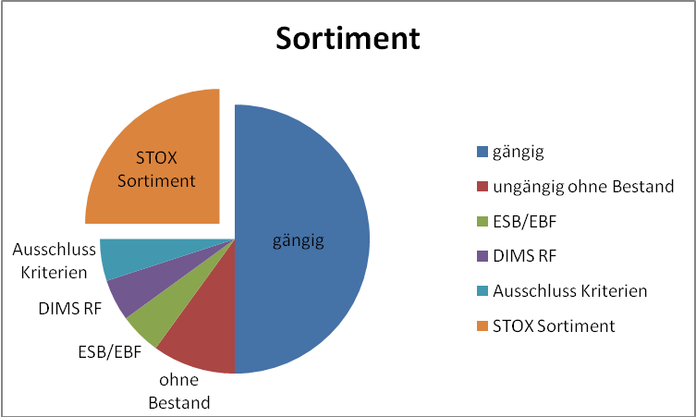

Figure 1‑1 - Assortment breakdown

The retailer's complete assortment is reduced step by step (i.e. parts scopes are taken away) until only the assortment relevant for DeadStock is left.

Requirement: FKT-SORT-1

The system must filter out the part scopes relevant to DeadStock from the dealer's complete range. In the process, part sizes are gradually deducted from the complete range.



Figure 1‑2 - Assortment determination

Requirement: FKT-SORT-2

The DeadStock machine range

1. includes only parts with free stock > 0.
2. does not contain parts for which the flag KZ\_RF\_NO\_EXCLUSION is set to 'J' in the local part master.
3. does not contain parts of Chrysler (MC brand only) and Fremd.
4. per market, other brands can be excluded (e.g. Mitsubishi in Germany).
5. does not contain old parts, tools, DRT and dangerous goods parts.  
   For the detection of DRT parts only the criterion PRIMUS field 134 - 5th digit = "D" is considered. Parts, which are exclusively used on the 7. The products with an "S" in the first place can be included in the DeadStock assortment. The DRT detection in STOX thus deviates from the DIMS/SICOS standard!
6. is restricted via the date fields "Creation date", "Last retirement" and "Last acquisition" (the date fields are preset centrally and can be changed individually for each site or left blank). If the period was not filled in the parameterization for operation or if the corresponding date field in the local part master is empty, the corresponding check is skipped. The comparison period is the value for **part category II** (i.e. the "smaller" value).  
   A central **change of** the preassignment for these date fields only has an effect for sites connected afterwards (or if an already connected site changes its settings and thereby "violates" the bandwidth, then a save is rejected). This change has no effect on the stored settings of an already connected operation.
7. also contains record type 2 parts (however, these can be excluded per operation).
8. does not contain parts from the initial stocking or initial filling (these are excluded either via the ESB or EBF indicator in the local parts master or after resetting the respective indicator for a further period of 4 months).[[2]](#footnote-2)
9. does not contain any parts from the DIMS feedback (one or more parameter sets are created and stored via an assignment table for STOX per market). If several parameter sets are stored, only the parts to which none of the RF parameter sets apply remain in the DeadStock range. Acceptance rates stored in the traceability parameter set are ignored (à acceptance of 0.0 is calculated).  
   Exception: If a DIMS repatriation-relevant part is excluded from repatriation because of open orders on the part itself or its alternatives, the part shall still be excluded from the deadstock range. The reason is that once the open orders are 0 again, the part can be returned.[[3]](#footnote-3)
10. does not contain parts with common alternatives (fixed parameters are used for common alternatives detection). I.e. if there is a common alternative for which the part can be used, the part does not go into DeadStock. All unilateral predecessors, bilateral alternatives, and the elective alternatives are reviewed. Replacements with co-delivered parts are not taken into account in the check - nor are parts with record type 2 / 3 in Germany or record type 3 in all other markets (see example below).
11. does not contain parts whose unit price or inventory value is below a threshold value.

**Example of testing for common alternatives:**

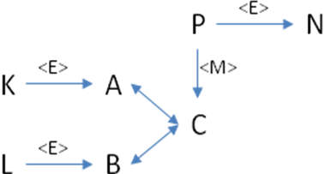

Our **candidate for DeadStock** **is part A.**If one of the part numbers **K, L, B or C is common**, then A is not included in the DeadStock assortment by machine (because A can be used for one of the common alternatives). Parts P and N are not checked for mobility (therefore do not play a role in a possible exclusion), since the replacement C à P is a co-supplied part for P.  
**Procedure:** To the DeadStock candidate (A), the leading part (C) is determined first (the "newest" two-sided substitution). For this part (C) all predecessors (one-sided or both-sided) are determined (chains with co-delivery parts are not considered). For each predecessor, the optional replacements are also determined. These parts (all predecessors and electives) are then tested for runnability.

Requirement: FKT-SORT-3

The system must determine the part category (Category II or III) relevant to DeadStock for each part **from the** dealer's **remaining** DeadStock **assortment** and categorize the part accordingly. For this categorization, only the settings of the site for the date fields "attachment", "last retirement" and "last acquisition" as well as the corresponding value of these fields in the local part master are relevant. The part is placed in category III if no condition from category II applies (i.e. highest possible category).

|  |  |  |  |  |  |  |  |  |  |
| --- | --- | --- | --- | --- | --- | --- | --- | --- | --- |
| **Settings** |  |  |  |  | **TODAY** | **01.01.2010** |  |  |  |
|  |  |  |  |  |  |  |  |  |  |
|  |  | Cat. II | Cat. III |  | Part | Attachment | last access | last departure | Category |
|  |  |  |  |  |  |  |  |  |  |
| Attachment |  | 12 | 24 |  | A | (ZERO) | (ZERO) | (ZERO) | Cat. III |
| last departure |  | 12 | 24 |  | B | (ZERO) | (ZERO) | 01.01.2008 | Cat. III |
| last access |  | (ZERO) | (ZERO) |  | C | (ZERO) | 30.06.2009 | 01.01.2009 | Cat. II |
|  |  |  |  |  | D | 01.01.2007 | 30.06.2009 | 01.01.2009 | Cat. II |
|  |  |  |  |  | E | 01.01.2007 | 30.06.2009 | 01.01.2008 | Cat. III |
|  |  |  |  |  | F | 01.01.2007 | 30.06.2009 | ZERO | Cat. III |

Requirement: FKT-SORT-4

DeadStock assortment updating (i.e. adding new parts and updating the part category) is done automatically at least once a week (see 7.1). The next update will then take place after 5 calendar days at the earliest.

Requirement: FKT-SORT-5

During the weekly update, the system checks the existing machine-determined assortment against the current RF criteria. Machine DeadStock parts included in the return (and not previously) are removed from the DeadStock range.

Requirement: FKT-SORT-6

The system automatically updates the inventory available in DeadStock when a new free inventory is posted in DIMS (when posted in DIMS, the DeadStock inventory is also updated).

All other relevant master data (e.g. price (BLP or VKP) and discount group) are determined and displayed from the current DIMS master data as required (at the time of the part search or order). So no additional synchronization with the DeadStock range is required here.

Requirement: FKT-SORT-7

The user can manually exclude parts from the automatic assortment and manually add parts that are not included in the automatic assortment. In addition, the category (discount rate) of parts can be changed (see section 4.7 and 4.11.3).

To support the manual process, DeadStock relevant information is added to the assortment analysis display in SICOS (see section 4.11.1).

Requirement: FKT-SORT-8

A part is deleted from the DeadStock assortment as soon as there is no more free stock, i.e. if stock is reported <= 0, the part is also deleted from DeadStock with the update. This will also delete all part number related DeadStock information (DeadStock note, machine / manual DeadStock category, DeadStock status, etc ...). Similarly, when a goods receipt occurs (i.e. when a planned or unplanned goods receipt is imported), the part is deleted from the DeadStock assortment.[[4]](#footnote-4) **It does not matter whether the part was picked up by machine or manually in DeadStock** **was picked up!**

Manually **excluded** parts are not deleted (from the DeadStock assortment) until the part is deleted from the *BESTAENDE* table in DIMS archiving (i.e. the part has record type 3, stock 0 and no movement for 2 years).

Deletion by a stock report <= 0 or a goods receipt is done via database triggers (see chapter 7.2).

If a manual exclusion is **removed from**a part, the part is deleted if it does not belong to the machine scope (empty machine part category) **or** it is included in DeadStock "normally" from this point on (with the last determined machine category).

Details of the categorization are shown in the diagram below!

Requirement: FKT-SORT-9

There are 3 part categories for parts included in the DeadStock assortment. The discount rate of a parts category can be parameterized differently per market (country) centrally. Default values are 15% (manually added parts), 25% and 50%. The centrally specified default value for a part category can be changed individually for each company.

Once parts are placed in DeadStock, they are not removed until they are sold off to zero stock, manually excluded, or a goods receipt is posted to a DeadStock part number. However, if a user changes his parameters, e.g. by setting the number of months of the clusters II and/or III at the investment date, date of last addition or date of last departure from e.g. 18 to 24 months, then the user tends to want to offer fewer parts via DeadStock.

Requirement: FKT-SORT-10

If the identifier for a previous parameter change is set when updating the assortment, the existing DeadStock assortment is deleted before the update and a recalculation is initiated as a result. Excluded from the deletion are manually added and manually excluded parts as well as parts for which a reservation is stored in DeadStock. For these parts (which have not been deleted), however, the previous **machine-determined** part category is reset. After recalculation, the parts with reservation, which are now no longer in the DeadStock assortment, are deleted (these have not received a machine part category due to the recalculation and can thus be detected). For the remaining reserved and manual parts, the current machine part category was entered.  
This process ensures that neither temporary excess stock (due to missing reservation) nor too many parts are included in the newly determined DeadStock assortment.

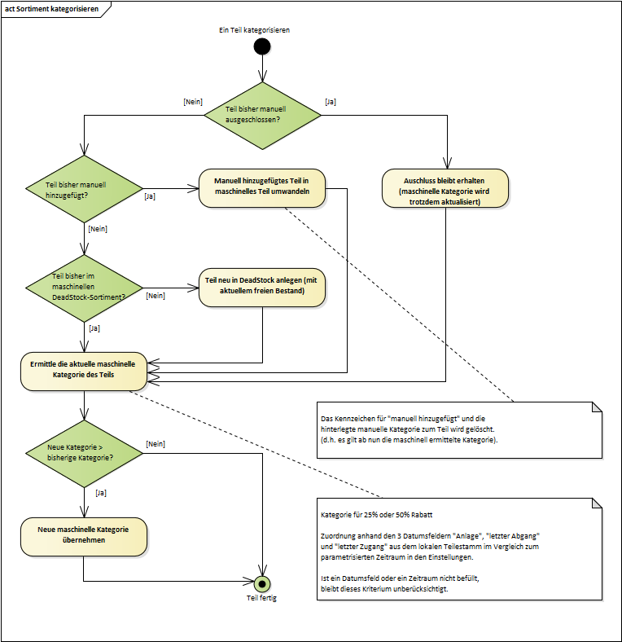

### Price determination (DeadStock)

The price determination in the part search and in the assortment determination is based on the current data in the part master and the current discount group matrix. This ensures that the current price and discount group information is accessed during a search or order. Details of the pricing of a part are described in the figure below.

Notice: VKP is always understood as the local BLP (field PREIS\_BLP in the local part master).

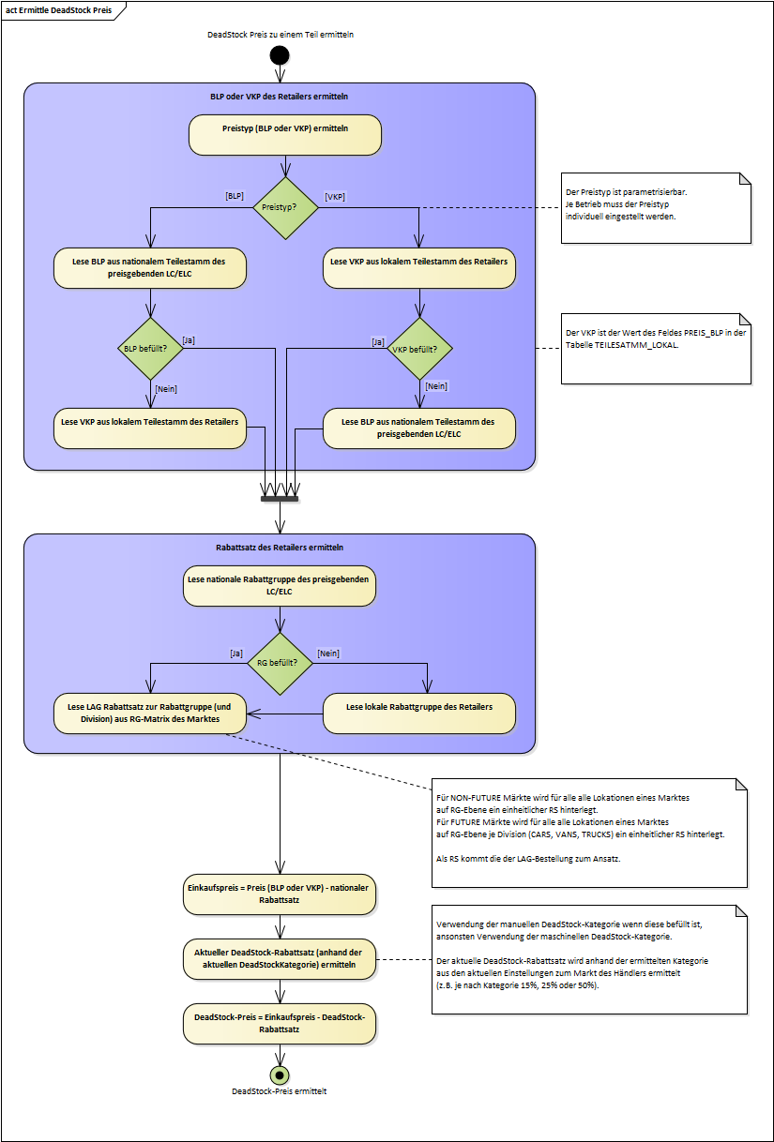

### Discount Group Matrix

Requirement: FKT-RG-1

In STOX, a uniform discount rate applies to all locations (dealers) in a market (country) at the discount group level. The discount rate of the LAG order is used for DeadStock and the discount rate of the VOR order is used for D2D. The discount group matrix per market is stored in the table "*STOX\_DISCOUNT\_MATRIX*" (see chapter 4.10.3.2).

Requirement: FKT-RG-2

The user can view in the panel "Part scope and RG matrix", the discount group matrix of his country used by STOX (for the discount rates of other countries he does not get authorization).

Requirement: FKT-RG-3

The admin controller can change and save the discount group matrix of a country used by STOX in the panel "Part scope and RG matrix". The discount group matrix for each store is loaded using an SQL import script (the data is provided by Daimler in an Excel or text file).

Requirement: FKT-RG-4

With the introduction of FUTURE it is necessary to make the discount rates in the market (country) different by division, i.e. the discount rates behind the discount groups can be different per division. For FUTURE markets, a separate RG matrix can be maintained for each of the CARS, VANS and TRUCKS divisions with different RG and discount rates per country.

For example, RG03 could carry the discount rate 35% for CARS, but for TRUCKS it could be only 30% or even 38%.

### Distance display

In the results display (see section 4.5.2) there is a "Distance" column. This contains the distance of the searching dealer to the possible seller in km.

Requirement: FKT-GUI-1

The display of the distance between two dealers is based on the direct distance ("as the crow flies") between the GPS coordinates of the two establishments. The display is in km.

The distance is only displayed if the GPS coordinates for both dealers are stored in the operating data. Otherwise, "-" is displayed in the distance field.

The distance is determined using the GPS coordinates of the farms. The GPS coordinates are imported from the GSSN (XML attribute <outletGps>). The coordinates are stored there in the format "degrees minutes seconds". These can be easily converted to decimal degrees. From this, the distance can then be derived using spherical geometry (source: MathWorld™ [http://mathworld.wolfram.com/SphericalTrigonometry.html)](http://mathworld.wolfram.com/SphericalTrigonometry.html).

Examples:

| Company number | City | GSSN GPS | Degrees/min/sec | Decimal degree |
| --- | --- | --- | --- | --- |
| 20800 (DE) | Landau | outletGpsX = +080705000  outletGpsY = +491235000 | E 08° 07' 05.000''  N 49° 12' 35.000'' | 8.118055  49.209722 |
| 21100 (DE) | Baden-Baden | outletGpsX = +081154670  outletGpsY = +484745610 | E 08° 11' 54.670''  N 48° 47' 45.610'' | 8.198519  48.796002 |
| 23300 (EN) | Bremen | outletGpsX = +085258710  outletGpsY = +530451420 | E 08° 52' 58.710''  N 53° 04' 51.420'' | 8.882975  53.08095 |
| 00298 (GB) | Belfast | outletGpsX = -055755000  outletGpsY = +543449000 | W 05° 57' 55.000''  N 54° 34' 49.000'' | -5.965277  54.580277 |
| 00384 (GB) | Norwich | outletGpsX = +011652000  outletGpsY = +523815000 | E 01° 16' 52.000''  N 52° 38' 15.000'' | 1.281111  52.6375 |

Table 1‑2 - Farms with GPS coordinates

This results in the following distances in km.

|  | 20800 (DE) | 21100 (DE) | 23300 (EN) | 00298 (GB) | 00384 (GB) |
| --- | --- | --- | --- | --- | --- |
| 20800 (DE) |  | 46 | 434 | 1134 | 612 |
| 21100 (DE) |  |  | 479 | 1167 | 648 |
| 23300 (EN) |  |  |  | 956 | 513 |
| 00298 (GB) |  |  |  |  | 524 |
| 00384 (GB) |  |  |  |  |  |

Table 1‑3 - distance table

For illustration 5 farms on the world map:

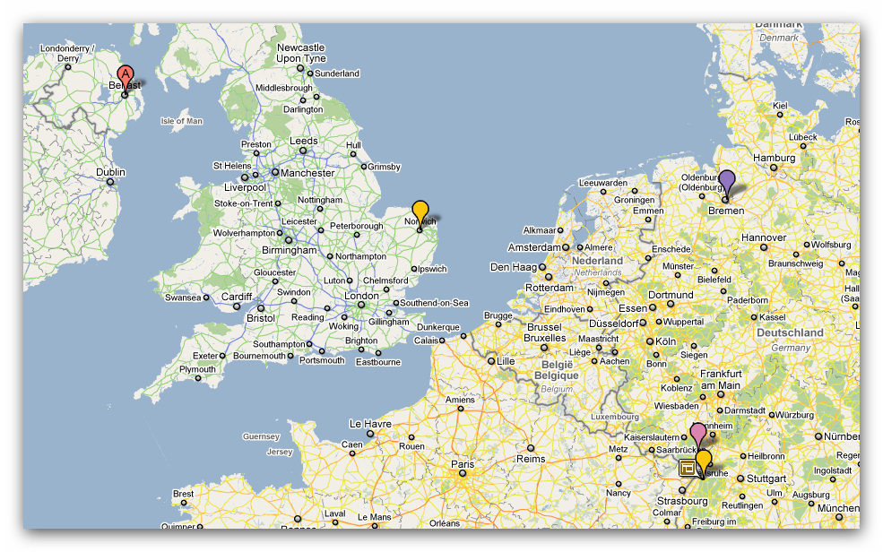

### Assignment of order numbers

Requirement: FKT-BEST-1

The system automatically generates a new order number when an order is placed. This consists of the order number range of the market (stored in the table "*STOX\_CENTRAL\_SETTINGS*") and the next consecutive number of the buyer (stored in the table "*ORDER\_NUMBERS*" in the field "*ANR\_STOX*") (see data model 3.1).

Requirement: FKT-BEST-2

The generated order numbers are 4-digit for the German market. All other countries receive a 5-digit order number.

Example for the MBVD market:

STOX order number range to the market (country): 6000 Last current ANR\_STOX of the purchasing company: 471 Next complete job number: 6472

### Basics of the parts search

Requirement: FKT-SUCH-11

The term "retail roles" used below is defined as follows: These are the roles "RetailerDefault" and "RetailerAdmin".

Requirement: FKT-SUCH-12

The term "own holdings" used in the following chapters (mainly chapter 4.5 Suche) is defined as follows: This is NOT the entered site number and its branch or main sites, but the set of all sites from the site lists "OrteDisposition", "OrteControlling", "OrteDS" and "OrteD2D" including their branch or main sites, which are already created in DIMS (table BETRIEBSDATEN\_KONZERN). However, it is irrelevant whether the operation DIMS is active or not. This is only relevant for retail roles and no wildcards are considered in the location lists. No establishments are excluded.

Requirement: FKT-SUCH-16

Only stocks from stock-active farms are displayed in DIMS (farm parameters):

* DIMS Status = Active
* DIMS Status = Inactive and Inventory Import Indicator = SPICS/PARAGON or SPICS/CORS.

Requirement: FKT-SUCH-17

An entered farm is ALWAYS considered as a separate farm. This applies to all roles.

This means especially for controllers (for retailers, due to the authorization, always entered = own company):

* it is not possible to place an order with an entered company
* it is always automatically searched for alternatives, quantity > 0 and stock without reservations
* own farms are displayed first and marked as such (yellow line and little house)

Example of treatment of own/entered farms:

Retailers with authorized locations: 200023300 (200023300 HB, 200023304, 200023309 ZB)

Taxpayers with authorized locations: \*

Part 4711, successor 4712

|  |  |  |  |  |
| --- | --- | --- | --- | --- |
|  | **200023300** | **200023304** | **200023309** | **200021212** |
| **Stock 4711 (free/reserved)** | 5 / 1 | 1 / 1 | 0 | 4 / 1 |
| **Stock 4712 (free/reserved)** | 2 / 1 | 0 | 3 / 1 | 6 / 2 |

Part search STOX:

|  |  |  |  |
| --- | --- | --- | --- |
|  | **Search 1** | **Search 2** | **Search 3** |
| **Entered operation:** | 200023300 | 200023300 | 200021212 |
| **Searched TNR** | 4711 | 4712 | 4711 |
| **With alternatives** | No | No | No |
| **Quantity requested** | 5 | 1 | 3 |

Results (only related to **own** farms and the **entered** farm, yellow lines represent the marking of own farms in STOX):

|  |  |  |  |  |
| --- | --- | --- | --- | --- |
| **Search 1 - Retailer** | **Search 1 - Controller** | **Search 2 - Retailer** | **Search 2 - Controller** | **Search 3 - Controller** |
| 200023300 - 4711 - 5/5 | 200023300 - 4711 - 5 | 200023300 - 4711 - 5/5 | 200023300 - 4711 - 5 |  |
| 200023300 - 4712 - 2/2 | 200023300 - 4712 - 2 | 200023300 - 4712 - 2/2 | 200023300 - 4712 - 2 |  |
| 200023304 - 4711 - 1/1 | 200023304 - 4711 - 1 | 200023304 - 4711 - 1/1 | 200023304 - 4711 - 1 |  |
| 200023309 - 4712 - 3/3 | 200023309 - 4712 - 3 | 200023309 - 4712 - 3/3 | 200023309 - 4712 - 3 |  |
|  |  |  |  | 200021212 - 4711 - 4 |
|  |  |  |  | 200021212 - 4712 - 6 |
| Own operations incl. alternatives, quantity > 0 and physical inventory | Entered operation incl. HB and ZB and alternatives, quantity > 0 and physical stock | Own operations incl. alternatives, quantity > 0 and physical inventory | Entered operation incl. HB and ZB and alternatives, quantity > 0 and physical stock | Entered operation incl. HB and ZB and alternatives, quantity > 0 and physical stock |

The following differences to a parallel search in the stock information system should be noted:

* Whether a part with record type 2 or 3 is displayed in the stock information depends on the selection criteria of the search. In the parts search (DeadStock & D2D) it depends on the setting of the respective operation.
* The role of the entered operation is different.
* In the stock information, the available stock over the entire alternative chain is considered as a total. In the part search (DeadStock & D2D), the stock is considered individually for each part of the alternative chain.
* In the stock inquiry, controller roles can display blocked stocks by searching with quantity = 0. This is not possible in the parts search.

#### DeadStock Process

Search in own stocks

Requirement: FKT-SUCH-1

The search in the stocks of the own plants is done with check "Stock > 0", i.e. the searched quantity is not considered here.

In the case of own stocks, the testing logic differs from that of external stocks. I.e. reservations are not deducted from the displayed stocks (cf. FKT-SUCH-3).

Background:

Before an "own" operation sells its unavailable stock via STOX in case of customer demand due to a STOX reservation, it makes more economic sense to use this stock itself before the retailer then has to buy the parts "expensively" via the LC.

Requirement: FKT-SUCH-2

A successful search in your own stocks does not reduce the quantity searched in the rest of the plants (i.e. there is no automatic splitting of the quantity searched).

Requirement: FKT-SUCH-3

The search in "foreign" stocks is done with check "(Stock - DeadStock Reservation - D2D Reservation) > 0", i.e. parts already ordered or requested via DeadStock or D2D (usually from other companies/buyers) or are deducted from the free stock.

Sort order of the results

Requirement: FKT-SUCH-4

In the results of the parts search, the stocks found in the entered company must always be displayed first in ascending order in the sort format (at the top) (regardless of price).

After that, the stocks found in the own plants are displayed (sorted by part number ascending in sort format and then by ascending plant number).

Requirement: FKT-SUCH-5

Sort order in the general overview for single search:

1) Preferred farms

2) Remaining farms (without problematic farms)

3) Problematic farms

If there are multiple results within a group, they are sorted first by highest savings potential, then in ascending order by distance.

Generally, the distance is displayed as a whole number, rounded commercially. The sorting should also already work with the integer, commercially rounded value. Otherwise, the sorting is no longer comprehensible for the user in case of integer equal distance.

Requirement: FKT-SUCH-6

In the general overview, multiple searches are first sorted by the part number searched for (in ascending order in sort format). If there are several results for one part number, the sorting order of the single search applies (see above)

Calculation of optimized results for multiple search

With multiple searches, a price-optimized view and a supplier-optimized view are calculated in addition to the overall view. In the optimized results, each part number is now displayed only 1x (exception: Stocks are found in the company's own operations). The following bases apply to the calculation:

Requirement: FKT-SUCH-7

In the price-optimized view, farms with the lowest DeadStock price are considered first. If more than one site with the same DeadStock price is found for a part number, the sites must be considered in the following order:

1. Preferred companies

2. Remaining farms (excluding problem farms)

3. Problematic farms

If there are several results within a group, the selection is made in ascending order of distance.

If a company has several part numbers, these are sorted in ascending order in the sort format.

Requirement: FKT-SUCH-8

In the supplier optimized view, optimization of the number of suppliers is performed. If several possibilities are found with the same number of suppliers (who can supply the same part numbers at the identical price) the plants must be considered in the following order:

1. Preferred establishments

2. Remaining farms (excluding problem farms)

3. Problematic farms

If there are several results within a group, they are sorted in ascending order by distance.

Example: Preferred plant A supplies part numbers 4711 and 4712 at the identical price X as the problematic supplier B. The system must display supplier A.

If a company has several part numbers, these are sorted in ascending order in the sort format.

Alternatives

Requirement: FKT-SUCH-9

If alternatives are to be considered in the search, the system must take into account one-sided successors as well as both-sided and optional replacements of the searched part number.

Result for multiple search of alternatives or same alternatives

Requirement: FKT-SUCH-10

In the result display, each part number (or alternative) found is displayed a maximum of once per supplier. If it is an alternative found, it will be displayed at the part number with the highest quantity found.

Example 1:

Alternatives: T4711 à T4799, T4712 à T4799 Inventory: at supplier T4799 - 10 pieces, no inventory on T4711 and T4712 Buyer looking: T4711 with 4 pieces and T4712 with 5 pieces

* Result: with searched part number 4712 the buyer gets 5 pieces displayed (with found part number 4799), with part number 4711 the buyer gets no result or no hit.

Example 2:

Alternatives: T4711 à T4799, T4712 à T4799 Inventory: at supplier T4799 - 10 pieces, no inventory on T4711 and T4712 Buyer looking: T4712 with 5 pieces and T4799 with 2 pieces

* Result: with searched part number 4712 the buyer gets 5 pieces displayed (with found part number 4799), with searched part number 4799 the buyer gets no result or no hit.

#### D2D process

Requirement: FKT-SUCH-13

The search in the stocks in the entered farm and the own farms is done with check "Stock > 0", i.e. the searched quantity is not considered here.

Requirement: FKT-SUCH-14

If alternatives are to be considered in the search, the system must take into account one-sided successors as well as both-sided and optional replacements of the searched part number.

Requirement: FKT-SUCH-15

In the case of the entered company and its own companies, the alternatives are always taken into account during the search.

### Email dispatch DeadStock

If a business successfully places an order, an email is sent to the vendor in the background.

Requirement: FKT-BEST-3

The email is sent to the email address stored in the operating data under STOX contact person.

Requirement: FKT-BEST-4

The email includes the following content:

* Company number and country of the buyer and seller
* Order date

Requirement: FKT-BEST-5

Below is a suggestion for the texts (subject and content). The texts can be adapted by Daimler AG before the GUI release.

**Subject:** There is a new order in STOX

**Text:**

Dear Sir or Madam,

there is a new order in STOX at your company 21212 - Germany.

Orderer: 23300 - Germany

Ordering time: 13.09.2010 15:12

Please process the purchase order in Logistics Bus STOX as soon as possible.  
Inform the customer immediately if you cannot deliver the order or cannot deliver it completely.

With kind regards

Logistics bus STOX

This is an automatically generated mail. Please do not reply to this mail.

<<Footer>>

Requirement: FKT-BEST-6

The email must be sent in the language of the seller.

### Ordering from own operations

Requirement: FKT-BEST-7

Basically, no parts can be ordered from own plants, i.e. if the search in own stocks delivers results, these parts cannot be transferred to the shopping cart.

Example: Site 23300 may not order from its branch site 23301 via STOX.

### MBVD partner store

Requirement: FKT-PSG-1

From STOX there should be a jump function to the MBVD partner store, which allows the merchant to place a shipping order with UPS.

Process description

1. The seller is processing a STOX purchase order in the *Order Overview* panel and now wants to initiate shipping (i.e. all items of the order have been processed).
2. Via a button in the *order overview* (subpanel *Sell*) or in the *order details* a jump to the MBVD partner store takes place. Jump here means that the user's Internet browser opens and the corresponding URL in the partner store is called. The form data for the dispatch are supplied in the call. The URL and form data are determined in the STOX application server in order to have more flexibility here in the event of changes at short notice (for a description, see chapters 4.4.1.1 and 4.4.2, for details of the interface, see chapter 8.2.1).
3. After jumping to the partner store, the order gets the status *shipped* (and the shipping date is set). A new jump is possible as long as the order is not yet in the *received* status (the shipping date is no longer updated).
4. For order tracking there is another button in the *order overview* (in all subpanels). Here, too, the jump to the partner store takes place, but to a different page (URL). No form data from STOX is supplied (for description see chapter 4.4.1.1, 4.4.1.2, 4.4.1.3).

### Manual exclusion of rejected parts (DeadStock)

It often happens that sellers reject order items for various reasons, e.g. because the part has been sold or reserved for a customer in the meantime, the part shows signs of use or is defective, or is simply no longer in stock (inventory difference).

This would not be problematic if the vendor manually excludes the part number from the DeadStock process in STOX if they can't or won't sell it, or if they write the part out of their DMS with zero inventory. However, since this does not happen as a rule, complaints from retail often arise that order items are rejected but the same part numbers continue to be offered for sale via DeadStock.

To minimize this problem, in the future, as soon as the seller rejects a DeadStock order item in the order details (changing the item status to "L" or setting the delivery quantity to 0), a dialog will appear asking whether this TNR should be manually excluded from the DeadStock assortment in the future.

Requirement: FKT-MAUS-1

When the status of a DeadStock order item changes to "L" (via status or delivery quantity zero), a popup appears asking "Do you want to manually exclude this part number from your DeadStock assortment?". The popup can be closed only by clicking the "Yes" button or the "No" button.

Requirement: FKT-MAUS-2

In the order details (DeadStock) a new column "man. Exclusion" included in the seller view (between the columns "Order value" and "Weight"). The new column will be shown only if there is at least one item in the "L" status. If no deleted position is included or the question for manual exclusion was answered with "No", the column remains hidden (see section 4.4.2).

Requirement: FKT-MAUS-3

If the question for manual exclusion is answered with "Yes", the following changes are stored in the DeadStock assortment or parts master when "Save" or "Close":

* A manual exclusion is stored for the part number (i.e. status "manually excluded") (the display in the part master panel is identical to when the "manually exclude from DeadStock" checkbox is activated).
* In the DeadStock Note field, the text "Manual exclusion as part of order processing!" is prefixed in addition to any existing entry. In addition, the order number and order date are also displayed.

If the question about manual exclusion is answered with "No", this is also noted in the DeadStock assortment, i.e. after "Save" or "Close" the field "SXPA\_FLAG\_EXCLUDED\_BY\_ORDER" is filled with either 'Y' or 'N'.

Requirement: FKT-MAUS-4

When the status of an order item is changed from "L" back to "A" or "V", the manual exclusion (i.e. the changes to the parts master or DeadStock assortment) are reversed. Even if the part number was added manually before, this state will be restored.

Requirement: FKT-MAUS-5

Three new fields are added to the "*STOX\_PARTS*" tables and one field is added to the "*STOX\_ORDER\_DETAILS*" tables for displaying in the order details and restoring the changes (see chapter 3.3).

* The "*SXPA\_FLAG\_EXCLUDED\_BY\_ORDER*" field contains a flag if the manual exclusion resulted from a deleted PO line item, i.e. 'Y' if the part was manually excluded and 'N' if the part was not excluded after the line item was rejected.
* The "*SXPA\_EXCLUDED\_BY\_ORDER\_NUMBER*" field contains the order number where the part number was manually excluded.
* The "*SXPA\_EXCLUDED\_BY\_ORDER\_DATE*" field contains the order date of the order where the part number was manually excluded.
* The "*SXOD\_FLAG\_MANUAL\_EXCLUDED*" field contains an indicator of whether the manual exclusion question was answered "Yes" or "No" (or the field is empty if the item is not rejected).

Notes

1. With the change of the order status from "in process" to "shipped" or "rejected" - as before - no change of the position status is possible anymore. If the entry regarding the exclusion is incorrect, the error must be corrected in the part master panel.
2. Deviating from the access authorization in the parts master panel, it is possible to manually exclude part numbers from the DeadStock assortment in the order details for the user roles "STOX Retailer Admin" and "STOX Retailer".
3. If the manual exclusion is removed again (after setting via the order details) in the parts master panel, all information about the manual exclusion within the order processing (e.g. note in the DeadStock note with order number and date of the deleted item) is also reset.

### D2D Assortment

For display in the D2D parts search, retail assortments are divided into four different categories:

1. Assortments that are **not** displayed in the parts search:

* Parts group old parts
* Foreign parts - FREMD brand (MC) and foreign (DC)
* Chrysler branded parts (MC) (after DC, Chrysler parts will be integrated into CARS from 2020)

1. Assortments that are displayed in the parts search without prices and cannot be ordered
2. Assortments that are displayed in the parts search with price, but still can not be ordered:

* Part group dangerous goods (because e.g. not shippable via UPS)
* Tool parts group (since mostly tools for use in the workshop)
* Vehicle-bound DRT (not complete parts group, but only technology info 5. Digit "D")

1. Assortments that are displayed in the parts search with price and are orderable (all parts that do not fall into category 1-3)

For each of the three assortment categories (1) to (3), any additional brands can be excluded on a market-related basis (analogous to DeadStock). These additional marks can be stored as parameters in the database on a market-by-market basis.

Examples:

* "new" FUTURE brands like Trucks Asia, DTNA, Trucks Latin America, Evobus India, Bus Latin America are shown in all European markets but are stored as not available for order (assortment-2)
* FUSO parts are displayed in MBD market without price and without possibility to order (assortment-2), but in MBUK with price and possibility to order (assortment-4)
* Evobus parts are displayed in MBD market "normally" with price and possibility to order (assortment-4), but in MBP with price and without possibility to order (assortment-3)
* SLR/Maybach (MC) are not displayed in MBE at all (assortment-1)

A rejection of a delivery request in D2D leads for a parameterized period of time to the fact that these parts are no longer displayed in the D2D parts search. A rejection of a request in the DeadStock process, on the other hand, has no effect on the display in the D2D parts search.

Additionally, locations (and thus their complete assortment) can be excluded (i.e. items of these locations will not be displayed in D2D parts search, see [FKT-D2D-LIEF-7](#FKT_D2D_LIEF_7))

The display of stocks of SA2 items can be set individually by each plant in subpanel 8.3 (STOX parts range and RG matrix, see chapter 4.10.3). If the SA2 positions are "deactivated" there, the positions (parts) of this location will not be displayed in the D2D part search "of other locations" (even if the free or available stock would be sufficient for the search). The parameter has no effect on the display of the stocks of its own farms.

Example:

Location A has set the parameter "Exclude record type 2 items from STOX assortment", location B has not set the parameter. When a user searches for parts "from site B", the SA-2 positions of location A are **not** displayed (but his own SA-2 positions are). When a user searches for parts "from site A", the SA-2 positions of site B as well as of his "own" sites are displayed.

Supplementary notes:

Exclusions via the STOX part master are only effective for the DeadStock process, but not for the D2D process (i.e. these parts will still be displayed in the D2D part search if none of the other criteria mentioned above prevent this).

### Available stock

For the D2D process, an "available inventory" is defined in addition to the "free inventory":

* The reserved quantity DS are the unresolved reservations from the DeadStock process (see 7.4).
* The reserved quantity D2D are the unresolved reservations from the D2D process (see 7.4). This includes delivery requests started via D2D or orders accepted but not yet delivered. Stocks that are blocked due to a D2D rejection do **not** count as reserved stock.

Example:

free stock / R20 8 Reservation from DS 3 Accepted (not yet delivered) order from D2D 1

Available stock 4 (= 8 - 3 - 1)

Started delivery request (L1) from D2D 1 Started delivery request (L2) from D2D 1 Not yet started delivery request (L3) from D2D 2

Available stock 2 (= 8 - 3 - 1 - 1 (L1) - 1 (L2))

Stopped delivery request (L1) (other supplier accepted) 1 Started delivery request (L3) from D2D 2

Available stock 1 (= 8 - 3 - 1 - 1 (L2) - 2 (L3))

Manually rejected delivery request (L2) 1 Machine rejected delivery request (L3) due to rejection of (L2) 2

Available stock 4 (= 8 - 3 - 1)  
(but in this case the available stock is **not** displayed because it is blocked for a period of time by the rejection)

### D2D delivery requests

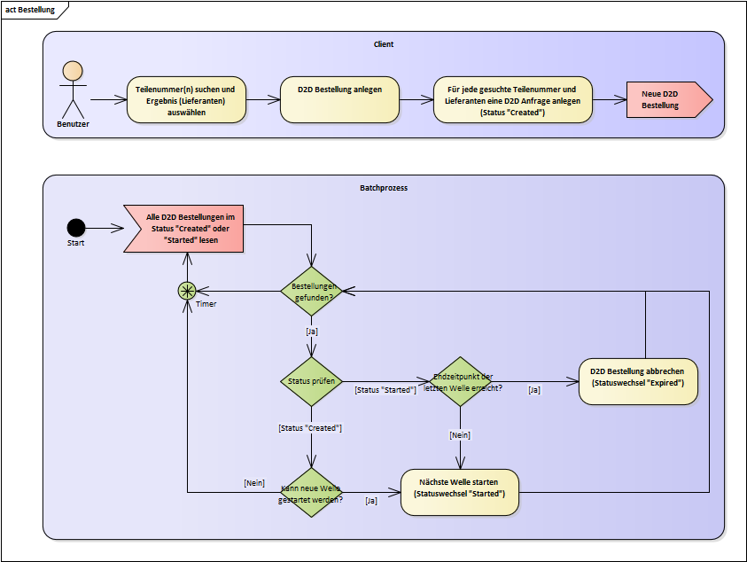

Figure 1‑3 - D2D order creation

Requirement: FKT-D2D-LIEF-1

After searching for parts and selecting or confirming the plants on the client, a new D2D order is created for each (searched) part number. For this purpose a new record is created in the table "*D2D\_ORDERS*" and for each selected supplier a corresponding record in the table "*D2D\_REQUESTS*" (D2D request).

The inquiries (for all selected suppliers) are initially still in the "*Created*" status. In this status, the request is not yet visible to the supplier.

Requirement: FKT-D2D-LIEF-2

Via a batch process (chapter 7.13), new requests are restarted in several waves or terminated after the last wave. Before each wave start, the farms whose current available stock no longer meets the search criteria are "deleted" from the wave (between the result determination and the start of the query, the available stock may have changed, status "*Invalid")*.

Requirement: FKT-D2D-LIEF-3

The order of the sellers whose request is started (i.e. in which wave the seller is requested) corresponds to the order in the display. Depending on the selection of sorting on the GUI based on the "delivery probability" for non-owned retail operations (see chapter 4.5.3) or by price in ascending or descending order.

Requirement: FKT-D2D-LIEF-4

When starting requests in a new wave, requests already started in previous waves remain "open". I.e. a seller can process (accept or reject) a started (open request) until it is cancelled by the buyer, automatically closed after X hours or accepted by another potential seller.

Requirement: FKT-D2D-LIEF-5

Various parameters are defined to control the requests. These are stored in the database and cannot be maintained via the GUI, but only via an update instruction (EPM ticket). All parameters are country-specific (i.e. to be maintained per country):

| Parameter | Description | Value |
| --- | --- | --- |
| WORKINGDAY\_TIMES | Times or period (per weekday) in which the requests to the sellers are started **(=working time window)**.See also FKT-GUI-390  The windows are divided accordingly for break times. | LKZ 200 Mon. - Fri. 08:00 to 12:00 and 13:00 to17:30 Sat. 08:00 to 12:00 |
| NUM\_OF\_SUPPLIERS\_PER\_WAVE | The number of sellers whose request is started per wave. | LKZ 200 X Seller |
| INCREASE\_SUPPLIERS\_FACTOR | Increasing factor - from wave X the number of sellers to be contacted is increased by factor Y (every further wave starts with this number) | LKZ 200 shaft X, factor 1.5 (= 50%) |
| INCREASE\_SUPPLIERS\_WAVE | From wave X, the number of sellers to be contacted is increased by a factor of Y | LKZ 200 shaft X |
| MAX\_NUM\_OF\_WAVES | Upper limit (max. number) of shafts. With the last wave, all remaining requests to potential sellers are started (even if this exceeds the specified number of sellers per wave). | LKZ 200 X Shafts |
| WAVE\_RUN\_TIME | Runtime of a wave, i.e. period until the next wave is started (in minutes). Break times and times outside the working time windows are not counted towards the duration. | LKZ 200 X minutes |
| FINISH\_WAITING\_TIME | Waiting time after the start of the last wave (in minutes).  End time of the D2D order = start time of the last wave + waiting time (break times and times outside the working time windows are not counted towards the waiting time). After that, the D2D order will be cancelled (i.e. all started requests to all sellers will be terminated). | LKZ 200 X minutes |
| MIN\_TOTAL\_RUN\_TIME | Minimum runtime from the start of the first wave to the end of the last wave (in minutes). Break times and times outside the working time windows are not counted towards the duration.  If, for example, only one wave is started due to fewer potential suppliers, it should run for at least x minutes. | LKZ 200 X minutes |
| REJECT\_BLOCKING\_TIME | Number of calendar days for which a seller who has manually rejected a request (not if the request has expired or another seller was faster) will not receive a new request for the rejected part number. | LKZ 200 14 calendar days |
| PREF\_SUPPLIER\_DISTANCE | Distance (in km) for potential sellers (sellers in this radius are preferred regarding "delivery probability") | LKZ 200 50 km |

Table 4 - Parameters for controlling requests

Requirement: FKT-D2D-LIEF-6

For D2D, a separate country-specific ordering calendar (D2D ordering calendar) is stored in the "country-specific parameters" (analogous to the "country calendar for SICOS"). National non-working days are maintained via the D2D ordering calendar and are additionally taken into account in the working time window (i.e. on these days the working time window is empty). The maintenance of the calendar is done analogously in SystemControl via the "Calendar" dialog.

Requirement: FKT-D2D-LIEF-7

Via an exclusion table, sites can be excluded as sellers centrally (e.g. PWI sites, Xentry test site). The table is maintained by template (service desk). For these excluded farms, no stocks are displayed in the result either. Exception: Excluded establishments are not included in own establishments (are included despite exclusion).

Requirement: FKT-D2D-LIEF-8

The start time of the shafts is not "precalculated" when the D2D order is created, but results dynamically based on the set parameters during the cyclic inspection by the batch process.

A "follow-up wave" starts "immediately" with the rejection of the last request of all sellers from the previous wave or when the runtime (incl. working time window without break times) of the previous wave is exceeded.

Requirement: FKT-D2D-LIEF-9

The end of the D2D order, is reached

* If the buyer cancels the D2D order   
  à Status of the order and all started requests "Cancelled", not started requests are deleted
* When a seller accepts the request  
  à status of the order and accepted request "Accepted", all started requests status "Stopped" and not yet started requests are deleted
* When all sellers have rejected their request (last wave has been started and thus no more potential sellers are available)  
  à Status of the order "Rejected" (all requests keep status "Rejected")
* Or when the waiting time after the last wave is reached and the complete duration of the order has exceeded the minimum duration  
  à Status of the order and all started and all not rejected requests "Expired"

Example:

Working Times Mon - Fri 08:00 - 12:00 or 14:00 - 18:00, Sat 08:00 - 12:00

Running time of one wave 90 min





On 03.10. an order is placed. As long as the order is not cancelled or accepted and potential suppliers still exist, the waves will start at the following times: 04.10. 08:00, 04.10. 09:30, 04.10. 11:00, 04.10. 14:30, 04.10. 16:00, 04.10. 17:30, 05.10. 09:00, 05.10. 10:30, 07.10. 08:00, 07.10. 09:30, ..

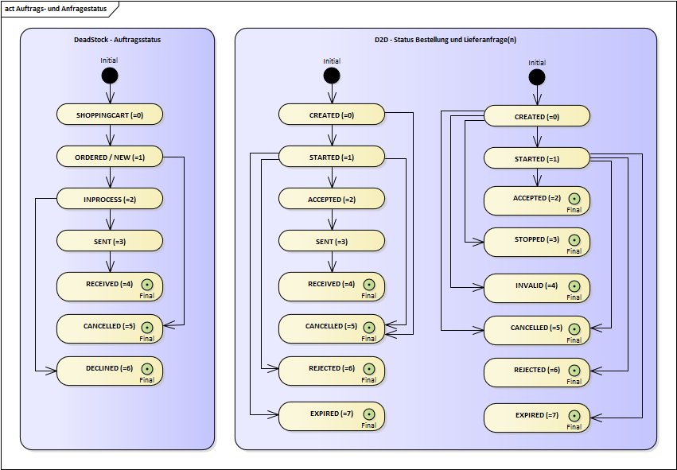

Figure 1‑4 - Order and Request Status (DeadStock and D2D)

#### Time zones

All times (working time windows, break times, etc.) always refer to the time zone of the **requested market** (seller's market). In level 1, this automatically coincides with the buyer's time zone as well. But in subsequent stages, requests may be made by a CPM and not by a concrete operation (or the user of a concrete operation).

However, various problems arise when a market covers different time zones (e.g. USA, Brazil). On the one hand, the time zone of an individual trader is not known. If there are several time zones within the country, the dealers cannot be assigned by the system (there is no information about this in the GSSN either). But even if this were known, taking individual time zones per dealer into account would pose many problems (waves could then no longer be compiled according to "delivery probability", the end or start of a wave would depend on the time zone of the plants within the wave (the end time of the wave would then no longer be uniform, etc.). Therefore, only one time zone may be used per market/country. For markets with multiple time zones (e.g. USA and Brazil), a uniform "middle" time zone is used within D2D. The working time windows and breaks must then be extended by the span of the time zones.

### D2D value (handling margin)

The D2D value of an order is determined according to the following procedure:

1. Order value at BLP/VKP = BLP or VKP of the position (depending on parameterized price type) \* quantity
2. EK value = order value to BLP/VKP - BEFORE discount rate (discount rate after BEFORE RG)
3. D2D value = EK value + handling margin per TNR

The determination of the BLP/VKP or the discount group is analogous to the DeadStock price determination (see 1.1.4).

The handling margin can be parameterized individually for each location (see 4.10.3.3). Which handling margin is applied (percentage, min. or max. value) depends on the order value of the respective D2D item (in relation to a threshold value). The percentage value of the handling margin (HM value) is calculated from EK value (net value) \* handling margin in %.

The following rules apply here:

* min. Value < percent HM value < max. value à Handling margin = percent HM value
* min. Value > percent HM value à Handling margin = min. value
* max. value < percent HM value à Handling margin = max. value
* max. value = 0 (corresponds to not maintained) à max. value = infinite (does not represent a limit) à Handling margin = min. value or percentage HM value

Example:

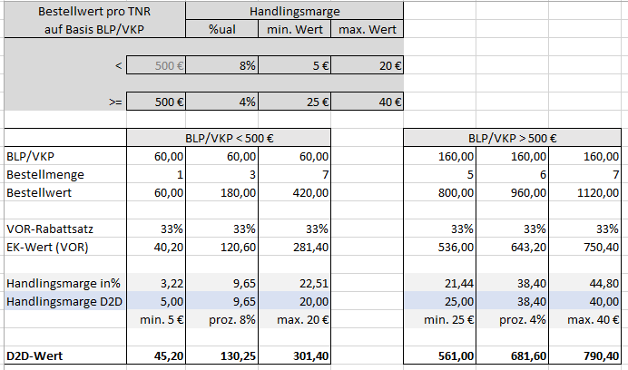

# System use cases

## Search single part - DeadStock

| Attribute | Explanation |
| --- | --- |
| Brief description | Search of a single part number in the complete country. |
| Preconditions | The current site number (site and country) is entered and the user is authorized for this site. |
| Required data | User input   * complete part number in input format * Part number with wildcard * searched quantity (>=1) * Alternative part search (optional)   Database   * DeadStock Assortments * current dealer inventory * current parts master data (local, national, global) * current alternative relationships |
| Process description | 1. Main scenario 2. The user enters the complete part number in any format (conversion to input format is automatic). 3. The user enters his desired quantity. 4. The user starts the search. 5. The companies that carry the part number you are looking for in sufficient quantity in the DeadStock assortment are shown in the general overview. 6. Alternative scenario - Wildcard    1. The user enters a part of the part number in the input format with wildcard (\*).    2. The user enters his desired quantity.    3. The user starts the search.    4. The companies that carry the searched part number incl. wildcard in sufficient quantity in the DeadStock assortment are displayed in the general overview. 7. Alternative scenario - search with alternatives    1. The user enters the complete part number in any format (conversion to input format is automatic) and activates the "Alternative search".    2. The user enters his desired quantity.    3. The user starts the search.    4. The companies that carry the part number you are looking for or an alternative in sufficient quantity in their DeadStock assortment are shown in the general overview. |

| Result | The part numbers found are displayed in the general overview. The price-optimized and supplier-optimized views are not calculated. Sort see 1.1.8 |
| --- | --- |
| Special cases / exceptions / errors | - |
| Dialogue drafts | 0 |
| Diagrams | Activity Diagram (following) |
| Open points | - |

Table 2‑1 - System use case: Search single part

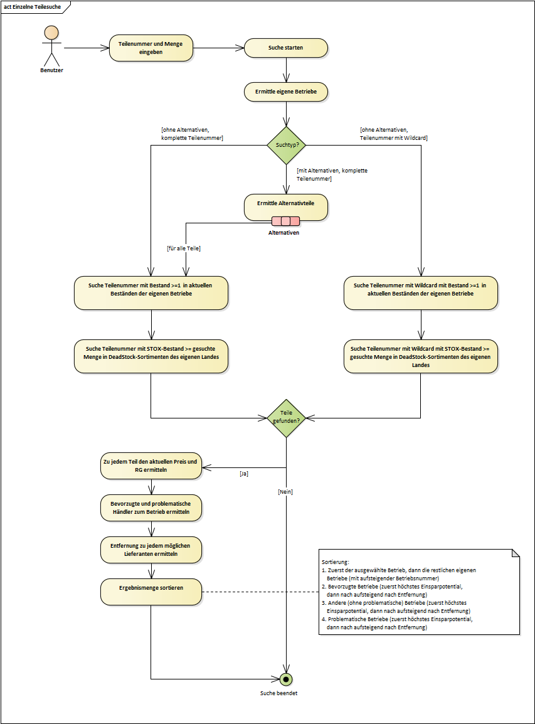

## Search multiple parts - DeadStock

| Attribute | Explanation |
| --- | --- |
| Brief description | Search of several part numbers in the complete country. |
| Preconditions | The current site number (site and country) is entered and the user is authorized for this site.  Searching for part number(s) with wildcard is not possible. |
| Required data | User input   * multiple part numbers * searched quantities (>=1)   Database   * DeadStock Assortments * current dealer inventory * current parts master data (local, national, global) * current alternative relationships |
| Process description | 1. Main scenario    1. The user enters several part numbers in any format (conversion to input format is automatic).    2. The user enters his desired quantities per part number.    3. The user starts the search.    4. The companies that carry one of the searched part numbers in sufficient quantity in the DeadStock assortment are displayed in the general overview.    5. The results are additionally displayed optimized by price and by supplier. 2. Alternative scenario - search with alternatives   Analogously (1) in addition the user activates the "Alternative search". |
| Result | The found part numbers are displayed in the general overview, price and supplier optimized. Sort see 1.1.8 |
| Special cases / exceptions / errors | - |
| Dialogue drafts | 0 |
| Diagrams | Activity Diagram (following) |
| Open points | - |

Table 2‑2 - System use case: Search multiple parts

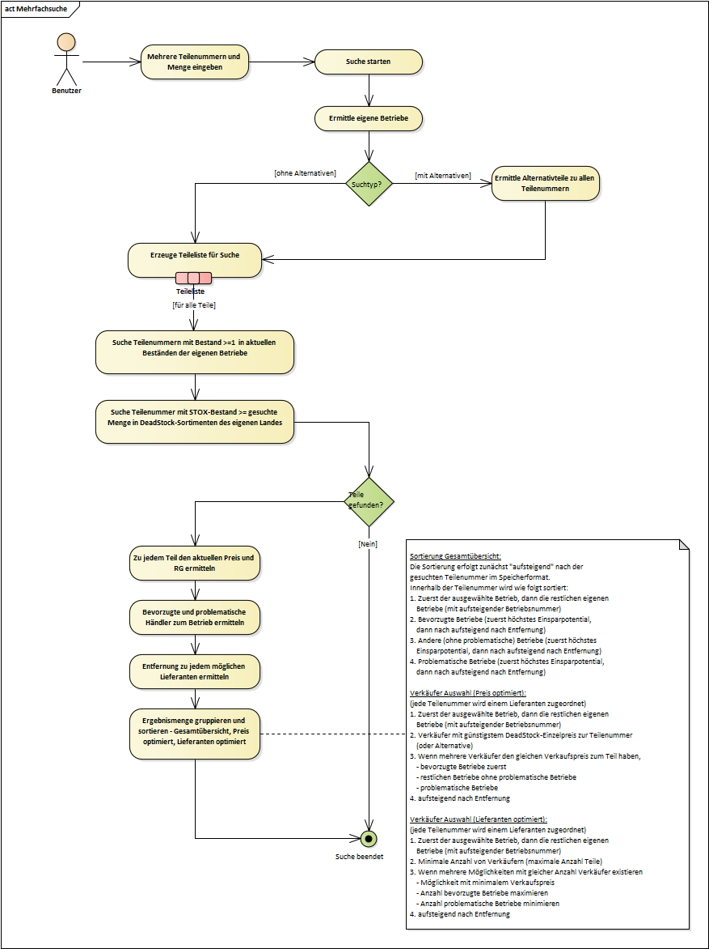

## D2D part search with subsequent D2D order processing

The following UseCase diagram contains an overview of the flows within the D2D process. The jump for VOR orders to StarOrder/StarOrderPlus is not considered.

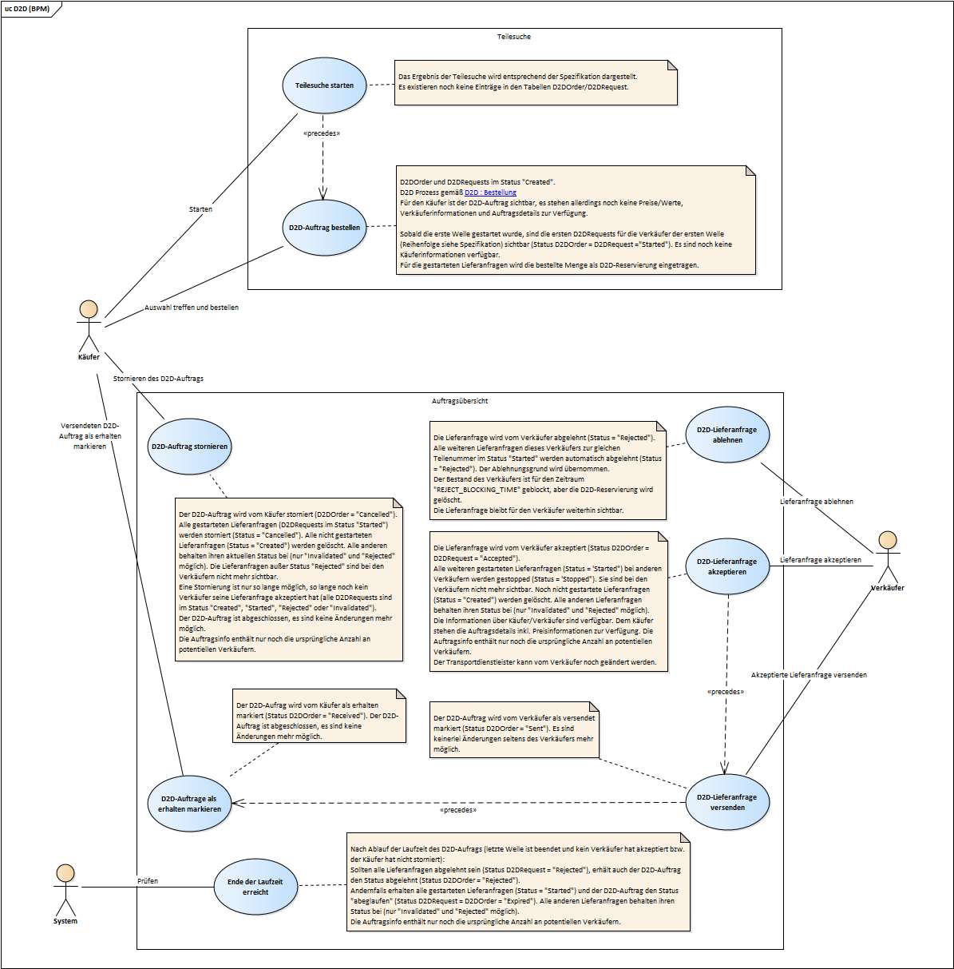

Figure 2‑1 - Overview UseCases D2D Part Search and D2D Order Processing

# Data model

The application will store most of its data in its own database schema "STOX". In addition, some changes are made to the already existing schemes "DIMS", "SD" and "SICOS".

## Extensions to schemas DIMS, SD and SICOS

Requirement: FKT-DB-2

Two new fields "*STOX\_ACTIVE*" and "*STOX\_INIT*" are added to the table "*BETRIEBSDATEN\_KONZERN*" for the activation of sites. When STOX is activated via the operating data panel, the "*STOX\_ACTIVE"* field is set. "*STOX\_INIT*" indicates whether all mandatory fields have been maintained for the location via the settings.

Both fields are "2-digit" each. The first digit is for the DeadStock process, the second digit for the D2D process respectively. Thus, activation can be performed separately for both processes.

Requirement: FKT-DB-3

For the storage of the GPS coordinates of the dealers from the GSSN import, the tables "*BETRIEBSDATEN\_KONZERN*" and "*GSSN\_POOL*" are extended by the fields "*GPS\_X\_GSSN*" and "*GPS\_Y\_GSSN*" respectively. These are filled with the corresponding content from the GSSN. In addition, the coordinates are converted to geodecimal values during import and stored in the also new fields "*GPS\_X\_GEODEC*" and "*GPS\_Y\_GEODEC*".

Requirement: FKT-DB-4

For the search for part numbers with wildcard, the table "*BESTAENDE*" is extended by a field "*RNR\_INSBATCH\_FMT*" and the table "*BESTAND\_ONLINE*" by a field "*TNR\_INSBATCH\_FMT*" (consecutive without spaces). When creating a new part number, this field is filled with the batch input format (i.e. without spaces). This field is needed to search for part numbers with wildcard. For initialization see section Data migration.

Requirement: FKT-DB-5

For storing the STOX order numbers for operation, the table "*ORDER\_NUMBERS*" is extended by a column "*ANR\_STOX*". This contains the last order number assigned. The order number range for STOX is stored per market in the table "*STOX\_CENTRAL\_SETTINGS*".

Requirement: FKT-DB-6

A new contact type for STOX (type 4) is introduced in the "*OPERATIONS\_CONTACTS*" table for storing the STOX contact. The fields for name, email, telephone and fax number are stored here in the same way as the contact person for scheduling or inventory information.

Requirement: FKT-DB-7

The storage of user settings (e.g. file storage, last settings for search fields) is done via the table "*USER\_PROPERTIES*" (analog to the procedure in DIMS or SICOS). No extensions to the data model are necessary here.

Notice: The storage of preferred or problematic merchants is not done per user but per merchant. Therefore, these operation lists are not stored in the "*USER\_PROPERTIES*" like all other operation lists in SICOS, but in the table "*STOX\_LOCAL\_SETTINGS*" (see chapter ...).

Requirement: FKT-DB-8

A new table is added to the SD (Master Data) schema for storing the currency associated with a country (name and currency symbol, if applicable).

|  |  |  |  |  |
| --- | --- | --- | --- | --- |
| **Column** | **Column Name** | **Data Type** | **Not zero?** | **Comments** |
| 1 | **CUR\_COUNTRY\_CODE** | NUMBER(3) | Y | Country code |
| 2 | **CUR\_LOGISTIC\_LEVEL** | VARCHAR2(1) | Y | Logistics level |
| 3 | CUR\_SHORT\_NAME | VARCHAR2(3) | Y | Abbreviation of the currency (e.g. EUR) |
| 4 | CUR\_LONG\_NAME | VARCHAR2(30) | Y | Full currency name |
| 5 | CUR\_SYMBOL | VARCHAR2(3) |  | Currency symbol (if available) |
| 6 | CUR\_WHS\_CURRENCY\_NAME | VARCHAR2(3) |  |  |
| 7 | CUR\_WHS\_CONVERSION\_RATE | NUMBER(12,4) |  |  |
| 8 | CUR\_WHS\_SYMBOL | VARCHAR2(3) |  |  |

Example:

|  |  |  |  |
| --- | --- | --- | --- |
| **CUR\_COUNTRY\_CODE** | **CUR\_SHORT\_NAME** | **CUR\_LONG\_NAME** | **CUR\_SYMBOL** |
| 200 | EUR | Euro | € |
| 537 | GBP | Pound sterling | £ |
| 569 | SEK | Swedish krona |  |
| 571 | CHF | Swiss franc |  |
| 577 | EUR | Euro | € |
| 705 | USD | US Dollar | $ |

## New DB schema STOX





## Description of new tables and fields

|  |
| --- |
| **Table Name** |
| STOX\_ADDRESSES |
| STOX\_ASSORTMENTS |
| STOX\_CENTRAL\_SETTINGS |
| STOX\_DEALER\_STATS |
| STOX\_DISCOUNT\_MATRIX |
| STOX\_FINANCIAL\_DATA |
| STOX\_INFO\_PAGES |
| STOX\_LOCAL\_SETTINGS |
| STOX\_ORDER\_DETAILS |
| STOX\_ORDERS |
| STOX\_PARTS |
| STOX\_RESERVATIONS |
| STOX\_SHIPPING\_MODES |
| STOX\_SUPPLIER\_SHIPPING\_MODES |
| STOX\_DEALER\_EXCLUSIONS |
| D2D\_ORDERS |
| D2D\_REQUESTS |

### Table STOX\_ADDRESSES

|  |  |  |  |  |
| --- | --- | --- | --- | --- |
| **Column** | **Column Name** | **Data Type** | **Not zero?** | **Comments** |
| 1 | **SXAD\_ISN** | NUMBER(14) | Y | Unique ISN |
| 2 | SXAD\_DEALER\_NAME | VARCHAR2(200 CHAR) |  | Dealer name |
| 3 | SXAD\_TYPE | NUMBER(1) |  | Address type (1=billing address, 2=delivery address) |
| 4 | SXAD\_ZIP\_CODE | VARCHAR2(40 CHAR) |  | Postal code |
| 5 | SXAD\_CITY | VARCHAR2(100 CHAR) |  | City |
| 6 | SXAD\_STREET | VARCHAR2(100 CHAR) |  | Street |
| 7 | SXAD\_HOUSE\_NUMBER | VARCHAR2(10 CHAR) |  | House number |
| 8 | SXAD\_PHONE | VARCHAR2(100 CHAR) |  | Phone number |
| 9 | SXAD\_FAX | VARCHAR2(100 CHAR) |  | Fax number |
| 10 | SXAD\_MAIL | VARCHAR2(400 CHAR) |  | Email address |

### Table STOX\_ASSORTMENTS

|  |  |  |  |  |
| --- | --- | --- | --- | --- |
| **Column** | **Column Name** | **Data Type** | **Not zero?** | **Comments** |
| 1 | **SXAS\_ISN** | NUMBER(19) | Y | Unique ISN |
| 2 | SXAS\_GLOC | NUMBER(9) | Y | Global location number |
| 3 | SXAS\_UPDATE\_TIME | DATE | Y | Time of the update (batch run) |
| 4 | SXAS\_NUM\_PARTS\_TOTAL | NUMBER(9) |  | Number of parts in DeadStock assortment |
| 5 | SXAS\_NUM\_NEW\_PARTS | NUMBER(9) |  | Number of new parts recorded during this run |
| 6 | SXAS\_NUM\_PARTS\_CATEGORY1 | NUMBER(9) |  | Number of parts in category 1 |
| 7 | SXAS\_NUM\_PARTS\_CATEGORY2 | NUMBER(9) |  | Number of parts in category 2 |
| 8 | SXAS\_NUM\_PARTS\_CATEGORY3 | NUMBER(9) |  | Number of parts in category 3 |
| 9 | SXAS\_NUM\_PARTS\_MANUAL\_INSERTED | NUMBER(9) |  | Number of manually picked up parts |
| 10 | SXAS\_NUM\_PARTS\_MANUAL\_EXCLUDED | NUMBER(9) |  | Number of manually excluded parts |

### Table STOX\_CENTRAL\_SETTINGS

|  |  |  |  |  |
| --- | --- | --- | --- | --- |
| **Column** | **Column Name** | **Data Type** | **Not zero?** | **Comments** |
| 1 | **SXCS\_COUNTRY\_CODE** | NUMBER(3) | Y | Country code |
| 2 | SXCS\_DISCOUNT\_RATE\_CATEGORY1 | NUMBER(2) |  | Default value for the discount rate for parts category 1 - manual parts (1..99) |
| 3 | SXCS\_DISCOUNT\_RATE\_CATEGORY2 | NUMBER(2) |  | Default value for the discount rate for parts category 2 - machine parts (1..99) |
| 4 | SXCS\_DISCOUNT\_RATE\_CATEGORY3 | NUMBER(2) |  | Default value for the discount rate for parts category 3 - machine parts (1..99) |
| 5 | SXCS\_DEF\_MONTHS\_CREATION\_CAT2 | NUMBER(2) |  | Default value for number of calendar months for parameter "Date plant" (category 2) |
| 6 | SXCS\_DEF\_MONTHS\_CREATION\_CAT3 | NUMBER(2) |  | Default value for number of calendar months for parameter "Date plant" (category 3) |
| 7 | SXCS\_MIN\_MONTHS\_CREATION\_CAT2 | NUMBER(2) |  | Minimum for number of calendar months for "Date plant" parameter (category 2) |
| 8 | SXCS\_MIN\_MONTHS\_CREATION\_CAT3 | NUMBER(2) |  | Minimum for number of calendar months for "Date plant" parameter (category 3) |
| 9 | SXCS\_MAX\_MONTHS\_CREATION\_CAT2 | NUMBER(2) |  | Maximum for number of calendar months for "Date plant" parameter (category 2) |
| 10 | SXCS\_MAX\_MONTHS\_CREATION\_CAT3 | NUMBER(2) |  | Maximum for number of calendar months for parameter "Date plant" (category 3) |
| 11 | SXCS\_DEF\_MONTHS\_OUTBOUND\_CAT2 | NUMBER(2) |  | Default value for number of calendar months for parameter "Date of last departure" (category 2) |
| 12 | SXCS\_DEF\_MONTHS\_OUTBOUND\_CAT3 | NUMBER(2) |  | Default value for number of calendar months for parameter "Date of last departure" (category 3) |
| 13 | SXCS\_MIN\_MONTHS\_OUTBOUND\_CAT2 | NUMBER(2) |  | Minimum for number of calendar months for parameter "Date of last departure" (category 2) |
| 14 | SXCS\_MIN\_MONTHS\_OUTBOUND\_CAT3 | NUMBER(2) |  | Minimum for number of calendar months for parameter "Date of last departure" (category 3) |
| 15 | SXCS\_MAX\_MONTHS\_OUTBOUND\_CAT2 | NUMBER(2) |  | Maximum for number of calendar months for parameter "Date of last departure" (category 2) |
| 16 | SXCS\_MAX\_MONTHS\_OUTBOUND\_CAT3 | NUMBER(2) |  | Maximum for number of calendar months for parameter "Date of last departure" (category 3) |
| 17 | SXCS\_DEF\_MONTHS\_INBOUND\_CAT2 | NUMBER(2) |  | Default value for number of calendar months for parameter "Date of last receipt" (category 2) |
| 18 | SXCS\_DEF\_MONTHS\_INBOUND\_CAT3 | NUMBER(2) |  | Default value for number of calendar months for parameter "Date of last receipt" (category 3) |
| 19 | SXCS\_MIN\_MONTHS\_INBOUND\_CAT2 | NUMBER(2) |  | Minimum for number of calendar months for parameter "Date of last access" (category 2) |
| 20 | SXCS\_MIN\_MONTHS\_INBOUND\_CAT3 | NUMBER(2) |  | Minimum for number of calendar months for parameter "Date of last access" (category 3) |
| 21 | SXCS\_MAX\_MONTHS\_INBOUND\_CAT2 | NUMBER(2) |  | Maximum for number of calendar months for "Date of last access" parameter (category 2) |
| 22 | SXCS\_MAX\_MONTHS\_INBOUND\_CAT3 | NUMBER(2) |  | Maximum for number of calendar months for "Date of last access" parameter (category 3) |
| 23 | SXCS\_MAX\_UNIT\_PRICE | NUMBER(15,2) |  | Maximum for parameter "minimum unit price |
| 24 | SXCS\_MAX\_POS\_VALUE | NUMBER(15,2) |  | Maximum for "minimum value per position" parameter |
| 25 | SXCS\_RFV\_ISN | VARCHAR2(200) |  | Reference to several DIMS RF parameter sets, separated by semicolon |
| 26 | SXCS\_ORDER\_NUMBER\_BASE | NUMBER(8) |  | Order number range for STOX orders (e.g. 70000) |
| 27 | SXCS\_BRANDS\_TO\_EXCLUDE | VARCHAR2(200) |  | List of brands to be additionally excluded for this market (DeadStock) |
| 28 | SXCS\_BRANDS\_TO\_EXCLUDE\_D2D | VARCHAR2(200) |  | List of brands **per category**to be additionally excluded for this market (D2D) |
| 29 | SXCS\_WORKINGDAY\_TIMES | VARCHAR2(2000) |  | Working time window (per weekday) |
| 30 | SXCS\_NUM\_OF\_SUPPLIERS\_PER\_WAVE | NUMBER(8) |  | Number of sellers whose request is started per wave |
| 31 | SXCS\_INCREASE\_SUPPLIERS\_FACTOR | NUMBER(5,2) |  | Increase factor |
| 32 | SXCS\_INCREASE\_SUPPLIERS\_WAVE | NUMBER(2) |  | The wave from which the increase factor takes effect |
| 33 | SXCS\_MAX\_NUM\_OF\_WAVES | NUMBER(8) |  | Upper limit (max. number) of shafts |
| 34 | SXCS\_WAVE\_RUN\_TIME | NUMBER(8) |  | Running time of a wave (in minutes) |
| 35 | SXCS\_FINISH\_WAITING\_TIME | NUMBER(8) |  | Waiting time after the start of the last wave (in minutes) |
| 36 | SXCS\_MIN\_TOTAL\_RUN\_TIME | NUMBER(8) |  | Minimum runtime from the start of the first wave to the end of the last wave (in minutes) |
| 37 | SXCS\_REJECT\_BLOCKING\_TIME | NUMBER(8) |  | Number of calendar days for which the TNR is blocked at the seller after the rejection |
| 38 | SXCS\_PREF\_SUPPLIER\_DISTANCE | NUMBER(8) |  | Distance (in km) for preferred sellers |

### Table STOX\_DEALER\_STATS/STOX\_DEALER\_STATS\_ARCHIV

|  |  |  |  |  |
| --- | --- | --- | --- | --- |
| **Column** | **Column Name** | **Data Type** | **Not zero?** | **Comments** |
| 1 | **SXDS\_GLOC**1 | NUMBER(9) | Y | Global location number |
| 2 | **SXDS\_MONTH**2 | DATE | Y | Statistics month |
| 3 | SXDS\_CREATION\_TIME | DATE |  | Timestamp when generating the statistics |
| 4 | SXDS\_SALE\_ORDERS | NUMBER(10) |  | Number of incoming orders (number of orders) |
| 5 | SXDS\_SALE\_ORDER\_POS | NUMBER(10) |  | Number of positions sold |
| 6 | SXDS\_SALE\_ORDER\_POS\_CANCELED | NUMBER(10) |  | Number of items rejected by the dealer (as seller) |
| 7 | SXDS\_SALE\_ORDER\_VAL\_GROSS | NUMBER(18,2) |  | Value of sold positions (at BLP/VKP) |
| 8 | SXDS\_SALE\_ORDER\_VAL\_NET | NUMBER(18,2) |  | Value of sold items (at BLP/VKP minus discount according to RG) |
| 9 | SXDS\_SALE\_ORDER\_VAL\_STOX | NUMBER(18,2) |  | Value of sold positions (at STOX price) |
| 10 | SXDS\_PURCHASE\_ORDERS | NUMBER(10) |  | Number of outgoing orders (number of orders) |
| 11 | SXDS\_PURCHASE\_ORDER\_POS | NUMBER(10) |  | Number of positions purchased |
| 12 | SXDS\_PURCHASE\_ORDER\_POS\_CANCEL | NUMBER(10) |  | Number of items rejected by the dealer (as a buyer) |
| 13 | SXDS\_PURCHASE\_ORDER\_VAL\_GROSS | NUMBER(18,2) |  | Value of purchased positions (at BLP/VKP) |
| 14 | SXDS\_PURCHASE\_ORDER\_VAL\_NET | NUMBER(18,2) |  | Value of purchased items (at BLP/VKP minus discount according to RG) |
| 15 | SXDS\_PURCHASE\_ORDER\_VAL\_STOX | NUMBER(18,2) |  | Value of purchased positions (at STOX price) |
| 16 | SXDS\_D2D\_SALE\_REQUESTS | NUMBER(10) |  | Number of delivery requests |
| 17 | SXDS\_D2D\_SALE\_REQ\_REJECTED | NUMBER(10) |  | Number of rejected delivery requests |
| 18 | SXDS\_D2D\_SALE\_REQ\_STOPPED | NUMBER(10) |  | Number of automatically stopped delivery requests |
| 19 | SXDS\_D2D\_SALE\_REQ\_EXPIRED | NUMBER(10) |  | Number of expired delivery requests |
| 20 | SXDS\_D2D\_SALE\_REQ\_SOLD | NUMBER(10) |  | Number of sold delivery requests |
| 21 | SXDS\_D2D\_SALE\_ORDER\_VAL\_GROSS | NUMBER(18,2) |  | Value BLP/VKP of the sold delivery requests |
| 22 | SXDS\_D2D\_SALE\_ORDER\_VAL\_NET | NUMBER(18,2) |  | Value net of sold delivery requests |
| 23 | SXDS\_D2D\_SALE\_ORDER\_VAL\_D2D | NUMBER(18,2) |  | Value D2D of the sold delivery requests |
| 24 | SXDS\_D2D\_PURCHASE\_ORDERS | NUMBER(10) |  | Number of orders |
| 25 | SXDS\_D2D\_PURCHASE\_REJECTED | NUMBER(10) |  | Number of rejected orders |
| 26 | SXDS\_D2D\_PURCHASE\_EXPIRED | NUMBER(10) |  | Number of expired orders |
| 27 | SXDS\_D2D\_PURCHASE\_CANCELED | NUMBER(10) |  | Number of cancelled orders |
| 28 | SXDS\_D2D\_PURCHASE\_SHOPPED | NUMBER(10) |  | Number of orders purchased |
| 29 | SXDS\_D2D\_PURCHASE\_VAL\_GROSS | NUMBER(18,2) |  | Value BLP/VKP of the purchased orders |
| 30 | SXDS\_D2D\_PURCHASE\_VAL\_NET | NUMBER(18,2) |  | Net value of purchased orders |
| 31 | SXDS\_D2D\_PURCHASE\_VAL\_D2D | NUMBER(18,2) |  | Value D2D of purchased orders |

### Table STOX\_DISCOUNT\_MATRIX

|  |  |  |  |  |
| --- | --- | --- | --- | --- |
| **Column** | **Column Name** | **Data Type** | **Not zero?** | **Comments** |
| 1 | **SXDX\_COUNTRY\_CODE**1 | NUMBER(3) | Y | Country code |
| 2 | **SXDX\_DISCOUNT\_GROUP2** | VARCHAR2(5) | Y | Discount group (00..99) |
| 3 | **SXDX\_DIVISION** 3 | NUMBER(3) | Y | Division ID (or 0 for non FUTURE markets) |
| 4 | SXDX\_DISCOUNT\_RATE | NUMBER(5,2) |  | Discount rate LAG (0..100) |
| 5 | SXDX\_DISCOUNT\_RATE\_BEFORE | NUMBER(5,2) |  | Discount rate VOR (0..100) |

### Table STOX\_FINANCIAL\_DATA

|  |  |  |  |  |
| --- | --- | --- | --- | --- |
| **Column** | **Column Name** | **Data Type** | **Not zero?** | **Comments** |
| 1 | **SXFD\_ISN** | NUMBER(14) | Y | Unique ISN |
| 2 | SXFD\_UST\_ID | VARCHAR2(100 CHAR) |  | Sales tax ID |
| 3 | SXFD\_SWIFT | VARCHAR2(100 CHAR) |  | SWIFT (also called BIC) |
| 4 | SXFD\_IBAN | VARCHAR2(100 CHAR) |  | International Bank Account Number |
| 5 | SXFD\_PSG\_DEBITOR\_NR | VARCHAR2(100 CHAR) |  | PSG accounts receivable number |

### Table STOX\_INFO\_PAGES

|  |  |  |  |  |
| --- | --- | --- | --- | --- |
| **Column** | **Column Name** | **Data Type** | **Not zero?** | **Comments** |
| 1 | **SXIP\_COUNTRY\_CODE** | NUMBER(3) | Y | Country code |
| 2 | SXIP\_MESSAGE | CLOB |  | Info News |

### Table STOX\_LOCAL\_SETTINGS

|  |  |  |  |  |
| --- | --- | --- | --- | --- |
| **Col** | **Column Name** | **Data Type** | **Not zero?** | **Comments** |
| 1 | **SXLS\_GLOC** | NUMBER(9) | Y | Global location number |
| 2 | SXLS\_DISCOUNT\_RATE\_CATEGORY1 | NUMBER(2) | Y | Discount rate for parts category 1 - manual parts (0..99) |
| 3 | SXLS\_DISCOUNT\_RATE\_CATEGORY2 | NUMBER(2) | Y | Discount rate for parts category 2 - machine parts (0..99) |
| 4 | SXLS\_DISCOUNT\_RATE\_CATEGORY3 | NUMBER(2) | Y | Discount rate for parts category 3 - machine parts (0..99) |
| 5 | SXLS\_MONTHS\_CREATION\_CAT2 | NUMBER(2) |  | Parameter Number of calendar months for "Date plant" (category 2) |
| 6 | SXLS\_MONTHS\_CREATION\_CAT3 | NUMBER(2) |  | Parameter Number of calendar months for "Date plant" (category 2) |
| 7 | SXLS\_MONTHS\_OUTBOUND\_CAT2 | NUMBER(2) |  | Parameter Number of calendar months for "Date plant" (category 2) |
| 8 | SXLS\_MONTHS\_OUTBOUND\_CAT3 | NUMBER(2) |  | Parameter Number of calendar months for "Date plant" (category 2) |
| 9 | SXLS\_MONTHS\_INBOUND\_CAT2 | NUMBER(2) |  | Parameter Number of calendar months for "Date plant" (category 2) |
| 10 | SXLS\_MONTHS\_INBOUND\_CAT3 | NUMBER(2) |  | Parameter Number of calendar months for "Date plant" (category 2) |
| 11 | SXLS\_MIN\_UNIT\_PRICE | NUMBER(15,2) |  | Minimum unit price" parameter |
| 12 | SXLS\_MIN\_POS\_VALUE | NUMBER(15,2) |  | Minimum value per position" parameter |
| 13 | SXLS\_PRICE\_TYPE | NUMBER(1) |  | Price type (0=BLP or 1=VKP) |
| 14 | SXLS\_FLAG\_EXCLUDE\_SA2 | VARCHAR2(1) |  | Indicator for exclusion of record type 2 parts |
| 15 | SXLS\_FLAG\_LATE\_PICKUP | VARCHAR2(1) |  | Late pickup indicator |
| 16 | SXLS\_INFO\_LATE\_PICKUP | VARCHAR2(20) |  | Comment (e.g. time) for late pickup |
| 17 | SXLS\_ORDER\_HINT\_COMMON | VARCHAR2(2000) |  | General ordering information |
| 18 | SXLS\_SHIPPING\_HINT | VARCHAR2(1000) |  | Shipping note |
| 19 | SXLS\_PREFERRED\_DEALERS | VARCHAR2(2000) |  | List of preferred dealers (max. 200 pieces) |
| 20 | SXLS\_UNPREFERRED\_DEALERS | VARCHAR2(2000) |  | List of problematic dealers (max. 200 pieces) |
| 21 | SXLS\_ACCOUNT\_ADDRESS | NUMBER(14) |  | The current billing address |
| 22 | SXLS\_DELIVERY\_ADDRESS | NUMBER(14) |  | The current delivery address |
| 23 | SXLS\_FLAG\_DEL\_LIKE\_ACC | VARCHAR2(1) |  | Indicator for different billing address |
| 24 | SXLS\_FLAG\_DEL\_LIKE\_OVERWRITTEN | VARCHAR2(1) |  | Indicator for manually overwritten delivery address |
| 25 | SXLS\_FINANCIAL\_DATA | NUMBER(14) |  | The current financial data |
| 26 | SXLS\_LAST\_ASSORT\_PARA\_CHANGE | DATE |  | Date of the last STOX assortment parameter change |
| 27 | SXLS\_FLAG\_RECALC\_ASSORTMENT | VARCHAR2(1) |  | Indicator for resetting and complete recalculation of the assortment |
| 28 | SXLS\_D2D\_MARGIN\_LIMIT | NUMBER(14) | Y | Value limit for handling margin |
| 29 | SXLS\_D2D\_MARGIN\_LOWER\_PERCENT | NUMBER(2) | Y | Percentage handling margin (order value smaller value limit) |
| 30 | SXLS\_D2D\_MARGIN\_LOWER\_MIN\_VAL | NUMBER(14) | Y | Min. handling margin (order value less than value limit) |
| 31 | SXLS\_D2D\_MARGIN\_LOWER\_MAX\_VAL | NUMBER(14) | Y | Max. Handling margin (order value less than value limit) |
| 32 | SXLS\_D2D\_MARGIN\_UPPER\_PERCENT | NUMBER(2) | Y | Percentage handling margin (order value greater than/equal to value limit) |
| 33 | SXLS\_D2D\_MARGIN\_UPPER\_MIN\_VAL | NUMBER(14) | Y | Min. handling margin (order value greater than/equal to value limit) |
| 34 | SXLS\_D2D\_MARGIN\_UPPER\_MAX\_VAL | NUMBER(14) | Y | Max. Handling margin (order value greater than/equal to value limit) |

### Table STOX\_ORDER\_DETAILS

|  |  |  |  |  |
| --- | --- | --- | --- | --- |
| **Column** | **Column Name** | **Data Type** | **Not zero?** | **Comments** |
| 1 | **SXOD\_ISN** | NUMBER(14) | Y | Unique ISN |
| 2 | SXOD\_SXOR\_ISN | NUMBER(14) | Y | Reference to the STOX order |
| 3 | SXOD\_RNR | VARCHAR2(19) | Y | Part number in memory format |
| 4 | SXOD\_POS\_STATUS | NUMBER(1) | Y | Position status (0..4) |
| 5 | SXOD\_POS\_NUMBER | NUMBER(14) |  | Position number |
| 6 | SXOD\_PART\_NAME | VARCHAR2(100) |  | Designation in the national language of the seller |
| 7 | SXOD\_PART\_LOCATION | VARCHAR2(20) |  | Seller's storage location (storage location 1 and 2 from local part master) |
| 8 | SXOD\_GROSS\_PRICE | NUMBER(15,2) |  | Price at BLP/VKP (gross price) |
| 9 | SXOD\_NET\_PRICE | NUMBER(15,2) |  | Price at BLP/VKP minus discount according to RG (net price) |
| 10 | SXOD\_STOX\_PRICE | NUMBER(15,2) |  | STOX price (after discount) |
| 11 | SXOD\_PART\_CATEGORY | NUMBER(1) |  | Part category (1, 2, 3) |
| 12 | SXOD\_ORDERED\_QUANTITY | NUMBER(10,2) |  | Order quantity |
| 13 | SXOD\_DELIVERY\_QUANTITY | NUMBER(10,2) |  | Delivery quantity |
| 14 | SXOD\_NATIONAL\_DISCOUNT\_GROUP | VARCHAR2(5) |  | National discount group (00..99) |
| 15 | SXOD\_NATIONAL\_DISCOUNT\_RATE | NUMBER(5,2) |  | National discount rate (1..99) |
| 16 | SXOD\_STOX\_DISCOUNT\_RATE | NUMBER(2) |  | Stox discount rate (e.g. 15, 25, 50) |
| 17 | SXOD\_PART\_WEIGHT | NUMBER(8,3) |  | Single weight |
| 18 | SXOD\_PART\_INFO | VARCHAR2(1000) |  | STOX Parts Information (from the seller) |
| 19 | SXOD\_ORDER\_COMMENT | VARCHAR2(1000) |  | Order note (of the buyer) |
| 20 | SXOD\_FLAG\_MANUAL\_EXCLUDED | VARCHAR2(1) |  | y', if part was excluded manually, after rejection of an order item 'N', if part was not excluded manually but the order item was rejected |
| 21 | SXOD\_CURRENCY\_SYMBOL | VARCHAR2(3) |  | Currency symbol |

### Table STOX\_ORDERS

|  |  |  |  |  |
| --- | --- | --- | --- | --- |
| **Column** | **Column Name** | **Data Type** | **Not zero?** | **Comments** |
| 1 | **SXOR\_ISN** | NUMBER(14) | Y | Unique ISN |
| 2 | SXOR\_CUSTOMER\_GLOC | NUMBER(9) | Y | Global location number of the buyer (purchaser) |
| 3 | SXOR\_SUPPLIER\_GLOC | NUMBER(9) | Y | Global location number of the seller (supplier) |
| 4 | SXOR\_ORDER\_STATUS | NUMBER(1) | Y | Order status (0..6) |
| 5 | SXOR\_FLAG\_ARCHIVED | VARCHAR2(1) |  | Indicator when the order is archived |
| 6 | SXOR\_ORDER\_NUMBER | NUMBER(14) |  | Order number |
| 7 | SXOR\_ORDER\_VALUE | NUMBER(17,2) |  | Order value of the order |
| 8 | SXOR\_NUM\_POS\_TOTAL | NUMBER(4) |  | Number of positions (total) |
| 9 | SXOR\_NUM\_POS\_DELETED | NUMBER(4) |  | Number of deleted positions |
| 10 | SXOR\_NUM\_POS\_CHANGED | NUMBER(4) |  | Number of changed positions |
| 11 | SXOR\_ORDER\_DATE | DATE |  | Time stamp of the order (order receipt) |
| 12 | SXOR\_PROCESSING\_DATE | DATE |  | Time stamp at the start of order processing |
| 13 | SXOR\_SHIPPING\_DATE | DATE |  | Timestamp order status "shipped |
| 14 | SXOR\_FINISHED\_DATE | DATE |  | Timestamp order status "completed |
| 15 | SXOR\_ORDER\_HINT\_COMMON | VARCHAR2(2000) |  | General ordering information |
| 16 | SXOR\_ORDER\_HINT\_SPECIFIC | VARCHAR2(1000) |  | Special order note |
| 17 | SXOR\_SHIPPING\_HINT | VARCHAR2(1000) |  | Shipping note |
| 18 | SXOR\_SHIPPING\_MODE | VARCHAR2(100) |  | Shipping method |
| 19 | SXOR\_SHIPPING\_MODE\_HINT | VARCHAR2(200) |  | Note for shipping method |
| 20 | SXOR\_SHIPPING\_COST | NUMBER(12,2) |  | Shipping costs |
| 21 | SXOR\_SHIPPING\_TIME | NUMBER(2) |  | Shipping time |
| 22 | SXOR\_DECLINED\_HINT | VARCHAR2(1000) |  | Comment for rejection of the order |
| 23 | SXOR\_CUSTOMER\_DELIVERY\_ADDRESS | NUMBER(14) |  | Delivery address buyer |
| 24 | SXOR\_CUSTOMER\_ACCOUNT\_ADDRESS | NUMBER(14) |  | Billing address buyer |
| 25 | SXOR\_SUPPLIER\_DELIVERY\_ADDRESS | NUMBER(14) |  | Delivery address seller |
| 26 | SXOR\_SUPPLIER\_ACCOUNT\_ADDRESS | NUMBER(14) |  | Billing address seller |
| 27 | SXOR\_CUSTOMER\_FD | NUMBER(14) |  | Tax and bank information of the buyer |
| 28 | SXOR\_SUPPLIER\_FD | NUMBER(14) |  | Tax and bank information of the seller |
| 29 | SXOR\_CUSTOMER\_CONTACT\_NAME | VARCHAR2(100) |  | Name of the STOX contact person of the buyer |
| 30 | SXOR\_CUSTOMER\_CONTACT\_PHONE | VARCHAR2(100) |  | Tel. of STOX Contact person of the buyer |
| 31 | SXOR\_CUSTOMER\_CONTACT\_FAX | VARCHAR2(100) |  | Fax of the STOX Contact person of the buyer |
| 32 | SXOR\_CUSTOMER\_CONTACT\_MAIL | VARCHAR2(400) |  | Email of the STOX contact person of the seller |
| 33 | SXOR\_SUPPLIER\_CONTACT\_NAME | VARCHAR2(100) |  | Name of the STOX contact person of the buyer |
| 34 | SXOR\_SUPPLIER\_CONTACT\_PHONE | VARCHAR2(100) |  | Tel. of the STOX Contact person of the seller |
| 35 | SXOR\_SUPPLIER\_CONTACT\_FAX | VARCHAR2(100) |  | Fax of the STOX Contact person of the seller |
| 36 | SXOR\_SUPPLIER\_CONTACT\_MAIL | VARCHAR2(400) |  | Email of the STOX contact person of the seller |
| 37 | SXOR\_CUSTOMER\_USER\_NAME | VARCHAR2(20) |  | User who initially created the order in the shopping cart |
| 38 | SXOR\_SHIPPING\_INITIATED | VARCHAR2(1) |  | Indicator if the shipment was initiated via a transport service provider |
| 39 | SXOR\_CURRENCY\_SYMBOL | VARCHAR2(3) |  | Currency symbol |
| 40 | SXOR\_CHANGED\_BY\_CUSTOMER | VARCHAR2(20) |  | User ID of the buyer (from the last change) |
| 41 | SXOR\_CHANGED\_BY\_SUPPLIER | VARCHAR2(20) |  | User ID of the seller (from the last modification) |

### Table STOX\_PARTS

|  |  |  |  |  |
| --- | --- | --- | --- | --- |
| **Column** | **Column Name** | **Data Type** | **Not zero?** | **Comments** |
| 1 | **SXPA\_GLOC**1 | NUMBER(9) | Y | Global location number |
| 2 | **SXPA\_RNR**2 | VARCHAR2(19) | Y | Part number in memory format |
| 3 | SXPA\_RNR\_INSBATCH\_FMT | VARCHAR2(19) | Y | Part number in InsertBatch format |
| 4 | SXPA\_COUNTRY\_CODE | NUMBER(3) | Y | Country code |
| 5 | SXPA\_STOCK\_FREE | NUMBER(10,2) | Y | free stock from DIMS/SICOS |
| 6 | SXPA\_STOCK\_RESERVED | NUMBER(10,2) | Y | Sum of reserved (ordered) parts from STOX |
| 7 | SXPA\_PART\_CATEGORY | NUMBER(1) |  | Machine part category (2, 3) |
| 8 | SXPA\_PART\_CATEGORY\_MANUAL | NUMBER(1) |  | Manual part category (1, 2, 3) |
| 9 | SXPA\_FLAG\_MANUAL\_INSERTED | VARCHAR2(1) | Y | 'J' if part was added manually |
| 10 | SXPA\_FLAG\_MANUAL\_EXCLUDED | VARCHAR2(1) | Y | 'Y' if part was excluded manually |
| 11 | SXPA\_STOCK\_DATE | DATE | Y | Last inventory report |
| 12 | SXPA\_CREATION\_DATE | DATE | Y | Entry date |
| 13 | SXPA\_CHANGE\_DATE | DATE | Y | Last change on record |
| 14 | SXPA\_INFO | VARCHAR2(200) |  | Additional information to the part number |
| 15 | SXPA\_FLAG\_EXCLUDED\_BY\_ORDER | VARCHAR2(1) |  | y', if part was excluded manually, after rejection of an order item 'N', if part was not excluded manually but an order item was rejected |
| 16 | SXPA\_EXCLUDED\_BY\_ORDER\_NUMBER | NUMBER(14) |  | Order number where the part number was manually excluded |
| 17 | SXPA\_EXCLUDED\_BY\_ORDER\_DATE | DATE |  | Order date of the order where the part number was manually excluded |

### Table STOX\_RESERVATIONS

|  |  |  |  |  |
| --- | --- | --- | --- | --- |
| **Column** | **Column Name** | **Data Type** | **Not zero?** | **Comments** |
| 1 | **SXRV\_ISN** | NUMBER(14) | Y | Unique ISN |
| 2 | SXRV\_SXOR\_ISN | NUMBER(14) |  | Reference to the DeadStock order (reservation from DS) |
| 3 | SXRV\_SXOD\_ISN | NUMBER(14) |  | Reference to the DeadStock order detail (reservation from DS) |
| 4 | SXRV\_D2OR\_ISN | NUMBER(14) |  | Reference to the D2D order (reservation from D2D) |
| 5 | SXRV\_D2RQ\_ISN | NUMBER(14) |  | Reference to the D2D request (reservation from D2D) |

### Table STOX\_SHIPPING\_MODES

|  |  |  |  |  |
| --- | --- | --- | --- | --- |
| **Column** | **Column Name** | **Data Type** | **Not zero?** | **Comments** |
| 1 | **SXSM\_ISN** | NUMBER(14) | Y | Unique ISN |
| 2 | SXSM\_COUNTRY\_CODE | NUMBER(3) | Y | Country code |
| 3 | SXSM\_MODE\_NAME | VARCHAR2(20) | Y | Unique name in the market |
| 4 | SXSM\_MODE\_PICKUP | VARCHAR2(1) | Y | Indicator for shipping type "Pickup |

### Table STOX\_SUPPLIER\_SHIPPING\_MODES

|  |  |  |  |  |
| --- | --- | --- | --- | --- |
| **Column** | **Column Name** | **Data Type** | **Not zero?** | **Comments** |
| 1 | **SXSS\_ISN** | NUMBER(14) | Y | Unique ISN |
| 2 | SXSS\_SUPPLIER\_GLOC | NUMBER(9) | Y | Global location number of the seller (supplier) |
| 3 | SXSS\_SHIPPING\_MODE\_NAME | VARCHAR2(20) | Y | Unique name |
| 4 | SXSS\_SHIPPING\_COST | NUMBER(15,2) |  | Shipping costs |
| 5 | SXSS\_SHIPPING\_TIME | NUMBER(2) |  | Shipping time |
| 6 | SXSS\_SHIPPING\_MODE\_HINT | VARCHAR2(200) |  | Note for shipping method |
| 7 | SXSS\_SHIPPING\_MODE\_SORT\_ORDER | NUMBER(2) | Y | Sequence of modes 1..N |

### Table STOX\_DEALER\_EXCLUSIONS

|  |  |  |  |  |
| --- | --- | --- | --- | --- |
| **Column** | **Column Name** | **Data Type** | **Not zero?** | **Comments** |
| 1 | **SXDE\_GLOC** | NUMBER(14) | Y | Global location number |

### Table D2D\_ORDERS

|  |  |  |  |  |
| --- | --- | --- | --- | --- |
| **Column** | **Column Name** | **Data Type** | **Not zero?** | **Comments** |
| 1 | **D2OR\_ISN** | NUMBER(14) | Y | ISN |
| 2 | D2OR\_CUSTOMER\_GLOC | NUMBER(9) | Y | Global location number buyer |
| ***3*** | D2OR\_SUPPLIER\_GLOC | NUMBER(9) |  | Global location number seller (after accepting a request) |
| 4 | D2OR\_RNR\_SEARCH | VARCHAR2(19) | Y | Searched part number in memory format |
| ***5*** | D2OR\_RNR\_ORDERED | VARCHAR2(19) |  | Ordered part number in memory format (after accepting a request) |
| 6 | D2OR\_ORDERED\_QUANTITY | NUMBER(10,2) |  | Order quantity |
| ***7*** | D2OR\_PART\_NAME | VARCHAR2(100) |  | Designation in national language of the seller (after accepting a request) |
| 8 | D2OR\_BRAND | NUMBER(3) |  | Brand (empty for wildcard search) |
| 9 | D2OR\_CREATION\_DATE | DATE | Y | Timestamp - D2D order generation |
| 10 | D2OR\_START\_DATE | DATE |  | Timestamp - start of D2D order |
| 11 | D2OR\_ACCEPTANCE\_DATE | DATE |  | Timestamp - accepting the order |
| 12 | D2OR\_SHIPPING\_DATE | DATE |  | Timestamp - order shipment |
| 13 | D2OR\_FINISHED\_DATE | DATE |  | Timestamp - receipt of order |
| 14 | D2OR\_CHANGE\_DATE | DATE | Y | Timestamp - Last change |
| 15 | D2OR\_ORDER\_STATUS | NUMBER(2) | Y | Order status (0=Created, 1=Started, 2=Accepted, 3=Sent, 4=Received, 5=Canceled, 6=Rejected, 7=Expired) |
| 16 | D2OR\_SUPPLIER\_COUNT | NUMBER(6) |  | Max. number of suppliers found or to be requested |
| 17 | D2OR\_CUR\_WAVE\_COUNTER | NUMBER(3) |  | Number of the currently started wave (1..n) |
| 18 | D2OR\_CUR\_WAVE\_START | DATE |  | Start time of the current wave |
| 19 | D2OR\_CUR\_WAVE\_END | DATE |  | End time of the current wave (at the latest) |
| 20 | D2OR\_CUR\_WAVE\_OPEN\_REQ | NUMBER(6) |  | Number of open requests of the current wave |
| 21 | D2OR\_FLAG\_ARCHIVED | VARCHAR2(1) |  | Indicator when the order is archived |
| 22 | D2OR\_ORDER\_NUMBER | NUMBER(14) |  | Order number |
| ***23*** | D2OR\_ORDER\_MARGIN | NUMBER(15,2) |  | Handling margin for the order |
| 24 | D2OR\_ORDER\_HINT\_COMMON | VARCHAR2(2000) |  | General ordering information |
| 25 | D2OR\_ORDER\_HINT\_SPECIFIC | VARCHAR2(1000) |  | Special order note |
| 26 | D2OR\_ORDER\_HINT\_PARTICULAR | VARCHAR2(1000) |  | Order reference that can be specified directly in the part search and is displayed directly to all potential sellers |
| 27 | D2OR\_CANCELLED\_HINT | VARCHAR2(1000) |  | Reason for cancellation (buyer) |
| ***28*** | D2OR\_SHIPPING\_HINT | VARCHAR2(1000) |  | Shipping note |
| ***29*** | D2OR\_SHIPPING\_MODE | VARCHAR2(100) |  | Shipping method |
| ***30*** | D2OR\_SHIPPING\_MODE\_HINT | VARCHAR2(200) |  | Note for shipping method |
| ***31*** | D2OR\_SHIPPING\_COST | NUMBER(12,2) |  | Shipping costs |
| ***32*** | D2OR\_SHIPPING\_TIME | NUMBER(2) |  | Shipping time |
| 33 | D2OR\_CUSTOMER\_DELIVERY\_ADDRESS | NUMBER(14) |  | Delivery address buyer |
| 34 | D2OR\_CUSTOMER\_ACCOUNT\_ADDRESS | NUMBER(14) |  | Billing address buyer |
| ***35*** | D2OR\_SUPPLIER\_DELIVERY\_ADDRESS | NUMBER(14) |  | Delivery address seller |
| ***36*** | D2OR\_SUPPLIER\_ACCOUNT\_ADDRESS | NUMBER(14) |  | Billing address seller |
| 37 | D2OR\_CUSTOMER\_FD | NUMBER(14) |  | Tax and bank information of the buyer |
| ***38*** | D2OR\_SUPPLIER\_FD | NUMBER(14) |  | Tax and bank information of the seller |
| 39 | D2OR\_CUSTOMER\_CONTACT\_NAME | VARCHAR2(100) |  | Name of the STOX contact person of the buyer |
| 40 | D2OR\_CUSTOMER\_CONTACT\_PHONE | VARCHAR2(100) |  | Tel. of STOX Contact person of the buyer |
| 41 | D2OR\_CUSTOMER\_CONTACT\_FAX | VARCHAR2(100) |  | Fax of the STOX Contact person of the buyer |
| 42 | D2OR\_CUSTOMER\_CONTACT\_MAIL | VARCHAR2(400) |  | Email of the STOX contact person of the buyer |
| 43 | D2OR\_CUSTOMER\_USER\_NAME | VARCHAR2(20) |  | User who created the order |
| ***44*** | D2OR\_SUPPLIER\_CONTACT\_NAME | VARCHAR2(100) |  | Name of the STOX contact person of the seller |
| ***45*** | D2OR\_SUPPLIER\_CONTACT\_PHONE | VARCHAR2(100) |  | Tel. of the STOX contact person of the seller |
| ***46*** | D2OR\_SUPPLIER\_CONTACT\_FAX | VARCHAR2(100) |  | Fax of the STOX contact person of the seller |
| ***47*** | D2OR\_SUPPLIER\_CONTACT\_MAIL | VARCHAR2(400) |  | Email of the STOX contact person of the seller |
| 48 | D2OR\_SHIPPING\_INITIATED | VARCHAR2(1) |  | Indicator if the shipment was initiated via a transport service provider |
| ***49*** | D2OR\_PART\_LOCATION | VARCHAR2(20) |  | Seller's storage location (storage location 1 and 2 from local part master) |
| ***50*** | D2OR\_GROSS\_PRICE | NUMBER(15,2) |  | Price at BLP/VKP (gross price) (after accepting a request) |
| ***51*** | D2OR\_NET\_PRICE | NUMBER(15,2) |  | Price at BLP/VKP minus discount according to RG (net price) (after accepting a request) |
| ***52*** | D2OR\_CURRENCY\_SYMBOL | VARCHAR2(3) |  | Currency symbol |
| ***53*** | D2OR\_NATIONAL\_DISCOUNT\_GROUP | VARCHAR2(5) |  | National discount group (00..99) |
| ***54*** | D2OR\_NATIONAL\_DISCOUNT\_RATE | NUMBER(5,2) |  | National discount rate (1..99) |
| ***55*** | D2OR\_PART\_WEIGHT | NUMBER(8,3) |  | Single weight |
| ***56*** | D2OR\_CHANGED\_BY\_CUSTOMER | VARCHAR2(20) |  | User ID of the buyer (from the last change) |

***Fields that are filled with values (from seller's point of view) only after an accepted delivery request***

### Table D2D\_REQUESTS

|  |  |  |  |  |
| --- | --- | --- | --- | --- |
| **Column** | **Column Name** | **Data Type** | **Not zero?** | **Comments** |
| 1 | **D2RQ\_ISN** | NUMBER(14) | Y | ISN |
| 2 | D2RQ\_D2OR\_ISN | NUMBER(14) | Y | FK ISN |
| 3 | D2RQ\_REQ\_SEQUENCE | NUMBER(3) | Y | Request order |
| 4 | D2RQ\_CUSTOMER\_GLOC | NUMBER(9) | Y | Global location number |
| 5 | D2RQ\_SUPPLIER\_GLOC | NUMBER(9) | Y | Global location number |
| 6 | D2RQ\_RNR\_ORDER | VARCHAR2(19) | Y | Part number in memory format |
| 7 | D2RQ\_RNR\_REQUEST | VARCHAR2(19) | Y | Part number in memory format |
| 8 | D2RQ\_PART\_NAME | VARCHAR2(100) |  | Designation in the national language of the seller |
| 9 | D2RQ\_BRAND | NUMBER(3) |  | Brand |
| 10 | D2RQ\_START\_WAVE | NUMBER(3) |  | Wave in which the request was started |
| 11 | D2RQ\_START\_DATE | DATE | Y | Start time of the request |
| 12 | D2RQ\_CHANGE\_DATE | DATE | Y | Last change |
| 13 | D2RQ\_STATUS | NUMBER(2) | Y | Status of the request (0=Created, 1=Started, 2=Accepted, 3=Stopped, 4=Invalid, 5=Canceled, 6=Rejected, 7=Expired) |
| 14 | D2RQ\_DECLINED\_HINT | VARCHAR2(1000) |  | Comment for rejection of the request |
| 15 | D2RQ\_SUPPLIER\_USER\_NAME | VARCHAR2(20) |  | User who accepted or rejected the request |
| 16 | D2RQ\_ORDER\_NUMBER | NUMBER(14) |  | Order number |
| 17 | D2RQ\_ORDER\_MARGIN | NUMBER(15,2) |  | Handling margin for the position |
| 18 | D2RQ\_SUPPLIER\_DELIVERY\_ADDRESS | NUMBER(14) |  | Delivery address seller |
| 19 | D2RQ\_SUPPLIER\_ACCOUNT\_ADDRESS | NUMBER(14) |  | Billing address seller |
| 20 | D2RQ\_SUPPLIER\_FD | NUMBER(14) |  | Tax and bank information of the seller |
| 21 | D2RQ\_SUPPLIER\_CONTACT\_NAME | VARCHAR2(100) |  | Name of the STOX contact person of the seller |
| 22 | D2RQ\_SUPPLIER\_CONTACT\_PHONE | VARCHAR2(100) |  | Tel. of the STOX contact person of the seller |
| 23 | D2RQ\_SUPPLIER\_CONTACT\_FAX | VARCHAR2(100) |  | Fax of the STOX contact person of the seller |
| 24 | D2RQ\_SUPPLIER\_CONTACT\_MAIL | VARCHAR2(400) |  | Email of the STOX contact person of the seller |
| 25 | D2RQ\_PART\_LOCATION | VARCHAR2(20) |  | Seller's storage location (storage location 1 and 2 from local part master) |
| 26 | D2RQ\_GROSS\_PRICE | NUMBER(15,2) |  | Price at BLP/VKP (gross price) |
| 27 | D2RQ\_NET\_PRICE | NUMBER(15,2) |  | Price at BLP/VKP minus discount according to RG (net price) |
| 28 | D2RQ\_CURRENCY\_SYMBOL | VARCHAR2(3) |  | Currency symbol |
| 29 | D2RQ\_NATIONAL\_DISCOUNT\_GROUP | VARCHAR2(5) |  | National discount group (00..99) |
| 30 | D2RQ\_NATIONAL\_DISCOUNT\_RATE | NUMBER(5,2) |  | National discount rate (1..99) |
| 31 | D2RQ\_PART\_WEIGHT | NUMBER(8,3) |  | Single weight |
| 32 | D2RQ\_SHIPPING\_HINT | VARCHAR2(1000) |  | Shipping note |
| 33 | D2RQ\_CHANGED\_BY\_SUPPLIER | VARCHAR2(20) |  | User ID of the seller (from the last modification) |

# Dialogspecification

The chapter describes the requirements for the STOX user interface.

## General standards and specifications

### Surface designations

The interface labels used in the prototype and concept (e.g. labels, column headers or tooltips) are not final and may be adjusted before the GUI release[[5]](#footnote-5).

Daimler AG is responsible for the surface designations. The designations and tooltips as well as their translations are maintained via the PGUARD tool provided by T-Systems.

### Look and Feel

The look and feel of STOX is based on DIMS/ SICOS.

Requirement: FKT-GUI-2

STOX will be included in the LOGBUS/ DIMS application framework as a stand-alone application.

Requirement: FKT-GUI-3

The system must present the functionalities analogous to DIMS/SICOS in a panel selection.

The main functions are divided into the following main dialogs:

* Start (initial dialog)
* Order overview
* Parts search
* Shopping cart
* Partial trunk
* Operating data
* Statistics
* Settings

Panels

Figure 4‑1 - Main dialogs in STOX

Other specifications

Requirement: FKT-GUI-4

All column headers, text fields, buttons, table cells and labels can - if desired - be highlighted with a tooltip[[6]](#footnote-6). An icon can only be assigned a name via the containing object (e.g.: Button, table cell) can be assigned a tooltip.

Requirement: FKT-GUI-5

All prices are displayed in the currency of the seller's pricing LC. Prices are displayed right-justified with 2 decimal places as well as thousand separators. The currency codes (symbol) are stored per country. If the currency code for a country is not stored, the short name of the currency is displayed (e.g.: SEK for Swedish krona).  
Hereinafter referred to as the *price format* .

Requirement: FKT-GUI-6

Stocks with decimal places are always rounded off (5.7 becomes 5). Order and delivery quantities are always integers. For stocks/quantities greater than 1000, use thousand separators. Display right-justified.

Requirement: FKT-GUI-7

All weights are given in kilograms with 3 decimal places and thousand separators. Display right-justified.  
Hereinafter referred to as *weight format* .

Requirement: FKT-GUI-8

Buttons will - if possible - be represented by a suitable/known symbol[[7]](#footnote-7). The function of the button is explained via tooltip. The symbols are proposed by Daimler AG.

Requirement: FKT-GUI-9

When updating data, the focus within a table is set to the first cell. The table automatically scrolls to the top. However, there are exceptions if the current line should remain highlighted for reasons of better usability (e.g. order overview à status change).

Requirement: FKT-GUI-10

Textareas are displayed with vertical scrollbar if required.

Requirement: FKT-GUI-11

Date input fields are stored with the patterns known from DIMS/ SICOS to control user input. In addition - if desired - the date can be entered via a calendar (popup).

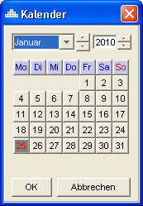

Figure 4‑2 - Entering the date via the calendar

Requirement: FKT-GUI-12

The commonly used date format contains the day (2 digits), month (2 digits), and year (4 digits) in language-dependent format. Example Germany: 01.03.2010. Display centered.

Requirement: FKT-GUI-13

In addition to the general date format, the generally used time format also contains the hours and minutes (each with 2 digits) in a language-dependent format. Example Germany: 01.03.2010 14:33. Display centered.

Requirement: FKT-GUI-14

The "LOGBUS time" (GMT + 1) is always stored in the database. The user always gets a date (+ time) displayed in his local time (time zone).

Requirement: FKT-GUI-15

The display of the part numbers should be left-justified in print format (analog DIMS/SICOS) (the conversion to print format takes place as soon as the corresponding input field loses the focus or when the input is confirmed via the "Enter" key).

Requirement: FKT-GUI-16

The company number should be able to be entered with and without leading zeros. Depending on how the user has entered the site number, it is also displayed in the *Site* input field (analogous to DIMS/SICOS).

Requirement: FKT-GUI-305

The designation of a part number in the national language of the seller is the designation from the national part master of the seller. If the part number is not available in the national part master, the designation from the local part master of the vendor is used (if it is stored there).

For WHS sites, the designations from the global part master are used. If there is no designation for the selected language in the global sub-tree, the designation from the national sub-tree is used - and if there is no designation there, the English designation from the global sub-tree is used.

### General functions of tables

Tables in STOX offer the range of functions known from SICOS/ DIMS. The functions are provided via the context menu of the table or table header.

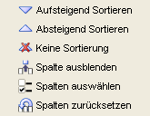

Figure 4‑3 - Table Header Context Menu

Tabellen

Figure 4‑4 - Table context menu

Additional functions can be provided via the context menu of the table. For example, marking an order as *shipped*.

Requirement: FKT-GUI-17

The system must allow the user in all tables to transfer the entire table or the selected range of a table to the clipboard. Formatting of the text does not take place. Likewise, no icons can be exported.

Requirement: FKT-GUI-18

The system offers the possibility to sort the tables by each column in both ascending and descending order via the context menu of the table headers. Double-click on a column heading to sort alternately in ascending and descending order by the associated column.

The function is not available for treetables. For individual tables, this function can be explicitly excluded in the concept.

Requirement: FKT-GUI-19

The system offers the possibility to configure the column order of a table via the context menu of the table headers. The columns can also be moved by drag & drop (column header).

The function is not available for treetables. For individual tables, this function can be explicitly excluded in the concept.

Requirement: FKT-GUI-20

The system offers the possibility to hide single or multiple columns of a table or to show hidden columns again individually via the context menu of the column headers.

The function is not available for treetables. For individual tables, this function can be explicitly excluded in the concept.

Requirement: FKT-GUI-21

The system offers the possibility to reset the columns to the original state via the context menu of the table headers. Hereby are:

* hidden columns are shown again.
* The original order of the columns restored

The function is not available for treetables. For individual tables, this function can be explicitly excluded in the concept.

Requirement: FKT-GUI-22

The system offers the possibility to cancel the sorting via the context menu of the table headings.

The function is not available for treetables. For individual tables, this function can be explicitly excluded in the concept.

Requirement: FKT-GUI-23

The system must remember the column order and the hidden columns of the table when shutting down the system and restore them at the next system start.

### General buttons (Buttons)

The following table gives an overview of recurring buttons and their basic functions in the STOX system. The exact function[[8]](#footnote-8) is explained in each case by a tooltip on the button.

| ****Button**** | ****Symbol**** | | ****Function**** |
| --- | --- | --- | --- |
| Store | | Button | Loads/ updates data. |
| Save | Button | | Saves user input. |
| Reset | Button | | Discards user input and possibly clears tables. |
| Close | close | | Closes the dialog (depending on the context with a query whether to save). |
| Edit | Button | | Opens an object for editing. |
| Details | Button | | Displays details about an object. |
| Print | Button | | Prints an object. |
| Delete | Button | | Deletes an object. |
| Delete line | Button | | Deletes the selected item(s) in a table. |
| Add line | Button | | Adds a new position in a table. |
| Jump | Button | | Jumps to another panel. |

Table 4‑1 - General overview of buttons

## Cross-panel functions

### Setting the 'active' operation

If the user sets active operation[[9]](#footnote-9) in a connected panel (see 4.2.1.1), the system must react as follows:

Requirement: FKT-GUI-24

The system must stop setting the active operation (error message) if the user is not authorized for the selection.

Requirement: FKT-GUI-25

The system must load the name of the farm and display it in the appropriate text fields.

Requirement: FKT-GUI-26

The system must set active operation in all connected panels (see 4.2.1.1). The data (company number and country are stored in the user properties when the application is shut down.

Requirement: FKT-GUI-27

The system must generate an error message (with a corresponding note) if no site number is stored, but this is required for data loading.

Requirement: FKT-GUI-306

The system must display an error message if a site number is stored that has not yet been activated. The system must lock all main panels except for the Start panel.

Requirement: FKT-GUI-307

The system must display an error message if a site number is stored that has not yet been initialized. The system must lock the Order Overview, Parts Search, Shopping Cart, Statistics, and Parts Master panels.

Requirement: FKT-GUI-308

The system must clear all connected panels (see 4.2.1.1). That is, delete all user input as well as results (on the GUI).

Requirement: FKT-GUI-420

The system must display the input fields for site number and country with a red background as soon as the user changes the loaded site (country or site number) and the data has not yet been reloaded. This makes it clear that the data displayed does not match the operation entered. As soon as the data for the entered farm (country and farm number) has been loaded, the background color of the two input fields turns white (default).

#### Connected panels

Setting the active mode has an effect on the following panels:

* Start (initial dialog)
* Order overview
* Part search (incl. multiple search)
* Shopping cart
* Settings
* Statistics
* Partial trunk

The *Operating Data* panel is an exception. If the operation is changed there, the change will not affect the rest of the panels. Background: The *Operational Data* panel is also used to view addresses and contacts of sellers and buyers.

### Print

Printing works in Logbus via PDF generation.

For example, when a user prints an order, a PDF document is generated and saved in the background. Subsequently, an attempt is made to open the saved PDF document with the operating system's standard viewing program[[10]](#footnote-10) . From the program, the user can then print the document as usual.

The layouts of the various documents are described in the chapter 5 .

Requirement: FKT-GUI-28

When clicking a *print* button within STOX, the system must generate a PDF document from the object (e.g. an order).

Requirement: FKT-GUI-29

The system must save the PDF document in the user's default storage directory[[11]](#footnote-11) . If saving to the default storage directory fails, an attempt is made to save the document to c:\. If the document cannot be saved there either, the user will receive an error message telling him to set the default storage directory.

Requirement: FKT-GUI-30

If the PDF document was saved successfully, an attempt is made to open the document with the standard viewer via a command to Windows. If no default viewer is set for PDF documents, the document cannot be opened automatically. An error message cannot be output here.

## Homepage

The main panel *Start* is displayed after starting the STOX application. It gives the user an overview of current events.

This gives the user an overview of the number of his open orders, the orders he has received and information about his DeadStock assortment. A large text box can be used to provide STOX traders with up-to-date information about STOX.

Requirement: FKT-GUI-31

The main *Start* panel can be seen and used by all users (regardless of role) for the sites assigned to them.

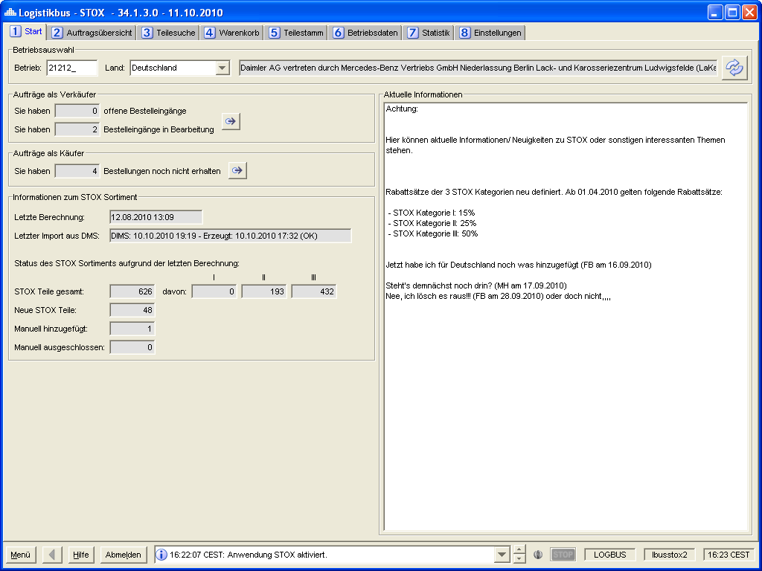

Figure 4‑5 - Panel Start

Operation selection

Requirement: FKT-GUI-32

The system must provide the input fields Country (combo box) and Site (text field, max. 6 digits, numeric).

Requirement: FKT-GUI-33

If the user confirms his entry in the Farm number field by pressing *Enter*, the active farm will be set and the information (information on orders and DeadStock assortment defined below) will be loaded.

Requirement: FKT-GUI-34

The system must load the current country-specific information[[12]](#footnote-12) on the orders and DeadStock assortment of the active operation when the application is started. Prerequisite: A valid operation is set and the user is authorized for the operation.

Requirement: FKT-GUI-35

When you click the *Load* button, the system must set the active mode. The requirements defined at 4.2.1 apply here.

Requirement: FKT-GUI-36

When clicking on the *Load* button, the system must load the information (on active operation) on the orders and DeadStock assortment and the current country-specific information.

Field description

Requirement: FKT-GUI-37

The system must provide and populate the following fields (if data is available).

| ****Field**** | ****Element**** | ****Format**** | ****Content**** |
| --- | --- | --- | --- |
| Current information | Textarea | - | Information provided by the STOX department for all distributors. |
| Orders not yet received | Text field | Integer. | Current number of orders not yet received (from buyer's point of view). An order is open from the buyer's point of view if it is in the status*new,* *in process* (DeadStock), *started, accepted* (D2D)or *shipped* . D2D and DeadStock orders are displayed "/" separately in the same text field, if the authorization for both processes is available. A tooltip clarifies the numbers |
| New orders received | Text field | Integer. | Current number of all received orders[[13]](#footnote-13) in status *new* (DeadStock) or *started* (D2D) (from seller's point of view). D2D and DeadStock orders will be displayed "/" separately in the same text field if the authorization for both processes is available. A tooltip clarifies the numbers |
| Orders in status *in process* | Text field | Integer. | Current number of orders in status *in process* (from seller's point of view) (DeadStock only). |
| Date of last batch run DeadStock Part size | Text field | Date format | Date of the last batch run to determine the DeadStock part count. |
| Date of last import from DMS system | Text field | - | Show date of last import from DMS system (analog DIMS order overview). |
| Total number of parts in DeadStock assortment | Text field | Integer. | Total number of parts in the retailer's DeadStock assortment. |
| Number of parts in DeadStock category I | Text field | Integer. | Show number of parts in the retailer's DeadStock assortment that are assigned to DeadStock category I. |
| Number of parts in DeadStock category II | Text field | Integer. | View the number of parts in the retailer's DeadStock assortment that are assigned to DeadStock category II. |
| Number of parts in DeadStock category III | Text field | Integer. | View number of parts in the retailer's DeadStock assortment that are assigned to DeadStock category III. |
| Number of manually added parts | Text field | Integer. | Number of parts in the dealer's DeadStock assortment that the dealer added manually. |
| Number of manually excluded parts | Text field | Integer. | Show number of parts in the retailer's DeadStock assortment that the retailer has manually excluded. |
| Number of new parts | Text field | Integer. | Number of parts in the retailer's DeadStock assortment that were newly added to the DeadStock assortment by the system during the last calculation. |

Table 4‑2 - Panel Start: Field description

Requirement: FKT-GUI-38

The following figures regarding the DeadStock range always refer to the status of the last range calculation.

Example: In the last calculation, 100 parts were manually excluded. Then the user manually excludes 3 more parts. The home page will continue to show 100 parts as manually excluded until the next DeadStock assortment calculation.

Only simple text can be displayed in the *Information* field (textarea). This means that no formatting in the sense of font, font size, font color, typeface, etc. can be applied. Also no graphics, tables or similar can be displayed.

Requirement: FKT-GUI-39

When you click the *Jump* button, the system must jump to the main *Order Overview* panel and reload the *Order Overview* . The selection criteria are set according to the button (See the table below).

| ****Jump for**** | ****Filter criteria in the Order Overview panel****[[14]](#footnote-14) |
| --- | --- |
| *Number of new orders received* and  *Number of orders in process*  (as seller) (One button for both) | - *Sell* tab is selected.  - All statuses are selected. |
| Number of orders not received (as buyer) | - *Buy* tab is selected.  - All statuses are selected. |

Table 4‑3 - Panel Start: Selection criteria when jumping to the Order Overview panel

Button overview

The following buttons are available on the *Start* panel:

| ****Button**** | ****Symbol**** | | ****Function**** | |
| --- | --- | --- | --- | --- |
| Download information | Button | Sets the active operation.  Updates information on orders, DeadStock assortment and current country-specific information of the operation. | |
| Jump to the *Order Overview*panel | Button | | Jumps to the *Job Overview*panel. | |

Table 4‑4 - Panel Start: Buttons

Requirement: FKT-GUI-40

The *Jump* buttons may only be active if an authorized operation has been entered and the information has been loaded.

## Order overview

In the main panel *Order Overview* the user can - as described below - view and edit the received and self-made orders as well as monitor their status. It is divided into the two main areas of *filter criteria* and *results table*. One of the three result tables - *Sell*, *Buy* or *Archive* - is always displayed.

Requirement: FKT-GUI-41

The main *Order Overview* panel and its subpanels can be seen and read by all users (regardless of role) for the sites assigned to them. Only users in the roles *Retailer,* *Retaileradmin* (for the sites assigned to them) have write access.

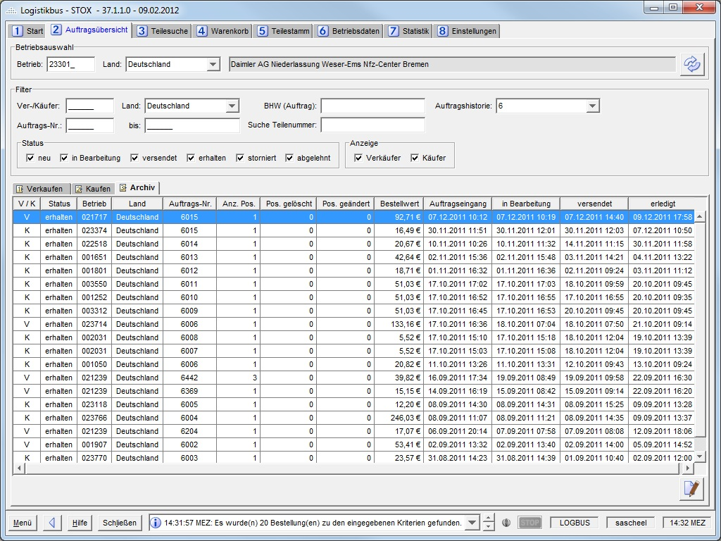

Figure 4‑6 - Order overview panel: Sell

In the *Filter criteria* section, the user can define various filter criteria to limit the amount of displayed orders. Then he can load the orders by clicking the *Load* button.

Button overview

The following buttons are available in the upper part of the Job Overview panel:

| ****Button**** | ****Symbol**** | | ****Function**** |
| --- | --- | --- | --- |
| Load orders | | Button | Sets the active operation.  Loads all orders matching the filter criteria. |

Table 4‑5 - Order overview panel: Buttons in the Filter Criteria area

Requirement: FKT-GUI-42

The system must allow the user to set ( *Load*button) the active operation (see 4.2.1).

Requirement: FKT-GUI-43

The system must allow the user to load and display orders - according to the filter criteria. This is done by clicking the *Load*button. The displayed fields of an order - as well as their display - are defined in the following chapters.

The two result tables *Buy* and *Sell* are basically loaded. For performance reasons, the *Archive* results table is only loaded when the *Archive* tab is selected.  
In newly loaded or unedited tables, the top row is always selected.

Requirement: FKT-GUI-44

If the user confirms his entry in one of the following fields with the *Enter*key, the orders are loaded.

- Company number - Order number from/to - Seller/buyer - Order reference

- Part number

Requirement: FKT-GUI-45

The system must clear the results tables before *loading* the orders.

Filter overview

Requirement: FKT-GUI-46

The system must provide the filter criteria described in the table below. The individual filters are "and"-linked.

| ****Filter**** | ****Element**** | ****Format**** | ****Multiple**** | ****Sonstiges**** | ****Gefiltertes Feld**** |
| --- | --- | --- | --- | --- | --- |
| Country (operation) | Combobox | Text | N |  | Own company number. |
| Betriebsnummer | Textfeld | 6-digit, numeric | N |  | Own company number. |
| Land (Ver-/ Käufer) | Combobox | Text | N |  | Betriebsnummer Ver-/Käufer (des Geschäftspartners). |
| Seller/Buyer | Textfeld | 6-stellig, numerisch | N |  | Company number seller/buyer (of the business partner). |
| Auftrags.-Nr. | Textfeld | 6-stellig,  numeric | N | From - To | Order number. |
| Bestellhinweis | Textfeld | max. 150 Zeichen | N | Bestellhinweis muss den Text enthalten. Case insensitive. | Spezieller Bestellerhinweis zur Bestellung/ zum Auftrag des Käufers. |
| Part number | Textfeld | max. 25 Zeichen | N |  | Part number (input option in all part number formats, analog part search without wildcard) |
| Anzeigetiefe | Combobox | Zahl | N | 6,12,18,24 (Monate) | Bestelleingangsdatum. |
| Status | Checkbox | - | J | neu  in Bearbeitung  akzeptiert  versendet  erhalten  storniert  abgelehnt  abgelaufen (nur sichtbar in Käufersicht) | Status der Bestellung.  Der Status neu entspricht im D2D-Prozess den beiden Status „Created“ und „Started“ (D2DOrder/D2DRequest)  Sichtbarkeit:  in Bearbeitung – nur bei DeadStock-Berechtigung  akzeptiert, abgelaufen – nur bei D2D-Berechtigung |
| Kauf/Verkauf | Checkboxen |  | J | - | Typ der Bestellung (Händler als Käufer oder Verkäufer). |
| Bestellprozess (DeadStock/D2D) | Checkboxen | - | J | Es muss immer eine der beiden Checkboxen ausgewählt sein | Bestellprozess DeadStock oder D2D  Falls beim Anwender nur die Berechtigung für einen der beiden Prozesse vorliegt, dann wird dieser Filterbereich nicht angezeigt |

Tabelle 4‑6 - Filterkriterien im Panel Auftragsübersicht

Anforderung: FKT-GUI-47

Die Filter haben folgenden Initialzustand:

- Betrieb: Letzte eingegebene Betriebsnummer  
- Land: Letztes eingegebene Land zum Betrieb (Käufer/ Verkäufer)  
- Status: Alle sichtbaren Status sind ausgewählt

- Bestellprozess: Sind beide Prozesse berechtigt, sind auch beide ausgewählt

Alle anderen Felder sind im Initialzustand leer bzw. nicht befüllt.

Anforderung: FKT-GUI-309

Der Eintrag im Filter *Auftragsnummer von* muss kleiner/gleich dem Eintrag im Filter *Auftragsnummer bis* sein (und umgekehrt). Das System gibt eine Fehlermeldung aus, wenn der Benutzer einen Wert eingibt, der diesem Kriterium nicht entspricht.

Anforderung: FKT-GUI-48

Der Filter *Anzeigetiefe* ist nur aktiv, wenn der Reiter Archiv ausgewählt ist. Der Standardwert ist 6 (Monate).

Anforderung: FKT-GUI-49

Die Filter *Kauf* und *Verkauf* sind nur aktiv, wenn der Reiter Archiv ausgewählt ist. Per Default sind beide Checkboxen markiert. Das System muss sicherstellen, das immer eine der beiden Checkboxen aktiviert ist.

Anforderung: FKT-GUI-50

Die Filter *Kauf* und *Verkauf* sind Live-Filter, das heißt, wenn der Benutzer ein Kriterium ausgewählt/abwählt, wird das Suchergebnis direkt gefiltert (ohne Datenbankabfrage). Gefiltert werden nur die Archivdaten.

Anforderung: FKT-GUI-51

Die Bezeichnung des Filters *Ver-/Käufer* ändert sich je nachdem welche Ergebnistabelle ausgewählt wurde. Zum Beispiel heißt der Filter „Käufer“, wenn die Ergebnistabelle *Verkaufen* ausgewählt ist.

Ergebnistabelle Kaufen à Filter heißt Verkäufer

Ergebnistabelle Verkaufen à Filter heißt Käufer

Ergebnistabelle Archiv à Filter heißt Ver-/Käufer

Es kann nur nach *Ver-/Käufer* gefiltert werden, die auch angezeigt werden.

Anforderung: FKT-GUI-334

Ist der Filter „Teilenummer“ aktiv, werden die Aufträge gefiltert auf die, die Positionen zur gesuchten Teilenummer enthalten. Um diesen Filter anwenden zu können, müssen die Daten neu geladen werden, kein Live-Filter (analog bspw. zum Filter „Auftragsnummer“).

Anforderung: FKT-GUI-335

Die Checkboxen im Bereich „Bestellprozess“ filtern den Prozesstyp der Aufträge: DeadStock oder D2D. Dieser Filter ist ein Live-Filter, das heißt das Suchergebnis wird direkt gefiltert (analog bspw. zum Filter „Status“).

Es muss immer mindestens eine Checkbox aktiv sein.  D.h. es ist systemseitig nicht möglich aus beiden Checkboxen die Haken zu entfernen.

Anforderung: FKT-GUI-336

Ist der Anwender nur für einen der beiden Prozesstypen (D2D oder DeadStock) berechtigt, dann werden auch nur die Aufträge zu diesem Prozesstyp geladen und angezeigt. Der entsprechende Filter ist nicht sichtbar.

### Ergebnistabellen

Allgemeine Festlegungen zu den Ergebnistabellen.

Requirement: FKT-GUI-52

By default, the system must sort the orders in the results tables according to the following criteria:

1. Status: new - in process - accepted - shipped - received - cancelled - rejected - expired (buyer view only)
2. Process: first D2D, then DS
3. Order receipt: descending (therefore: the 18.04.2010 before the 11.04.2010)
4. Order number: descending

(The archive table is sorted by order receipt only)

Requirement: FKT-GUI-53

Empty quantities (e.g. deleted positions or changed positions) are displayed in the tables with a '0'. Currency symbols are only displayed if the amount is > 0.

Requirement: FKT-GUI-328

An indication of preferred or problematic business partners is displayed in the *Buy* and *Sell* result tables. Analogous to the parts search procedure, the "preferred" or "problematic business partner" icon is displayed in front of the company no. in the "Buyer" or "Seller" column (depending on the results tables). The icon display always refers to the current selection/saving of the farms in the buy and sell settings at the selected farm[[15]](#footnote-15).

#### Sell

The *Sales* results table displays all orders or delivery requests[[16]](#footnote-16) received by the active merchant[[17]](#footnote-17) , i.e. all orders in which the merchant acts as a seller.

Table definition and functions

Requirement: FKT-GUI-54

The system must display one purchase order per row in the *Sales* results table with the following columns (values)[[18]](#footnote-18) :

| ****Visibility****[[19]](#footnote-19) | ****Column**** | ****Format**** | ****Display**** |
| --- | --- | --- | --- |
| X | Process | Text | Process through which the order was created: D2D or DeadStock. This column is only visible if the user is authorized for both processes |
| X | Status | Text | Current status of the order. |
| X | User ID | Text | The user who made the last relevant change. See FKT-GUI-423 for the breakdown of relevant changes. |
| \* | Buyer | 6-digit, numeric | Company number of the ordering dealer.  Incl. ICON for preferred or problematic supplier |
| \* | Country | Text | Country designation of the ordering dealer |
| X | Order number | Numeric, Integer | Order number of the ordering dealer. |
| X | Pos. Total | Numeric, Integer | Number of order items in the order. |
| X | Item Deleted | Numeric, Integer | Number of deleted order items in the order (delivery quantity = 0). At D2D: In case of rejection of a D2D request: Pos. deleted = 1. |
| X | Item Changed | Numeric, Integer | Number of order items in the order for which the delivery quantity was corrected downwards (quantity > 0). |
| X | Order value | Price format | Order value of the order (delivery quantity × DeadStock price / delivery quantity × D2D price + D2D handling margin). |
| X | Incoming orders | General time format | Time at which the buyer ordered (DeadStock)/Start of delivery request (D2D). |
| X | In process | General time format | Time at which the seller can place the order to the 1. Time opened (DeadStock) / Time when the seller accepted or rejected the order and saved (D2D) |
| X | Shipping initiated | Checkbox | Checkbox is active (ticked) when shipping (via MBVD partner store) has been initiated (column does not contain a heading, but an icon and a tooltip). |
| X | Dispatched | General time format | Time when the order was marked as *shipped* . |
| X | Done | General time format | Time when the order was marked as *received*, *rejected* or *cancelled* . |

Table 4‑7 - table order overview selling: Column description

Requirement: FKT-GUI-55

The system must open a selected order by clicking the *Edit* button in the *Order Details* panel (see 4.4.2)*(Seller view*). Exactly one order must be selected.

Requirement: FKT-GUI-57

Double-clicking on a cell in the table opens the underlying order in the *Order Details* panel (see 4.4.2)*(seller view*).

Requirement: FKT-GUI-58

The system must set the status of a DeadStock order to *in process* when the order is first opened. In case of a D2D order, the status remains in the *new*status until the user changes the item status to *accepted* or *rejected* and saves it or the status is changed externally (e.g. by the buyer).

Requirement: FKT-GUI-59

The system must transfer a selected order to the status shipped by clicking the *Mark as* *shipped* button (after confirmation via popup). If an order item of the purchase order is still unprocessed, the user receives a message that he must process the order item first.

Requirement: FKT-GUI-60

The *Mark as sent* button may be active only if the user is in the *Retailer* or *Retaileradmin* role and is authorized for active operation. The selected order must either have the status *In process* and at least 1 position must have the position status *Accepted* (A) or *Changed* (V) or be completely *accepted* .

Requirement: FKT-GUI-321

The system must transfer a selected order to the status *shipped* by clicking the *Initiate shipping* button (after confirmation via popup) and the shipping date is set. If an order item of the purchase order is still unprocessed, the user receives a message that he must process the order item first. Afterwards a jump to the MBVD partner store takes place (jump means here the opening of the Internet browser with the URL of the partner store).

Requirement: FKT-GUI-322

The *Initiate shipping* button may be active only if the user is in the *Retailer* or *Retaileradmin* role and is authorized for active operation and the order is in the *In process, Accepted* or *Shipped* status.

The button is only visible if the active site belongs to the market Germany (country code 200).

Requirement: FKT-GUI-323

The *Order tracking* button is only visible and active if the active site belongs to the Germany market (country code 200).

Requirement: FKT-GUI-337

In the Sales view, only D2D orders/D2D delivery requests are displayed in the Started, Accepted, Sent, Received, and Rejected statuses.

Requirement: FKT-GUI-423

The sales view displays the user who is making certain changes.

The saved column setting in the Sell, Buy and Archive tables for the users will be reset once with the introduction of the column.

When the following changes are made, the user ID is saved.

**DS:**

Status New: Cell is not filled

In progress: User who saves the last change (also on position level).

Status Sent: Generally, the user ID is not saved when transitioning to the Sent status and in the Sent status. An exception is when an unsaved change (item status or the delivery quantity) is also saved during the transition to the Shipped status.

**D2D:**

Status New: User who opens the order details for the first time, if the user has the *Retailer* or *Retaileradmin* role and is assigned to the site.

Status Accepted: User is saved when accepting. Changing the shipping method does not change the user ID.

Status Sent: When switching to the Sent status and in the Sent status, the user ID is not saved.

**DS and D2D:**

Status Rejected: User who rejects and saves the job.

Button overview

The following buttons are available in the *Sell* section:

| ****Button**** | ****Symbol**** | | ****Function**** |
| --- | --- | --- | --- |
| Edit | | Button | Opens the selected order in the Order details panel for editing. |
| Mark as shipped | versendet | | Sets the status of the order to *shipped*. |
| Order tracking |  | | Jump to the partner store for order tracking |
| Initiate shipping | truck | | Sets the status of the order to *shipped* and jumps to the shipping form in the partner store and activates the Shipping *initiated* flag in the order overview. |

Table 4‑8 - Order overview panel: Buttons of the Sell table

#### Buy

The *Buy* results table displays all orders[[20]](#footnote-20) for which the active dealer (entered site number in the site selection) acts as the buyer.

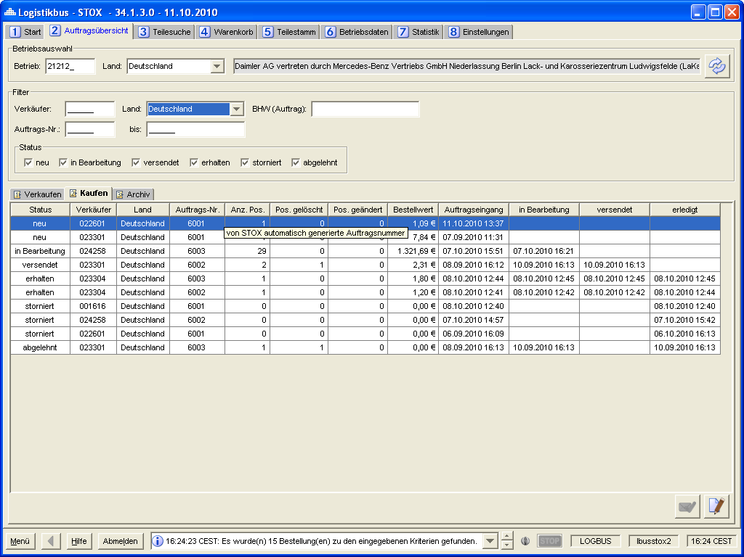

Figure 4‑7 - Order overview panel: Buy

Table definition and functions

Requirement: FKT-GUI-61

The system must display one purchase order per row in the *Purchase* results table with the following columns (values)[[21]](#footnote-21) :

| ****Visibility****[[22]](#footnote-22) | ****Column**** | ****Format**** | ****Display**** |
| --- | --- | --- | --- |
| X | Process | Text | Process through which the order was created: D2D or DeadStock. This column is only visible if the user is authorized for both processes |
| X | Status | Text | Current status of the order. |
| X | User ID | Text | The user who made the last relevant change. See FKT-GUI-424 for the breakdown of relevant changes. |
| \* | Seller | 6 digits | Company number of the selling dealer.  Incl. ICON for preferred or problematic supplier |
| \* | Country | Text | Country name of the selling dealer |
| X | Order info | Text | This column is filled only for D2D orders. This column is only visible if the user is authorized for the D2D process |
| X | Order number | Numeric, Integer | Order number of the buyer.  D2D only: A tooltip shows the searched part number (can also be wildcard and BHW and sales order number if available (incl. language dependent text). As soon as the D2D order has been accepted, the supplied part number incl. language-dependent text is also displayed.  Example of an accepted order with BHW and customer order number:  Wanted part number: B67870\*  Supplied part number: B6 7 87 0476  BHW: xxx  Sales order number: 123 |
| X | Pos. total | Numeric, Integer | Number of order items in the order. |
| X | Pos. deleted | Numeric, Integer | Number of deleted order items in the order (quantity = 0).  For D2D when rejecting a complete D2D order or a cancellation = 1.  For DeadStock in the case of a cancellation = number of items included |
| X | Pos. changed | Numeric, Integer | Number of order items in the order for which the quantity was corrected downwards (quantity > 0). |
| \* | Order value | Price format | Order value of the order. (Delivery Quantity × DeadStock Price / Delivery Quantity × D2D Price + D2D Handling Margin) |
| X | Incoming orders | General time format | Time at which was ordered. |
| X | in process | General time format | Time when the seller opened the order (DeadStock) / Time when a seller accepted and saved the delivery request (D2D) . |
| X | dispatches | General time format | Time when the seller marked the order as *shipped* . |
| X | done | General time format | Time when the order was marked as *received*, *rejected*, *cancelled* or *expired* . |
| X | BEFORE order | Checkbox | This column is editable only for D2D orders. It is only visible if the user is authorized for the D2D process and has the authorization to place D2D and VOR orders for the ordering company. |

Table 4‑9 - Table order overview Buy: Column description

Requirement: FKT-GUI-62

The system must open a selected order by clicking the *Edit* button in the *Order Details* panel (see 4.4.2)*(Buyer View*). Exactly one order must be selected. For D2D orders, this is only possible when the D2D order is in the status "Accepted" or following ("Sent", "Received"). If the D2D order is in a different status, an info dialog will appear indicating which status the D2D order is in and that order details cannot be displayed in this status. In addition, the searched part number (can also be wildcard) and BHW and sales order number if available are also displayed.

Requirement: FKT-GUI-64

Double-clicking on a cell in the table opens the underlying order in the *Order Details* panel (see 4.4.2)*(buyer's view*). For D2D orders, this is only possible when the order is in the status "Accepted" or following ("Sent", "Received"). If the D2D order is in a different status, an info dialog will appear indicating which status the D2D order is in and that order details cannot be displayed in this status. In addition, the searched part number (can also be wildcard) and BHW and sales order number if available are also displayed.

Requirement: FKT-GUI-65

The system must transfer a selected order to the status *received* by clicking the*Mark* *as* *received* button (after confirmation via popup).

Requirement: FKT-GUI-66

The *Mark as received* button may be active only if the selected order is in the *shipped* status and if the user is in the *Retailer* or *Retaileradmin* role and is authorized for active operation.

Requirement: FKT-GUI-324

The *Order tracking* button is only visible and active if the active site belongs to the Germany market (country code 200).

Requirement: FKT-GUI-338

In the column "Order info" a summary of the current status of the D2D order is shown in the form "a / b / c / d ". The placeholders have the following meaning, which is explained by a tooltip:

* a: Number of sellers originally selected by the user for the D2D order
* b: Number of open delivery requests (status "Created")
* c: Number of delivery requests already started (status "Started")
* d: Sum of the number of rejected ("Rejected" status) and invalid ("Invalid" status) delivery requests à the inventory check at the time the delivery request was started was no longer successful

This information is checked in the background at regular intervals (every 5 minutes) while the D2D order is still in the "Started" status. If there are any changes, the user will be notified as follows: The lines of D2D orders whose order info has changed are displayed in italics and bold. The user must then reload the data to see the current job info. Once a D2D order is in Accepted, Rejected, Sent, Received, Cancelled, or Expired status, only placeholder "a" (number of sellers the user originally selected for the D2D order) is displayed.

Example:

D2D ordering has started, totaling 100 potential vendors, the first wave of 20 potential vendors has started: Order info 100/80/20/0

In the meantime, 10 potential vendors have declined and the next wave of 20 potential vendors has been launched: Order Info: 100/60/30/10

The next wave starts with 20 potential sellers, but for 3 the inventory check is no longer successful: Order Info: 100/37/50/13

A seller accepts the delivery request. Order info 100

Requirement: FKT-GUI-339

The checkbox in the "PRE-Order" column is not selected by default, but can be selected by the user if required. This is only possible for D2D orders that are in Created, Started, Cancelled, Rejected or Expired status. (Annotation: If a BEFORE order was already placed as part of the part search, the part numbers were removed from the search result and were no longer available for a D2D order). Since the VOR order is based on the searched part number, a VOR order is only possible for D2D orders that are not based on a wildcard search. Only then is the part number you are looking for clearly known. For Evobus part numbers, a VOR order is also not possible.

Requirement: FKT-GUI-340

If the checkbox in the "BEFORE order" column is set for at least one order, then the "BEFORE order" button becomes active. When the button is clicked, a question dialog appears asking if the user wants to create a VOR order for the searched part numbers of the selected D2D orders:

Yes - The status of all selected D2D orders in Created or Started status will be set to Cancelled, and the rejection reason will be set accordingly ("Order item ordered by VOR"). For all others (status "Cancelled", "Rejected" or "Expired") the D2D order remains unchanged. There is a jump in StarOrder/StarOrderPlus (depending on the configuration of the ordering site, analog VOR button in part search) for all part numbers (in input format), the selected ordering site (breakdown in FacingLocation) and the ordered quantity. If BHW and sales order number exist, they are also transferred to the target system. The same applies if part numbers/orders are included whose status has changed in the meantime (no longer "Created" or "Started"). They are also not transferred and displayed in an info dialog.

If more than one customer number is determined for the selected part numbers (parts have different brands), then the jump is performed for one (any) of these customer numbers. The target system (SO/SOP) ensures that the order is split according to the customer number.[[23]](#footnote-23)

If there are still open processes in StarOrder/StarOrderPlus, they will be overwritten (the user will be made aware of this beforehand in an info dialog). If several different sales order numbers are contained (after cleaning up multiple existing part numbers), the jump is aborted and an error message including a listing of the sales order numbers appears. (Background: In StarOrder/StarOrderPlus, only one sales order number can be processed per order)

No - The dialog closes, no further actions, everything remains as before

A tooltip can be stored for the button.

Requirement: FKT-GUI-341

The *Cancel order* button is active only if exactly one order (DS or D2D) is selected, which is in the Created or Started (new) (D2D) or Ordered/New (DS) status.

Requirement: FKT-GUI-342

By clicking the *Cancel order* button, a question dialog appears asking whether the selected order should really be canceled:

Yes - the selected order will be cancelled ("Cancelled" status). An automatic cancellation notice is stored.

At D2D: All started delivery requests (status = "Started") are transferred to the status "Cancelled". All delivery requests that have not yet been started (status = "Created") are deleted. All others retain their status. If in the meantime a potential seller has accepted the delivery request or the D2D order has been completed (time without an accepted delivery request expired), then the cancellation is cancelled, the buyer is informed about it in an info dialog and the order overview data is reloaded.

At DeadStock: The order quantity of all contained items is set to 0 (status "S"), the status of the order is set to "Cancelled". If in the meantime the seller has accepted the DS order, then the cancellation is canceled, the buyer is informed about it in an info dialog and the order overview data is reloaded. Cancelled orders are no longer visible to the potential seller.

No - The dialog closes, no further actions, everything remains as before

A tooltip can be stored for the button.

Requirement: FKT-GUI-343

The buyer view displays all D2D orders (regardless of status).

Requirement: FKT-GUI-424

The buyer view displays the user who is making certain changes.

When the following changes are made, the user ID is saved.

**DS and D2D**:

Status New: User ID that places the order.

Status Canceled: User ID that cancels the order.

Other status: No update of the buyer user ID.

Requirement: FKT-GUI-426

The *Move to archive* button allows the user to manually move an order in the *Buy* tab to the archive if it has the status *Received*, *Cancelled*, *Rejected* or *Expired* . Multiple selection is possible to move several orders to the archive at once. As soon as at least one order does not have the required status*(Received*, *Cancelled, Rejected* or *Expired*), the button will be disabled.

After the orders have been successfully moved to the archive, the dialog is automatically updated so that the orders are no longer displayed in the *Buy* tab.

The button is displayed only for users with the *Retailer* or *Retaileradmin* roles, if they are assigned to the site.

A tooltip can be stored for the button.

By moving to the archive, the user can prevent the popup for rejected or expired orders (see FKT-GUI-404) from appearing when logging in again.

Button overview

The following buttons are available in the *Buy* section:

| ****Button**** | ****Symbol**** | ****Function**** |
| --- | --- | --- |
| Move to archive |  | Moves the selected orders to the archive.  The button is provided with a text analogous to the button BEFORE order.  The button will be placed in the lower left corner of the dialog. |
| Edit | Button | Opens the selected order in the Order details panel for editing. |
| Mark as received | erhalten | Sets the status of the selected order to *received.* |
| Order tracking |  | Jump to the partner store for order tracking |
| BEFORE order |  | Jump in SO/SOP for the part numbers of the selected orders. Only visible if the user is authorized for D2D |
| Cancel order |  | Cancels the selected order (DeadStock or D2D) |

Table 4‑10 - Order overview panel: Buttons of the Buy table

#### Archive

In the archive all archived orders are displayed[[24]](#footnote-24) . Orders are automatically archived by the system STOX (batch process).

The archived orders are not loaded until you switch to the *Archive* tab.

Requirement: FKT-GUI-67

The system must load the archived orders[[25]](#footnote-25) when the user switches to the *Archive* tab and the archive data has not been loaded yet.

Table definition and functions

Requirement: FKT-GUI-68

The system must display one purchase order per row with the following columns (values)[[26]](#footnote-26) in the *Archive* results table:

| ****Visibility****[[27]](#footnote-27) | ****Column**** | ****Format**** | ****Display**** |
| --- | --- | --- | --- |
| X | Process | Text | Process through which the order was created: D2D or DeadStock. This column is only visible if the user is authorized for both processes |
| X | Kind/ Type | Purchase / Sale | Distinguish whether the company acted as buyer/seller when placing the order. |
| X | Status | Text | Current status of the order. |
| X | User ID | Text | The user who made the last relevant change. See FKT-GUI-423 and FKT-GUI-424, when the change is relevant as buyer or seller. |
| \* | Operation | 6-digit company number | Company number of the dealer from whom he ordered/who ordered from him (without LKZ) |
| \* | Country | Text | Country (as text) of the dealer from whom he has ordered/ who has ordered from him |
| X | Order number | Numeric, Integer | Order number.  D2D/Buyer's View Only: A tooltip shows the searched part number (can also be wildcard) and BHW and sales order number if available |
| X | Pos. total | Numeric, Integer | Number of order items in the order. |
| X | Pos. deleted | Numeric, Integer | Number of deleted order items in the order (delivery quantity = 0). If no item has been deleted, a 0 is displayed. |
| X | Pos. changed | Numeric, Integer | Number of order items in the order for which the quantity was corrected downwards (delivery quantity > 0 < order quantity). If no item has been deleted, a 0 is displayed. |
| See Tabelle 4‑7 and Tabelle 4‑9 | Order value | Price format | Order value of the order ((delivery quantity × DeadStock price or delivery quantity × D2D price + D2D handling margin) |
| X | Incoming orders | General time format | Time when order was placed (DeadStock) or delivery request was started (D2D). |
| X | in process | General time format | Time when the seller opened the order (DeadStock) or accepted or rejected the delivery request and saved it (D2D). |
| X | dispatches | General time format | Time when the seller marked the order as shipped. |
| X | done | General time format | Time when the order was marked as received, rejected or cancelled. |

Table 4‑11 - Table order overview archive: Column description

Requirement: FKT-GUI-70

Double-clicking on a cell in the table opens the underlying purchase order in the *Purchase Order Details* panel (see 4.4.2).

Order as buyer: In *seller's point of view*  
order as seller: From the *buyer's point of view*

The order details are available in case of a D2D order from the buyer's point of view only if the D2D order is in the status "Accepted" or following ("Sent" and "Received"). If the D2D order is in a different status, an info dialog will appear indicating which status the D2D order is in and that order details cannot be displayed in this status. In addition, the searched part number (can also be wildcard) and BHW and customer order number if available are also displayed.

Requirement: FKT-GUI-325

The *Order tracking* button is only visible and active if the active site belongs to the Germany market (country code 200).

Button overview

The following buttons are available in the *Archive* section:

| ****Button**** | ****Symbol**** | | ****Function**** |
| --- | --- | --- | --- |
| Details | | Button | Opens the selected order in the Order details panel for viewing/editing[[28]](#footnote-28). The same conditions apply as when double-clicking on the table cells |
| Order tracking |  | | Jump to the partner store for order tracking |

Table 4‑12 - Order overview panel: Buttons of the archive table

### Order details

The *Order Details* panel shows details about an order as well as its order items.

The panel can be accessed in different modes:

* For information/ processing as a buyer à Buyer'*s view*.For D2D orders, order details can only be displayed for orders in Accepted, Sent, and Received status.
* For information/ processing as seller à *Seller view*(see also process description "manual exclusion of rejected parts" in chapter 1.1.12)

Depending on the status of the order, the user can perform various actions to process the order.

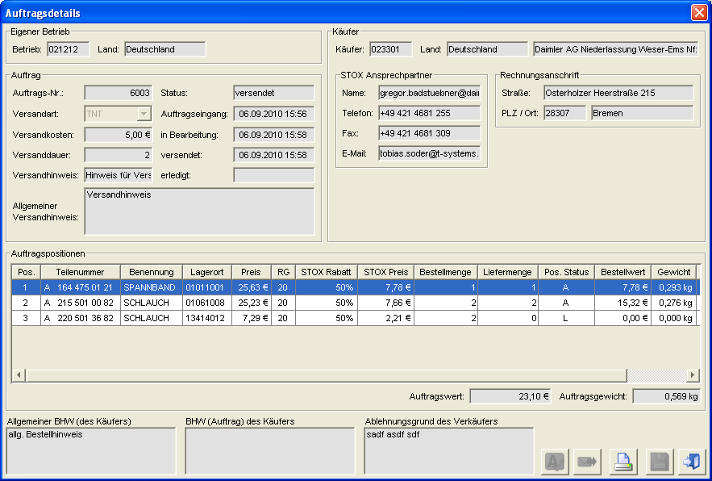

Figure 4‑8 - Order details panel

Requirement: FKT-GUI-71

The system must allow actions only depending on the mode and status of the order. If the combination of mode and status is not correct, the system must prevent the action. Defined in the tables below:

Actions as a seller depending on the status (DeadStock)

| ****Action**** | ****new****[[29]](#footnote-29) | ****in process**** | ****dispatches**** | ****done****[[30]](#footnote-30) |
| --- | --- | --- | --- | --- |
| Customize delivery method |  |  |  |  |
| Adjust delivery quantity(s) |  | X |  |  |
| Accept all pos |  | X |  |  |
| Adjust position status |  | X |  |  |
| Cancel |  |  |  |  |
| Mark as "sent |  | X |  |  |
| Initiate shipping |  | X | X |  |
| Mark as "received |  |  |  |  |
| Enter rejection note |  | X |  |  |
| Save |  | X |  |  |
| Order tracking | X | X | X | X |

Table 4‑13 - Panel order details: Actions as seller (status dependent) (DeadStock)

Actions as a seller depending on the status (D2D)

| ****Action**** | ****new****[[31]](#footnote-31) | | ****accepts**** | | ****dispatches**** | | | ****done****[[32]](#footnote-32) | |
| --- | --- | --- | --- | --- | --- | --- | --- | --- | --- |
| Customize delivery method | X | | X | |  | | |  | |
| Adjust delivery quantity(s) |  | |  | |  | | |  | |
| Accept all pos | X | |  | |  | | |  | |
| Adjust position status | X | |  | |  | | |  | |
| Cancel |  |  | | |  | |  | | |
| Mark as "sent |  | | X | |  | | |  | |
| Initiate shipping |  | | X | | X | | |  | |
| Mark as "received |  | |  | |  | | |  | |
| Enter rejection note | X | |  | |  | | |  | |
| Save | X | | X | |  | | |  | |
| Order tracking | X | | | X | | X | | | X | |

Table 4‑14 - Panel order details: Actions as a seller (status-dependent) (D2D)

Actions as a buyer depending on the status (DeadStock)

| ****Action**** | ****new****[[33]](#footnote-33) | ****in process**** | ****dispatches**** | ****done****[[34]](#footnote-34) |
| --- | --- | --- | --- | --- |
| Customize delivery method | X |  |  |  |
| Adjust order quantity(s) | X |  |  |  |
| Accept all pos |  |  |  |  |
| Adjust position status | X |  |  |  |
| Cancel | X |  |  |  |
| Mark as "sent |  |  |  |  |
| Initiate shipping |  |  |  |  |
| Mark as "received |  |  | X |  |
| Enter rejection note |  |  |  |  |
| Save | X |  |  |  |
| Order tracking | X | X | X | X |

Table 4‑15 - Panel order details: Actions as buyer (status dependent) (DeadStock)

Actions as a buyer depending on the status (D2D)

| ****Action**** | ****new****[[35]](#footnote-35) | ****accepts**** | ****dispatches**** | ****done****[[36]](#footnote-36) |
| --- | --- | --- | --- | --- |
| Customize delivery method |  |  |  |  |
| Adjust order quantity(s) |  |  |  |  |
| Accept all pos |  |  |  |  |
| Adjust position status |  |  |  |  |
| Cancel |  |  |  |  |
| Mark as "sent |  |  |  |  |
| Initiate shipping |  |  |  |  |
| Mark as "received |  |  | X |  |
| Enter rejection note |  |  |  |  |
| Save |  |  |  |  |
| Order tracking |  | X | X | X |

Table 4‑16 - Panel order details: Actions as a buyer (status-dependent) (D2D)

Field description

Requirement: FKT-GUI-72

The system must provide and populate the following fields (if data is available).

VK = Seller view

K = Buyer view

GUI = representation in the application

PDF = representation during PDF printing

"-" = will not be displayed

| ****VK GUI/PDF****[[37]](#footnote-37) | ****K GUI/PDF****37 | | | ****Field**** | ****Element**** | ****Format**** | | ****Content**** | |
| --- | --- | --- | --- | --- | --- | --- | --- | --- | --- |
| \*/\* | \*/\* | | | Company number of the buyer | Text field | 6-digit, numeric | | Company number of the buyer | |
| \*/\* | \*/\* | | | Country of the buyer | Text field | Text | | Country of the buyer | |
| \*/\* | -/\* | | | Name of the buyer (billing and delivery address) | Text field | Text | | Company name of the buyer | |
| \*/\* | -/\* | | | Delivery address of the buyer | several text fields | Text | | Street, house no., postal code, city | |
| \*/\* | -/\* | | | Billing address of the buyer | several text fields | Text | | Street, house no., postal code, city | |
| \*/\* | -/\* | | | STOX Contact person of the buyer | several text fields | Text | | Name, telephone, fax and email (from operating data) | |
| -/\* | -/\* | | | IBAN of the buyer | Text field | Text | | IBAN of the buyer | |
| -/\* | -/\* | | | SWIFT of the buyer | Text field | Text | | SWIFT of the buyer | |
| -/\* | -/\* | | | VAT ID of the buyer | Text field | Text | | VAT ID of the buyer | |
| X/X | \*/\* | | | Company number of the seller | Text field | 6-digit, numeric | | Company number of the seller | |
| X/X | \*/\* | | | Seller country | Text field | Text | | Seller country | |
| -/X | \*/\* | | | Name of the seller (billing and delivery address) | Text field | Text | | Company name of the seller | |
| -/X | -/\* | | | Delivery address of the seller | several text fields | Text | | Street, house no., postal code, city | |
| -/X | -/\* | | | Billing address of the seller | several text fields | Text | | Street, house no., postal code, city | |
| -/X | \*/\* | | | STOX Contact person of the seller | several text fields | Text | | Name, telephone, fax and email (from operating data) | |
| -/X | \*/\* | | | IBAN of the seller | Text field | Text | | IBAN of the seller | |
| -/X | \*/\* | | | SWIFT of the seller | Text field | Text | | SWIFT of the seller | |
| -/X | \*/\* | | | VAT ID of the seller | Text field | Text | | VAT ID of the seller | |
| X/X | \*/\* | | | Order number | Text field | Numeric | | Order number of the order | |
| X/X | \*/\* | | | Order status | Text field | Text | | Current order status of the order | |
| X/X | \*/\* | | | Shipping method | Combo box | Text | | Shipping method of the order (marked yellow if changeable)  DeadStock - Seller shipping methods  D2D - Shipping methods of the buyer  Tooltip: Fully advertised shipping type + fixed text (if maintained) | |
| \*/\* | \*/\* | | | Shipping costs | Text field | Price format | | Shipping costs of the shipping method (data of the seller - DeadStock, data of the buyer D2D)  Tooltip possible | |
| \*/\* | \*/\* | | | Shipping time | Text field | Numeric | | Shipping time of the shipping method (data of the seller - DeadStock, data of the buyer D2D)  Tooltip possible | |
| \*/\* | \*/\* | | | Shipping note | Text field | Text | | Shipping information of the shipping method (seller's information - DeadStock, buyer's information D2D)  Tooltip: Fully written shipping note + fixed text (if maintained) | |
| X/X | \*/\* | | | General shipping notice of the seller | Textarea | Text | | General shipping information (information of the seller - DeadStock and D2D)  Tooltip: Fully written general shipping note + fixed text (if maintained) | |
| X/X | \*/\* | | | Incoming orders | Text field | Time format | | Date of order receipt (DeadStock)/Date of start of delivery request (D2D) | |
| X/- | \*/- | | | Date edited | Text field | Time format | | Date Processing of the order by the vendor (DeadStock)/Date Acceptance/rejection of the order by the vendor (D2D) | |
| X/- | \*/- | | | Date sent | Text field | General time format | | Date on which the order was marked as *shipped* . | |
| X/- | \*/- | | | Date done | Text field | General time format | | Date when the order was marked as *received*, *cancelled, expired* or *rejected* . | |
| \*/\* | \*/\* | | | Aut. Buyer's order note | Textarea | Text | | General order note of the buyer | |
| \*/\* | \*/\* | | | Special order note from the buyer | Textarea | Text | | Special order note of the buyer for this order, always empty in seller's view | |
| X/X | | X/X | Special order note of the buyer for this order | | Textarea | | Text | | Special order note of the buyer for a D2D order (also only visible for D2D orders), see also Anforderung: FKT-GUI-422  Displayed to the seller already before accepting the D2D delivery request. Field is not editable. Background color is red (CI compliant) if at least 1 character is included. A tooltip displays the complete text. | |
| X/X | \*/\* | | | Note rejection | Text field | Text. 100 characters | | Comment that the seller must fill in when rejecting one or more items; in the D2D process, it can also be a system-assigned comment. | |
| X/X | \*/\* | | | Total weight[[38]](#footnote-38) | Text field | Weight format | | Total weight of all order items. | |
| X/X | \*/\* | | | Total price38 | Text field | Price format | | Total DeadStock/D2D price of all order items  For D2D: plus handling margin | |

Table 4‑17 - Panel order details: Description of the displayed fields

Dependencies of the fields on the mode

Requirement: FKT-GUI-73

The system must populate and show/hide the fields depending on the mode: see Tabelle 4‑17 and Tabelle 4‑18.

Table definition and functions

VK = Seller view

K = Buyer view

GUI = representation in the application

PDF = representation during PDF printing

"-" = will not be displayed

| ****VK GUI/PDF****[[39]](#footnote-39) | ****K GUI/PDF****39 | ****Column**** | ****Format**** | ****Editable**** | ****Display**** |
| --- | --- | --- | --- | --- | --- |
| X/X | \*/\* | Pos | Numeric. Integer |  | Position number within the order |
| X/X | \*/\* | Part number | Print format |  | Ordered part number |
| X/- | \*/- | Part number | Memory format |  | Ordered part number (in last position). |
| X/X | \*/\* | Naming and DeadStock note | Text and icon |  | Designation of the part (in the national language of the seller). If a DeadStock note is present, the icon is displayed. In the tooltip the user sees the DeadStock note.  DeadStock note only for DeadStock orders  The PDF does not include the DeadStock note |
| X/X | -/- | Storage location | Text |  | Storage location of the part at the seller. Display only in seller's view. |
| X/X | \*/\* | Unit price | Price format |  | Unit price of the part (price from national/local TS of the seller at the time of receipt of the order). BLP/VKP depending on what was selected when the order was received. |
| X/X | \*/\* | Discount group | Numeric. Integer |  | National discount group of the part. |
| X/X | X/X | DeadStock category | Percentage value |  | DeadStock discount (e.g. 15%, 25% or 50%). Only visible for DeadStock orders |
| X/X | \*/\* | DeadStock/D2D Price | Price format |  | DeadStock or D2D price of the seller  DeadStock: Single Price Discount from Discount Group (LAG) - DeadStock Discount  D2D: Unit price - discount from discount group (VOR) |
| X/X | \*/\* | Order quantity | Numeric. Integer | X (DS) | Order quantity of the part (editable as a buyer). Not editable for D2D orders |
| X/X | \*/\* | Delivery quantity | Numeric. Integer | X (DS) | Quantity delivered (editable as seller). Not editable for D2D orders |
| X/X | \*/\* | Position status | Text | X | Current status of the position. Editable by seller:  - unprocessed (U) - accepted (A) - modified (V) (not possible for D2D orders) - deleted (L)  - canceled (S) |
| X/X | \*/\* | Order value | Price format |  | Delivery Quantity \* DeadStock/D2D Price |
| X/X | \*/\* | D2D handling margin | Price format |  | D2D Handling Margin. Only visible for D2D orders |
| X/- | -/- | Man. Exclusion | Checkbox |  | Display only in seller view, if at least one item in status rejected and part excluded. Checkbox is active (ticked) if the position was rejected and on it the question about manual exclusion was answered with "Yes" (column gets a tooltip). Only visible for DeadStock orders |
| X/X | \*/\* | Weight | Weight format |  | Weight of the item (delivery quantity times individual weight of the part) |
| -/- | \*/\* | Order reference (Pos.) | Text |  | Buyer's order note for this item. Display only in buyer's view. Not visible for D2D orders |

Table 4‑18 - Order items table: Column description

Requirement: FKT-GUI-344

In the case of a D2D order, the buyer/seller information is not available until a potential seller has accepted and saved the delivery request (see also Tabelle 4‑17 - Panel Bestelldetails: Beschreibung der angezeigten Felder).

For the buyer, the order value is not visible in the order overview until a potential seller has accepted and saved the delivery request.

See also the following tables:

* Tabelle 4‑7 - Tabelle Auftragsübersicht Verkaufen: Spaltenbeschreibung
* Tabelle 4‑9 - Tabelle Auftragsübersicht Kaufen: Spaltenbeschreibung
* Tabelle 4‑11 - Tabelle Auftragsübersicht Archiv: Spaltenbeschreibung
* Tabelle 4‑17 - Panel Bestelldetails: Beschreibung der angezeigten Felder.

Requirement: FKT-GUI-74

The system must hide the Delivery Address area if the delivery address is the same as the billing address.

Requirement: FKT-GUI-75

The system must display the position status in a language-dependent manner.

Requirement: FKT-GUI-76

The system must allow the user to edit the *Order Quantity* columns in the table. The system must only allow integers between 0 and the *delivery quantity of* the item. Saving to the database is done only after clicking the *Save*button. The delivery quantity is adjusted to the entered order quantity.

Requirement: FKT-GUI-77

The *Order quantity* column may only be edited if the combination of mode and order status is correct (see Tabelle 4‑15).

Requirement: FKT-GUI-78

The buyer can cancel an order item by setting the *order quantity of* the item to 0 and saving it. If the order does not contain any other items with order quantity > 0, the status of the order is set to canceled.

Requirement: FKT-GUI-79

In the seller view, orders in the cancelled status must not be displayed. Likewise order items with the order quantity = 0.

Requirement: FKT-GUI-80

The system must allow the user to edit the *Delivery Quantity* columns in the table. The system may only allow numeric entries between 0 and the *order quantity of* the item. Saving to the database is done only after clicking the *Save*button.

Requirement: FKT-GUI-81

The column *Delivery quantity* may only be edited if the combination of mode and order status is correct (see Tabelle 4‑13).

Requirement: FKT-GUI-82

The system must adjust the *total weight* and *price* when the *delivery quantity* changes.

Requirement: FKT-GUI-83

The system must *set* the *item status to* *deleted (L)* if the user changes the delivery quantity to 0 (input X = 0). Saving to the database is done only after clicking the *Save*button.

Requirement: FKT-GUI-84

The system must *set* the *item status to* *canceled (S)* if the user changes the order quantity to 0 (enter X = 0). Saving to the database is done only after clicking the *Save*button.

Requirement: FKT-GUI-85

The system must set the *item status to* changed *(V)* if the user changes the delivery quantity to a value greater than 0 and less than the order quantity (0 < input X < order quantity). Saving to the database is done only after clicking the *Save*button.

Requirement: FKT-GUI-86

The system must set the *item status to* *accepted(A)* when the user changes the delivery quantity back to the order quantity. Saving to the database is done only after clicking the *Save*button.

Requirement: FKT-GUI-87

The system must allow the user to edit the *Position Status* column in the table.

*Seller's view*:

Clicking in the line changes the 'U' to an 'A'. With another click in the cell, the 'A' changes to an 'L'. After that, the rotation starts all over again. In 'U' can no longer be converted back.

If the user changes the *item status* to 'L', the system must set the delivery quantity to 0 (zero). In the D2D process, the rejection reason is pre-populated by the language-dependent text "D2D request manually rejected", but can also be overwritten by the user.

If the user changes the *item status* to 'A', the system must set the delivery quantity to the order quantity. Saving to the database is done only after clicking the *Save*button. If a rejection reason has already been set, it will be deleted again.

*Buyer's perspective*:

Clicking in the line changes the 'U' to an 'S' (setting the order quantity to 0 (zero)). With another click the 'S' changes back to a 'U' (thereby the order quantity is set back to the delivery quantity). This editing option is only available for DeadStock orders.

Requirement: FKT-GUI-88

The system may only allow editing of the *position status* if:

- The order has been opened in the *seller view* and it is in the order status *in process* (DeadStock) or *new* (D2D). or - The order has been opened in the *buyer view* and it is in the order status *new* (DeadStock).

(see Tabelle 4‑15)

If a buyer opens a *new* DeadStock order in the order status and the seller also opens it in parallel, the buyer can make changes but cannot save them.  
The buyer will be notified by message.

Basically, when saving changes in orders (DS & D2D), it is checked whether the changes may still be made, or whether in the meantime the data has been changed in such a way that the change is no longer allowed (Ex: When saving a D2D request that has just been accepted, a check is made to see if another one has not already been accepted and thus the current one can thus no longer be accepted).

Requirement: FKT-GUI-89

The system may allow editing of the *item status, delivery quantity* , and *order quantity* only for users in the *Retailer* or *Retaileradmin* roles (for the sites assigned to the users).

Requirement: FKT-GUI-90

The system must ensure in the DeadStock process that the user fills in the *Comment Rejection* field when rejecting one or more order items (The system must stop saving (error message) if the user has not entered a comment).

If the seller rejects all items, the order status will be set to Rejected when saved and the current date will be set as *Date Done* .

Requirement: FKT-GUI-91

The system must limit the input in the *Comment Rejection* field to 1000 characters.

Requirement: FKT-GUI-92

The *Comment rejection* field may only be edited by users in the *Retailer* or *Retaileradmin* roles (for the sites assigned to the user). Saving to the database is done only after clicking the *Save*button.

Requirement: FKT-GUI-425

In general, all editable fields must be marked in yellow (CI compliant), including editable fields in the table. If a field is no longer editable, it should become gray again. The color highlighting should update when dependent fields are changed. For example: If you change a deadstock position to the position status Deleted, the field *Reason for rejection of the seller* turns yellow and as soon as the position status Deleted is removed from all positions, the field becomes uneditable and gray again.

The red marking of the *Buyer's Note* field is not restricted by the requirement, as the field is not editable in the order details. For this field applies: If at least 1 character is stored in the field, the field is displayed in red (CI compliant) background color. If **no** character is stored, it is displayed in gray background color.

Button overview

The following buttons are available in the *Order Details* section:

| ****Button**** | ****Symbol**** | | ****Function**** |
| --- | --- | --- | --- |
| Accept all positions | | akzeptieren | Marks all items that have not yet been changed as *accepted* (only visible in the *seller's view* ). |
| *From the seller's point of view*  Mark order as *shipped* | | versendet | *In seller view*  Sets the current time as the *date sh* ipped and transfers the order to the status *shipped*. |
| *From the seller's point of view*  Initiate shipping | truck | | *In seller view*  Sets the current time as the *date shipped* (if the date is not already set) and transfers the order to the status *shipped* and activates the *Shipment initiated* flag *in* the order overview. |
| Mark order as *received in* *buyer view* | | erhalten | *In buyer view*  Sets the current time as the *date done* and transfers the order to the status *received*. |
| Print | Button | | Prints the order. |
| Save | Button | | Saves the quantities and status changes as well as the annotations. |
| Close | close | | Saves the changes (after confirmation) and closes the dialog. |
| Order tracking |  | | Jump to order tracking in MB Partner Shop |

Table 4‑19 - Panel order details: Button descriptions

Requirement: FKT-GUI-93

The system must enable/disable the buttons depending on the status of the order. The following table shows in which status the buttons are active:

| ****Field**** | ****new**** | ****in process**** | ****accepts**** | ****dispatches**** | ****done****[[40]](#footnote-40) |
| --- | --- | --- | --- | --- | --- |
| Accept all positions | X | X |  |  |  |
| *From the seller's point of view*  Mark order as *shipped* |  | X | X |  |  |
| *From the seller's point of view*  Initiate shipping |  | X | X | X |  |
| Mark order as *received in* *buyer view* |  |  |  | X |  |
| Print | X | X | X | X | X |
| Save | X | X (seller only) | X (seller only) |  |  |
| Order tracking | X | X | X | X | X |

Table 4‑20 - Panel order details: Buttons depending on status

Requirement: FKT-GUI-94

When clicking the *Accept all items* button, the system must mark all unprocessed order items as *accepted* (set processing status). Saving to the database is done only after clicking the *Save*button.

Requirement: FKT-GUI-95

When clicking the *Mark order as shipped/received* or *Initiate shipping* button, the system must set the status of the order to *shipped/received* and close the dialog. Via a popup[[41]](#footnote-41) the user has to confirm his input. When you select (click), the unsaved changes are automatically saved in the database[[42]](#footnote-42).

Requirement: FKT-GUI-96

The *Mark order as shipped* button may be active only if the order is in the status *in process* or *accepted* and the item status of all order items is either *accepted, changed* or partially *deleted* .

Requirement: FKT-GUI-326

The *Initiate Shipping* button may only be active if the order is in the *In Process,* *Accepted* , or *Shipped* status and the item status of all order items is either *Accepted*, *Changed* , or Only Partially *Cleared* . If all order items are deleted, the *Initiate shipping* button is not active.

Requirement: FKT-GUI-97

The *Mark order as received* button may be active only if the order is in the *shipped* status.

Requirement: FKT-GUI-98

When you click the *Print* button, the system must save and open the order as a PDF. The general procedure for printing is described in the chapter 4.2.2 . The format of the printout at chapter 5.

Requirement: FKT-GUI-99

When you click the *Close* button, the system must close the dialog. If the user has edited the order and not yet saved the changes, a "You have made changes" question dialog appears. Do you want to save these changes and close the dialog?". If the user confirms with YES, the changes are saved and the dialog is closed (see also [FKT-GUI-100](#FKT_GUI_100)). If he clicks NO, the changes are discarded and the dialog is closed. With CANCEL the dialog is still displayed and he can save.

After closing the dialog, the selected line (order) is still highlighted in the order overview, provided that the order is still contained in the then current overview. If the order is no longer included in the overview (e.g. due to the changed order status that no longer matches the set status filter), the first line is highlighted.

Requirement: FKT-GUI-345

In case of a D2D order, the seller can change the shipping method (order status = "Started" and item status "A" or order status "Accepted"). The **buyer** 's shipping methods are available. The shipping method "Pickup" (if deposited) is not available for selection. By default, the buyer's first shipping method is selected (according to the order of shipping providers, see also chapter 4.10.2, 9.3).

Requirement: FKT-GUI-100

When you click the *Save* button, the system must save the user's changes to the database.

* If a rejected delivery request is saved (status = "Rejected"), a question dialog appears offering the user 3 choices:
  + Yes - The delivery request will be saved. This and all other started D2D requests for this part number and operation are set to the status "Rejected". In addition, the current operation is blocked for the parameterizable period *REJECT\_BLOCKING\_TIME* for further requests for this part number. The dialog is closed and the data is reloaded. A specific tooltip can be stored for the button.
  + No - The part number will be rejected for this order only. Other existing D2D requests for this part number and operation will not be changed. New D2D requests are possible for this part number. The quantity reserved for this order is released. A specific tooltip can be stored for the button.
  + Cancel - the delivery request will not be saved, the previous state will be kept. A specific tooltip can be stored for the button.
* If a seller accepts a delivery request and saves it, he is informed in an info dialog about the obligation of a binding delivery of the order according to the GTC:
  + Ok - The delivery request is saved and the data is updated as the buyer's information is now available. All other started delivery requests (status = 'Started") to other sellers will be stopped (status = 'Stopped"). They are no longer visible with the sellers. Delivery requests that have not yet been started (status = "Created") are deleted. All other delivery requests maintain their status. The dialog is closed and the data is reloaded.
  + Cancel - the delivery request will not be saved, the previous state will be kept.
* A changed shipping method can only be saved if the delivery request was already in the "Accepted" status or was set in the same step. Otherwise, the user is informed in an error dialog that saving a changed shipping type is only possible for delivery requests in the status "Accepted". The changed shipping method is not saved.

Basically, when saving D2D orders / delivery requests, it is checked if the action is still possible at all, because in the meantime (since the last loading of the data) changes may have occurred: e.g. another seller has accepted the delivery request, the buyer has cancelled the D2D order or the D2D order has expired. In such a case, the saving process is aborted and the user is informed about the new data situation in an info dialog. The data will be reloaded.

Requirement: FKT-GUI-101

The*Accept* *all items* *, Mark order as shipped/received* or *Initiate shipping* *and Save* buttons may be active only if the user is in the *Retailer* or *Retaileradmin* role and is authorized for active operation.  
The *Initiate shipping* and *Order tracking* buttons are only visible if the active site belongs to the Germany market (country code 200).

Requirement: FKT-GUI-327

When saving a DeadStock order (via the *Save* button or when closing the *Order Details* panel in the Seller view), the system checks whether the delivery quantity has been reduced for an order item or whether the item has been deleted. If this is the case, an email will be sent to the email address(es) stored in the operating data under STOX contact person, indicating this.[[43]](#footnote-43).   
The dispatch is analogous to the email dispatch when triggering a DeadStock order:

1. Mail subject and mail content are fixed in the database.
2. Mail subject and mail content are issued in the national language of the buyer (i.e. the buying company).
3. In the mail content are included the company number and country of the seller, the STOX order number and all reduced or deleted items of the order. At the end, there is a reference to the automatically generated mail and the disclaimer.
4. The part numbers are output in print format and sorted by item number in ascending order.
5. The sender of the mail is the [noreply@daimler.com](mailto:noreply@daimler.com) address.

Example of the generated mail.

**Subject:** Reference to reduced or deleted order(s) in STOX

**Text:**

Dear Sir or Madam,

we would like to inform you that your STOX order 8015 will probably not be delivered completely by the seller 4711 - Germany.

The vendor has reduced or deleted the delivery quantity(s) for the following purchase order item(s):

**Item Part number Order quantity Delivery quantity 1**A 110 016 04 76 2 1 2 A 102 031 01 33 2 0

**Reason for rejection:**  
Inventory difference or reserved for customer.

Please note:

This email is solely for your information about the current processing status of the above mentioned order and may/may not reflect the final processing status.

If you have any questions, please contact the seller.

With kind regards

Logistics bus STOX

This is an automatically generated mail. Please do not reply to this mail.

<<Disclaimer>>

Requirement: FKT-GUI-346

When accepting a D2D order (via the *Save* button or when closing the *Order Details* panel in the Seller View), an email will be sent to the email address(es) stored in the Buyer's operational data under STOX Contact Person, indicating this.   
The dispatch is analogous to the email dispatch when triggering a DeadStock order:

1. Mail subject and mail content are fixed in the database.
2. Mail subject and mail content are issued in the national language of the buyer (i.e. the buying company).
3. In the mail content are the company number and country of the seller, the D2D order number. At the end, there is a reference to the automatically generated mail and the disclaimer.
4. The part numbers are output in print format, exception: Searched part number is a wildcard part number.
5. The sender of the mail is the [noreply@daimler.com](mailto:noreply@daimler.com) address.

Example of the generated mail.

**Subject:** Reference to an accepted D2D order in STOX

**Text:**

Dear Sir or Madam,

we would like to inform you that your D2D order 8015 has been accepted by seller 4711 - Germany.

**Item Requested Ordered/delivered quantity Shipping method**

**Part number Part number 1**B67870\* B6 7 87 0476 2 UPS

If you have any questions, please contact the seller.

With kind regards

Logistics bus STOX

This is an automatically generated mail. Please do not reply to this mail.

<<Disclaimer>>

Requirement: FKT-GUI-414

As soon as a D2D order expires (status "Expired") or is rejected (status "Rejected", all delivery requests have been rejected), an email will be sent to the email address(es) stored in the buyer's operational data under STOX contact person, indicating this.   
The dispatch is analogous to the email dispatch when triggering a DeadStock order:

1. Mail subject and mail content are fixed in the database.
2. Mail subject and mail content are issued in the national language of the buyer (i.e. the buying company).
3. In the mail content are the D2D order number and the part number you are looking for. At the end, there is a reference to the automatically generated mail and the disclaimer.
4. The part number is output in print format.
5. The sender of the mail is the [noreply@daimler.com](mailto:noreply@daimler.com) address.

Example of the generated mail.

**Subject:** Reference to an expired/rejected D2D order in STOX

**Text:**

Dear Sir or Madam,

we would like to inform you that your D2D order 8015 for the part number A4711 you are looking for has expired/rejected.

With kind regards

Logistics bus STOX

This is an automatically generated mail. Please do not reply to this mail.

<<Disclaimer>>

## Search

The main *Part Search* panel provides the user with the ability to search for parts and add them to the *shopping cart* for purchase as part of the DeadStock process.

The user can search for alternatives, part numbers with wildcard as well as multiple part numbers[[44]](#footnote-44). The result display shows the user either all results or, in the case of DeadStock, a price-optimized or supplier-optimized result.

Requirement: FKT-GUI-102

The main *Part Search* panel can be seen and used by all users (regardless of role) for the sites assigned to them.

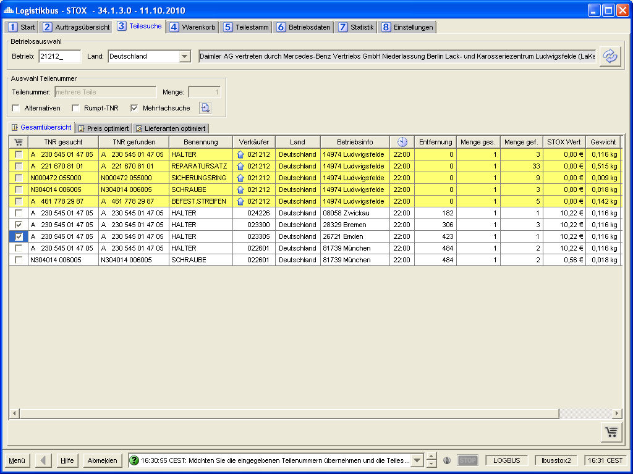

Figure 4‑9 - Panel Search: Presentation of results General overview

Operation selection

Requirement: FKT-GUI-103

The system must provide the input fields Country (combo box) and Site (text field, max. 6 digits, numeric).

Requirement: FKT-GUI-104

If the user confirms his entry in the Site number field with the *Enter*key, the active site is set and the part search is executed (if a part number is stored or the multiple search with stored part number is selected - otherwise the search is not executed and a message is displayed instead).

Requirement: FKT-GUI-105

When you click the *Load* button, the system must set the active mode. The requirements defined at 4.2.1 apply here.

Requirement: FKT-GUI-106

When clicking the *Load* button, the system must execute the part search after successfully setting the operation (if a part number is stored or the multiple search with stored part number is selected - otherwise the search is not executed and a message is displayed instead). If no result could be found for the search, a message is displayed.

Requirement: FKT-GUI-107

When you click the *Load* button, the system should load the shopping cart for the site and the logged-in user and update the *Shopping cart* panel.

Requirement: FKT-GUI-347

With the introduction of the D2D process, the part search must distinguish for which process - D2D or DeadStock (previous STOX) the part search is to be used. Via toggle buttons to the left of the "Operation Selection" area, the user can control whether they are in the D2D or DeadStock process (the D2D toggle button is first). Only exactly one process can be selected at a time. If the user is only authorized for one of the two processes, the toggle buttons are not visible and only the GUI elements and functions of the respective authorized process are available. The selected toggle button has a red background color.

Requirement: FKT-GUI-348

When selecting the DeadStock process, the previous part search is almost unchanged (3 sub-tabs). Only the Total Overview tab is renamed to "DeadStock Overview".

Requirement: FKT-GUI-349

When selecting the D2D process, only the "D2D Overview" sub-tab is available. The search criteria are extended (see chapter 4.5.1).

Requirement: FKT-GUI-350

When changing the process using the toggle buttons, the results in the sub-riders are deleted. The set search criteria are retained.

Requirement: FKT-GUI-351

If the logged-in user is authorized for the DeadStock and the D2D process, the D2D process (toggle button) is selected by default when the application is started.

Requirement: FKT-GUI-421

The execution of the D2D part search can be aborted via the "Stop" button. With the D2D parts search, longer runtimes are possible than with the DeadStock parts search due to the extended search criteria, e.g. all countries, and the extended data volume (not only DeadSock parts).

### Search criteria

The search is always executed for the selected/active operation (DeadStock process). The search criteria allow the user to enter the desired part number(s) and quantity(s), as well as define various options to simplify the part search.

Overview search criteria

Requirement: FKT-GUI-108

The system must provide the search criteria described in the table below for both the D2D and DeadStock processes:

| ****Filter**** | ****Element**** | ****Format**** | ****Multiple**** | ****Other/ Description**** |
| --- | --- | --- | --- | --- |
| Part number | Text field | TNR format | (YES)[[45]](#footnote-45) | Searched part number in input format, print format or memory format, with and without wildcard (\*). |
| Quantity | Text field | Numeric,  Integer | - | Quantity sought. |
| Alternatives | Checkbox | True/False | - | Alternatives are included in the search.  Selected by default in the D2D process (at the start of the application) |
| Multiple search | Checkbox | True/False | - | Multiple search is active. |

Table 4‑21 - Panel Search: Overview search criteria

Notice: The search options Alternatives, Wildcard and Multiple search, can only be selected in the following five combinations:

|  | Alternatives | Wildcard | Multiple search |
| --- | --- | --- | --- |
| Combination 1 | No | No | No |
| Combination 2 | Yes | No | No |
| Combination 3 | Yes | No | Yes |
| Combination 4 | No | No | Yes |
| Combination 5 | No | Yes | No |

Requirement: FKT-GUI-109

The system must allow part number inputs in input format, print format, or save format.

Requirement: FKT-GUI-110

The system must fill the filter *quantity* with quantity 1 by default. Searching with quantity = 0 is not possible (even in multiple search) (DeadStock and D2D).

Requirement: FKT-GUI-111

If the user confirms his entries in the *Part number* field or in the *Quantity* field with the *Enter*key, the active mode is set and the part search is initiated.

Requirement: FKT-GUI-112

When you click the *Open Multiple Input Window* button, the system must open the *Multiple Input* dialog. Existing part numbers are automatically sorted in ascending order in the sort format.

Requirement: FKT-GUI-113

The system must automatically restrict the parts search in stage 1 to the country of the registered operation (active operation). An international search is possibly planned for stage 2.

Requirement: FKT-GUI-352

If the checkbox for the multiple search is selected, the dialog for maintaining the part numbers opens immediately.

Requirement: FKT-GUI-353

When searching in the DeadStock process, a valid, authorized farm must be entered in the farm selection (as before).

When searching in the D2D process, the following rules apply to the operation input:

* Users of the RetailerAdmin and RetailerDefault roles: A valid and authorized establishment number must be entered for the search (OrteD2D). The operation must also be active for the D2D process. Otherwise a corresponding error dialog appears, the search is not started
* User of the role market controller: It is mandatory to enter a company number, even if not a valid one (e.g. 1 / Germany) or active for the D2D process. If no site number is entered, an error dialog appears and the search is not started. Based on the eligibility, no order is possible in any case (VOR and D2D).
* Users of the Admin Controller role: It is not necessary to enter a valid company number. Due to the authorization is not possible to order in any case (VOR and D2D)

Requirement: FKT-GUI-354

The search option "Hull part number" is omitted. It is replaced by the possibility to search for part numbers using a wildcard (\*), e.g. A651010\*.

Requirement: FKT-GUI-355

In the wildcard search, the entry of the part number code letter is always mandatory. If the part number code letter is not specified, an error dialog appears and the search is not performed. The same rules apply for the input as before for the fuselage part number search. If the rules are not followed, an error dialog appears and the search is not started.

Requirement: FKT-GUI-356

The system must provide the search criteria described in the table below during the D2D process:

| ****Filter**** | ****Element**** | ****Format**** | ****Other/ Description**** |
| --- | --- | --- | --- |
| Operating list | RadioButton + combobox | List | Maintenance of site lists similar to e.g. SICOS Controlling, restricted to the LKZ of the authorized sites of the site list OrteD2D, sorted alphabetically. There is no restriction with the admin controller |
| Country | RadioButton + combobox | List | List of all eligible countries, sorted alphabetically  The "All" selection is also available for the Admin Controller role  This option is selected when the application is started |
| LC Region | RadioButton + combobox | List | List of all available LC regions, sorted by company number  Only visible for users of the roles STOX Market Controller and STOX Admin Controller |
| Wholesale inventories | Checkbox | True/False | For selection: Wholesale inventories are included in the search  Checkbox is selected at the start of the application |
| MB GTC Ltd | Checkbox | True/False | When selecting: MB GTC GmbH stocks are included in the search.  The checkbox is selected when the application is started.  Retailer roles: Only visible and selectable if the user is authorized for at least one location (locations D2D) that is from an authorized country in the new parameter (ALLOWED\_COUNTRIES\_GTC) list in the table APP\_PROPERTIES.  Steerer roles (Market steerer and Admin steerer): Visible and selectable independently of the locations in the locations D2D list and the allowed countries from the new parameter (ALLOWED\_COUNTRIES\_GTC) list in the table APP\_PROPERTIES. |

Table 4‑22 - Panel Search: Overview search criteria D2D

The last settings are not saved.

Requirement: FKT-GUI-415

The following sorting options (for potential sellers only) can be selected by the user in the D2D process (RadioButtons):

* Delivery probability (selected by default)
* Price ascending
* Price descending

The last settings are not saved. Exactly one sort must always be selected. Tooltips can be stored on the individual RadioButtons.

Sorting by price (ascending and descending) is only possible if the businesses to be searched are located in the same currency area (e.g. Germany and Austria, both have € as currency). The information from the CURRENCIES table is decisive for this. Only then will the max. or min. D2D value also be displayed in the results table of the part search.

This means for the individual search criteria:

* Operating list: When starting the search while selecting sorting by price (ascending or descending), a check is made to see if establishments from different currency areas are included in the selected list of establishments. If yes, the search is aborted and the user is informed in an error dialog that sorting by price (ascending or descending) is only possible between countries of the same currency and that he has to change either the site list or the selected sorting.
* Country: When changing the country selection, the sorting filters for price ascending/descending are activated/deactivated immediately. With the "All" country selection, the price filters are disabled and the delivery probability filter is selected. When selecting a specific country, the sorting filters for prices are activated and the last selection of filters remains.
* LC Region: When selecting this search criterion, it is not possible to select the sorting price (ascending or descending) (radio buttons become inactive). If one of the two was selected, it is deselected. The radio button for selection by delivery probability is selected.

Requirement: FKT-GUI-422

In the partial search of the D2D process, the user can store a special order note. This order note will be applied to the next D2D orders that the user creates by clicking the "D2D Order" button. After the D2D orders are created, the input field is cleared.

The input field has a capacity of 1000 characters. A tooltip on the input field displays the complete text. The input field is scrollable.

The input field is editable only if the user has the authorization to create D2D orders for the selected site.

Button overview

The following buttons are available in the *Search Criteria* area:

| ****Button**** | ****Symbol**** | | ****Function**** |
| --- | --- | --- | --- |
| Search parts | | Button | Sets the active operation.  Look for parts. |
| Open multiple input window | Button | | Opens a popup for entering multiple part numbers for multiple search (4.5.1.1). |
| GTC Portal |  | | When clicking: Opens internet browser to the webpage of the GTC store displaying the search based on the selected part number.  The button is only visible for retail users.  The button is only active if exactly one line in the result table with the GTC result has been selected. (D2D order button deactivated in that case) |

Table 4‑23 - Panel part search: Buttons in the Filter Criteria area

#### Search for multiple part numbers

If the user has selected the search criterion *Multiple search* , the user can search for several part numbers at the same time.

In the *Multiple input* panel, the user can enter several part numbers together with their (individual) quantities. The input is done directly in the table or by a file import.

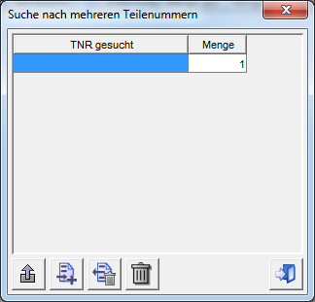

Figure 4‑10 - Panel Search: Multiple entry of part numbers

Requirement: FKT-GUI-114

If the *Multiple search* filter is set, the system must perform the search for multiple part numbers.

Requirement: FKT-GUI-116

The *Open multiple input window* button is active only if the *Multiple search* filter is set.

Requirement: FKT-GUI-117

If the *Multiple search* filter is set, the system must display a tooltip above the Part number text box with all part numbers (incl. quantities) that are stored in the multiple search at that time (sorted by storage format). For example, the text field itself says "several parts". The fields Part number and Quantity are deactivated!

Requirement: FKT-GUI-118

The system must enable (disable) the *Price Optimized View* and *Vendor Optimized View* tabs in the DeadStock process if the user enables (disables) the *Multiple Search* filter. By default, the 2 tabs are disabled (not selectable).

Requirement: FKT-GUI-119

If more than one part number is searched for, the system must calculate a price-optimized and a supplier-optimized result in the DeadStock process (see 4.5.2.2).

Requirement: FKT-GUI-120

If the user confirms his entries in the last cell of the table with the *Enter* or *Tab*key, the system must append a new row.

Requirement: FKT-GUI-121

When clicking the *Add part number* button, the system must append a new line.

Requirement: FKT-GUI-122

The system must fill the *quantity* with 1 by default when a new record is created.

Requirement: FKT-GUI-123

A maximum of 20 part numbers may be entered.

Requirement: FKT-GUI-124

When you click the *Remove part number* button, the system must delete the part numbers marked in the table. All rows that are selected (no matter which or how many columns are selected) will be deleted. If no line is selected, none will be deleted. Does not take effect until the changes are saved.

Requirement: FKT-GUI-125

When you click the *Delete all part numbers* button, the system should delete all part numbers (all records) from the table. Does not take effect until the changes are saved.

Requirement: FKT-GUI-126

When you click the *Close* button, the system must immediately start the part search with the currently selected part numbers.

When you click on the red cross to close the dialog, only the dialog is closed, changes are discarded, the search is not started.

Requirement: FKT-GUI-330

When exiting the multiple search by switching to the search for single or wildcard part numbers, the system must continue to store in the background all part numbers that were last used by the user in the multiple search. When switching to the multiple search again, the stored part numbers are displayed to the user again. When closing the logistics bus, the part numbers in the multiple search are not saved.

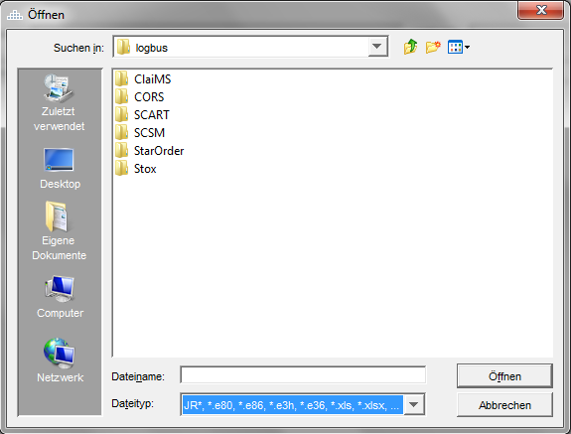

Figure 4‑11 - File selection dialog multiple search

Requirement: FKT-GUI-331

When clicking the *Import part numbers* button, the system must display a file selection dialog to the user. Via the dialog, only files in predefined formats are displayed to the user for selection. Only files with the following names *JR\*, \*.e80, \*.e86, \*.e3h, \*.e36, \*.xls, \*.xlsx, \*.csv, \*.txt* are listed in the selected directory[[46]](#footnote-46). Files in any other format are not selectable. Exactly one file can be selected.

Requirement: FKT-GUI-332

When you click the *Open* button, the system reads the records from the file according to the format and checks the content to make sure that at least 2 "columns" (part numbers and quantity) are included. Optional are two more columns "Sales order number" (column 3) and "BHW" (column 4). Additional "columns" in the file are ignored without error message. The part numbers can be specified in all formats known to Logbus (memory format, input format, print format). The format for sales order number and BHW corresponds to the specifications for manual entry.

If there is a violation of the import format for the respective file, the system must display a speaking error message in a popup. The error message is maintained by the department via PGuard.

Requirement: FKT-GUI-333

For each valid record, the system must create a new row in the multiple search table. If during the import process more than the maximum number of part numbers for multiple search (see FKT-GUI-123) are detected (including the part numbers already entered), the import will be aborted, the system must display a corresponding info message in a popup. The error message is maintained by the department via PGuard.

If, in addition to the info message, there is also an error message due to a format violation, then the system must display the error message with priority. The info message is omitted in this case.

Requirement: FKT-GUI-357

The table for the parts of the multiple search is supplemented by the columns "Order number" and "BHW". The cells of these columns are editable. However, if the search is started from an import from SO+/SO/SCOT, this data is taken from the import and can no longer be changed.

Requirement: FKT-GUI-358

The input formats for the columns "Order number" and "BHW" depend on the role and the target VOR system (or FacingLocation) of the site to be ordered.

* Retailer role and target system for VOR order SOP: Sales order number is numeric, max. 35 digits, BHW is alphanumeric, max. 35 digits
* Retailer role and target system for PRE-order SO: The sales order number is alphanumeric, max. 10 digits, the BHW is alphanumeric, max. 12 digits
* Controller Role or DeadStock: Here there are no restrictions by a target system, the maximum values from the D2D target system restrictions apply: The sales order number is alphanumeric, max. 35 digits, the BHW is alphanumeric, max. 35 digits.

If the site to be ordered is changed, which also results in a change of target system, and the search is repeated or the dialog for the multiple search is opened, a warning dialog appears: The values of the "Sales order number" and "BHW" columns in the multiple search are deleted. Should we proceed with the search?

Yes - the values in the "Sales order number" and "BHW" columns are deleted and the search is started.

No - All values are retained, the search is not started. The previous search results will remain.

Requirement: FKT-GUI-359

As part of the DeadStock process, the data from the columns "BHW" and "Sales order number" in the "Shopping cart" are to be transferred to the field "BWH (Pos.)" (semicolon-separated). If the position is ordered, this info is also in the order details exclusively in the field "BWH (Pos.)".

Requirement: FKT-GUI-360

In the D2D process, the BHW and the sales order number in the order details should only be transferred to the field "BWH (order) of the buyer" (buyer view only) (sales order number;BHW).

Requirement: FKT-GUI-361

If the checkbox "Take over sales order number and BHW" is selected, the entries of the columns Sales order number and BHW will be taken over from the last row when adding a new row (via Add button or Tab).

Table definition and functions

Requirement: FKT-GUI-127

The system must display the following columns per row in the *Multiple Entry* table:

| ****Column**** | ****Format**** | ****Display**** |
| --- | --- | --- |
| Part number | Print format | Searched part number in print format.  Allow input in print, input or save format, no wildcard. |
| Quantity | Numeric. Integer | Quantity. |
| Sales order number | Depending on the target system and process | Order number |
| BHW | Depending on the target system and process | BHW |

Table 4‑24 - Panel multiple input: Column description

Button overview

The following buttons are available in the *Multiple Input* panel:

| ****Button**** | ****Symbol**** | ****Function**** |
| --- | --- | --- |
| Close | close | Asks the user if they want to accept the changes and start the part search. |
| Delete all part numbers | Button | Empties the complete table. |
| Remove part numbers | Button | Deletes the selected rows from the table. |
| Add part number | Button | Appends a new row to the end of the table |
| Import part numbers | 24_Export | Opens file selection dialog for importing part numbers from an import file. |
| Transfer customer order number and BHW | Checkbox | Selection: Sales order number and BHW are copied from the last line to a newly created line  The checkbox is selected by default. The last setting is saved |

Table 4‑25 - Panel multiple input: Buttons

#### Search for alternatives

If the user has selected the search criterion *Alternatives* , the search will consider alternatives.

Requirement: FKT-GUI-129

If the *Alternatives* filter is set, the system must include the alternatives in the part search.

Requirement: FKT-GUI-130

When searching for alternatives, the system must consider unilateral successors as well as bilateral and optional replacements.

Requirement: FKT-GUI-362

If the user sets the *Alternatives*filter, a wildcard search is not allowed. When starting the search, the user is informed with an error dialog that a combination of wildcard and alternative search is not allowed.

Requirement: FKT-GUI-363

It is always searched for alternatives of the part number in the entered operation and in the own operations, regardless of whether the selection "Alternatives" was selected or not (not with wildcard search) (DS and D2D).

#### Search for part numbers with wildcard

To search for a part number with wildcard, the first part of the part number searched for must be entered followed by "\*" (symbol for wildcard). The search for a part number with wildcard cannot be combined with the search for alternatives and/or the multiple search.

Searching for a part number with wildcard allows to get a basic part number incl. all possible ES1 or ES2 displayed. Example:

I am looking for part number A4711\* which still exists as A4711 80 or A4711 5B21. While the normal search only shows the A4711 as a result, the wildcard search result also shows the other two part numbers.

Requirement: FKT-GUI-131

If the wildcard symbol is used when entering the part number, the system must perform the wildcard search.

Requirement: FKT-GUI-132

If the wildcard symbol is used when entering the part number, an error dialog appears after pressing the search button if the checkbox for "Alternatives" is selected. The search is not started. Within the dialog for the search of multiple part numbers the input of a wildcard is not possible.

Requirement: FKT-GUI-133

The entered part number must consist of at least the identification letter as well as the first 4 digits of the part number (after the KB) and the wildcard symbol. For example, B4711\*.

If the part number starts with the code letter A, at least 10 digits after the code letter and the wildcard symbol must be entered, e.g. A0123456789\*.

If the entered part number does not meet these minimum requirements and a search is started, an error message is displayed indicating that the entered part number is too short.

In the future, the tooltip explaining the input options will be displayed on the label of the text field for entering the part number (tooltip used to be on the "Hull part number" checkbox).

Requirement: FKT-GUI-134

The part number must be entered in the input format. Entering the code letter is mandatory for the wildcard search.

Requirement: FKT-GUI-364

Old parts (ES1 = 7\*) are not considered in the wildcard search).

### Result presentation DeadStock

The search results are presented in different views (only for multiple searches). The following requirements apply to all three result presentations.

Requirement: FKT-GUI-135

If an alternative to the searched part number is found, the system must display the alternative in italics.

Requirement: FKT-GUI-136

If additional parts are required for an alternative part, a note on additional parts is displayed (icon 'M').

Requirement: FKT-GUI-137

If the seller belongs to a certain group (e.g. own plants or preferred suppliers) the system must show a corresponding icon in the Seller column. If a vendor/company does not belong to any of the following groups, no icon is displayed.

| ****Group**** | ****Symbol**** | ****Description**** |
| --- | --- | --- |
| Entered operation | One house | Stock is still available in the entered plant. |
| Own operations | Three houses | The user's own operations still exist. |
| Preferred suppliers | Blue plus | Operation is stored in the list of preferred suppliers. |
| Problematic suppliers | Red minus | Operation is deposited in the list of problematic suppliers. |

Table 4‑26 - Representation of the seller

Requirement: FKT-GUI-138

The *price optimized view* as well as the *supplier optimized view* are only calculated/displayed if the user has selected the multiple search and searches for more than one part number.

Requirement: FKT-GUI-139

If the user double-clicks on the *Part number searched*column, the system jumps to the main *Part master* panel and updates the panel for the combination of site (own site) and searched part number.

Requirement: FKT-GUI-140

If the user double-clicks on the *Part number found*column, the system jumps to the main *Part master* panel and updates the panel for the combination of operation (own operation) and part number found.

Requirement: FKT-GUI-141

Double-clicking on a cell in the *Salesperson* column jumps to the Farm *Data* panel (chapter 4.8) and fills the Farm and Country fields there with the values of the underlying row.

Requirement: FKT-GUI-142

If a *DeadStock* *note* is stored for a part number found, an icon is displayed before the designation (**!**). In addition, the *DeadStock* *note* is displayed as a tooltip in the Naming cell.

Requirement: FKT-GUI-143

If the user clicks the Add *to Cart* button, the system must add all the items selected in the *Add to Cart* column to the cart and then jump to the *Cart* panel.

Requirement: FKT-GUI-144

Farms may only be displayed in the result if they have sufficient stock (free stock minus DeadStock and D2D reservation is greater than or equal to the quantity searched for).

The entered farm as well as the user's own farms are displayed even if their stock is smaller than the searched quantity.

Basically, the searched quantity must always be > 1 (see also Anforderung: FKT-SUCH-1 and Anforderung: FKT-SUCH-13).

Farms are excluded from the result based on the requirement described in FKT-GUI-392.

Requirement: FKT-GUI-145

Results from own operations are highlighted in color.

Button overview

The following buttons are available below the results tables:

| ****Button**** | ****Symbol**** | ****Function**** |
| --- | --- | --- |
| add to shopping cart | einkaufswagen | Adds all selected items (checkbox in column selected in *shopping cart* ) to the shopping cart and then jumps to the *Shopping Cart*panel.  The button is active only if the user is in the *Retailer*, *Retaileradmin* or *Admin controller* roles. |

Table 4‑27 - Panel Part Search DeadStock: Button overview

#### General view

In the general view, all parts corresponding to the search criteria are displayed.

Table definition and functions

Requirement: FKT-GUI-146

The system must display one part number per row with the following columns in the *General* results table:

| ****Column**** | ****Format**** | | ****Display**** | |
| --- | --- | --- | --- | --- |
| in shopping cart | Checkbox | | Editable. Marks whether the part should be added to the shopping cart when you click the *Add to Cart* button.  The checkbox is uncheckable for lines with parts from the own plants. | |
| Part number searched | Print format | | Searched part number (incl. wildcard "\*") | |
| Part number found | Print format | | Found part number (may be different from searched part number when searching for part number with wildcard or for alternatives).  Italic, if alternative part number. Icon for possible delivery parts. | |
| Naming | - | | Designation of the found part number (in the national language of the seller). If a DeadStock note is available for the part number found, an icon is displayed and a tooltip with the DeadStock note is shown (only for third-party companies). | |
| Seller | 6 digits. Numeric | | 6-digit company number of the seller.  Incl. ICON for either entered operation, own operations, preferred supplier or problematic supplier. | |
| Country | Text | | Country of the seller. | |
| Operating info | Text | | Zip code and place | |
| Late pickup | Icon | | If late pickup is possible, the time is displayed. | |
| Distance | Text | | Distance from GPS calculation in kilometers. | |
| Quantity searched | Numeric. Integer | | Quantity sought. | |
| Quantity found | Numeric. Integer | | Quantity found (current DeadStock inventory, see also Anforderung: FKT-SUCH-3). | |
| DeadStock order value | Price format | | DeadStock order value of the item (seller's DeadStock price times quantity searched), also for own operations if the part is included in the DeadStock assortment, 0 otherwise | |
| Advantage | Price format | | Advantage = ((BLP of the LC responsible for delivery - discount rate according to discount group) - DeadStock price) x quantity sought  Formula is displayed as tooltip, also for own operations, if the part is included in the DeadStock assortment, otherwise 0 | |
| Weight | Weight format | | Net weight of the item (net weight times quantity searched). | |
| Part number found | | Memory format | | Display of the found part number in the memory format (hidden by default, but if explicitly selected by the user, it remains displayed) | |

Table 4‑28 - Panel part search: Columns General view of results

Requirement: FKT-GUI-147

The column *Quantity searched* must be editable (only for DeadStock). The user can enter integers between 0 and the *found quantity* in a text field. If a user changes the quantity to 0, this part number (later) will not be added to the shopping cart (no hint message will be displayed).

Requirement: FKT-GUI-148

The system must automatically update the DeadStock order value and the item's benefit when the user changes and confirms the value in the *Quantity Wanted* column (for third-party operations only).

Requirement: FKT-GUI-149

The system must automatically update the weight of the item when the user changes and confirms the value in the *Quantity searched* column.

#### Optimized by price or optimized by supplier

The optimized views show the price-optimized or the supplier-optimized search result. This view is only available if the user is searching for multiple part numbers.

The optimized results are displayed in treetables to clearly assign the found part numbers to the individual sellers. The main branches of the treetables show the operational information, the sub-branches show the information about the found part numbers. Each seller (main branch) is assigned the part numbers (sub-branches) found with him.

Requirement: FKT-GUI-150

The system must display the price-optimized result and the supplier-optimized result each in a treetable.

Requirement: FKT-GUI-151

The system must display one main branch per vendor with the following values:

| ****Column**** | ****Format**** | ****Display**** |
| --- | --- | --- |
| in shopping cart | Checkbox | Editable. Marks whether all parts of the supplier should be added to the shopping cart when clicking the *Add to* cart button.  The checkbox is uncheckable for suppliers who are own plants. |
| Seller | 6-digit company no. and country as text | Company number and country.  Icon for entered farm, own farms, preferred or. problematic farm. |
| Zip code and city | - | Zip code and city. |
| Distance | - | Distance in km. As the crow flies according to GPS calculation. |
| Late pickup | - | Time when late pickup is possible. |
| Wanted/Found | - | Pos searched / Pos found. Hit rate in % (as tooltip?) |
| DeadStock order value of the order | Price format | DeadStock order value across all items for this facility (DeadStock price times quantity searched). For own operations always 0.00. |
| Advantage (total) | Price format | Advantage = ((BLP of the LC responsible for delivery - discount rate according to discount group) - DeadStock price) x quantity sought  Tooltip "Advantage over all positions at the seller".  Advantage value over all positions for this operation. For own operations always 0.00. |
| Weight | Weight format | Net total weight of all parts "ordered" from this dealer (the order). Total (net weight per TNR times quantity sought). |

Table 4‑29 - Elements of the main branch

Requirement: FKT-GUI-152

The system must display a sub-branch below a main branch (seller) for each part number with the following values:

| ****Column**** | ****Format**** | ****Display**** |
| --- | --- | --- |
| in shopping cart | Checkbox | Editable. Marks whether the part should be added to the shopping cart when you click the *Add to Cart* button.  The checkbox is uncheckable for lines with parts from the own plants. |
| Part number searched | Print format | Wanted part number. |
| Part number found | Print format | (may be different from searched part number when searching for alternatives).  Italic, if alternative part number. Icon for possible supplied parts. |
| Naming | - | Designation of the found part number (in the national language of the seller). If a DeadStock note is available for the part number found, an icon is displayed and a tooltip with the DeadStock note is shown. |
| Quantity searched | Numeric. Integer | Quantity sought. Editable. |
| Quantity found | Numeric. Integer | Quantity found at the seller (current DeadStock inventory, see also Anforderung: FKT-SUCH-3) |
| DeadStock order value of the position | Price format | DeadStock single price times quantity sought.  For own operations always 0.00. |
| Advantage | Price format | Advantage = ((BLP of the LC responsible for delivery - discount rate according to discount group) - DeadStock price) x quantity sought  Formula is displayed as a tooltip.  For own operations always 0.00. |
| Weight | Weight format | Quantity sought times net unit weight. |

Table 4‑30 - Sub-branch elements

Requirement: FKT-GUI-153

The column *Quantity searched* must be editable. The user can enter integers between 0 and the *found quantity* in a text field. If a user changes the quantity to 0, this part number (later) will not be added to the shopping cart (no hint message will be displayed).

Requirement: FKT-GUI-154

The system must automatically update the DeadStock order value and the item's benefit when the user changes and confirms the value in the *Quantity Wanted* column. In addition, the DeadStock order value and the advantage of the associated main branch must be updated (for third-party operations only).

Requirement: FKT-GUI-155

The system must automatically update the weight of the item when the user changes and confirms the value in the *Quantity searched* column. In addition, the total weight of the associated main branch must be updated.

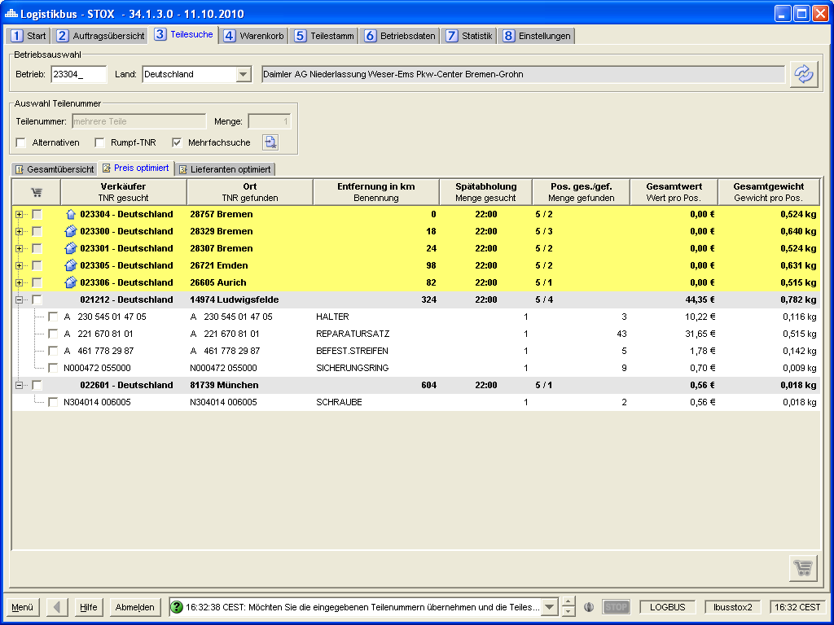

Figure 4‑12 - Part search panel: Optimized search.

### Result display D2D

The search results are displayed in the "D2D Overview" sub-tab. There is no price- or supplier-optimized representation as in the DeadStock process. Some display principles are adopted from the DeadStock process.

Requirement: FKT-GUI-365

The representation principles from the requirements FKT-GUI-135-137, 139-142 and 144-145 are also applied in the D2D process (alternatives, operational representation, jump in part master and operational data).

Requirement: FKT-GUI-366

Result lines of incorrectly entered part numbers (no valid TNR format or no description determined, not with wildcard search) are displayed completely in red, bold font.

Requirement: FKT-GUI-367

For valid part numbers**(without** wildcard), for which there is no positive search result (contents of the columns "No. pot. Seller" (0) and "Quantity found" (0)), only the contents of these two columns are displayed in red, bold font.

Requirement: FKT-GUI-368

The header lines are displayed in bold font, the background is petrol (analog JCFR). Headers for which no result was found are grayed out.

The detail lines are displayed in normal font, the background is white by default. (Analog DeadStock / Price/Supplier Optimized View). Detail lines where the potential seller is a central location (GLC, WHS, GTC) are displayed with green background (exact color tone is defined during development, CI compliant).

Button overview

The following buttons are available below the results table:

| ****Button**** | ****Symbol**** | ****Function**** |
| --- | --- | --- |
| Start D2D order | einkaufswagen | Starts a *D2D* order for all selected items (checkbox selected in D2D order column).  The button is active only if at least one position is selected and the user is authorized to start D2D orders for the selected site. |
| Start PRE-Order |  | Starts a VOR *order* for all selected items (checkbox selected in VOR order column).  The button is active only if at least one position is selected and the user is authorized to start BEFORE orders for the selected operation. |

Table 4‑31 - Panel part search D2D: Button overview

Table definition and functions

Requirement: FKT-GUI-369

The following columns are displayed in the search result. Tooltips are possible for all column headers. Tooltips on cells are available on demand (columns with jump target or content relevant à see in detail description in the following table).

| ****Column**** | ****Format**** | | ****Header (TNR grouped)**** | | ****Detail line**** | |
| --- | --- | --- | --- | --- | --- | --- |
| +/- | Icon | | Icon Plus/Minus to expand and collapse the details | | In case of an item not orderable via D2D (due to D2D assortment or a non-D2D dealer), including tooltip with contact information of the facility (order of contacts depending on availability: Stox, inventory information, operational data) | |
| D2D Order (Shopping Cart Icon)  C:\Projekte\Logistikbus\branches\logbus-57.0.0.0\resources\images\app\16_Shoppingcart.png | Checkbox | | Editable. Marks whether the part should be selected across all potential sellers | | Editable. Marks whether the part should be selected for a specific vendor for a later D2D request | |
| Part number searched | Print format | | Searched part number | | Searched part number | |
| Part number found | Print format | | - | | Found part number (may be different from searched part number if searched with wildcard or for alternatives).  Italics if different (wildcard or alternatives). Icon for possible supplied parts. | |
| Naming | Text | | Designation of the searched part number (in the national language of the searching company). If no or no valid site number is selected, the designation in the selected GUI language (if available, otherwise the English one) from the Global Part Master is displayed  No designation is displayed for wildcard search | | Designation of the found part number (in the national language of the seller, if not available the local designation of the seller).  If the found part is included in the DeadStock assortment of the potential seller, an icon with a tooltip with a standard text (PGuard) will be displayed if the user has DeadStock rights or has the role of market or admin controller:    If a DeadStock note is available for the found part number, the DeadStock note of the potential seller is displayedin addition to the standard text in the tooltip (only for third-party companies). | |
| Number of potential sellers | Numeric | | Total of all farms found (i.e. incl. own farms, WHS, GTC and non-D2D farms)  If the quantity is 0, the value is displayed in bold, red letters | | 6-digit company number of the seller.  Incl. icon for either entered site, own sites, preferred supplier or problematic supplier ~~or site not participating in D2D process~~ (but not central sites (GLC, WHS, GTC). | |
| Country | Text | | - | | Country of the potential seller | |
| Operating info | Text | | - | | Zip code and city of the potential seller  Tooltip: Name of the potential seller | |
| Late pickup | Text | | - | | If late collection from the potential seller is possible, the time is displayed  Only filled for retail operations participating in the D2D process, otherwise empty | |
| Distance | Text | | - | | Distance to potential seller from GPS calculation in kilometers | |
| Quantity searched | Numeric, Integer | | Quantity requested | | Quantity requested | |
| Quantity found | Numeric, Integer | | Quantity found summed across all farms (regardless of whether it is a potential seller)  If the quantity is 0, the value is displayed in bold, red letters | | Found available quantity at potential seller (physical inventory at own operations, available inventory at all others) | |
| Min. D2D value | Price format | | Smallest D2D value of all potential sellers and own operations (see also Anforderung: FKT-GUI-415) | | - | |
| Max. D2D value | Price format | | Largest D2D value of all potential sellers and own operations (see also Anforderung: FKT-GUI-415) | | - | |
| D2D value | Price format | | - | | ((VKP or BLP - BEFORE discount rate according to RG) x quantity sought) + D2D handling margin  Only filled for retail operations participating in the D2D process, otherwise empty  Also filled for own operations | |
| EK Value (VOR) | Price format | | - | | (BLP - BEFORE discount rate as per RG) x quantity sought  Only filled for retail operations participating in the D2D process, otherwise empty  Also filled for own operations | |
| Weight | Weight format | | - | | Net weight according to PRIMUS x quantity sought  If there is no weight specification (=0), the value is displayed in bold, red font | |
| PRE-order | | Checkbox | | Editable. Marks whether the part is intended for a VOR order | | - | |
| Part number found (memory format) | Memory format | | - | | Display of the found part number in the memory format (hidden by default, but if explicitly selected by the user, it remains displayed) | |

Table 4‑32 - Panel part search: Columns search result D2D

Requirement: FKT-GUI-370

The result display grouped by part numbers is hierarchically structured in a table. The header consists of general information about the searched part number, the detail lines below contain the search results. The detail lines can be expanded or collapsed as required (analogous to DeadStock / price/supplier optimized view). The results table is not sortable, the columns are movable.

Requirement: FKT-GUI-371

If only one part number is searched for, the detail lines are expanded in the result display. If several part numbers are searched for (multiple search), then only the header lines are displayed in the results display, the details can be expanded by the user if required. Exception: The search returns a positive result only for one part number, then this result is displayed expanded.

Requirement: FKT-GUI-372

The detail rows can be expanded and collapsed using the plus/minus icon in the first column.

Requirement: FKT-GUI-373

The detail lines can be expanded and collapsed by double-clicking on the header line.

Requirement: FKT-GUI-374

The detail lines can be completely expanded or collapsed using menu items in the context menu (right mouse button):

* Are all detail lines collapsed: Menu item to show all detail lines 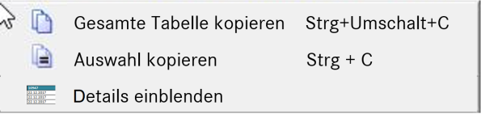
* Are all detail lines expanded: Menu item to hide all detail lines 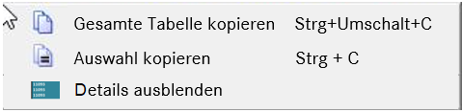
* Are there expanded and collapsed detail lines: Menu item for showing or hiding all detail lines 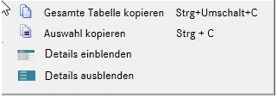

Requirement: FKT-GUI-375

The order of the search results (headers) is as follows:

1. Part numbers (sorted by memory format) for which there is no search result. There are no detail lines in this case. The result in the columns "Quantity found" and "Number of potential sellers" is zero.
2. Part numbers (sorted by memory format) for which there is a positive search result.

Requirement: FKT-GUI-376

The display order of the plants of the found search results (search result per searched part number) is as follows:

1. Entered operation (if available)
2. Own operations (if any)
3. Wholesale operations
4. Retail operations

Requirement: FKT-GUI-377

The display order of wholesale locations found (per part number searched) when searching for wholesale inventory is as follows:

1. GLC
2. ~~EastHub[[47]](#footnote-47)~~
3. MBUSI: Always displayed when stock is present
4. Evobus Ulm: Always displayed if stock is present (stock is displayed if present, regardless of the brand of the searched part)
5. WHS (multi-level or facing locations, analogous to inventory information): For the country of the entered site number, all WHS levels to be displayed are determined from WHS\_MULTI\_LEVELS and sorted. If not available, then "Facing Locations": Sorted by company number in ascending order
6. MB GTC Ltd

Requirement: FKT-GUI-378

The site number entered will have the following effect on which Facing Locations are displayed when searching for wholesale inventory:

1. Valid company number: For the country of operation, the multi-level wholesale locations are identified. If there is no entry: The facing location is determined on the basis of the facility number and the stocks of the facing location or all other wholesale locations in the same country are determined and displayed.
2. Invalid company number: The multi-level wholesale locations are determined for the selected country. If there is no entry: The facing location cannot be determined exactly, which is why the inventories of all wholesale locations in the selected country (country of operation selection) are determined and displayed (analogous to inventory information).
3. No company number: The inventories of all wholesale locations are determined and displayed.

Requirement: FKT-GUI-379

The determination and display of retail stocks depends on the selection of search criteria as well as on the authorization:

* Admin Controller: The display of retail stocks is not limited, the selection of the search criteria is decisive (e.g. D2D search criterion country = "**All**", company selection not relevant: the positive search results from **all** countries are displayed)
* MarketController, RetailAdmin, RetailerDefault: Only retail stocks that are from the same country as the selected (although possibly invalid) site are determined and displayed. Even if the authorization would be more far-reaching (would include several countries). Thus, cross-country D2D orders are prevented (e.g. D2D search criterion LC Region = "Hannover", site selection = 1 / Germany: only the positive search results from Germany within the LC Region Hannover are displayed)

Requirement: FKT-GUI-380

The retail locations found are grouped as follows (per part number searched):

1. All retail operations participating in the D2D process
2. All retail operations that do not participate in the D2D process

Requirement: FKT-GUI-381

Further sorting per searched part number:

All retail operations not participating in the D2D process are sorted/grouped by probability of delivery (as no D2D prices are available here). For companies participating in the D2D process, the user can choose between sorting/grouping by delivery probability and price (ascending or descending).

Sorting/grouping by delivery probability is done according to the following rules:

1. Potential sellers with distance <= PREF\_SUPPLIER\_DISTANCE km, sorted by distance in ascending order. If the distance is the same, ascending by company no.
2. Potential sellers where the part number is included in the DeadStock assortment, sorted by distance in ascending order (distance > PREF\_SUPPLIER\_DISTANCE km). If the distance is the same, ascending by company no.
3. All other potential sellers sorted by
   1. Available stock descending
   2. Date of last receipt (local partial master) ascending (if the field is empty this corresponds to the latest date)
   3. Date of last retirement (local partial master) ascending (if the field is empty, this corresponds to the oldest date)
   4. Creation date (local sub-master) in ascending order (if the field is empty, this corresponds to the most recent date), if date of last acquisition and date of last retirement are empty
   5. Distance ascending

If the sorting "Price ascending" or "Price descending" is selected, the farms (participating in the D2D process) are displayed sorted by the D2D value in ascending or descending order. In both cases, if the value is the same, it is sorted in descending order according to the available stock.

Generally, the distance is displayed as a whole number, rounded commercially. The sorting should also already work with the integer, commercially rounded value. Otherwise, the sorting is no longer comprehensible for the user in case of integer equal distance.

Requirement: FKT-GUI-382

The checkbox "D2D order" is editable (header and detail level) only if

* the user has the authorization for D2D ordering for the entered operation and
* if the found part may be ordered via D2D (see D2D assortment in chapter 1.1.13) and
* if there is at least one positive search result at a retail operation that is not one of the company's own operations and that participates in the D2D process. In this case the checkbox is also selected automatically

Requirement: FKT-GUI-383

The "D2D Order" checkbox at the header level reflects the selection state at the detail level:

* White without hook: No selection at detailed level (e.g. only positive search results in own plants and/or central locations)
* Gray with hook: At least one selection on detail level, but not all detail lines selected or selectable (e.g. at least one positive search result on retai level, but also positive search results for central locations)
* White with hook: All detail lines are selected (and therefore selectable) (only positive search results on retai level)

If the selection is made using the checkbox at header level, all editable checkboxes at detail level are selected or deselected.

Requirement: FKT-GUI-384

The checkbox "D2D order" can be marked analog to the filters in the dialog SICOS / Controlling LC / VOR order times by dragging with pressed mouse button. All selectable checkboxes in the selected area will then be selected or deselected. After selecting/deselecting, the user is asked by message if he wants to accept it. This handling is also carried over into the DeadStock process (all three tabs).

Requirement: FKT-GUI-385

The checkbox "BEFORE order" (available only on header level) is inactive (not editable) in the following cases:

* An incorrect part number (no valid part number format) was entered
* Searched part number is a wildcard part number
* This is an Evobus part number
* No or no valid company number was entered
* There is no authorization for VOR ordering (neither an authorization for StarOrder nor for StarOrderPlus)

In all other cases the checkbox "BEFORE order" is active (editable) but not automatically selected.

Requirement: FKT-GUI-416

The checkboxes "BEFORE order" and "D2D order" must not be selected for a part number at the same time. If the user selects the "BEFORE order" checkbox, all selected "D2D order" checkboxes for this part number will be deselected. If the user selects one of the checkboxes for "D2D order", the checkbox "BEFORE order" is deselected for this part number.

Requirement: FKT-GUI-386

If a part number is not orderable via D2D (e.g. a dangerous goods part - see KT-GUI-369) or a potential vendor does not participate in the D2D process, the following icon is displayed in the +/- column: . A tooltip clarifies the information. The tooltip also contains the contact information of the contact person Stox or stock information (name, phone number, eMail address) if available, otherwise that of the site from the site data. In this case, no prices will be displayed.

Requirement: FKT-GUI-387

A positive search result can only be achieved if the available stock is >= the searched quantity. The definitions for available inventory and D2D assortment are detailed in chapters 1.1.13 and 1.1.14 .

Requirement: FKT-GUI-388

The VOR order button becomes active if at least one checkbox in the "VOR order" column has been selected and the authorization for VOR orders for the selected site exists. When the button is clicked, a question dialog appears asking if the user wants to create a VOR order for the selected part numbers:

Yes - All resulting searched part numbers will be removed from the part search or multiple search and the search result. A jump into StarOrder/StarOrderPlus (depending on the configuration of the ordering facility, analogous to VOR button in DIMS) for the selected, found part numbers (in input format), the selected facility (breakdown in facing location) and the quantity searched for. In the case of a multiple search, BHW and sales order number are also transferred to the target system. If there are still open processes in StarOrder/StarOrderPlus, they will be overwritten (the user will be made aware of this beforehand in an info dialog). If several different sales order numbers are contained (after cleaning up multiple existing part numbers), the jump is aborted and an error message including a listing of the sales order numbers appears. (Background: In StarOrder/StarOrderPlus, only one sales order number can be processed per order)

If more than one customer number is determined for the selected part numbers (parts have different brands), then the jump is performed for one (any) of these customer numbers. The target system (SO/SOP) ensures that the order is split according to the customer number.[[48]](#footnote-48)

No - The dialog closes, no further actions, everything remains as before

A tooltip can be stored for the button.

Requirement: FKT-GUI-389

The button D2D order becomes active if at least one checkbox in the column "D2D order" was selected and the authorization for D2D orders for the selected company is available. When the button is clicked, a question dialog appears asking if the user wants to start a D2D order for the selected part numbers:

Yes - All resulting searched part numbers will be removed from the part search or multiple search and the search result. The D2D order is created. The next consecutive order numbers will be assigned (same number range as DeadStock orders). This and the part number searched for are communicated to the user in an info dialog (for further tracking in the order overview).

Only one part number can be requested per order (searched part number) per potential seller. If more than one part number (alternatives/wildcard) is selected for a potential vendor, the user is informed about it with an error dialog, the part numbers and potential vendors are listed in it. The user is prompted to adjust his selection accordingly. The order process is canceled.

No - The dialog closes, no further actions, everything remains as before

A tooltip can be stored for the button.

If a D2D order is already running (status CREATED and STARTED) for a searched part number (in case of wildcard search comparison to the entered part number, e.g. N0000\*) for which the D2D order is to be started, an info message is displayed to the user that a new D2D order is not possible. No further D2D order will be started for these parts. They will be removed from the part search or multiple search and the search result.

Example 1:

Searched part number N0000\* à Order possible with all combinations found

|  |  |  |
| --- | --- | --- |
| D2D checkbox | Found part number | Supplier |
| X | N00007 | Seller 1 |
| X | N00007 | Seller 2 |
| X | N00007 | Seller 3 |
| X | N00008 | Seller 4 |
| X | N00008 | Seller 5 |
| X | N00008 | Seller 6 |

Example 2:

Searched part number N0000\* à Order only possible if each seller is selected only once (see example combination)

|  |  |  |
| --- | --- | --- |
| D2D checkbox | Found part number | Supplier |
| X | N00007 | Seller 1 |
|  | N00007 | Seller 2 |
|  | N00007 | Seller 3 |
|  | N00008 | Seller 1 |
| X | N00008 | Seller 2 |
| X | N00008 | Seller 3 |

Requirement: FKT-GUI-390

If the D2D order is started outside the parameterized opening hours of the country, the user will be notified in an error dialog:

Attention: Your order request is outside the business hours stored in the system ([x] to [y] hours). Processing by the seller is possible on [date, time] at the earliest. Do you want to start the order request?"

Yes - The D2D order will be initiated as described, but will only start from the specified opening time.

No - The dialog closes, no further actions, everything remains as before

Requirement: FKT-GUI-391

If a found part is included in the DeadStock assortment of the potential seller, this is indicated by an icon in the Designation column:  In this case, the menu item Transfer to DeadStock shopping cart is available in the context menu of this line (right mouse button), provided that the user has the authorization for DeadStock (Places listDS filled) and for placing DeadStock orders for the site selected in the site selection and the selected site is enabled for the DeadStock process. It does not matter if the potential vendor is also active for the D2D process. Multiple selection of such cells is possible, then all selected parts will be added to the DeadStock shopping cart. When clicking on the menu item, a question dialog appears asking whether the marked part numbers should be transferred to the DeadStock shopping cart and deleted from the D2D parts search (incl. multiple search dialog):

Yes - All resulting searched part numbers will be removed from the part search or multiple search and the search result. A jump is made to the shopping cart tab with the selected, found part numbers and sellers. The part numbers/sellers are added to the shopping cart, existing data in the DeadStock shopping cart is retained.

No - The dialog closes, no further actions, everything remains as before

Requirement: FKT-GUI-392

The following potential suppliers will be excluded from the search:

* The potential supplier has rejected a request for this part number in the REJECT\_BLOCKING\_TIME period (see FKT-D2D-LIEF-5) (status = "Rejected")
* For users of one of the retail roles: Establishments that are excluded as potential sellers (via exclusion table).

Requirement: FKT-GUI-417

The following constellations in the result are highlighted by an orange (CI color) cell color (only relevant for result rows where a D2D order is possible):

* Same part number found with different searched part numbers (e.g. A + B searched, and C found with both) à Cell TNR found highlighted orange
* Same supplier found with different searched part numbers (e.g. A + B searched, A + B etc. found at supplier 4711) à Cell seller highlighted orange
* Same part number & same supplier found with different searched part numbers (e.g. A + B searched, and C found with supplier 4711 with both) à Cell TNR found and seller highlighted orange

## Shopping cart

The main panel *Shopping Cart* offers the user the possibility to order the parts he/she put into the shopping cart. Here the user can "complete" the order by selecting the shipping method, correcting any quantities and entering the order instructions.

**Notice:** There is a separate shopping cart for each site and (logistics bus) user - i.e. if two different users are authorized for the same site, they both have their own shopping cart for this site. As long as an order is still in the shopping cart (i.e. has not yet been ordered), the two users do not "see" the orders in each other's shopping carts. Both can independently search for parts and add them to "their" shopping cart to the same "buyer operation".

Requirement: FKT-GUI-156

For each successfully ordered item, a reservation for the ordered quantity is entered at the seller (in the "STOX\_PARTS" table) (the order quantity is added to the reserved quantity). Furthermore, the reservation is additionally stored in the table "STOX\_RESERVATIONS" (this allows the reservation to be "resolved" again at a later time by a batch process).

Requirement: FKT-GUI-157

The main *Shopping Cart* panel can be seen and read by all roles (for the farms assigned to them). Users in the ***Retailer*, *Retaileradmin* , and *Admin Controller*** roles are **also allowed to order the shopping cart for their sites**. For all other roles the *Order* button is disabled.

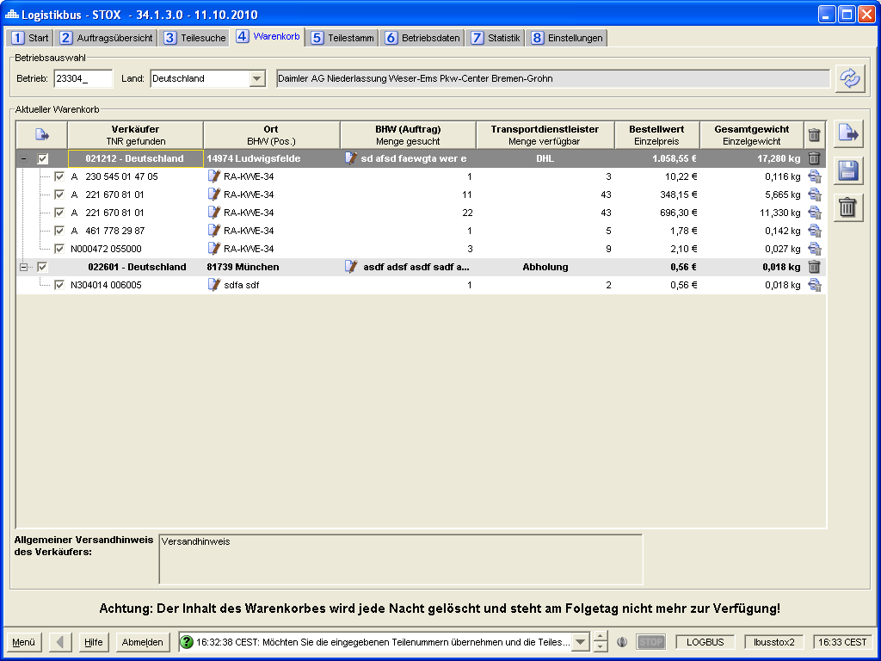

Figure 4‑13 - Shopping cart panel

Operation selection

Requirement: FKT-GUI-158

The system must provide the input fields Country (combo box) and Site (text field, max. 6 digits, numeric).

Requirement: FKT-GUI-159

If the user confirms his entry in the Farm number field by pressing *Enter*, the active farm is set and the shopping cart is loaded.

Requirement: FKT-GUI-160

When you click the *Load* button, the system must set the active mode. The requirements defined at 4.2.1 apply here.

Requirement: FKT-GUI-161

When you click the *Load* button, the system must load the shopping cart after successfully setting the operation.

Shopping cart

Requirement: FKT-GUI-162

The system must display the shopping cart in a treetable. The shopping cart is sorted in ascending order by plant number and then by part number in the sort format.

Requirement: FKT-GUI-163

The system must display one main branch per vendor with the following values:

| ****Column**** | ****Editable**** | ****Format**** | ****Display**** |
| --- | --- | --- | --- |
| Seller |  | 6-digit company no. and country as text | Company number and country.  Icon preferred or. problematic operation. |
| Location |  | - | Zip code and city. |
| Special order note | X | Text field | First XX characters of the special order note to the order/order.  Icon for opening an input dialog.  The complete hint is displayed as a tooltip. |
| Shipping method | X | Combo box | Postal service provider of the seller. When a service provider is selected the costs incurred before. Duration and the remark displayed as a tooltip. |
| DeadStock order value (order) |  | Price format | Sum of all parts in the shopping cart with this seller based on DeadStock price times quantity searched ("parts to order"). |
| Weight (order) |  | Weight format | Net total weight of all parts assigned to this seller (of the order). |
| Delete | (X) | Icon | Icon + tooltip. Deletes all items (parts) assigned to this seller. |
| Order | (X) | Checkbox | Checkbox. If selected, then all items (parts) assigned to this seller will be ordered. |

Table 4‑33 - Shopping cart: Elements of the main branch

Requirement: FKT-GUI-164

The system must display a sub-branch below a main branch (seller) for each part number with the following values:

| ****Column**** | ****Editable**** | ****Format**** | ****Display**** |
| --- | --- | --- | --- |
| Part number found |  | Print format | Found part number. |
| BHW | X | - | Order note for the position (Incl. Icon + Tooltip). |
| Quantity searched | X | Numeric. Integer | Quantity sought. Editable via a text field. Enter a numeric value between 0 and the found quantity. |
| Quantity found |  | Numeric. Integer | Quantity found at the seller (current DeadStock inventory, see also Anforderung: FKT-SUCH-3). |
| DeadStock order value (Pos) |  | Price format | DeadStock unit price \* Quantity wanted. |
| Weight (Pos) |  | Weight format | Quantity sought \* Net individual weight. |
| Delete | (X) | Icon | Icon + tooltip. Deletes the position. |
| Order | (X) | Checkbox | Checkbox. If selected, then this position is ordered. |

Table 4‑34 - Shopping cart: Elements of the sub-branch

Requirement: FKT-GUI-165

The *Shipping Type* field of each main branch must be editable. It is highlighted in yellow (before selecting a transport service provider) and the field says "Please select ...". When hovering over the cell, a tooltip appears with the text "Please select a transportation provider by clicking in the cell." The user can select the desired transport service provider from a combo box. The combo box is filled with the transport service providers available at the seller. When a user selects a transport service provider, a tooltip displays the costs, duration, and comments stored by the seller).

Requirement: FKT-GUI-166

The *BHW* field of each sub-branch must be editable. The user can fill in the orderer note for an order item (part) in a text field here. Automatic shortening to 71 characters (max. customer order number and BHW from multiple search, separated by semicolon). The width of the field does **not** automatically adjust based on the entered character length.

The user can use the context menu to apply a stored BHW to the remaining positions of the main branch .

If after the input of a BWH the input field is left or the BWH is taken over on the remaining positions the store button is activated automatically.

If the change is not saved, the user is notified by a message when loading the main panels, changing applications or closing the logistics bus.

Requirement: FKT-GUI-167

The *Special Order Note* field of each main branch must be editable.

The user clicks on the icon/button and a simple modal dialog opens (textarea and Save and Discard button). There the user can fill the special order note for an order. Automatic limitation to 1000 characters. The width of the field does **not** automatically adjust based on the entered character length.

Requirement: FKT-GUI-168

The column *Quantity searched* must be editable. The user can enter numerical values in a text field up to the maximum amount *found* . It is not possible to enter values < 0.

If a user changes the searched quantity to 0, this part number will be used in case of

* an order via the shopping cart is not ordered (no notification message is displayed).
* the data will be removed from the shopping cart after clicking the "Save" button (no message will be displayed).
* of a click on the button "Load" and subsequent confirmation of saving removed from the shopping cart.

If a user changes the searched quantity to a value greater than the found quantity, the user is notified of this by an error message when leaving the cell. After confirming the message, the system automatically resets the original quantity searched for.

After making a change and leaving the cell, the save button will automatically become active. If the change is not saved, the user is notified by a message when loading the main panels

Requirement: FKT-GUI-169

The system shall automatically update the DeadStock order value of the item when the user changes and confirms the value in the *Quantity Wanted* column. In addition, the order value of the associated main branch must be updated.

Requirement: FKT-GUI-170

The system must automatically update the weight of the item when the user changes and confirms the value in the *Quantity searched* column. In addition, the total weight of the associated main branch must be updated.

Requirement: FKT-GUI-171

When clicking the*Order* button ,the system mustsend the order forall main branches where the checkbox is active . Before that, however, the order must be checked for completeness. Once it is complete, the user must confirm in a popup that they actually want to submit the order. If it is not complete, the user receives a message indicating which entries are still missing.

When creating the order, an order number is generated, the delivery quantity is set equal to the order quantity and the item status is set to unprocessed.

Furthermore, the system must remove the successfully ordered main branch from the shopping cart.

The Order button is active only if the checkbox of at least one main branch is selected. After ordering, the checkboxes of all main and sub-branches are active.

Requirement: FKT-GUI-172

Before sending the order, the stocks of the parts to be ordered must be checked again. If the stock has decreased in the meantime (e.g. due to a new reservation in STOX) and there is not enough stock left, an error message with the corresponding part number will be displayed to the user. The complete sub-branch of these part numbers is displayed in dark red font and the cell "Quantity available" now shows the new available quantity (which max. can be ordered).

Requirement: FKT-GUI-173

If an order is sent successfully, the system must show the user an info about it in the status bar including the order number and send an email to the seller[[49]](#footnote-49) . The email notifies the seller that there is a new order in STOX (details about email sending in chapter 1.1.8.2).

Requirement: FKT-GUI-174

An order is considered incomplete if no transport service provider has been selected and/or all items in the *Quantity searched* column have been set to 0.

Requirement: FKT-GUI-175

When double-clicking the Delete main branch field/icon, the system must delete the main branch with all its positions. The system must ask the user by message whether he wants to delete the main branch or not.

The deletion must be confirmed by clicking the "Save" button for it to take effect.

When clicking the *Delete* sub-branch field/icon, the system must delete the item (part). If the sub-branch is the last of the associated main branch, it must also be deleted.

Requirement: FKT-GUI-176

When you click on the *Delete shopping cart* button, the system must delete the shopping cart for active operation (also in the database) (after prompting via popup).

Requirement: FKT-GUI-177

Double-clicking on a cell with a site number jumps to the Site *Data* panel (chapter 4.8) and fills the Site and Country fields there with the values of the underlying row.

Requirement: FKT-GUI-178

If the user double-clicks on a *part number*, the system jumps to the main *Part Master* panel and updates the panel for the combination of operation (own operation) and found part number.

If a note from the seller is stored for a part number, this is also referred to in the shopping cart panel via an "i icon".

If you move the mouse cursor over the "i-Icon", the tooltip will display the note from the Parts Master panel.

Requirement: FKT-GUI-179

When you click the *Save Shopping Cart* button, the system must save the changes to the entire shopping cart in the database.

Requirement: FKT-GUI-180

The system must automatically save the entire shopping cart in the database after the following actions:

* Adding a part
* Sending an order
* Click on the Save button

Requirement: FKT-GUI-181

If the user has unsaved changes and reloads the main tab or changes the main tab or application (or logs off the logistics bus), the system must ask the user if he wants to save the changes, discard them or do nothing (popup).

Requirement: FKT-GUI-182

The system must display in a textarea the shipping notice of the currently selected seller[[50]](#footnote-50).

Requirement: FKT-GUI-183

The system must display a note in a textarea that unordered shopping carts are deleted nightly (maintenance of the text via PGUARD).

Button overview

The following buttons are available in the *Shopping Cart* panel:

| ****Button**** | ****Symbol**** | | ****Function**** | |
| --- | --- | --- | --- | --- |
| Load shopping cart | Button | Sets the active operation.  Loads the shopping cart. | |
| Order shopping cart | bestellen | Order the shopping cart. | |
| Save shopping cart | Button | Saves the changes to the shopping cart | |
| Delete shopping cart | Button | Deletes the shopping cart. | |

Table 4‑35 - Panel shopping cart: Buttons

## Partial trunk

The *Parts Master* panel is taken from DIMS/ SICOS and extended with DeadStock information/ STOX functionality.

The new DeadStock fields are placed in the lower right area. To do this, the *Predecessor Alternatives* and *Successor Alternatives* areas must be reduced in height somewhat. The new STOX related data should also be visible in DIMS / SICOS.

Notice: See also process description "manual exclusion of rejected parts" in chapter 1.1.12.

Requirement: FKT-GUI-184

The main panel *Part master* can be seen and read by all roles. The ***Retaileradmin*** and *Admin Controller* roles are additionally allowed to set the DeadStock parameters for the parts of its sites if they are authorized for DeadStock and the selected site is active for DeadStock.

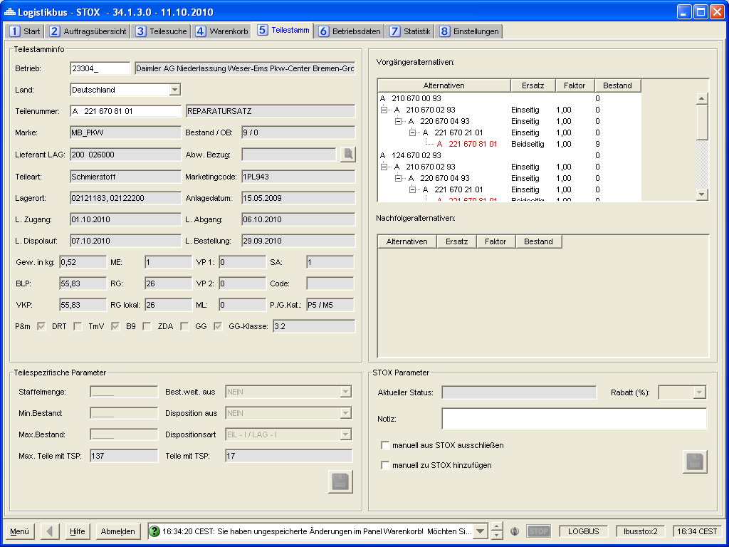

Figure 4‑14 - Part master panel

Requirement: FKT-GUI-185

The panel *Part master* must be transferred from DIMS / SICOS. The *Predecessor Alternatives* and *Successor Alternatives* sections must be reduced in height so that the DeadStock fields have sufficient space.

Requirement: FKT-GUI-186

The part-specific parameters and the deviating reference must not be editable in STOX.

Requirement: FKT-GUI-187

The new DeadStock fields may only be visible in DIMS and SICOS if the user is authorized for STOX and for the entered operation for DeadStock.

Requirement: FKT-GUI-188

The new DeadStock fields are only editable if the user is in the ***Retaileradmin*** or *Admin* role and is authorized for DeadStock for the selected site and the selected site is active for DeadStock.

Requirement: FKT-GUI-329

The DeadStock parameters are extended, resulting from 1.1.12, by a non-editable text field. This text field is only visible if the part number was manually excluded by rejection in the DeadStock order.

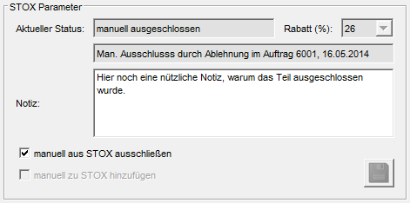

Figure 4‑15 - Additional note for manual exclusion by rejection in the order

Field description

Requirement: FKT-GUI-189

In the DeadStock Information section, the fields described below must be newly included:

| ****Field**** | ****Element**** | ****Editable**** | ****Format**** | ****Content**** |
| --- | --- | --- | --- | --- |
| Current DeadStock status | Text field |  | - | Current DeadStock status of the part:  - automatic - manual - excluded  Incl. tooltip per status. |
| DeadStock category | Combobox | X | Percent | Current discount rate of the DeadStock category. Only the discount rates stored for this site can be selected. |
| Info manual exclusion from order | Text field |  | - | Additional information of the order from which the manual exclusion of the part number results. |
| DeadStock note | Text field | X | - | Individual comment on the part number (e.g.: Version number, production year...).  Max. 100 characters. |
| Manually exclude from DeadStock | Checkbox | X | - | Manually excludes the part from DeadStock. |
| Manually add to DeadStock | Checkbox | X | - | Manually adds the part to DeadStock. |

Table 4‑36 - Panel Part Master: New DeadStock fields

Editable fields depending on the DeadStock status

Requirement: FKT-GUI-190

The *Current DeadStock Status* field is not editable. It is set automatically when the system or the user changes the status.

Requirement: FKT-GUI-191

The*Exclude* *manually from DeadStock* checkbox must only be editable if the part is not part of the DeadStock assortment or has been automatically added to the DeadStock assortment. That is, the DeadStock status must be either *empty*, *automatic* , or *excluded.*

Requirement: FKT-GUI-192

The*Add* *manually to DeadStock* checkbox may only be editable if the part has a stock > 0 and has NOT been automatically added to the DeadStock assortment. That means the current DeadStock status must be either *manual* or empty (à not set).

| DeadStock ****Cluster / Action**** | ****Empty**** | ****Automatic**** | ****Manual**** | ****Excluded**** |
| --- | --- | --- | --- | --- |
| DeadStock category |  | X | X |  |
| DeadStock note |  | X | X | X |
| Manually exclude from DeadStock | X | X |  | X |
| Manually add to DeadStock | X |  | X |  |

Table 4‑37 - Panel Part Master: Editability of the DeadStock fields

Changes to the DeadStock category

Requirement: FKT-GUI-193

The DeadStock category may be changed as desired (both up and down). If the DeadStock status <> is excluded, a DeadStock category must be stored.

Button overview

The following buttons are available in the *DeadStock Information* section of the Parts Master panel:

| ****Button**** | ****Symbol**** | | ****Function**** |
| --- | --- | --- | --- |
| Save | | Button | Saves the changes to the DeadStock fields. |

Table 4‑38 - Panel Part Master: Button overview

Requirement: FKT-GUI-194

The *Save* button may be active only if the user is authorized to write to STOX/DeadStock for the selected operation (OrteDS check).

Requirement: FKT-GUI-195

When you click the *Save* button, the system must save the changes to the DeadStock fields in the database. The changes take effect live in DeadStock (for new part searches) after a successful save.

Requirement: FKT-GUI-196

If the user has unsaved changes and changes the main tab, the application or logs off from the logistics bus, the system must ask the user if he wants to save the changes, discard them or do nothing (popup).

## Operating data

The panel *operating data* is taken over from SICOS and extended by the STOX information/ STOX functionality.

Requirement: FKT-GUI-197

The main panel *Operational Data* can be seen and read by all roles.

Requirement: FKT-GUI-198

The *operating data panel* known from SICOS must be integrated as the main panel in STOX.

Requirement: FKT-GUI-199

The subpanel *composite dispo* and *operating parameters* must be hidden in STOX.

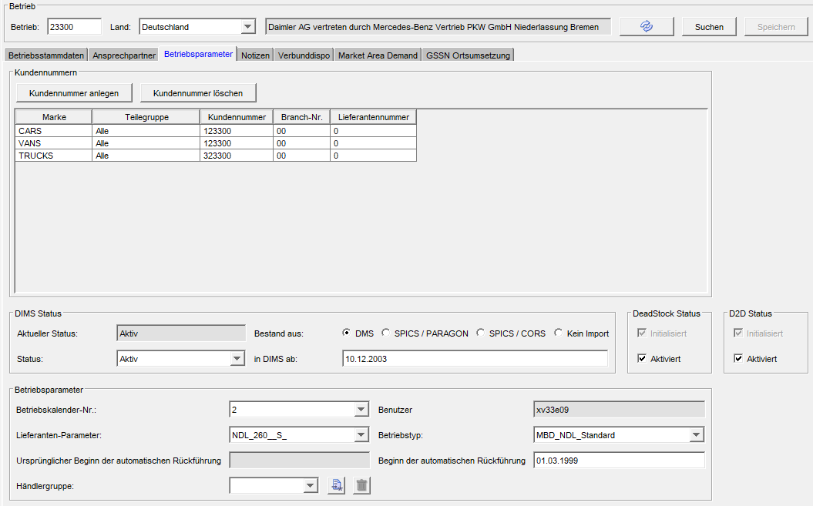

Figure 4‑16 - Operating data panel: Adjustments operating master data

Requirement: FKT-GUI-200

The *Operational Data panel* gets a new subpanel *Contact Persons* behind the subpanel *Operational Master Data*.

Requirement: FKT-GUI-201

The two elements *Contact person inventory information* and *Contact person disposition* are moved from the subpanel *Plant master data* to the new subpanel *Contact person* .

Requirement: FKT-GUI-202

A new element *Contact person STOX,* analogous to the already existing *contact* person elements, must be created.

Requirement: FKT-GUI-203

In the *Operating parameters* subpanel, the *Initialized* checkbox *(for DeadStock)* must be added. This indicates whether the operation for DeadStock is already initialized (checkbox is selected). The checkbox is not editable and is set automatically by the system. Since the Operating parameters subpanel is only visible in SICOS (see FKT-GUI-199), the checkbox is also only visible there.

Requirement: FKT-GUI-204

In the *Operating parameters* subpanel, the *Enabled* checkbox *(for DeadStock)* must be added. This indicates whether the operation is enabled for DeadStock (checkbox is selected). The checkbox is editable only by the (STOX) admin. Since the Operating parameters subpanel is only visible in SICOS (see FKT-GUI-199), the checkbox can only be changed there.

Requirement: FKT-GUI-393

In the *Operating parameters* subpanel, the *Initialized (for D2D)* checkbox must be added. This indicates whether the operation for the D2D process is already initialized (checkbox is selected). The checkbox is not editable and is set automatically by the system. Since the Operating parameters subpanel is only visible in SICOS (see FKT-GUI-199), the checkbox is also only visible there.

Requirement: FKT-GUI-394

In the Operating parameters subpanel, the *Enabled (for D2D)* checkbox must be added. This indicates whether operation is enabled (checkbox is selected) for the D2D process. The checkbox is editable only by the (STOX) admin. Since the Operating parameters subpanel is only visible in SICOS (see FKT-GUI-199), the checkbox can only be changed there.

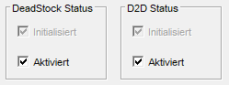

Requirement: FKT-GUI-205

The *STOX contact person* area is visible only if the user is authorized for STOX (DeadStock or D2D).

Requirement: FKT-GUI-206

The *STOX contact person* can only be changed for users in the roles *Retaileradmin* (for the sites assigned to him) or STOX *Admincontroller* (in STOX and in SICOS).

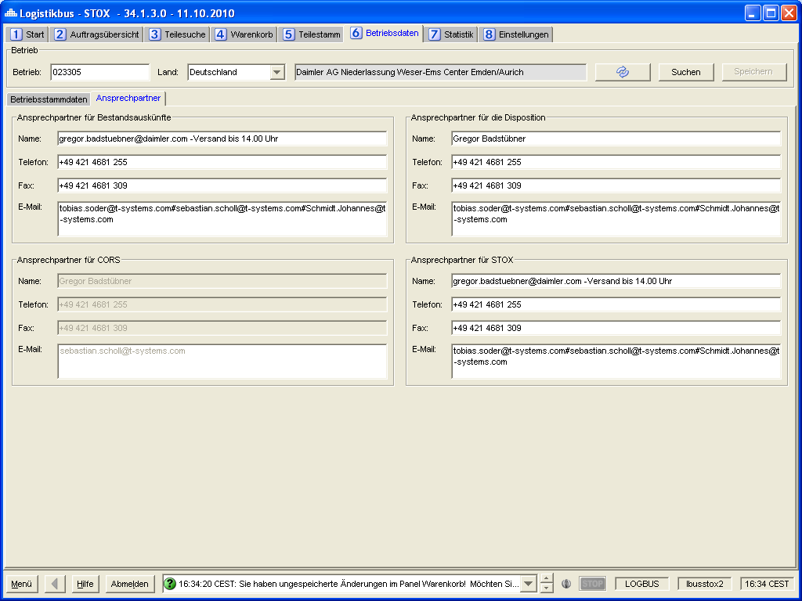

Figure 4‑17 - Operating data panel: Supplement subpanel contact person

### Search function of the operating data

The search function in the operating data is to be expanded to include a new search criterion, location, among other things.

Requirement: FKT-GUI-207

The *Country* field must be saved in the user properties when logging off from LOGBUS. When LOGBUS is started, the value saved at logout (the country) must be set automatically.

Requirement: FKT-GUI-208

The status of the *Country* checkbox must be saved in the user properties when logging off from LOGBUS. When LOGBUS is started, the status saved at logout must be restored automatically.

Requirement: FKT-GUI-209

Under the *PLZ* (postal code) filter, the new *City* filter is added. This filters the *CITY* field from the BETRIEBSDATEN\_KONZERN table.

There is **no** distinction between upper and lower case.

Requirement: FKT-GUI-210

The phone number must be entered with at least 4 digits (if shorter, the Search button remains inactive). Spaces in the stored phone number are ignored.

Requirement: FKT-GUI-211

The filter *name* is adjusted so that it is **not** case sensitive.

Requirement: FKT-GUI-212

All filter criteria except *country* must be stored with a tooltip.

Requirement: FKT-GUI-213

In the table, the *City* column (after *ZIP code*column) must be added.

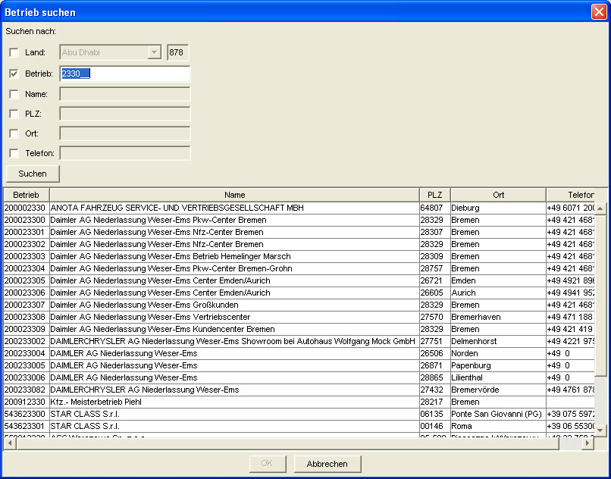

Figure 4‑18 - Operating data panel: Search extension

## Statistics

The main *Statistics* panel provides the user with an overview of their completed purchases and sales. Buy and sell data are displayed cumulatively over a user-defined time period.

The panel is divided into two sections (D2D and DeadStock). The upper area contains the data for the D2D process and the lower area contains the data for the DeadStock (formerly STOX) process. Both areas are further divided into "Sales data" and "Purchasing data" respectively.

Requirement: FKT-GUI-214

The main *Statistics* panel can be seen and read by all users (regardless of role) for their assigned locations.

Operation selection

Requirement: FKT-GUI-215

The system must provide the input fields Country (combo box) and Site (text field, max. 6 digits, numeric).

Requirement: FKT-GUI-216

If the user confirms his entry in the Farm number field with the *Enter*key, the active farm is set and the statistics are loaded.

Requirement: FKT-GUI-217

When you click the *Load* button, the system must set the active mode. The requirements defined at 4.2.1 apply here.

Requirement: FKT-GUI-218

When you click the *Load* button, the system must load the statistics after successfully setting the operation.

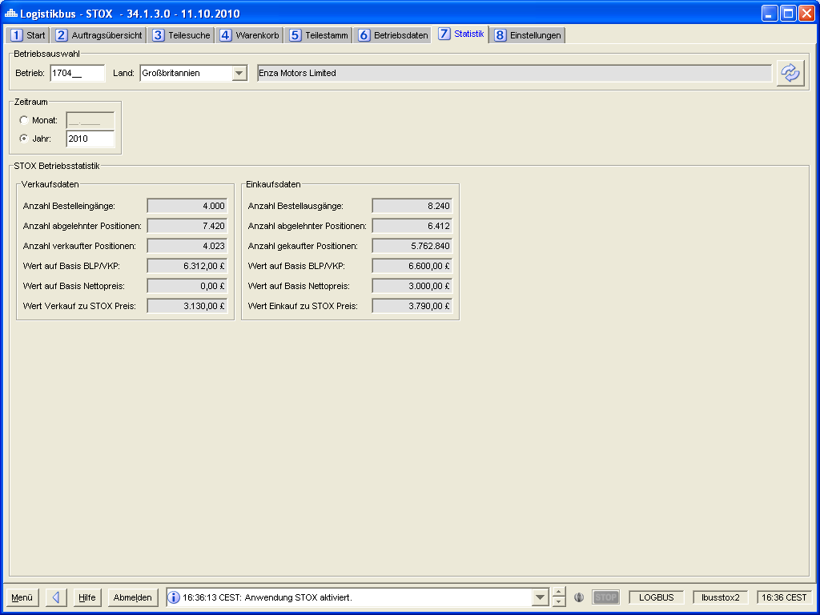

Figure 4‑19 - Panel Statistics

Overview filter criteria

Requirement: FKT-GUI-219

The system must provide the filter criteria described in the table below:

| ****Filter**** | ****Element**** | ****Format**** | ****Other/ Description**** |
| --- | --- | --- | --- |
| Period | Radiobuttongroup | - | 2 radio buttons: Year and month. |
| Year | Text field | 4 digits, numeric | 4-digit year (e.g. 2009). Only active if radio button Year is selected. |
| Month | Text field | Month 2 digits + Year 4 digits | 2-digit month and 4-digit year. Only active if radio button Month is selected. |

Table 4‑39 - Panel Statistics: Filter criteria

Requirement: FKT-GUI-220

The system must enable the *Year* text box and disable the *Month* text box when the *Year* radio button is selected.

Requirement: FKT-GUI-221

The system must enable the *Month* text box and disable the *Year* text box when the *Month* radio button is selected.

Requirement: FKT-GUI-222

Before loading the statistics, the system must check whether a plausible period (either year or month) has been entered (analogous procedure e.g. in SICOS- Controlling). If not, an error message must be issued.

Requirement: FKT-GUI-223

The system must check whether a valid (authorized) operation has been entered before loading the statistics. If not, an error message must be issued.

Requirement: FKT-GUI-224

If the user confirms his entries in the *Month* or *Year* text box with Enter, the system must load the statistics.

Button overview

The following buttons are available in the *Statistics* panel:

| ****Button**** | ****Symbol**** | | ****Function**** |
| --- | --- | --- | --- |
| Load statistics | | Button | Sets the active operation.  Loads the statistics. |

Table 4‑40 - Panel Statistics: Buttons

Field description

Requirement: FKT-GUI-225-1

The system must provide and populate the following fields in the DeadStock area (if data exists). The numbers, values always refer to the selected period. Canceled orders are not included in the statistics (à Date *in process* must always be filled à Status is not equal to *new*). The area is visible only if the user is authorized for DeadStock. If an unauthorized operation is subsequently loaded, the display is retained, only the values of the operation statistics are deleted.

| ****Field**** | ****Element**** | ****Format**** | ****Content**** |
| --- | --- | --- | --- |
| Number of orders received | Text field | Numeric. Integer | Number of orders received by the distributor. |
| Number of rejected positions (VK) | Text field | Numeric. Integer | Number of items rejected by the trader. |
| Number of positions sold | Text field | Numeric. Integer | Number of items shipped by the dealer. |
| Value based on BLP/VKP (VK) | Text field | Price format | Value of items shipped at the retailer based on BLP/ VKP. |
| Value based on net price (UK) | Text field | Price format | Value of items shipped at the retailer based on the net price. |
| Value Sale at DeadStock Price | Text field | Price format | Value of items shipped at the dealer based on DeadStock price. |
|  |  |  |  |
| Number of outgoing orders | Text field | Numeric. Integer | Number of outgoing orders from the dealer. |
| Number of rejected positions (EC) | Text field | Numeric. Integer | Number of order items from the dealer that were rejected by the selling dealer. |
| Number of positions bought | Text field | Numeric. Integer | Number of items purchased by the trader (status = received). |
| Value based on BLP/VKP (EK) | Text field | Price format | Value of the positions purchased by the trader on the basis of BLP/ VKP. |
| Value based on net price (EK) | Text field | Price format | Value of items purchased by the trader based on the net price. |
| Value purchase at DeadStock price | Text field | Price format | Value of positions bought by the trader based on DeadStock price. |

Table 4‑41 - Panel Statistics: Field Overview DeadStock

Requirement: FKT-GUI-225-2

The system must provide and populate the following fields in the D2D area (if data is available). The numbers, values always refer to the selected period. The area is visible only if the user is authorized for D2D. If an unauthorized operation is subsequently loaded, the display is retained, only the values of the operation statistics are deleted.

| ****Field**** | ****Element**** | ****Format**** | ****Content**** |
| --- | --- | --- | --- |
| Number of delivery requests | Text field | Numeric. Integer | Sales data - number of delivery requests received by the dealer (= requested items). |
| Number of rejected delivery requests | Text field | Numeric. Integer | Sales data - number of delivery requests rejected by the dealer (= rejected items). |
| Number of unprocessed delivery requests | Text field | Numeric. Integer | Sales data - number of delivery requests that were automatically terminated due to timeout or sale by another company. |
| Number of accepted delivery requests | Text field | Numeric. Integer | Sales data - number of delivery requests accepted by the dealer (= items sold). Request accepted and status of the order is "shipped" or "received". |
| Value based on BLP/VKP | Text field | Price format | Sales data - value of delivery requests accepted by the dealer (= items sold, number of delivery requests accepted). based on BLP/ VKP (= sales value) |
| Value based on net price | Text field | Price format | Sales data - value of delivery requests accepted by the distributor (= sold items, number of accepted delivery requests). based on net price (= BLP/VKP minus discount rate according to discount group) |
| Value based on D2D Price | Text field | Price format | Sales data - value of delivery requests accepted by the dealer (= items sold, number of delivery requests accepted). based on D2D price (= value incl. handling margin) |
|  |  |  |  |
| Number of orders | Text field | Numeric. Integer | Purchasing data - number of orders originated by the dealer  Each order is counted as a "1" regardless of whether delivery requests were made to one or 500 potential sellers. |
| Number of rejected orders | Text field | Numeric. Integer | Purchasing data - number of orders rejected by the dealer (all delivery requests for the order were rejected manually or timeout) |
| Number of cancelled orders | Text field | Numeric. Integer | Purchasing data - number of orders cancelled by the retailer. |
| Number of successful orders | Text field | Numeric. Integer | Purchasing data - number of orders purchased/successfully placed by the merchant. A delivery request has been accepted and status of the order is "received". |
| Value based on BLP/VKP | Text field | Price format | Purchasing data - value of orders purchased by the dealer based on BLP/ VKP (= sales value) |
| Value based on net price | Text field | Price format | Purchasing data - value of orders purchased by the distributor based on net price (= BLP/VKP minus discount rate according to discount group) |
| Value based on D2D Price | Text field | Price format | Purchasing data - value of orders purchased by the retailer based on D2D price (= value incl. handling margin) |

Table 4‑42 - Panel Statistics: Field overview D2D

Annotation: All value fields contain the price at BLP or VKP, depending on the setting of the associated trader (in case of sale this is the "own" setting, in case of purchase this is the setting of the respective seller). If the price base is changed during the selected period (from BLP to PPP or vice versa), the result will be a mixed value of BLP and PPP.

## Settings

The main *Settings* panel combines user settings, operational settings and administrative items for STOX. It is divided into subpanels:

* Operating data and user settings
* Buy and sell settings
* STOX Part Scope and RG Matrix
* Administration

Requirement: FKT-GUI-226

After complete maintenance and storage of all mandatory fields (see 1.1.1) for a location, the system must set the "STOX\_INIT" indicator in the site data table (see "Aktivierung und Freischaltung"). After that, the mandatory fields can no longer be deleted, but only changed.

Requirement: FKT-GUI-227

In the Operational data and User settings panel, a textarea is provided that contains information about the mandatory fields (text from Daimler AG).

Requirement: FKT-GUI-228

If changes are made in one of the subpanels and not saved, the user must be notified by message when switching to another main panel, another application or when closing LOGBUS. Via Yes/No/Cancel the user has to decide how to handle/proceed with the changes.

Requirement: FKT-GUI-229

The system shall provide the subpanels *Operational Data and User Settings*, *Buy and Sell Settings*, *STOX Parts Scope and RG Matrix* , and *Administration* .

Requirement: FKT-GUI-230

The system must display the subpanels depending on the user role ("L"= read access, "S"= write access, "-"= no access):

| ****Panel / Roll**** | ****Retailer**** | ****Retaileradmin**** | ****Marktsteurer**** | ****Admin Controller**** |
| --- | --- | --- | --- | --- |
| Operating data and user settings[[51]](#footnote-51) | L | S | L | S |
| Ver/buy settings[[52]](#footnote-52) | (S) | S | L | S |
| Part size and RG matrix[[53]](#footnote-53) | L | (S) | L | S |
| Administration | - | - | - | S |

Table 4‑43 - Panel settings: Subpanels in dependence of the rolls

### Operating data and user settings

In the *Operating Data and User Settings* subpanel, the user can edit his addresses and contact information relevant for STOX and specify other operating information relevant for STOX. In addition, the user can define his personal settings.

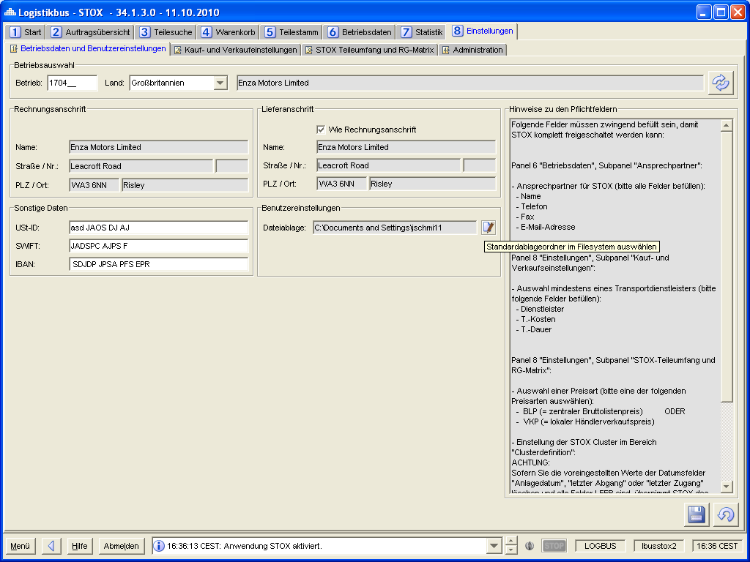

Figure 4‑20 - Panel settings: Operating data and user settings

Operation selection

Requirement: FKT-GUI-231

The system must provide the input fields Country (combo box) and Site (text field, max. 6 digits, numeric).

Requirement: FKT-GUI-232

If the user confirms his entry in the Operation number field with the *Enter*key, the active operation is set and the settings are loaded.

Requirement: FKT-GUI-233

When you click the *Load* button, the system must set the active mode. The requirements defined at 4.2.1 apply here.

Requirement: FKT-GUI-234

When clicking the *Load* button, the system must load the settings (STOX relevant operating data for active operation) after successfully setting the operation.

Field description

Requirement: FKT-GUI-235

The system must provide and populate the following fields (if data is available). In the table, delivery address is abbreviated as LA and billing address as RA.

| ****Field**** | ****Element**** | ****Editable**** | ****Format**** | ****Content**** |
| --- | --- | --- | --- | --- |
| LA Overwrite | Checkbox | J | - | If enabled, the delivery address can be overwritten. Synchronization with GSSN then no longer takes place |
| LA Name | Text field | J | - | Name of the delivery address |
| LA Street | Text field | J | - | Street of the delivery address |
| LA House number | Text field | J | - | House number of the delivery address |
| LA POSTCODE | Text field | J | - | Postal code of the delivery address (alphanumeric) |
| LA Place | Text field | J | - | Place of delivery address |
| Different billing address | Checkbox | J | - | If activated, the billing address can be edited by selecting from the list |
| RA Operating selection | Combobox | N | - | All establishments from OrteD2D and OrteDS incl. main and branch establishments (only establishment numbers without wildcards, regardless of establishment status, also GSSN establishments)  Only from the country of the currently loaded operation  In the case of taxpayers, only the main and branch establishments of the loaded establishment |
| RA Name | Text field | N |  | Invoice font name |
| RA Street | Text field | N | - | Invoice font street |
| RA House number | Text field | N | - | House number of the invoice font |
| RA POSTCODE | Text field | N | - | Zip code of the invoice font |
| RA Place | Text field | N | - | Place of invoice writing |
| VAT ID | Text field | J | - | Sales tax ID (account information) |
| SWIFT | Text field | J | - | SWIFT number (account information) |
| IBAN | Text field | J | - | IBAN number (account information) |
| PSG accounts receivable no. | Text field | J | - | PSG accounts receivable number |
| File storage | Text field | J | - | Default path where files are stored (e.g. printouts as PDF) |
| Notes | Textarea | N | - | Note text on the mandatory data |

Table 4‑44 - Panel settings: Overview fields operating data and user settings

Requirement: FKT-GUI-236

The system may allow editing of the delivery address as well as other operational data only if the logged-in user is in the *Retaileradmin* or *Admin Controller* role and is authorized to operate in STOX.

The user settings are not affected. These are user-dependent and can therefore be edited by any user.

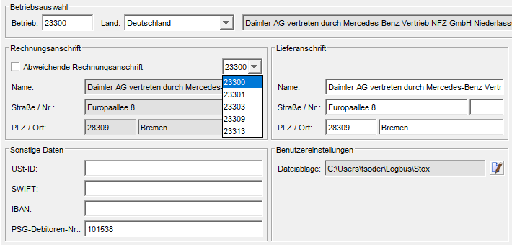

Figure 4‑21 - Panel settings: Different billing address

Requirement: FKT-GUI-237

If the user sets a checkmark in the *Different billing address* checkbox, the selection box of the establishments becomes active. In addition to the loaded site number (default), this also contains all sitesDS and sitesD2D incl. main and branch sites of the currently active user (only complete site numbers without wildcards). PlacesDS and PlacesD2D that do not match the selected country in panel 8.1 are not displayed. If you select a different company number, its address will be used as the billing address. The values in the text fields cannot be changed manually. Initially the checkbox is disabled. This means that the billing address is the same as the address of the site in the site selection.

If the checkbox is deactivated again after an activation, the address of the company is automatically set again in the company selection and taken over as the billing address for this company the next time it is saved.

By default, the delivery address corresponds to the selected site number. However, this can be changed manually, i.e. the fields are editable (but there is no separate checkbox "Like billing address" or similar for this).

Requirement: FKT-GUI-316

If a different billing address has been entered but the different company is not (or no longer) in the OrteDS or OrteD2D lists including main and branch companies of the currently active user, the company number is added to the selection box (otherwise the display would not be consistent).

When the site selected for the billing address is deleted (via template 22 "Delete site"), the address of the original site is set again as the billing address.

Requirement: FKT-GUI-418

If the checkbox for manually overwriting the delivery address is selected, the text fields of the delivery address become editable. Changes can be saved. There is then no synchronization of the GSSN data with the manual data of the delivery address. If the checkbox is deselected again, the delivery address again corresponds to the site data of the site.

Requirement: FKT-GUI-238

At the first startup, the following default values are set in the *Operating data and User settings* panel:

| ****Field**** | ****Default value**** |
| --- | --- |
| Different billing address | Not selected/selected |
| Billing address | Address of the establishment from GSSN data. |
| Delivery address | Address of the establishment from GSSN data. |
| File storage | Default storage directory of the user |
| Other data | Not filled. |

Table 4‑45 - Panel settings: Default values Operating data and user settings

Requirement: FKT-GUI-239

When you click the *Save* button, the system must save the changes made by the user to the database.

Requirement: FKT-GUI-240

When you click the *Discard Entries* button, the system must - after confirmation via a popup - discard the changes made by the user and set the previously loaded settings.

Requirement: FKT-GUI-241

When clicking the *Set Path* button, the system must open a Java FileChooser dialog. There the user can select a folder in the file system. If he confirms this in the FileChooser dialog with *YES*, the marked folder is defined as *default storage* . If he cancels the setting of the folder in the FileChooser dialog with *Cancel* , the input is discarded.

Button overview

The following buttons are available in the *Operating data and User settings* subpanel:

| ****Button**** | ****Symbol**** | | ****Function**** |
| --- | --- | --- | --- |
| Load settings | | Button | Sets the active operation.  Loads the settings for the selected operation/user. |
| Discard inputs | | Button | Discards the user input. |
| Set path | | Button | Opens a FileChooser dialog where the user can select the desired path. |
| Save | Button | | Saves the user input. |

Table 4‑46 - Order overview panel: Buttons of the Buy table

### Buy and sell settings

In the *Buy and Sell Settings* subpanel, the user can customize settings for buying and selling parts. This includes settings for the shipping methods offered as well as automatic order comments.

In addition, the user can define 2 lists (preferred suppliers and problematic suppliers), through which he can refine his search results.

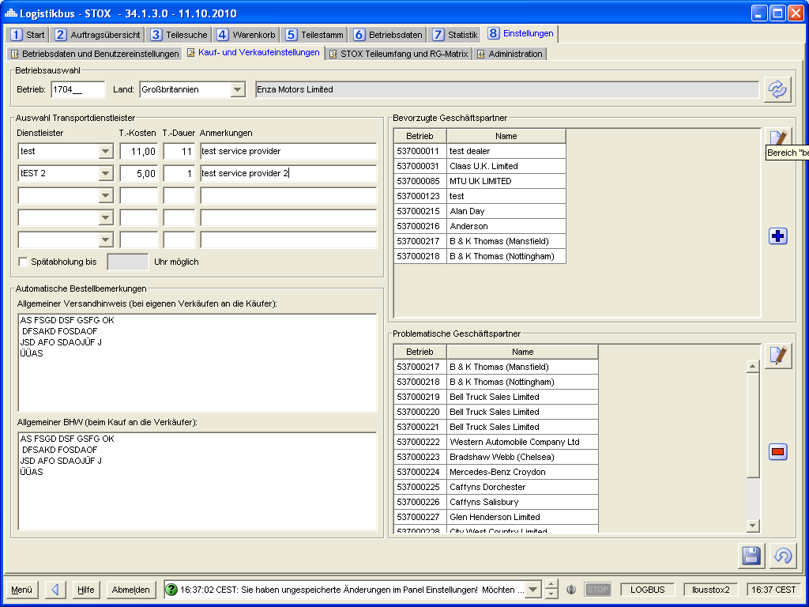

Figure 4‑22 - Panel settings: Buy and sell settings

Operation selection

Requirement: FKT-GUI-242

The system must provide the input fields Country (combo box) and Site (text field, max. 6 digits, numeric).

Requirement: FKT-GUI-243

If the user confirms his entry in the Operation number field with the *Enter*key, the active operation is set and the settings are loaded.

Requirement: FKT-GUI-244

When you click the *Load* button, the system must set the active mode. The requirements defined at 4.2.1 apply here.

Requirement: FKT-GUI-245

When you click on the *Load* button, the system must load the sales/purchase settings and the operation lists after the operation has been successfully set.

Field description

Requirement: FKT-GUI-246

The system must provide and populate the following fields (if data is available). In the table, shipping type is abbreviated as VA. The defined shipping methods (transport service provider) apply to both processes (DeadStock and D2D).

| ****Field**** | ****Element**** | ****Editable**** | ****Format**** | ****Content**** |
| --- | --- | --- | --- | --- |
| 5x VA Name | Combobox | J | - | Name of the postal service provider (the shipping method)  Selection from the 5 service providers of the market as well as input of a free text possible. |
| 5x VA costs | Text field | J | Price format (currency identifier as tooltip) | Approximate cost of shipping (of a standard package). Mandatory field, if VA Name filled. |
| 5x VA expected duration | Text field | J | Integer | Estimated time of shipment. Mandatory field, if VA Name filled. |
| 5x VA Notes | Text field | J | Max. 100 characters | Comment on the shipping method. |
| VA late pickup possible | Checkbox | J | - | Selected: Late pickup possible until xx o'clock. |
| VA Late collection until | Text field | J | Max. 8 characters | Time until which collection is possible. Mandatory field if late pickup is selected. |
| Ordering information | Textarea | J | Max. 2000 characters | Remark to be attached to outgoing orders (user as buyer). |
| Shipping note | Textarea | J | Max. 1000 characters | Remark to be attached to incoming orders (user as seller). |
| Preferred suppliers | Table | N | Max. 200 plants | List of preferred suppliers (company number and name). Editable via operating list panel. Sorted in ascending order by company number. |
| Problematic suppliers | Table | N | Max. 200 plants | List of problematic suppliers (company number and name). Editable via operating list panel. Sorted in ascending order by company number. |

Table 4‑47 - Panel settings: Overview fields operating data and user settings

Requirement: FKT-GUI-247

The system may allow processing of transportation service providers as well as automatic order notices only if the logged-in user is in the role of *Retaileradmin* or *Admin Controller* and is authorized to operate in STOX. At least one valid, standard transportation service provider (not "pickup") (including cost and duration) must be deposited.

The lists (preferred and problematic suppliers) may also be edited by users in the *Retailer* role. These lists are valid for all STOX users of the selected company.

The display order of the transport service providers in DeadStock (selection as buyer in shopping cart and order details) or D2D (selection as seller in order details, see chapter 4.4.2) corresponds to the order of the values entered in dialog 8.2 (Buy and sell settings) . The initial sequence is fixed by the department. For the D2D process (order details), ONLY the central transport service providers of the store (except "pickup") specified by the department are available for selection by the seller (freely entered transport service providers are not available for selection).

Requirement: FKT-GUI-248

If the user sets the *Late pickup possible*filter, the system must activate the *Late pickup until* text field. If the user removes the checkmark, the text field must be deactivated.

Requirement: FKT-GUI-249

If the *Late pickup possible* filter is set, the system must check if the user has set the *Late pickup until* empty text field before saving. If so, the user receives an error message.

Requirement: FKT-GUI-250

When you click the *Save* button, the system must save the changes made by the user to the database. If the entries are insufficient/incorrect (e.g. more than 200 plants or missing VA costs/ VA duration), saving is aborted and a meaningful error message is displayed.

Requirement: FKT-GUI-251

When you click the *Discard Entries* button, the system must - after confirmation via a popup - discard the changes made by the user and set the previously loaded settings.

Requirement: FKT-GUI-252

When you click on the *Open dialog* button, the system must open the site list dialog. In the operating lists dialog, the elements for selecting, creating, deleting and copying a list are hidden (since they are not needed here). The list of preferred or problematic suppliers corresponds to the assigned plants (right table) in the dialog.   
The user can modify the respective list (search for establishments (only for the country of his currently deposited establishment), add or remove). If the user confirms the sites by clicking the *OK*button, the list of preferred or problematic suppliers will be added or removed. If he cancels with *Cancel* , the input (newly added or deleted farms) is discarded.

When saving, the lists of preferred or problematic business partners are transferred to all other locations in the location network (i.e. all main and branch locations initialized in DeadStock or D2D).

Requirement: FKT-GUI-253

At the first startup, the following default values are set in the *Buy and Sell Settings* panel:

| ****Field**** | ****Element**** |
| --- | --- |
| Late pickup | Not selected |
| Postal service provider | No service provider selected. |
| Order remarks | Not filled. |
| Other fields | Empty |

Table 4‑48 - Panel settings: Default values purchase and sale settings

Button overview

The following buttons are available in the *Verification/Purchase Settings* subpanel:

| ****Button**** | ****Symbol**** | ****Function**** |
| --- | --- | --- |
| Load settings | Button | Sets the active operation.  Loads the settings for the selected operation/user. |
| Discard inputs | Button | Discards the user input. |
| Open dialog | Button | Opens the *operation list panel* for editing the operation lists. |
| Save | Button | Saves the user input or saves supplier lists. |

Table 4‑49 - Panel settings: Buttons of the Verification/Purchase Settingssubpanel

### Criteria Part Scope and RG Matrix

In the *Part Scope and Discount Group Matrix* subpanel the user can make settings for the calculation of his DeadStock part scope as well as view the *discount* group matrix currently valid for STOX (DeadStock and D2D).

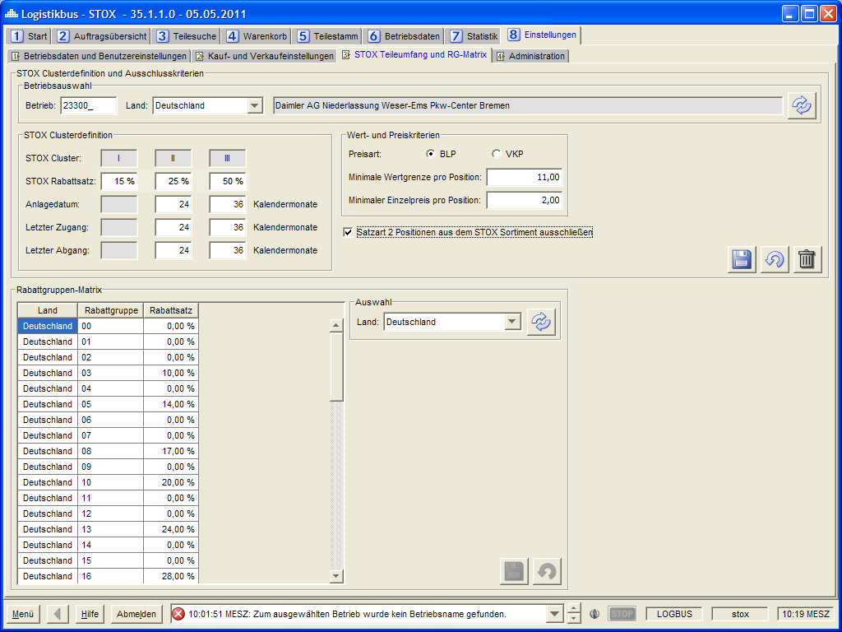

Figure 4‑23 - Panel settings: Criteria part scope

The "DeadStock Cluster Definition" area and the two fields "Minimum Value Limit per Item" or "Minimum Unit Price per Item" have no influence on the D2D process. If a user has no "DeadStock rights" (i.e. his *OrteDS* are empty), the fields are hidden.

#### Criteria part scope

Operation selection

Requirement: FKT-GUI-254

The system must provide the input fields Country (combo box) and Site (text field, max. 6 digits, numeric).

Requirement: FKT-GUI-255

If the user confirms his entry in the Operation number field with the *Enter*key, the active operation is set and the settings are loaded.

Requirement: FKT-GUI-256

When you click the *Load* button, the system must set the active mode. The requirements defined at 4.2.1 apply here.

Requirement: FKT-GUI-257

When you click the *Load* button, the system must load the settings (for active operation) after the operation has been successfully set.

Field description

Requirement: FKT-GUI-258

The system must provide and populate the following fields (if data is available):

| ****Field**** | ****Element**** | ****Editable**** | ****Format**** | ****Content**** |
| --- | --- | --- | --- | --- |
| 3x DeadStock category | Text field |  | - | DeadStock categories I - III. |
| 3x DeadStock discount rate | Text field | J | 2-digit integer between 0 and 99 | Discount rate in percent to DeadStock category. Default value of the market as tooltip. |
| 3x Investment date | Text field | J | 2-digit integer | Definition of the maximum investment date (in months in the past). 2x editable (cluster II and III)  Default value of the market as tooltip. |
| 3x last access | Text field | J | 2-digit integer | Definition of the maximum date of the last receipt (in months in the past). 2x editable (cluster II and III)  Default value of the market as tooltip. |
| 3x last exit | Text field | J | 2-digit integer | Definition of the maximum date of the last departure (in months in the past). 2x editable (cluster II and III)  Default value of the market as tooltip. |
| Price type BLP | Radio button | J | - | Radiobuttongroup Price type: Selection BLP. |
| Price type VKP | Radio button | J | - | Radiobuttongroup Price type: Selection VKP. |
| Min. value limit per pos. | Text field | J | Price format without currency identifier | Minimum value limit per position (lower limit). |
| Min. unit price per pos. | Text field | J | Price format without currency identifier | Minimum unit price per position (lower limit). |
| Exclude SA2 | Checkbox | J | - | Exclude record type 2 from STOX part scope. |

Table 4‑50 - Panel settings: Fields Overview Subpanel Part Scope

Requirement: FKT-GUI-259

The system must disable the BLP price type when the user selects the VKP price type.

The system must disable the VKP price type when the user selects the BLP price type.

The selected price type applies to both the D2D and DeadStock processes.

Requirement: FKT-GUI-260

The monthly values*(investment date, last retirement* and *last acquisition*) may only be editable for DeadStock Clusters II and III.

Requirement: FKT-GUI-310

When filling the input fields of the monthly values, the system must check whether the values in cluster III are larger than those in cluster II. If not, an error message will be displayed.

Requirement: FKT-GUI-261

The system must check the entered monthly values*(creation date, last retirement* and *last acquisition*) for the associated bandwidths[[54]](#footnote-54) before saving. If a monthly value exceeds or falls below the associated bandwidth, an error message is displayed to the user with the associated field and the lower and upper limit values. Saving is canceled.

Requirement: FKT-GUI-262

Before saving, the system must check that the user enters either none or both monthly values of a criterion*(creation date, last retirement* and *last acquisition*). If the user has filled in only one monthly value for a criterion, a meaningful error message is displayed to the user. Saving is canceled.

Examples:

The user enters for the criterion

- *last exit for* both cluster II and cluster III no valueà OK

- *Creation date* enter a value for cluster III and leave cluster II empty à Not OK

- *Creation date* a value for cluster II and cluster III a à OK

The system must check that the user has entered a discount rate for all clusters before saving (default values are those set centrally). If the user has not stored a discount rate for a cluster, a meaningful error message is displayed. Saving is canceled.

Requirement: FKT-GUI-263

The system must check the entered minimum values*(min. value limit* and *min. price per position*) for the market-specific maximum value[[55]](#footnote-55) before saving. If a minimum value exceeds the associated maximum value, an error message is displayed to the user with the associated field as well as the maximum possible input value. Saving is canceled.

Requirement: FKT-GUI-264

The system must check if a price type is selected before saving. If no price type is selected, an error message is displayed to the user and saving is aborted.

Requirement: FKT-GUI-265

When the user clicks on the *Discard entries* button, the system must - after confirmation via a popup - discard the user's entries and set the previously loaded settings.

Requirement: FKT-GUI-266

When you click the *Save* button, the system must perform the checks described above and, if successful, save the user input to the database.

Changes to the price type take effect live in STOX (for new part searches) after successful save.

When the settings are saved for the first time (if not changed), the default values for DeadStock discount rate, Investment date, Date l. Addition and Date l. Retirement are saved. If the default values change after saving, they are not automatically applied[[56]](#footnote-56).

When the settings are successfully saved, the system checks whether any of the following parameters have changed (i.e. the value has been changed or deleted):

* Number of months for date of installation, last retirement or last acquisition
* Minimum value limit or unit price per item
* Price type (only if a minimum value limit or unit price per position is set)
* Exclusion record type 2 positions

If one of these parameters is changed, an identifier is set to perform a deletion of the existing assortment beforehand during the next assortment calculation (see section 1.1.2).

Requirement: FKT-GUI-267

When you click the *Reset* button, the system will have to delete the merchant's settings and reset them to the default settings of the store. The reset must be confirmed by the user in a popup. The individual fields are reset as follows:

| ****Field**** | ****Element**** |
| --- | --- |
| DeadStock discount rate | Default value of the market. |
| Investment date | Default value of the market. |
| Last access | Default value of the market. |
| Last departure | Default value of the market. |
| Price type BLP | Unchanged (there is no default value). |
| Price type VKP | Unchanged (there is no default value). |
| Min. value limit per pos. | Empty. |
| Min. unit price per pos. | Empty. |
| Exclude SA2 | Farms with LKZ = 200: selected.  All other operations: not selected |

Table 4‑51 - Panel settings: Default values part size

Button overview

The following buttons are available in the *Cluster Definition* area:

| ****Button**** | ****Symbol**** | ****Function**** |
| --- | --- | --- |
| Load settings | Button | Sets the active operation.  Loads the settings for the selected operation. |
| Discard inputs | Button | Discards the user input. |
| Save | Button | Saves the user input. |
| Reset. | Button | Sets the parameters to the default settings of the market. |

Table 4‑52 - Panel settings: Buttons of the subpanel Part Scope 1

#### Discount group matrix

Requirement: FKT-GUI-268

The user must be able to select a country in a combo box*(RG country*).

Requirement: FKT-GUI-269

When you click the *Load discount groups* button, the system should load the discount group matrix for the selected country.

Requirement: FKT-GUI-270

The system must display one discount group per row in the *RG Matrix* table with the following columns (depending on whether the "FUTURE active as of" date from the country-specific parameters for the country has already been reached, different columns are displayed for maintaining the discount rate.

| ****Column**** | ****Format**** | ****Display**** |
| --- | --- | --- |
| Country | Text | Country in which the discount group is valid (Corresponds to the country from the combo box *RG country*). |
| Discount group | 5 digits | Discount Group Number. |
|  |  |  |
| Only for NON-FUTURE markets (countries) | | |
| Discount rate (LAG) | Percentage. 2 digits with decimal places | Discount rate of the associated discount group (editable for admin). |
| Discount rate (VOR) |
|  |  |  |
| Only for FUTURE markets (countries) | | |
| Discount rate CARS (LAG) | Percentage. 2 digits with decimal places | Discount rate of the associated discount group (editable for admin). |
| Discount rate VANS (LAG) |
| Discount rate TRUCKS (LAG) |
| Discount rate CARS (VOR) |
| Discount rate VANS (VOR) |
| Discount rate TRUCKS (VOR) |

Table 4‑53 - Panel settings: Columns of the RG matrix table

Requirement: FKT-GUI-271

The Discount Rate column must be editable for users in the *Admin Controller* role. Numerical values between 0.00 and 99.99 can be entered.

Requirement: FKT-GUI-272

When you click the *Save* button, the system should save the changes to the discount group matrix in the database. The change of the discount group will only affect future part searches or orders!

Requirement: FKT-GUI-273

The *Save* and *Discard* buttons may only be visible to the Admin Controller role.

Requirement: FKT-GUI-274

When you click the *Discard entries* button, the system must discard the user's entries - after confirming them via a popup - and set the previously loaded settings.

Requirement: FKT-GUI-275

For the *Retailer*, *Retaileradmin* and *Market Controller* roles, the combo box is restricted to the countries for which the user is authorized via the *OrteDS* and *OrteD2D* parameters.

The following buttons are available in the *RG Matrix* area:

| ****Button**** | ****Symbol**** | ****Function**** |
| --- | --- | --- |
| Load discount groups | Button | Loads the discount group matrix for the selected country. |
| Save discount groups. | Button | Saves the changes in the discount group matrix. |
| Discard inputs | Button | Resets the user entries in the discount group table. |

Table 4‑54 - Panel settings: Buttons of the subpanel Part Scope 2

#### Location-based handling margin

Requirement: FKT-GUI-395

For the *Retaileradmin* role, a location-based handling margin becomes maintainable for the D2D process. This is valid for all discount groups and divisions. In subpanel 8.3 (STOX part scope and RG matrix), the area "D2D handling margin" is included for this purpose. If a user has no "D2D rights" (i.e. his *locationsD2D* are empty), the area is hidden.

All fields and labels in this area are stored with tooltips and can be maintained via PGuard.

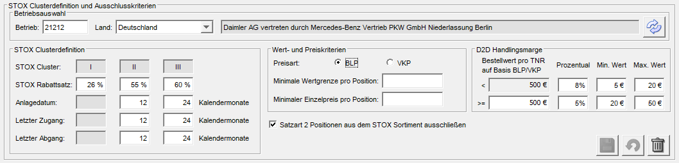

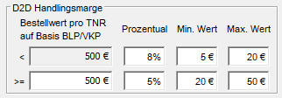

Requirement: FKT-GUI-396

All editable fields are integer (>= zero) and filled with a value of zero by default. The field "Order value per TNR < x" is not editable. The displayed value is automatically taken from the "Order value per TNR >= x" field (for each change).

If the "Min. value" entry is not zero, it must always be less than the "Max. value". Should the Min. value >= the Max. Value or the Max. Value <= the Min. value, the storage is aborted and a corresponding error message is displayed.

The *Retaileradmin* has the possibility to enter a value for a percentage as well as minimum or maximum values for a handling margin up to or above a threshold value of x €[[57]](#footnote-57) .

### Administration

The *Administration* subpanel is designed for admin control. These can change general parameters here and define bandwidths for operating settings. All settings are market-specific. This means that the user must first select a market (country) and can then adjust its settings.

Requirement: FKT-GUI-276

The *Administration* tab is displayed only for users in the *Admin* role.

Requirement: FKT-GUI-277

The system must provide the user with a possibility to select the market and load the settings for this market ( *Market* combo box and *Load*button).

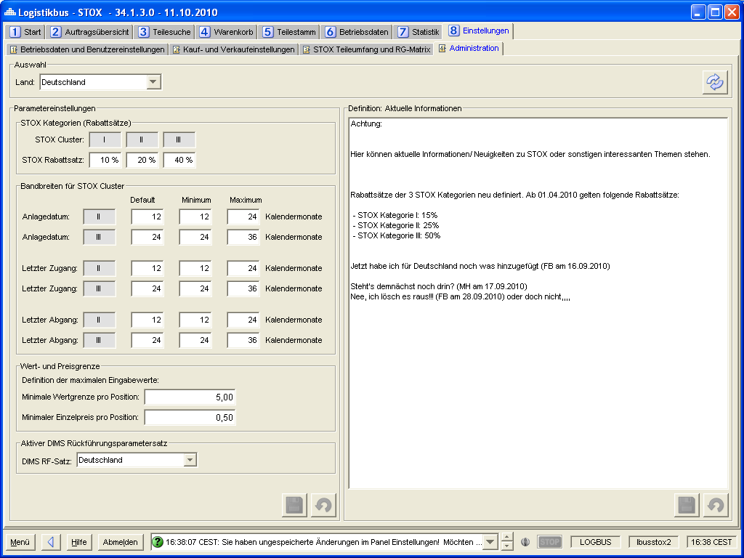

Figure 4‑24 - Panel settings: Administration

Field description

Requirement: FKT-GUI-278

The system must provide and populate the following fields:

| ****Field**** | ****Element**** | ****Editable**** | ****Format**** | ****Content**** |
| --- | --- | --- | --- | --- |
| Market | Combobox | J | Country as text | Selection of the market for which the parameters will be loaded. |
| 3x DeadStock category | Text field |  | - | DeadStock categories I - III. |
| 3x DeadStock discount rate | Text field | J | 2-digit number between 0 and 99 | Default value for the DeadStock discount rate to the DeadStock category in percent. |
| 2x Creation date Default value | Text field | J | 2-digit number between 0 and 99 | Default value for the *investment date* criterion (in months). |
| 2x investment date  Minimum | Text field | J | 2-digit number between 0 and 99 | Minimum value (lower limit) for the criterion *investment date* (in months). |
| 2x investment date  Maximum | Text field | J | 2-digit number between 0 and 99 | Maximum value (upper limit) for the criterion *investment date* (in months). |
| 2x last access Default value | Text field | J | 2-digit number between 0 and 99 | Default value for the criterion *last receipt* (in months). |
| 2x last access  Minimum | Text field | J | 2-digit number between 0 and 99 | Minimum value (lower limit) for the criterion *last receipt* (in months). |
| 2x last access  Maximum | Text field | J | 2-digit number between 0 and 99 | Maximum value (upper limit) for the criterion *last receipt* (in months). |
| 2x last outgoing Default value | Text field | J | 2-digit number between 0 and 99 | Default value for the criterion *last departure* (in months). |
| 2x last exit  Minimum | Text field | J | 2-digit number between 0 and 99 | Minimum value (lower limit) for the criterion *last departure* (in months). |
| 2x last exit  Maximum | Text field | J | 2-digit number between 0 and 99 | Maximum value (upper limit) for the criterion *last departure* (in months). |
| Min. value limit per pos. | Text field | J | Price format without currency identifier | Maximum input value by traders for the criterion *Min. value limit per position*. |
| Min. price per pos. | Text field | J | Price format without currency identifier | Maximum input value by traders for the criterion *Min. unit price per position*. |
| RF parameter set | Multi-Select combo box | J | - | Traceability record or records of the selected country to be used for the exclusion of traceable parts when determining the DeadStock assortment (RF type DIMS only).  If at least one feedback record is true, the part is excluded from the DeadStock range. |
| Latest STOX information | Textarea | J | - | Current STOX information displayed on the home page. |

Table 4‑55 - Panel settings: Field overview Subpanel Administration

Requirement: FKT-GUI-279

When you click the *Load* button, the system should load the parameters and the info text for the selected store.

Requirement: FKT-GUI-311

The entered default value must be between the minimum and maximum value. In case of incorrect entry, an error message is displayed when leaving the input field.

Requirement: FKT-GUI-312

The entered minimum value must be smaller than the default value and the maximum value. In case of incorrect entry, an error message is displayed when leaving the input field.

Requirement: FKT-GUI-313

The entered maximum value must be greater than the default value and the minimum value. In case of incorrect entry, an error message is displayed when leaving the input field.

Requirement: FKT-GUI-280

When you click the *Discard Entries* button, the system must - after confirming via a popup - discard the user entries and set the previously loaded settings.

Range *parameters*: Discards the changes made to the parameters.

Area *current STOX information*: Discards the changes to the info text.

Requirement: FKT-GUI-281

When you click the *Save* button, the system must save the parameters or the info text to the database.

Button overview

The following buttons are available in the *Administration* section:

| ****Button**** | ****Symbol**** | ****Function**** |
| --- | --- | --- |
| Loading. | Button | Loads the parameters and info text for the selected market. |
| Discard inputs | Button | Range *parameters*: Discards the changes made to the parameters.  Area *current STOX information*: Discards the changes to the info text. |
| Save | Button | Range *parameters*: Saves the parameters.  Area *current STOX information*: Saves the info text. |

Table 4‑56 - Panel settings: Buttons of the Administration subpanel

### Maintenance of other settings

The following additional settings and data are not maintained via the GUI. Maintenance takes place directly in the database via T-Systems

* Postal service providers (per market)
* Currency connoisseur

## Adjustments and extensions in SICOS

In SICOS some minor adjustments are necessary due to the introduction of STOX/DeadStock. The largest part in the assortment analysis and operating data.

### Adjustments assortment analysis

The user should get an easy way to see his DeadStock assortment via the assortment analysis.

Therefore, in the individual overview of the assortment analysis, the columns DeadStock status, DeadStock category (discount rate) and DeadStock note are added.

Requirement: FKT-GUI-282

The system must include the following non-editable columns in the individual overview:

New columns

| ****Column**** | ****Format**** | ****Display**** |
| --- | --- | --- |
| DeadStock category | Percentage value | DeadStock discount (e.g. 15%, 25% or 50%) of the part at the time of execution (from the local settings of the operation) |
| DeadStock status | - | DeadStock status of the part at the time of execution |
| DeadStock note | - | DeadStock note of the part at the time of execution |

Table 4‑57 - Assortment analysis: New columns

Requirement: FKT-GUI-283

The system will populate the new *DeadStock Status*, *DeadStock Category* (discount rate) and *DeadStock Note* fields with - the current at the time of execution - values when running an assortment analysis.

Requirement: FKT-GUI-284

The system may only display the DeadStock Status, DeadStock Category (Discount Rate) and DeadStock Note columns if the logged on user is authorized for STOX/DeadStock (OrteDS check) and the selected site number is initialized for DeadStock.

Requirement: FKT-GUI-285

When you double-click on a cell (all columns except for the *default quantity*), the system jumps to the *SICOS parts master* panel with the *part number of* the selected row and the *site number* and loads the data.

Requirement: FKT-GUI-286

The new columns *DeadStock status*, *DeadStock category* (discount rate) and *DeadStock note* are appended in enumerated order to the end of the table (à as last 3 columns).

The already existing column *movement* is moved to the fourth last position.

### Adjustments SICOS operating data

The SICOS operating data panel is adapted and extended as described in the chapter 4.8 .

### Adjustments SICOS part master

The part master panel known from SICOS is extended as described in the chapter 4.7 . The DeadStock parameters are only visible if the user/facility is authorized for STOX (DeadStock).

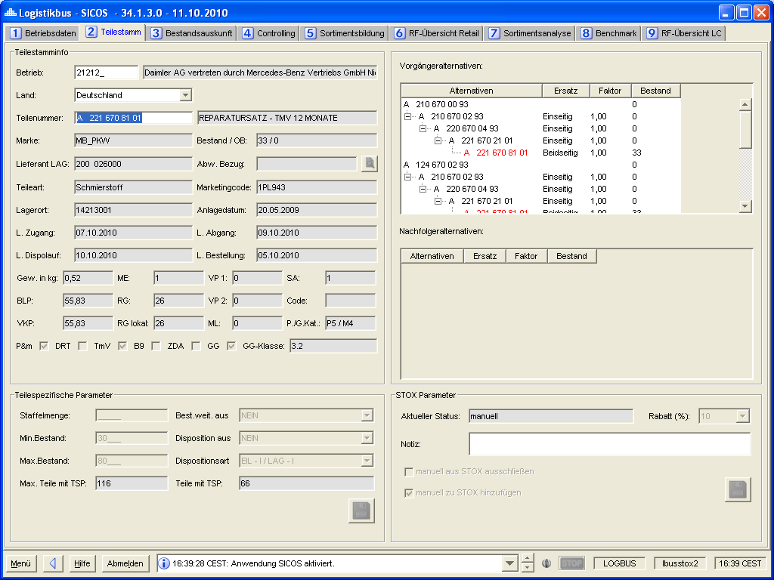

Figure 4‑25 - DeadStock extension in SICOS part master panel

Requirement: FKT-GUI-287

The SICOS part master panel is extended by the STOX (DeadStock) functionality as described in the chapter 4.7 .

Requirement: FKT-GUI-288

The system must comply with the appropriate authorization checks (4.7). Editing of STOX (DeadStock) information is not possible in SICOS.

Requirement: FKT-GUI-289

The other functionality of the SICOS part master panel remains unaffected by the extension.

### Adjustments operating lists

The search function in the farm lists is to be adapted to the new search function of the farm data panel. This results in the following requirements.

Requirement: FKT-GUI-290

The *Country* fields must be saved in the user properties when logging off from LOGBUS. When LOGBUS is started, the values (countries) saved at logout must be set automatically.

Requirement: FKT-GUI-291

Under the *Operation* filter, the new *Operation name* filter is added. This filters the field NAME from the table BETRIEBSDATEN\_KONZERN (the field must contain the search term).

Requirement: FKT-GUI-292

Under the *ZIP* (postal code) filter, the new *Phone number* filter is added. This filters the field TELEPHONE from the table BETRIEBSDATEN\_KONZERN. The telephone number must be entered with at least 4 digits, analogous to the search in the operating data panel. Spaces are also ignored here. If the entered phone number is smaller than 4 digits, the "Search" button remains inactive.

Requirement: FKT-GUI-293

The *Company name* and Place name filters are adjusted so that they are **not** case sensitive.

Requirement: FKT-GUI-294

All filter criteria (text fields/combobox) must be stored with a tooltip.

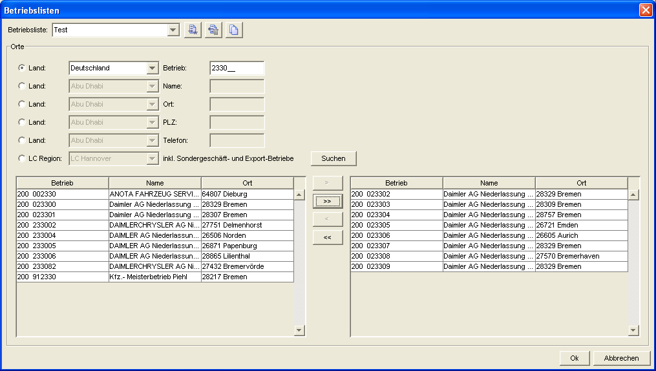

Figure 4‑26 - Panel operation lists: Extensions

## Adaptations and extensions in DIMS

Some minor adjustments are necessary in DIMS due to the introduction of STOX.

### Adjustments DIMS part master

The parts master panel known from DIMS is extended by the STOX (DeadStock) functionality as described in the chapter 4.7 . The STOX (DeadStock) parameters are only visible if the user/operation is authorized for STOX (DeadStock).

Requirement: FKT-GUI-295

The DIMS part master panel is extended by the STOX (DeadStock) functionality as described in the chapter 4.7 .

Requirement: FKT-GUI-296

The system must comply with the appropriate authorization checks (4.7). It isnot possible toedit STOX (DeadStock) information in DIMS.

Requirement: FKT-GUI-297

The other functionality of the DIMS part master panel remains unaffected by the extension.

## License text

The license text is displayed to the user when logging on to the logistics bus (selecting the STOX application). The user must accept the license text 1x to use STOX. If the license text changes, the user must accept it again at the next login.

The respective (market-specific) license text is determined based on the country code of the first entry in the user's *OrteDS* parameter (the entry can also be a 200\* for a market controller, for example). If the *placesDS* are empty or the first entry is only "\*", the license text is displayed based on the current language of the user. The "first entry" means the first value **after the** **alphanumeric sorting of** **the** list (e.g. "\*,200\*,200023300,200123\*,543123456\*"), i.e. the order of entry in the LBPS does not matter.

Requirement: FKT-GUI-298

The system must display the current STOX license text to the user when logging in (as known from the CORS application). There the user has the possibility to accept the license text, cancel and save the license text as a PDF file.

If the user clicks Accept, he can work with STOX[[58]](#footnote-58), if he clicks Cancel, STOX will not be displayed and the user will see the license text again at the next startup (or after application change).

The user, if authorized for DeadStock and D2D, must accept both license texts in order to work with STOX.

Requirement: FKT-GUI-299

If the user has accepted the current license text, it will not be displayed at the next startup.

Requirement: FKT-GUI-300

If the license text is changed, all users must confirm the license text again[[59]](#footnote-59). The same procedure as described above applies.

Requirement: FKT-GUI-397

The same procedure is applied as soon as a user is authorized for the D2D process. The locationsD2D are checked instead of the locationsDS.

## Notifications

It applies to all notifications: A maximum of 5 notifications are displayed staggered on top of each other. All others will be displayed one after the other once the last of the 5 visible ones has been closed.

With release 60, the time interval for checking notifications has been outsourced to the database as a parameter (default value = 10 minutes, table app\_properties, parameter stox.gui.server.StoxOrderServer.ORDER\_CHECK\_SLEEPTIME\_MILLIS). In addition, notifications can be turned on or off globally (default value = true, table app\_properties, parameter stox.gui.server.StoxOrderServer.ORDER\_CHECK\_ACTIVE).

### New order in DeadStock/D2D

If the user is logged in to the logbus, the user should be made aware of STOX orders received in a timely manner (D2D and DeadStock).

Requirement: FKT-GUI-301

If the user is logged on to LOGBUS, STOX checks every 10 minutes:

* DeadStock: If there are orders in the status *new* for its authorized sites (parameter OrteDS).
* D2D: Are there delivery requests in status *started for* its authorized sites (parameter sitesD2D).

Requirement: FKT-GUI-302

If an order/delivery request is found in the status *new/started* , a desktop notification (as known from Outlook, for example) must be displayed to the user at the bottom right. The user must actively close the desktop notification (with a left click on the red cross in the notification).[[60]](#footnote-60)

The notifications (D2D and DeadStock) have the same color (yellow, 240/190/125). One popup is displayed per authorized operation and type (D2D or DeadStock). Order numbers are sorted by date of order receipt, newest first. A maximum of 5 order numbers are displayed.

Requirement: FKT-GUI-303

The notification contains the following information:

**LOGBUS STOX**There is at least one new order in DeadStock/D2D.

Operating no.: xxx xxxxxx

Order no.: xxxx

Link to the order overview

Requirement: FKT-GUI-398

By clicking on the link in the "Show order" popup, the Logistics bus application becomes active, the STOX application becomes active and the tab 2 Order overview, sub-tab 1 Sell are selected.

All filters are deleted, the company incl. country is taken from the popup, all status checkboxes are selected and the data is loaded. Actions of the exited logistics bus application or tabs are executed accordingly (save-request etc.).

The popup closes after clicking on the link.

Requirement: FKT-GUI-304

The notifications are displayed only for users in the *Retailer* and *Retaileradmin* roles. Notifications are not displayed for a user in the *Retaileradmin* role if the "Notifications disabled" flag is set in LBPS.

### Orders with status "In process" in the archive

If the user is logged in to the logbus and there are orders in the archive whose status is still set to "in process", the seller should be notified of this in a timely manner (i.e. the notification appears only if the logged-in user is also the seller of the order). In the D2D environment, this message should not normally occur (the shafts are closed within a parameterizable time).

Requirement: FKT-GUI-317

If the user is logged on to LOGBUS, STOX checks the LOGBUS every 3rd time the user logs on. Checking interval (i.e. every 30 minutes with the current interval of 10 minutes) whether there is an order/delivery request in the status *in process or accepted* in the archive for its authorized sites (parameters OrteDS and OrteD2D).

Requirement: FKT-GUI-318

If an order/delivery request is found in the status *in process or accepted* , a desktop notification (as known from Outlook, for example) must be displayed to the user at the bottom left. The user must actively close the desktop notification (with a left click on the red cross in the notification).[[61]](#footnote-61)

The color of the notification must be clearly distinguishable from that of the chapter 4.14.1 (the background color should be CI-compliant blue):80/151/171).

The notifications (D2D and DeadStock) have the same color. One popup is displayed for each authorized operation.

Requirement: FKT-GUI-319

The notification contains the following information:

**Open orders in STOX archive**

There is at least one order in the order ARCHIVE which still has the status "in process" or "accepted" as a seller.Operating no.: xxx xxxxxx

Link to the order overview

Requirement: FKT-GUI-320

The notifications are displayed only for users in the *Retailer* and *Retaileradmin* roles. Notifications are not displayed for a user in the *Retaileradmin* role if the "Notifications disabled" flag is set in LBPS.

Requirement: FKT-GUI-419

By clicking on the link in the popup "Show order", the Logistics bus application becomes active, the STOX application becomes active and the tab 2 Order overview, sub-tab 1 Sell are selected.

All filters are deleted, the company incl. country is taken from the popup, all status checkboxes are selected and the data is loaded. Actions of the exited logistics bus application or tabs are executed accordingly (save-request etc.).

The popup will close after you click on the link.

### Accepted D2DOrder

If the user is logged into the logbus, the user should be alerted to accepted D2D orders in a timely manner (buyer's view).

Requirement: FKT-GUI-399

If the user is logged in to LOGBUS, STOX checks every 10 minutes whether there are any new (for which no notification has been shown yet) D2D orders in the *Accepted* status for his authorized sites (parameter PlacesD2D).

Requirement: FKT-GUI-400

If at least one D2D order is found in the status *Accepted* , a desktop notification (as known from Outlook, for example) must be displayed to the user at the bottom center. The user must actively close the desktop notification (with a left click on the red cross in the notification).

The notifications differ in color from the previous ones (CI compliant green, 170/200/145).

One popup is displayed for each authorized operation. Order numbers are sorted by order receipt date, newest first. A maximum of 5 order numbers are displayed.

Requirement: FKT-GUI-401

The notification contains the following information:

**Accepted D2D order**

There is an accepted D2D order:

Operating no.: xxx xxxxxx

Order no.: xxxx, xxxx

Link to the order overview

Requirement: FKT-GUI-402

The notifications are displayed only for users in the *Retailer* and *Retaileradmin* roles. Notifications are not displayed for a user in the *Retaileradmin* role if the "Notifications disabled" flag is set in LBPS.

Requirement: FKT-GUI-403

By clicking on the link in the popup "Show D2D order", the Logistics bus application becomes active, the STOX application becomes active and the tab 2 Order overview, sub-tab 2 Buy are selected.

All filters are deleted, the company incl. country is taken from the popup, all status checkboxes are selected and the data is loaded. Actions of the exited logistics bus application or tabs are executed accordingly (save-request etc.).

The popup closes after clicking on the link.

### Expired/rejected D2D order

If the user is logged into the logbus, the user should be alerted to expired/rejected D2D orders in a timely manner (buyer view). He will also receive an eMail (see also Anforderung: FKT-GUI-414).

Requirement: FKT-GUI-404

If the user is logged in to LOGBUS, STOX checks every 10 minutes whether there are any new (for which no notification has been shown yet) D2D orders in status *Rejected* or *Expired* (within the last 24 hours) for his authorized sites (parameter PlacesD2D) (per D2D order, not per delivery request). Only D2D orders that are not archived will be considered.

Requirement: FKT-GUI-405

If at least one D2D order is found in the status *Rejected* or *Expired* , the user must be shown a desktop notification at the bottom center (as known e.g. from Outlook). The user must actively close the desktop notification (with a left click on the red cross in the notification).

The notifications differ in color from the previous ones (CI compliant green, 170/200/145).

One popup is displayed for each authorized operation. Order numbers are sorted by order receipt date, newest first. A maximum of 5 order numbers are displayed.

Requirement: FKT-GUI-406

The notification contains the following information:

**Expired/Rejected D2D Order**

There is an expired/rejected D2D order:

Operating no.: xxx xxxxxx

Order no.: xxxx, xxxx

Link to the order overview

Requirement: FKT-GUI-407

The notifications are displayed only for users in the *Retailer* and *Retaileradmin* roles. Notifications are not displayed for a user in the *Retaileradmin* role if the "Notifications disabled" flag is set in LBPS.

Requirement: FKT-GUI-408

By clicking on the link in the popup "Show D2D order", the Logistics bus application becomes active, the STOX application becomes active and the tab 2 Order overview, sub-tab 2 Buy are selected.

All filters are deleted, the company incl. country is taken from the popup, all status checkboxes are selected and the data is loaded. Actions of the exited logistics bus application or tabs are executed accordingly (save-request etc.).

The popup closes after clicking on the link.

### D2D order not yet shipped

If the user is logged into the logbus, the user should be alerted in a timely manner to D2D orders that have been accepted but not yet shipped (seller view).

Requirement: FKT-GUI-409

If the user is logged on to LOGBUS, STOX checks every 10 minutes whether there are D2D orders for his authorized sites (parameter PlacesD2D), which were accepted at least 4h ago, but have not been shipped yet.

Requirement: FKT-GUI-410

If at least one D2D orderis found, accepted at least 4h ago, but not yet shipped, the user must be shown a desktop notification in the bottom center (as known from Outlook, for example). The user must actively close the desktop notification (with a left click on the red cross in the notification).

The notifications differ in color from the previous ones (CI compliant green, 170/200/145).

One popup is displayed for each authorized operation. Order numbers are sorted by date of order receipt, newest first. A maximum of 5 order numbers are displayed.

Requirement: FKT-GUI-411

The notification contains the following information:

**D2D order not yet shipped**

There is one D2D order that has not yet shipped:

Operating no.: xxx xxxxxx

Order no.: xxxx, xxxx

Link to the order overview

Requirement: FKT-GUI-412

The notifications are displayed only for users in the *Retailer* and *Retaileradmin* roles. Notifications are not displayed for a user in the *Retaileradmin* role if the "Notifications disabled" flag is set in LBPS.

Requirement: FKT-GUI-413

By clicking on the link in the popup "Show D2D order", the Logistics Bus application becomes active, the STOX application becomes active and the tab 2 Order overview, sub-tab 1 Sell are selected.

All filters are deleted, the company incl. country is taken from the popup, all status checkboxes are selected and the data is loaded. Actions of the exited logistics bus application or tabs are executed accordingly (save-request etc.).

The popup closes after clicking on the link.

# Print output specification

The chapter Druckausgabenspezifikation describes the layout of printable elements in STOX.

## General requirements

Requirement: FKT-PRINT-1

The system must create the objects in the current language[[62]](#footnote-62) of the logged-in user.

Requirement: FKT-PRINT-2

Only the designations are translated. The contents of the fields (e.g. shipping note or naming) cannot be translated.

Requirement: FKT-PRINT-3

When translating the designations, care must be taken to ensure that the length of the texts is approximately identical in each language.

## STOX purchase order

A STOX purchase order can be printed from the Purchase Order Details panel. A distinction is made between the seller's and buyer's perspective.

Requirement: FKT-PRINT-4

The system must distinguish between buyer and seller view when printing the order. Details in the following tables Field Description and Column Description.

Requirement: FKT-PRINT-5

The printout - if filled - must contain the following fields: see Tabelle 4‑17.

Requirement: FKT-PRINT-6

The printout must contain the following fields per order item: see Tabelle 4‑18.

The order is as follows (if column exists):

1. Position number
2. Part number ordered
3. Naming
4. Storage location
5. BHW (Pos.)
6. Unit price
7. Discount group
8. DeadStock discount rate
9. DeadStock/D2D Price
10. Order quantity
11. Delivery quantity
12. Position status
13. Order value
14. Weight

Requirement: FKT-PRINT-7

The system must follow the Daimler AG template when printing the order:

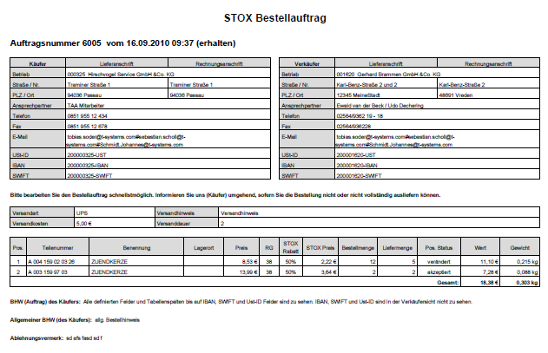

Figure 5‑1 - Template for printing an order in seller view

Requirement: FKT-PRINT-8

The system must assign the file name as follows:

9-digit company number. + order number + current date + current time + indication if PDF was generated as buyer (C) or seller (S), e.g. 200024258\_2010.10.1-155631\_6002.C.pdf

Requirement: FKT-PRINT-10

The PDF document contains a general text with information about editing, such as: Please process the order request as soon as possible. Inform.... (Fixed text, translated).

Requirement: FKT-PRINT-11

For better traceability of the values, the D2D handling margin is not displayed as an additional column for D2D orders, but as a separate line above the total line:

|  |  |  |
| --- | --- | --- |
| Pos. status | Order value | Weight |
| accepts | 111,09 € | 0,130 kg |
| Handling Margin: | 10,00 € |  |
| **Total:** | **121,09 €** | **0,130 kg** |

Requirement: FKT-PRINT-12

The "Buyer's special order note for this order" is displayed in the PDF document below the buyer/seller data (across the entire width of the document) (only for D2D orders).

# Permissions

The chapter Authorizations describes the necessary changes in the LBPS as well as the rights database (RAD) in the logistics bus.

Requirement: FKT-RIGHTS-36

It must be possible to manage the permissions for the STOX application via LBPS in the same way as for the other Logbus application

### Parameters: Places STOX

Requirement: FKT-RIGHTS-9

In the LBPS a new parameter *Places ST* *OX* must be provided in the *STOX* *Parameter* area.

Requirement: FKT-RIGHTS-10

The *Places STOX* parameter looks like, for example, the already existing *Places Disposition* parameter offers the same functionality.

### STOX Rollers

Requirement: FKT-RIGHTS-12

In the LBPS, the *STOX* roles must be available for selection in the STOX area:

* STOX Retailer
* STOX Retailer Admin
* STOX Market controller
* STOX Admin Controller

## Adjustments rights database

The rights database (RAD) of the logistics bus must be extended as follows.

### Adding the new elements

Requirement: FKT-RIGHTS-15

The new roles, authorizations and parameters must be made known in the rights database.

Requirement: FKT-RIGHTS-16

In the rights database, the new roles, authorizations and parameters must be assigned to the STOX application.

Requirement: FKT-RIGHTS-17

The new rights must be created in the rights database.

### Resources and rights

For STOX, new resources and rights must be created in the authorization Excel. These must then be assigned to the individual roles.

Requirement: FKT-RIGHTS-18

Corresponding resources must be created in the authorization Excel.

Requirement: FKT-RIGHTS-19

The following rights must be created in the authorization excel:

C = Change

R = Read

CLSX = Change Locations STOX

RLSX = Read Locations STOX

Requirement: FKT-RIGHTS-20

In the authorization excel, roles and resources must be linked via a right.

### Extensions for D2D process

Requirement: FKT-RIGHTS-21

The previous places list OrteSTOX is renamed to OrteDS (DeadStock).

Requirement: FKT-RIGHTS-37

The following of the previous rights are renamed:

CLDS = Change Locations DeadStock

RLDS = Read Locations DeadStock

Requirement: FKT-RIGHTS-22

A new list PlacesD2D (analogous to PlacesDS) must be included for the new process D2D.

Requirement: FKT-RIGHTS-23

The LBPS application must be extended accordingly so that the OrteD2D list for the STOX application can be maintained for all users (maintenance rules analogous to OrteDS).

Requirement: FKT-RIGHTS-24

The LBPS application must be extended accordingly, so that at least one of the lists OrteDS or OrteD2D must be maintained per user.

Requirement: FKT-RIGHTS-35

The LBPS application must be extended accordingly by another parameter (checkbox) "Notification disabled". The parameter is not selected by default. The parameter should only be maintained for users of the RetailerAdmin role (to be ensured organizationally). Only the LBPS roles System Administrator and Super Administrator are allowed to maintain this parameter.

Requirement: FKT-RIGHTS-25

The following rights must be added to the authorization excel:

* CLD2D = Change Locations D2D
* RLD2D = Read Locations D2D

Requirement: FKT-RIGHTS-26

The following applies to the parts search:

* If both location lists are filled, then the user sees masks of both processes and can switch back and forth between the processes/masks via toggle button
* If one of the two lists is empty, only the masks of the respective process are displayed (PlacesDS = DeadStock process, PlacesD2D = D2D process). The toggle button for switching between processes is not visible
* In the D2D parts search, the "LC Region" search option is only available for users of the Market Controller and Admin Controller roles

Requirement: FKT-RIGHTS-27

The following applies to the order overview:

* Only if the PlacesD2D list is filled, the user will also see the new columns for the D2D process in the tables.
* The "Process" column is only visible if both locations lists are filled.
* The filter for the process (DeadStock/D2D) is only visible if both locations lists are filled.
* The "BEFORE order" button is visible only if the Places list PlacesD2D is filled.

Requirement: FKT-RIGHTS-28

The Shopping Cart tab is only visible when the Places listDS is filled.

Requirement: FKT-RIGHTS-33

The following applies to the home page: The "DeadStock assortment information" area is only visible if the user is authorized for DeadStock for the selected operation.

Requirement: FKT-RIGHTS-34

The following applies to the display of statistics:

* The "DeadStock" area is only visible if the user is authorized for DeadStock for the selected operation
* The "D2D" area is only visible if the user is authorized for D2D for the selected operation

Requirement: FKT-RIGHTS-38

The following applies to the display of settings - STOX part scope and discount group matrix:

* The areas relevant for DeadStock are only displayed if the user is authorized for DeadStock for the selected operation (cluster definition, value and price criteria)
* The "Handling margin" area relevant for D2D is only visible if the user is authorized for D2D for the selected operation
* The SA2 selection and price selection areas are always visible

Requirement: FKT-RIGHTS-29

Only the LBPS roles System Administrator and Super Administrator are allowed to assign the roles STOX Market Controller and STOX Admin Controller. Users of the LBPS Market Admin role may only assign the Retailer and RetailerAdmin roles. For this purpose, the corresponding users of the role Marktadmin are cleaned up once with the release deployment. In the future, this rule must be taken into account organizationally when creating users.

Requirement: FKT-RIGHTS-30

A new resource "Search\_D2D (SEARCH\_D2D)" is added. It is necessary because the Admin Controller role has read-only rights in the D2D process, but also change rights (create orders) in the DeadStock process.

Requirement: FKT-RIGHTS-31

A new resource "HandlingMargin (HM)" is added. Only the RetailerAdmin role is allowed to maintain the handling margin.

Requirement: FKT-RIGHTS-32

Due to these requirements, the following changes result for the authorization excel and the resulting entries in the rights database:

|  |  |  |  |  |
| --- | --- | --- | --- | --- |
| **#Applications: STOX** |  |  |  |  |
|  | **RetailerDefault** | **RetailerAdmin** | **Market controller** | **Admin Controller** |
| **STOX (SX)** |  |  |  |  |
| - Start (START) | L (DS), L (D2D) | L (DS), L (D2D) | L (DS), L (D2D) | L |
| - Orderoverview (ORDERS) | Ä (DS), Ä (D2D) | Ä (DS), Ä (D2D) | L (DS), L (D2D) | L |
| - Search (SEARCH) | Ä (DS) | Ä (DS) | L (DS) | Ä |
| - Search\_D2D (SEARCH\_D2D) | Ä (D2D) | Ä (D2D) | L (D2D) | L |
| - Shoppingcart (CART) | Ä (DS) | Ä (DS) | L (DS) | Ä |
| - Partmaster (PARTS) | L (DS), L (D2D) | Ä (DS), L (D2D) | L (DS), L (D2D) | Ä |
| - Dealermasterdata (DMD) | L | L | L | L |
| + ActivateStoxDealer (ASXD) |  |  |  | Ä |
| + ContactPerson (COPE) | L | L, Ä (DS), Ä (D2D) | L | Ä |
| + DMS (DMS) |  |  | L | L |
| + Notes (NOTE) |  |  | Ä (DS), Ä (D2D) | Ä (DS), Ä (D2D) |
| - Statistic (STAT) | L (DS), L (D2D) | L (DS), L (D2D) | L (DS), L (D2D) | L |
| - Options (OPT) | L (DS), L (D2D) | L (DS), L (D2D) | L (DS), L (D2D) | L |
| + Dealerdata (DDAT) | L (DS), L (D2D) | Ä (DS), Ä (D2D) | L (DS), L (D2D) | Ä |
| + BuyAndSellOptions (BNSO) | L (DS), L (D2D) | Ä (DS), Ä (D2D) | L (DS), L (D2D) | Ä |
| + DealerLists (PUD) | Ä (DS), Ä (D2D) | Ä (DS), Ä (D2D) |  | Ä |
| + Assortment (ASSORT) | L (DS), L (D2D) | Ä (DS), Ä (D2D) | L (DS), L (D2D) | Ä |
| + Discount matrix (DM) | L (DS), L (D2D) | L (DS), L (D2D) | L (DS), L (D2D) | Ä |
| + Administration (ADMIN) |  |  |  | Ä |
| + HandlingMargin (HM) | L (D2D) | Ä (D2D) | L (D2D) | L |
| - CheckNewOrderThread (CNOT) | L | L |  |  |
|  |  |  |  |  |
|  |  |  |  |  |
|  |  |  |  |  |
|  |  |  |  |  |
| **Mögliche Rechte:** |  |  |  |  |
| Read access for all locations without the ability to make changes on the database. | **L** |  |  |  |
| Ändernder Zugriff für alle Orte mit der Möglichkeit, Änderungen auch in der Datenbank zu hinterlassen. | **Ä** |  |  |  |
| L with the restriction that only the data of the locations in the list OrteDS can be read (e.g. DS={20022519, 200364\*}). | **L (DS)** |  |  |  |
| L mit der Einschränkung, dass lediglich die Daten der Orte in der Liste Orte\_D2D gelesen werden können (z.B. D2D={20022519, 200364\*}). | **L (D2D)** |  |  |  |
| Ä with the restriction that only the data of the locations in the list OrteDS can be changed (e.g. DS={20022519, 20036411}). | **Ä (DS)** |  |  |  |
| Ä mit der Einschränkung, dass lediglich die Daten der Orte in der Liste OrteD2D geändert werden können (z.B. D2D={20022519, 20036411}). | **Ä (D2D)** |  |  |  |
| **Kombinationen:** | **L, Ä (DS), Ä (D2D)** |  |  |  |
|  | **L (DS),**  **L (D2D)** |  |  |  |
|  | **Ä (DS),**  **Ä (D2D)** |  |  |  |
|  | **Ä (DS),**  **L (D2D)** |  |  |  |
|  |  |  |  |  |
| Dabei gilt: |  |  |  |  |
| **Pro Benutzer kann eine Liste DS definiert werden!** | |  |  |  |
| Liste Orte\_DS = Eine Liste, die beliebig viele Orte enthalten kann, deren Daten der jeweilige Benutzer lesen oder ändern darf. | **DS** |  |  |  |
| **Pro Benutzer kann eine Liste D2D definiert werden!** |  |  |  |  |
| Liste Orte\_D2D = Eine Liste, die beliebig viele Orte enthalten kann, deren Daten der jeweilige Benutzer lesen oder ändern darf. | **D2D** |  |  |  |

# Batch-Spezifikation

Folgende Tabelle gibt einen Überblick der neuen bzw. erweiterten Batchprozesse:

| Prozess | Start / Intervall | Verweis | Kurzbeschreibung |
| --- | --- | --- | --- |
| Aktualisierung Sortiment | zyklisch | 7.1 | Aktualisierung des DeadStock-Sortiments Ermittlung gelöschter Positionen Ermittlung automatisch gelöschter TNR |
| Löschung aus Sortiment | täglich | 7.2 | Löschung unberechtigter TNR aus DeadStock-Sortiment |
| Aktualisierung Bestand | Bestandsimport | 7.3 | Aktualisierung des STOX-Bestands |
| Auflösung Reservierung | täglich (mehrfach) | 7.4 | Auflösung der reservierten Bestände |
| Archivierung | täglich | 7.5 | Archivierung „alter“ Bestellaufträge |
| Löschung | monatlich | - | Endgültige Löschung alter Daten |
| Aktualisierung Statistik | monatlich | 7.6 | Berechnung der (Verkaufs-) Statistiken zum Händler |
| GSSN Synchronisation | täglich | 7.7 | Synchronisation der Rechnungsanschrift mit den GSSN Adressdaten. |
| GPS-Import | wöchentlich | 7.8 | Import der GPS Koordinaten |
| Zurücksetzen Warenkorb | täglich | 7.9 | Zurücksetzen des Warenkorbs |
| Umnummerierung | manuell /  monatlich | 7.10 | Umnummerierung eines Händlers |
| Trainingsumgebung | täglich | 7.11 | Generierung von Testdaten für die Trainingsumgebung |
| Bereinigung Geschäftspartner-Listen | täglich | 7.12 | Löschen aller Betriebe aus den Geschäftspartner-Listen, die nicht mehr in DIMS existieren |
| D2D Lieferanfragen | zyklisch | 7.13 | Starten und Beenden Lieferanfragen |

Tabelle 7‑1 - Übersicht Batchprozesse

## Ermittlung und Aktualisierung des DeadStock-Sortiments

### Ablauf

Der zur Ermittlung bzw. Aktualisierung des DeadStock-Sortiments benötigte Batch-Prozess wird ein ständiger Prozess, der einmalig gestartet wird und anhand von Prioritäten die DeadStock-Betriebe zyklisch abarbeitet. Dabei werden eine parametrisierbare Anzahl Betriebe parallel bearbeitet. Um die nächtlichen Dispositionsprozesse nicht negativ zu beeinflussen, kann der Prozess zu diesen Zeiten mit weniger Parallelität gesteuert werden (siehe Abschnitt 7.1.3).

Anforderung: FKT-BATCH-1

Im Regelbetrieb (d.h. wenn kein Rollout kompletter Märkte stattfindet) wird jeder DeadStock-Betrieb mindestens einmal wöchentlich aktualisiert. Die nächste Aktualisierung erfolgt frühestens nach 5 Kalendertagen (Ausnahme sind Betriebe, für die eine Neuberechnung aufgrund von Parameteränderungen notwendig ist).

Recalculation due to parameter changes takes place when changes are made in the "Part Scope" area. Jedoch nicht, wenn ausschließlich die Preisart geändert wurde, da die Preisart lediglich Auswirkung auf die Berechnung des STOX Wertes für das über DeadStock angebotene Sortiment hat. Only if the price type is changed together with another parameter (e.g. "Minimum value limit per position" and/or "Minimum unit price per position"), this will result in a recalculation.

Requirement: FKT-BATCH-2

Der Parallelisierungsgrad für den Batch-Prozess muss zeitgesteuert parametrisierbar sein.

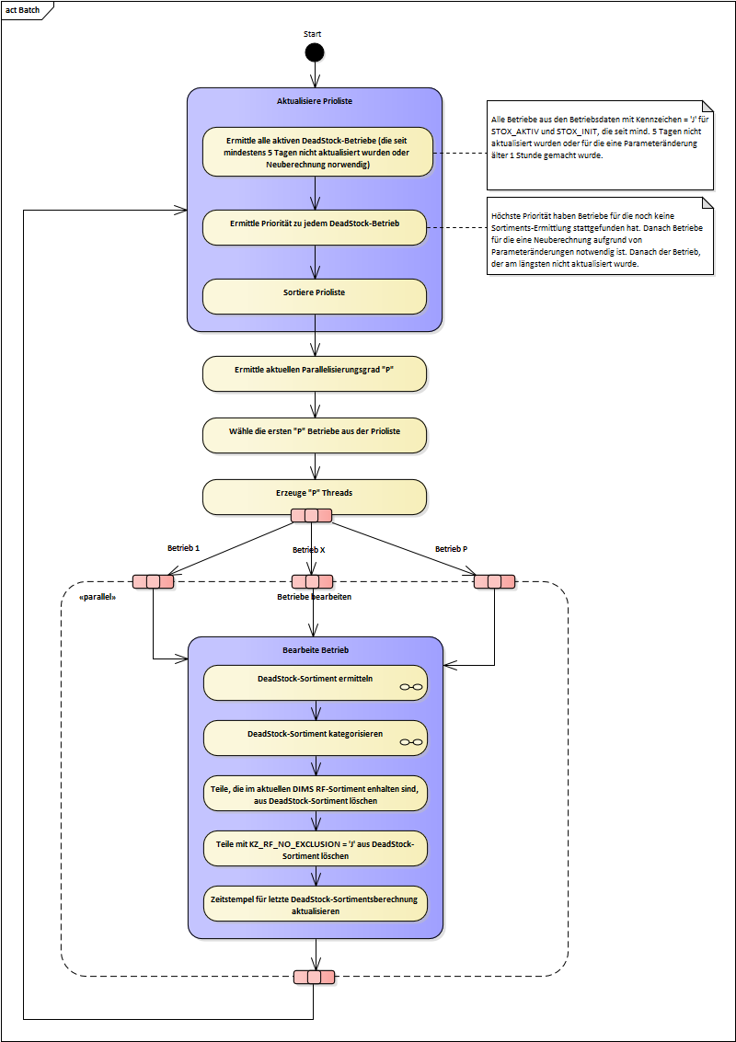

Figure 7‑1 - Batch Process DeadStock Assortment Determination

### Priorities

Requirement: FKT-BATCH-3

The system assigns a priority to each DeadStock operation. The priority depends on the time of the last update of this operation. Companies whose assortment has not yet been determined (e.g. in the case of a new activation) are given the highest priority. Next higher priority is given to the plants for which recalculation is necessary due to parameter changes. After that come the farms that have not been updated for more than 5 days.

Requirement: FKT-BATCH-4

The system must update the current priorities on a regular basis (before each selection of the next operation to be processed).

### Configuration

The following parameters for the batch process can be stored via a configuration file (XML file):

| Name | Description | Example |
| --- | --- | --- |
| *DefaultParallelization* | Defines the degree of parallelization if no separate *timeslot* has been defined for the current time. | <DefaultParallelization> 5 </DefaultParallelization> |
| *Timeslot* | A *timeslot* always contains a start and end time and the degree of parallelization for this interval. | <TimeSlot> <StartTime>00:00:00</startTime> <EndTime>05:59:59</endTime> <parallelization>1</parallelization> </TimeSlot>  <TimeSlot> <StartTime>19:00:00</startTime> <EndTime>23:59:59</endTime> <parallelization>3</parallelization> </TimeSlot> |

In the example configuration given above, only one site would be processed in parallel during scheduling between 0:00 and 6:00, 3 sites would always be processed during imports between 7:00 and 0:00, and 5 sites would be processed in parallel during legal hours.

### Mail information

#### General

With the update of the DeadStock assortment, the STOX contact persons of the respective location receive an automated email containing both the changes due to the current calculation of the DeadStock assortment and further process information.

Automated mail is divided into three sub-areas. A separate PDF file with the affected part numbers is generated for each subarea and included as an email attachment. The respective file name is output in the national language of the dealer (i.e. the company).

1. New DeadStock parts based on the current calculation of the assortment (PDF file "New-Parts-in-STOX\_LKZ+Operation\_Number\_YYYMMDD.pdf").
2. Automatic deletion of unauthorized part numbers from the product range (PDF file "Automatische-Löschung\_LKZ+Betriebsnummer\_JJJMMDD.pdf").
3. Rejected purchase order items (PDF file "Rejected\_items\_LKZ+firm\_number\_YYYYMMDD.pdf").

Requirement: FKT-BATCH-15

The system automatically sends an email with the respective changes and notes following the determination or update of the DeadStock assortment. The email is sent to the email address(es) stored in the company data under STOX contact person and also to the country-specific distribution addresses stored in the database[[63]](#footnote-63) (initially filled for Germany, can be changed/added later). The dispatch is analogous to the email dispatch when triggering a DeadStock order:

1. Mail subject and mail content are fixed in the database.
2. Mail subject and mail content are output in the local language of the merchant (i.e. the company).
3. The mail content includes the company number, country and time of calculation. At the end, there is a reference to the automatically generated mail and the disclaimer.
4. The sender of the mail is the address [noreply@daimler.com](mailto:noreply@daimler.com).
5. The mail is also generated during the initial DeadStock calculation and in this case contains all parts from the initial calculation.
6. If no changes or information are available for a subarea, this subarea (and the associated PDF file) are omitted from the generated mail.

Example of the generated mail:

**Subject:** Changes/process notes due to the current calculation of the STOX range

**Text:**

Dear Sir or Madam,

in the current calculation of the STOX range there were changes for your location 4711 - Germany.

If unauthorized part numbers for your location were automatically deleted by STOX or if order entry items were rejected by your location, we would like to point this out to you (to increase the process quality):

**New parts in STOX**

Within the framework of the current calculation of the STOX range

Time: 13.09.2010 15:12

parts NEW have been added for your location.

We provide you with these parts at part number level in the form of the PDF file "New parts in STOX". So you can check if you want to offer these NEW parts via STOX or exclude them manually.

========================================================================================

**Automatic deletion of unauthorized part numbers**

Since the last calculation, part numbers have been automatically deleted from the STOX assortment, as they are not allowed to be offered according to the applicable STOX GTC.

We provide you with the part numbers in the PDF file "Automatic deletion".

========================================================================================

**Rejected order entry items of your location**

Since the last calculation, order entry items from your location have been rejected for sale.

Since rejections lead to dissatisfaction on the buyer side, we provide the rejected part numbers in the PDF file "Rejected Items" for your review.

Notice:

- If you cannot sell a part number, please set it manually to exclusion (STOX part master).

- If you find a stock shortage for a part number, please correct this stock shortage in your local in-house system as soon as possible.

========================================================================================

In this mail we provide you with a PDF file only for the items where there were also changes/process notes in STOX.

With kind regards

Logistics bus STOX

This is an automatically generated mail. Please do not reply to this mail.

<<Disclaimer>>

#### Subarea A - new DeadStock parts

This subsection lists the new parts that have been added to the DeadStock range based on the current calculation.

Requirement: FKT-BATCH-16

The new part numbers will be included in a PDF file as an email attachment.

1. The part numbers are output in print format but listed in ascending order in memory format.
2. In addition, the designation in the national language of the dealer (from the national or local part master), the current free stock, the storage location (storage location 1 from the local part master) and the prices of national BLP, local BLP (VKP) and DAK are also output. In the first row, the column headers are output in the dealer's national language.

#### Subfield B - automatic deletion

This subarea lists the parts deleted by the daily check (see chapter 7.2), which have been performed since the last calculation of the DeadStock assortment.

#### Subarea C - Rejected purchase order items

In this subarea, the order items of the location (from seller's point of view) are listed, which have been rejected since the last calculation of the DeadStock assortment, i.e. all items with date *in process* since the last calculation of the DeadStock assortment and with item status *deleted*, are output.

Rejected delivery requests in the D2D process are not included in evaluation.

Requirement: FKT-BATCH-19

The deleted items are inserted in a PDF file. The part numbers are output in print format but listed in ascending order in memory format.

The following information is output in the PDF file:

* Part number (in print format)
* Designation (from the national part master)
* Current stock at the time of calculation of the DeadStock range
* Storage location 1
* Reason for rejection
* Manual exclusion (Yes /No)

In the first row, the column headers are output in the dealer's national language.

## Deletion of unauthorized part numbers from the DeadStock assortment

Requirement: FKT-BATCH-17

The system checks the DeadStock assortment daily for:

* Chrysler parts (MC brand only),
* DRT (PRIMUS field 134 - 5th digit = "D")
* Old parts

which were added manually or automatically (due to a PRIMUS master data change) to STOX.

These parts are then deleted from the DeadStock assortment. The deleted part numbers and the reason for deletion are stored in the database (table STOX\_PARTS\_DELETED) for later mail dispatch.

Notice: Contrary to the specialist concept, foreign parts are to be left out/not deleted for the time being during automatic deletion. The reason for this is that some dealers still have Mercedes-Benz part numbers that are no longer listed in the global parts master and are also not available in all national parts masters. If the specialist concept were to be implemented as originally planned, the consequence would be that the "former" Mercedes-Benz part numbers (which are declared as foreign parts in DIMS/SICOS and thus also in STOX) could no longer be offered via STOX at all (since we would automatically delete them during the next check).

As there is also the consideration in the context of the SPM introduction to obtain the price/part master info via IPS (and many of these parts are still managed there), the automatic deletion for third-party parts was "postponed" for the time being. As soon as we change the data source and can then also completely and clearly identify foreign parts as such, we will then also have foreign parts deleted.

Requirement: FKT-BATCH-18

The automatically deleted part numbers are inserted as part of an automated mail in the form of a PDF file as an email attachment. The part numbers are output in print format but listed in ascending order in memory format.

The following information is output in the PDF file:

* Part number (in print format)
* Designation (from the national part master)
* Storage location 1

The reason for deletion is displayed in the local language of the merchant. The following expenses will be incurred for German operations:

* According to STOX AGB Chrysler parts (MC brand) are not allowed to be offered
* According to STOX AGB foreign parts may not be offered
* According to STOX AGB this theft relevant part (DRT) may not be offered
* According to STOX AGB old parts may not be offered
* In the first row, the column headers are output in the dealer's national language.

The email dispatch is integrated into the automated email for the calculation of the DeadStock assortment (see chapter 7.1.4).

## Updating the stock / Goods receipt

The inventory available in STOX is updated synchronously with the posting of an inventory message in DIMS. This is done via database triggers on the table *BESTAENDE* in SICOS.

When a goods receipt is posted (planned or unplanned goods receipt with quantity > 0), a part is deleted from the DeadStock assortment. This is done via a database trigger on the *FLUESSE* table in DIMS.

Requirement: FKT-BATCH-5

The system must update the available inventory displayed in STOX synchronously with the inventory posted in DIMS/SICOS.  
As soon as a new stock of "0" is reported (i.e. when stock changes to "0"), the part is deleted from DeadStock. If a manual exclusion from DeadStock is stored for the part, this exclusion remains and only the machine DeadStock category is deleted (otherwise the part would immediately come back into the DeadStock assortment if it gets stock again at a later time and the manual exclusion is removed afterwards). The procedure for posting a planned or unplanned goods receipt with a quantity greater than "0" is similar.

Requirement: FKT-BATCH-6

When creating new records (INSERT) of the *BESTAENDE* table, the import module must additionally save the part number in the input format (this is required for the wildcard search in the own inventories).

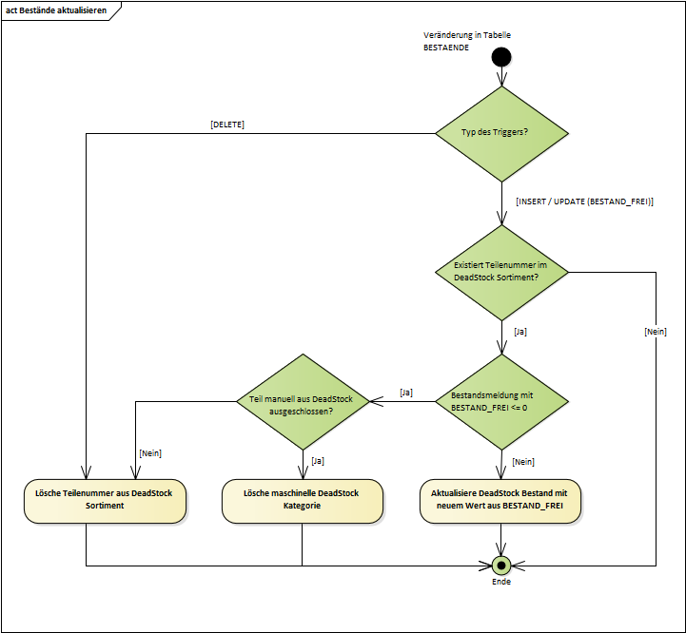

Figure 7‑2 - Trigger inventory update

## Dissolution of the reserved stocks

### Resolution of the reservation in DeadStock

The resolution of reservations is partly done "online" (i.e. triggered by a user action) or system-side via a cyclic batch process (this runs several times a day, frequency and time(s) are still being coordinated and defined). With GoLive R60, this process is scheduled hourly.

Requirement: FKT-BATCH-7a

The system checks all entered reservations from the "STOX\_RESERVATIONS" table on a daily basis. The following criteria exist for system resolution of a reservation:

1. The position was rejected (position status "rejected") and the date "in process" is older 24 hours.
2. The item has been shipped (order status "shipped" or "received" and item status "accepted" or "changed") and the "shipped" date is older than 24 hours (this also affects D2D orders, see Auflösung der Reservierung in D2D).
3. The order was archived (the archiving period is 1 week)

The following reservations are resolved by user actions (see chapter Dialogspezifikation):

1. The position is canceled (position status "canceled")[[64]](#footnote-64)

If one of the criteria is met, the reservation is removed from the "STOX\_RESERVATIONS" table and the corresponding quantity is deducted from the total reserved quantity (in the "STOX\_PARTS" and "BESTAENDE" tables).

Example:

The seller currently has a STOX inventory of 5 pieces of a part number and already has a STOX reservation of 2 pieces of that part. A buyer orders a piece of this part via STOX today (04/20) at 2pm. The reservation with the seller is increased "immediately" to 3 pieces (i.e. all other buyers will only see the part if the quantity they are looking for is <= 2 pieces). The following cases are conceivable:

1. The buyer cancels the item at 14:30, before the seller opens the order and the status goes to "in process". The reservation is released immediately when it is saved and is then released again as "free stock" for the parts search.
2. The seller rejects the position on 04/20 at 6pm. On the following day (21.04. approx. 6-10 a.m.) the next batch run is running - but the date "in process" is not yet 24 hours old - the reservation remains. On the day after next (22.04. approx. 6-10 o'clock) the reservation is then dissolved.
3. The seller accepts the position and sets the order to "shipped" - the further process is analogous (2), only the "check date" is now the "shipped" date.
4. The seller does nothing - the order is archived after 1 week. During the next batch run, the reservation is resolved.

Notice:

There may be constellations in which the seller has already reported the changed inventory to DIMS (and this has also been posted), but the reservation has not yet been cancelled. In the meantime, this can lead to the fact that the physically existing remaining stock due to the reservation is not displayed in STOX (e.g. original quantity of 2, 1 part sold via STOX, stock report of 1 piece to DIMS, reservation of 1 not yet resolved à no display of the remaining quantity of 1 piece until the reservation has been resolved!).

Note DAG:

These constellations are accepted by DAG, because in case of an immediate cancellation of a reservation, in case of rejection or shipment, the correct physical stock (before debiting the order quantity or the stock adjustment posting) is not yet posted in DIMS and thus an excessively high available STOX stock would be indicated.

The time offset of 24 hours is justified by the fact that

- the data extraction from the DMS e.g. for Alpha+ already starts at 18:30 and later DMS inventory changes in STOX would not be taken into account.

- in the MBVD market, between 30 and 40 different companies send their movement and inventory data to Logbus every day with a one-day time delay. In the MBI market, more than 50 farms are affected at times.

These would lead to complaints by the buyer/seller when ordering such a part, if the seller has to refuse the order due to lack of stock.

### Resolution of the reservation in D2D

Reservations are partially resolved "online" (i.e. triggered by a user action) or system-side via the cyclic batch process for starting or ending delivery requests (waves). This runs "permanently", so that the cancellation of the reservation takes place without further delay.

Requirement: FKT-BATCH-7b

The following criteria exist for system resolution of a reservation:

1. The end of an order has been reached (the waiting time after the last wave has expired). All delivery requests that are still started will be terminated and the reservation will be cancelled.
2. The order has been shipped (order status "shipped" or "received") and the "shipped" date is older than 24 hours (this is done in the batch process for reservation resolution from DeadStock, see 7.4.1)

The following reservations are resolved by user actions (see chapter Dialogspezifikation):

1. The delivery request is rejected (since the rejection cannot be reversed, the reservation can be cancelled immediately). However, the available stock is blocked by this for a parameterized period and is not displayed.
2. Another supplier accepts his delivery request (all other started delivery requests are thereby terminated)
3. The order is cancelled by the buyer (all started delivery requests are terminated)

If one of the criteria is true, the reservation is removed from the "STOX\_RESERVATIONS" table and the corresponding quantity is deducted from the total reserved quantity (in the "RESERVATIONS" table).

## Archiving

The archiving of old or no longer required data is done in two steps.

Requirement: FKT-BATCH-8

The system "moves" each purchase order to the order archive after 1-week. This is done by setting an indicator at the respective order. In addition, the following adjustments will still be made:

* If an order is moved that is still in the 'shipped' status, then the status is automatically set to 'received' and the date in the 'done' column is set to the current day. In this case, 00:00 is always entered as the time in order to be able to recognize the automatic setting of the date even later.
* In addition, for all orders in the archive that are still in the 'sent' status and the "sent" date is older than 7 days, the status is automatically set to 'received' and the date in the "completed" column is set to the current day. In this case, 00:00 is always entered as the time in order to be able to recognize the automatic setting of the date even later.

The (new) batch process for setting this flag runs daily. After setting the flag, the orders are displayed on the client in a different view.

The procedure applies to both DeadStock and D2D.

Requirement: FKT-BATCH-9

The system permanently deletes old purchase orders from the database after 25 months. The entries in the tables STOX\_ORDERS and STOX\_ORDER\_DETAILS or D2D\_ORDERS and D2D\_REQUESTS are deleted. Deleting the orders may also delete "old" (now unreferenced) entries of the STOX\_ADDRESSES and STOX\_FINANCIAL\_DATA tables. The date of receipt of the order is decisive.

In addition, the oldest entries of the STOX\_ASSORTMENTS table are deleted for operation (at least the last two entries or the history of the last 25 months are required - period analogous to the deletion of purchase orders).

This process is integrated into the standard deletion process from DIMS/SICOS (this runs monthly for each operation).

## Statistics

Requirement: FKT-BATCH-10

The system always generates the statistics information per trader for the previous month in a new batch process at the beginning of the month. As a rule, the data for the previous month are available on the 3rd calendar day of the month. The date of receipt of the order is decisive.

Requirement: FKT-BATCH-11

The information is stored in the "STOX\_DEALER\_STATS" table. The following values are saved for the operation and the respective month (each order or position is considered by the corresponding criteria in one month at the most). After the calculation, the new or updated values are copied to the archive table "STOX\_DEALER\_STATS\_ARCHIV". If a site is completely deactivated (in DIMS), only the data in the "STOX\_DEALER\_STATS" table is deleted, the historical values are retained in the archive.

| Description | Field name | Criteria |
| --- | --- | --- |
| 1. *Number of incoming orders (number of orders)* | SXDS\_SALE\_ORDERS | All orders (operation as seller) with date "in process" in current month (but without canceled orders). |
| 1. *Number of positions sold* | SXDS\_SALE\_ORDER\_POS | Sum of sold positions (position status "accepted" or "changed") from shipped orders (order status "shipped" and date "shipped" in current month). |
| 1. *Number of rejected positions* | SXDS\_SALE\_ORDER\_POS\_CANCELED | Sum of items from completely rejected orders (order status "rejected" and date "completed" in current month) and individually rejected items (date "shipped" in current month and item status = "rejected). |
| 1. *Value (BLP / VKP) of the sold positions* | SXDS\_SALE\_ORDER\_VAL\_GROSS | Value of sold positions (see (2)) at BLP or VKP value (depending on the trader's setting at the time of sale). The value corresponds to the value of the items from the "Order details". |
| 1. *Value (net) of positions sold* | SXDS\_SALE\_ORDER\_VAL\_NET | Value of the sold items (see (2)) at the net price (i.e. the value from (4) minus the discount according to the discount group). |
| 1. *Value (DeadStock) of sold positions* | SXDS\_SALE\_ORDER\_VAL\_STOX | Value of sold positions (see (2)) at the DeadStock price(i.e. the value from (5) minus the DeadStock discount). |
|  |  |  |
| 1. *Number of outgoing orders (number of orders)* | SXDS\_PURCHASE\_ORDERS | All orders (operation as buyer) with date "in process" in current month (but without canceled orders). |
| 1. *Number of positions bought* | SXDS\_PURCHASE\_ORDER\_POS | Sum of purchased items (item status "accepted" or "changed") from received orders (order status "received" and date "completed" in the current month). |
| 1. *Number of rejected positions* | SXDS\_PURCHASE\_ORDER\_POS\_CANCEL | Sum of items from completely rejected orders (order status "rejected" and date "completed" in the current month) and individually rejected items (date "sent" in the current month and item status = "rejected"). |
| 1. *Value (BLP / VKP) of the sold positions* | SXDS\_PURCHASE\_ORDER\_VAL\_GROSS | Value of the purchased positions (see (8)) at BLP or VKP value (depending on the seller's attitude at the time of purchase). The value corresponds to the value of the items from the "Order details". |
| 1. *Value (net) of positions sold* | SXDS\_PURCHASE\_ORDER\_VAL\_NET | Value of the purchased items (see (8)) at the net price (i.e. the value from (10) minus the discount according to the discount group). |
| 1. *Value (DeadStock) of sold positions* | SXDS\_PURCHASE\_ORDER\_VAL\_STOX | Value of the purchased positions (see (8)) at the DeadStock price(i.e. the value from (11) minus the DeadStock discount). |
|  |  |  |
| 1. *Number of delivery requests* | SXDS\_D2D\_SALE\_REQUESTS | All delivery requests (operation as seller) with end time of the request in the current month (without cancelled orders). |
| 1. *Number of rejected delivery requests* | SXDS\_D2D\_SALE\_REQ\_REJECTED | Sum of rejected requests with end time of the request in the current month. |
| 1. *Number of automatically stopped delivery requests* | SXDS\_D2D\_SALE\_REQ\_STOPPED | Sum of stopped requests (due to sale by other company) with end time of request in current month. |
| 1. *Number of expired delivery requests* | SXDS\_D2D\_SALE\_REQ\_EXPIRED | Sum of requests expired due to timeout with end time of the request in the current month. |
| 1. *Number of sold delivery requests* | SXDS\_D2D\_SALE\_REQ\_SOLD | Sum of sold items (status "accepted") from shipped or received orders (order status "shipped" or "received") with end time of the request in the current month. |
| 1. *Value BLP/VKP of the sold delivery requests* | SXDS\_D2D\_SALE\_ORDER\_VAL\_GROSS | Value of the positions sold by the trader (see (17)) |
| 1. *Value net of sold delivery requests* | SXDS\_D2D\_SALE\_ORDER\_VAL\_NET | Value of the positions sold by the trader (see (17)) |
| 1. *Value D2D of the sold delivery requests* | SXDS\_D2D\_SALE\_ORDER\_VAL\_D2D | Value of the positions sold by the trader (see (17)) |
|  |  |  |
| 1. *Number of orders* | SXDS\_D2D\_PURCHASE\_ORDERS | All orders (operation as buyer) with end time of the order in the current month (without canceled orders). |
| 1. *Number of rejected orders* | SXDS\_D2D\_PURCHASE\_REJECTED | Sum of rejected orders with end time of the order in the current month. |
| 1. *Number of expired orders* | SXDS\_D2D\_PURCHASE\_EXPIRED | Sum of expired orders with end time of the order in the current month. |
| 1. *Number of cancelled orders* | SXDS\_D2D\_PURCHASE\_CANCELED | Sum of canceled orders with end time of the order in the current month. |
| 1. *Number of orders purchased* | SXDS\_D2D\_PURCHASE\_SHOPPED | Sum of purchased orders with end time of the order in the current month. |
| 1. *Value BLP/VKP of the purchased orders* | SXDS\_D2D\_PURCHASE\_VAL\_GROSS | Value of the positions purchased by the trader (see (25)) |
| 1. *Net value of purchased orders* | SXDS\_D2D\_PURCHASE\_VAL\_NET | Value of the positions purchased by the trader (see (25)) |
| 1. *Value D2D of purchased orders* | SXDS\_D2D\_PURCHASE\_VAL\_D2D | Value of the positions purchased by the trader (see (25)) |

Notice:

The end time of a delivery request is

* the date of rejection by the seller or
* the time when the request is stopped because another vendor accepts or
* the time when the request is stopped due to timeout or
* the time when the request is transferred to the "sent" or "received" status (the request was accepted before, but this time is not relevant for the statistics).

The end time of an order is

* the time when the order is cancelled or
* the time when all delivery requests for the order have been rejected or
* the time when the order is stopped due to timeout or
* the moment when the order is transferred to the "received" status (a delivery request for the order was previously accepted, but this moment is not relevant for the statistics).

## GSSN Synchronization

Requirement: FKT-BATCH-12

The system synchronizes the billing addresses of all STOX sites (in the STOX\_LOCAL\_SETTINGS and STOX\_ADDRESSES tables) on a daily basis. Only the **current** billing address will be overwritten with the current address from GSSN. It must also be taken into account whether an address is entered as a different billing address at another company and this must also be changed accordingly. Addresses already used in orders will not be overwritten (the new address will only be used in all subsequent orders).

## GPS import

Requirement: FKT-BATCH-13

The system imports the XML attribute <outletGps> from the GSSN file into the corresponding fields of the tables "*BETRIEBSDATEN\_KONZERN*" or "*GSSN\_POOL*".

## Reset shopping cart

Requirement: FKT-BATCH-14

The system deletes the unordered parts from the shopping cart once a day. This ensures that no obsolete items (stocks) are "left behind" in the shopping cart. The time (time) of deletion depends on the market. The times are specified centrally and stored in the system. As a rule, the time should take place during "overnight" in the respective market.

## Renumberingsprocesses

The existing DIMS batch process for renumbering will be extended.

Requirement: FKT-UMNR-04

The following describes the adjustments that arise in connection with different billing addresses:

Example: Company 23300 has entered company 23301 as a different billing address

* 1. Site 23301 is renumbered (renumbering, merging):  
     During renumbering, the system checks whether the address of the site to be changed is entered in the STOX\_LOCAL\_SETTINGS for another site as a different billing address. If this is the case, this reference is deleted. The new billing address of the affected company is its own address.
  2. Operation 23300 is renumbered (renumbering, merging):  
     There is nothing to do at this point, because the information about the different billing address is stored in the STOX\_LOCAL\_SETTINGS. These are deleted in the relevant renumbering processes.

### Renumbering

The requirements for the standard case are described here (i.e. renumbering from operation A to operation B).

Requirement: FKT-UMNR-01

During renumbering, the following information is deleted or changed for operation A :

* Before renumbering, the statistics information (see 7.6) is generated for the current month, this information is transferred to the table "STOX\_DEALER\_STATS" and also stored in the statistics archive.
* The STOX enabled and STOX initialized flags are reset (for DeadStock and D2D).
* The STOX contact person (BETRIEBS\_KONTAKTE table) is deleted.
* The STOX settings (STOX\_LOCAL\_SETTINGS table) are deleted.
* The STOX shipping modes (STOX\_SUPPLIER\_SHIPPING\_MODES table) are deleted.
* The DeadStock assortment (table STOX\_PARTS) including all manual changes will be deleted (if the operation was already disabled for DeadStock before, the assortment is already deleted).
* The DeadStock assortment statistics (STOX\_ASSORTMENTS table) are deleted.
* Generated or started D2D orders (from site A) that have not yet been accepted by any supplier are canceled ("Cancelled" status).
* Started D2D delivery requests (at operation A) are stopped (status "Rejected") and not started D2D delivery requests are deleted (status "Invalid").
* If site A is in the exclusion table, it will be renumbered there.
* All other STOX information (e.g. purchase and sales statistics, orders and related financial and address data) remains and can be evaluated via the database if required.
* For all sites where site A is stored as a different billing address, the different billing address must be deleted (the address of the own site (site data, not different delivery address) becomes the billing address again).

The new operation B is not active in STOX (DeadStock and D2D). Activation must take place as part of the "normal" switch-on process, or initialization by the operation itself.

### Separation

Here, the requirements for the case of a plant separation are described (i.e. a partial assortment of plant A is split off in plant B). A separation for which the receiving site B already exists in DIMS is 2-step - i.e. the partial assortment is first split off into a dummy site and this dummy site is then merged with site B in a second step (see 7.10.3).

Requirement: FKT-UMNR-02

When disconnected, the following information about operation A is deleted or changed:

* At the issuing plant A, the parts that have been transferred to plant B are deleted from the DeadStock assortment (table STOX\_PARTS).

Parts and manual inclusions/exclusions from Plant A's DeadStock assortment that have not been relocated are not changed or deleted. If operation B is a new DIMS operation (and therefore not active in STOX), activation must take place as part of the "normal" switch-on process, or initialization by the operation itself.

### Merge

Here, the requirements for the case of a plant merger are described (i.e. the complete assortment of plant A is transferred to plant B).

Requirement: FKT-UMNR-03

When merging, the following information on (donor) site A is deleted or changed:

* Before merging, the statistics information (see 7.6) is generated for the current month and also stored in the statistics archive.
* The STOX enabled and STOX initialized flags are reset (for DeadStock and D2D).
* The STOX contact person (BETRIEBS\_KONTAKTE table) is deleted.
* The STOX settings (STOX\_LOCAL\_SETTINGS table) are deleted.
* The STOX shipping modes (STOX\_SUPPLIER\_SHIPPING\_MODES table) are deleted.
* The DeadStock assortment (STOX\_PARTS table) including all manual changes will be deleted (if the operation was already disabled for STOX before, the assortment is already deleted).
* The DeadStock assortment statistics (STOX\_ASSORTMENTS table) are deleted.
* Generated or started D2D orders (from site A) that have not yet been accepted by any supplier are canceled ("Cancelled" status).
* Started D2D delivery requests (at operation A) are stopped (status "Rejected") and not started D2D delivery requests are deleted (status "Invalid").
* If site A is in the exclusion table, it will be deleted there.
* All other STOX information (e.g. purchase and sales statistics, orders and related financial and address data) remains and can be evaluated via the database if required.
* For all sites where site A is stored as a different billing address, the different billing address must be deleted (the address of the own site (site data, not different delivery address) becomes the billing address again).

During merging, the following information is performed at (receiving) site B:

* If the receiving site B is already active in DeadStock, the indicator for recalculation of the assortment is set (analogous to a recalculation due to parameter changes). In the process, parts from the transferred assortment are included in the DeadStock assortment according to the criteria of the new operation.

If the new operation B is not active in STOX, the activation must take place within the "normal" switch-on process, or the initialization by the operation itself.

## Training environment

For the training, the required functions and data are integrated into the existing training environment for DIMS/SICOS. The basis for the training data is real data from **seven** Italian plants (referred to as real plants in the further sections) from production. These are provided once by the Daimler department. The training data is reset to the initial state every night (i.e. **all** changes made during the day in the training, e.g. changes to user settings, orders placed, etc. are discarded).

### Operating master data

* The operation data (incl. operation numbers) are analogous to the training operations DIMS. In addition, the farms are stored with different GPS coordinates - these are randomly distributed over the respective country/market.
* There are seven different farms in the real data - each training farm is derived from one of these farms. For example, if a market contains 15 training sites, sites 1, 8 and 15 are derived from the data of the first live site, sites 2 and 9 from the data of the second live site, and so on. The procedure is the same for all other markets.
* For each training site, a branch site is created that has the same stocks (part number and stock) as the main site. The branches are not active for STOX. The site number of the branch site is derived from the main site number (main site number + 1000), e.g. training site (=main site) 200910008 à branch site 200911008.  
  The branches do not have any other data.

### Central parts master data

* Using the part numbers from the Italian real data, the current data for the tables PARTS\_GROBAL, PARTS\_NATIONAL and ALTERNATIVES are determined once. These are exported and imported during each training run. This also includes part designations for all currently available Wholesale locations. The alternatives contain the complete replacement chains of all part numbers from the real data.
* For the correct display of the designation in the respective national language, the supplier parameterization must be extended in the training data. For each market, the respective (E)LC must be set and the national master data of all wholesale locations must be imported for all current part numbers in the training. Training operations must be assigned to "their" wholesale location for each market.

### Transfer of current production data

Every day, when the training environment is initialized, the following data of all markets is taken from the production database:

* General terms and conditions and texts for mail dispatch
* Current information in panel 1 (start panel)
* Discount groups matrix
* Centrally stored transport service providers

For markets where no data is yet stored in the production, the English information is used (except for the GTCs, these will remain empty).

Depending on the country selection, the corresponding information is displayed in the training environment. All static names of buttons, labels, tooltips, notes on mandatory fields, etc. (which are maintained via PGuard). (which are maintained via PGuard) correspond to the current release status and are updated for the release.

### Fixed default values

The following data are set or stored daily when the training environment is initialized:

* Default values of the bandwidths for the DeadStock clusters for investment date, last addition and last disposal
  + in cluster II 15 calendar months
  + in cluster III 24 calendar months
* Minimum and maximum values of the ranges for the DeadStock clusters for investment date, last inflow and last outflow
  + in cluster II as minimum value 0 and as maximum value 18 calendar months
  + in cluster III as minimum value 12 and as maximum value 24 calendar months
* Value and price limit
  + minimum value limit per position a value of 5,00
  + minimum single value per position a value of 1.00
* An email address for the STOX contact person is already stored in the operating data. This is reported in advance by the DAG per store (change of default can be made via the configuration file).

### DeadStock assortment

The basis for the DeadStock assortment is the data from the real farms. This data has been compiled by the department so that the following results, among others, can be displayed in the parts search:

* Alternatives (incl. reference to supplied parts)
* Wildcard search (with code letter A, B, N, Q)
* Part number with code letter A and ES1 (80 TNR)
* Part number with code letter A and ES2
* DRT parts
* Parts in own operation and in branch operation
* Parts with DeadStock note in the part master (for displaying the ! icon)

The real data is used to generate the stocks and the local part master data of the training companies. The DeadStock ranges of the training companies are thus different (there are seven different ranges).

The reference date for the deduction of the real data is 12.12.2012. Therefore, when the training environment is initialized, the difference (TODAY - 12/12/2012) is always added for the date fields in the local part master (creation date, last acquisition, last retirement, and last automatic LBES).

Example: "Date of last departure" in the **real data** is 22.02.2010. If the initialization takes place on 04.04.2013 (=TODAY), the difference (TODAY - 12.12.2012) = 113 days. So the field will be filled with 02/22/2010 + 113 days = 06/15/2010.

This ensures that the results are identical each day when DeadStock assortments are determined.

### Order archive and statistics

* For the display of orders in the order overview (Sell, Buy and Archive), historical orders are randomly generated during initialization. Orders are generated for each farm to a maximum of 6 other farms in the market. Four orders with random positions are created for each of these farms. In the archive, in addition to "normal" orders, orders with status 'received' with time 00:00 in the "completed" column and orders with status 'in progress' (operation is seller) are generated. The orders in the archive are no more than 2 months old.
* The statistics values contain only fictitious data for the past 24 months (including up to the previous month) at the monthly and annual level - i.e. the data is always randomly generated for the past 24 months during initialization. The values shown in the statistics do **not coincide with** the "archive" order overview and are different for all training companies.

### Batch processes and mail dispatch

Only three of the batch processes (see section 7) are needed for the training environment:

* The DeadStock assortment is updated after initialization or after the entries in the "Cluster definition and exclusion criteria" area have been changed and saved and the associated recalculation due to parameter changes. However, the recalculation starts after 2 minutes (and not after 1 hour).
* The deletion of unauthorized part numbers from the DeadStock assortment takes place at fixed times (10, 12 and 14 o'clock). If part numbers have been deleted, they will be output in the mail the next time the assortment is recalculated.
* In the course of recalculation, the notices of rejected items to the seller and deletion of unauthorized part numbers are also issued in the automatic mail.
* The automatic mails for the notice of a new order entry and the notice of deleted or reduced order items are generated and sent immediately when the events occur.
* The process to start the waves/supply requests is available.

### Training procedure

The training procedure is analogous to the live start of a new STOX operation, i.e.

* Starting the logistics bus client and logging into the training environment
* The terms and conditions appear (accept or not accept)
* The panels are inactive until the basic settings have been made (if not, no activation takes place)
* The operating data can be loaded. The farms are already activated for STOX but not yet initialized.
* The assortment is calculated immediately after activation (depending on the number of training farms, this may take a few minutes)

All remaining functions such as parts search, parts purchase, parts sales, settings, etc. function analogously to production.

### Restrictions

* No feedback parameters for STOX are stored in the training data, i.e. no check for parts included in the DIMS feedback is performed when determining the DeadStock assortment.
* For German operations, when you jump to the Mercedes-Benz partner store (both at "Initiate shipping" and at "Order tracking"), the partner store home page is displayed in the browser.
* For the SICOS assortment analysis, a calculated proposal based on the analysis wizard "ALL PARTS" should already be available in the general overview. This should be editable in the individual overview. The date of the calculated analysis should be today minus 1 or 2 days, as proposals older than 30 days are automatically deleted. The extent to which this requirement can be implemented must be checked during implementation. Here the cooperation of the department is necessary to generate an appropriate proposal.

## Automatic cleaning of the business partner lists

Requirement: FKT-BATCH-20

The system deletes all site numbers that no longer exist in DIMS from the preferred and problematic business partner lists (SXLS\_PREFERRED\_DEALERS and SXLS\_UNPREFERRED\_DEALERS fields in STOX\_LOCAL\_SETTINGS table, respectively) on a daily basis.   
For this purpose, the system checks for all STOX sites whether the assigned sites are still available in the site data or in the GSSN pool. The system deletes all sites that no longer exist from the corresponding list in the STOX\_LOCAL\_SETTINGS table.

The processing by the system should take place in the night time. The time (time) of deletion depends on the market. The times are specified centrally and stored in the system.

## D2D Checkorders and delivery requests

Requirement: FKT-BATCH-21

To start (and stop) the waves or delivery requests, a cyclic batch process is required, which is started once and cyclically reads and processes the generated D2D orders (in "Created" or "Started" status) (see section 1.1.15). The processing is sequential and permanent.

If there are no D2D orders or delivery requests to be processed in a cycle (no order in "Created" or "Started" status), the process pauses for one minute and then checks again.

# Specification of the system interfaces

## Input interfaces

All required inbound interfaces (e.g., dealer inventories, local, or national and global master data) already exist in the logistics bus (i.e., DIMS/SICOS). Since STOX is another application in the logistics bus, this data can be shared.

## Output interfaces

### UPS interface (MBVD partner store)

Communication with the MBVD partner store portal is done via HTTP GET request. The required data is supplied in the query string. To do this, an XML document is first created with all the required data. The XML document is then compressed (GZIP format) and the binary data is subsequently Base64 encoded. Finally, the URL encoding for the actual request takes place: (XML à GZIP à Base64 à URL encoding).

The following table describes the fields of the XML document that are supplied by STOX in the interface (optional fields can be omitted in the XML document):

|  |  |  |  |  |
| --- | --- | --- | --- | --- |
| **Field name** | **Optional** | **Type / Length** | **Description** | **Example** |
| reference1 | No | String max. 35 characters | Description of the shipment, appears on the UPS label | STOX ANR 12345 - 11.05.2012 10:15 |
| reference2 | Yes | String max. 35 characters | "BHW (order)" of the order, if stored in STOX | Winter tires order |
|  | | | | |
| Sender / Seller | | | | |
| id | No | Integer | Company number (without LKZ) | 23118 |
| company | No | String max. 35 characters | Company name from GSSN | Car dealership Maier & Co |
| name | No | String max. 35 characters | Name (STOX contact person) | Michael Mustermann |
| ~~phone~~ | ~~No~~ | ~~String max. 15 characters~~ | ~~Phone no. (STOX contact person)~~ | ~~07832/3098894~~ |
| email | No | String max. 100 characters | E-mail address(es) (STOX contact person) | [max.mustermann@mercedes.de](mailto:max.mustermann@mercedes.de)  [peter.pan@mercedes.de](mailto:peter.pan@mercedes.de) |
| address1 | No | String max. 35 characters | Street and house number of the sender from GSSN | Sample street 1 |
| address2 | Yes | String max. 35 characters | Continued street and house no. |  |
| zipcode | No | String max. 9 characters | Zip code of the plant from GSSN | 77716 |
| city | No | String max. 30 characters | Place name of the plant from GSSN | Haslach |
| country | No | String 2 characters | Country code (ISO) of the plant | DE for LKZ 200 |
| debtor | No | String max. 10 characters | PSG accounts receivable no. | 123456789 |
| ustid | No | String max. 14 characters | UST-ID | DE12345678 |
|  | | | | |
| Recipient / Buyer | | | | |
| id | No | Integer | Company number (without LKZ) | 23118 |
| company | No | String max. 35 characters | Company name from GSSN | Maier family |
| name | No | String max. 35 characters | Name (STOX contact person) | Max Maier |
| ~~phone~~ | ~~No~~ | ~~String max. 15 characters~~ | ~~Phone no. (STOX contact person)~~ | ~~07832/999458~~ |
| email | No | String max. 100 characters | E-mail address(es) STOX contact person) | [max.mustermann@maier.de](mailto:max.mustermann@maier.de)  [peter.pan@maier.de](mailto:peter.pan@maier.de) |
| address1 | No | String max. 35 characters | Street and house number of the sender from STOX Delivery address | Sample street 99 |
| address2 | Yes | String max. 35 characters | Continued street and house no. |  |
| zipcode | No | String max. 9 characters | Postal code of the company from STOX Delivery address | 64839 |
| city | No | String max. 30 characters | Place name of the plant from STOX Delivery address | Münster |
| country | No | String 2 characters | Country code (ISO) of the plant | DE for LKZ 200 |
| debtor | No | String max. 10 characters | PSG accounts receivable no. | 123456789 |
| ustid | No | String max. 14 characters | UST-ID | DE12345678 |

Notice:   
Due to the problem with separators and spaces, the phone number is not supplied by STOX.

Example (blank lines and indentations are for readability only and may be omitted):

<?xml version=&quot;1.0&quot; encoding=&quot;UTF-8&quot; ?>

<package

reference1="STOX order 6028 from 13.02.2012 10:43"

reference2="winter tires order"&gt

<sender id=&quot;23118&quot;>

<company>Autohaus Maier & Co</company>

<name>Michael Mustermann</name>

~~<phone>07832/3098894</phone>~~

<email>max.mustermann@mercedes.de;peter.pan@mercedes.de</email>

<address1>Sample Street 1</address1>

<zipcode>77716</zipcode>

<city>Haslach</city>

<country>DE</country>

<debitor>1234567890</debitor>

<ustid>DE12345678</ustid>

</transmitter>

<receiver id=&quot;1815&quot;>

<company>Autohaus Müller</company>

<name>Peter Müller</name>

~~<phone>07832/999458</phone>~~

<email>pmueller@mercedes-mueller.de;kmüller@mercedes-mueller.de</email>

<address1>Sample street on the small slope 99a,N</address1>

<address2>outbuilding rear</address2>

<zipcode>47803</zipcode>

<city>Krefeld</city>

<country>DE</country>

<debitor>1234567890</debitor>

<ustid>EN 216166161</ustid>

</receiver>

</package>

# Data migration specification

## Initialization of the part number in the input format

The Stocks table is extended by a field to include the part number by input format. This field will be filled in the future during the creation (import). For the existing data sets, a one-time initialization is performed by a program to be created.

## Initialization of the PSG customer number

For the interface to the MBVD partner store, each company needs its PSG accounts receivable number. This can be maintained in the Operating Data and User Settings panel. Initial filling is performed once. For this purpose, Daimler provides an Excel file with the following information:

* DIMS company number of the respective location (mandatory)
* PSG customer number of the company number (optional)
* VAT ID of the company number (optional)

Only the supplied information will be imported (i.e. there will be no deletion of the VAT ID stored in STOX if it is not supplied in the file). Any VAT ID data already contained in STOX will be overwritten by the import.

## D2D process

Re-sorting of transport service providers for the German market. In the German market, UPS is to be in first place, pickup in second place, and the remaining TSPs in the other places. If no UPS is created in a company, the first "correct" TSP (i.e. not "Collection") should be stored as the first TSP instead of UPS.

The LAG discount rates are adopted in full as VOR discount rates in the German market.

1. Extensions for further levels

In this section, useful extensions for subsequent stages are listed briefly (and without prioritization).

1. ~~Design and implementation of a training environment for the application.~~
2. Display of partial quantities found and automatic search for remaining quantity (i.e. splitting the searched quantity among several dealers).
3. Adding new discount groups to the RG matrix via the dialog in the settings.
4. ~~Part number search in the order overview (analog DIMS).~~
5. Logging of orders with local stock > 0 or with stock = 0 and a filled field "Date last automatic LBES". Detection of STOX purchases in the retail inventory, which may not be taken back via the DIMS-RF!
6. Marking of "P&m" parts in the parts search (via icon).
7. ~~Extension of the assortment analysis with parameters for the selection / exclusion of the DeadStock assortment.~~
8. ~~Extension of the assortment analysis individual overview by the display of the RG national and local and the deviating reference.~~
9. Selection of a standard transport service provider at the seller (which is automatically set initially in the shopping cart at the buyer).
10. Possibility of international sales and search function over several countries.
11. ~~Import function for multiple part search (e.g. Excel).~~
12. Jump function from SICOS stock information to STOX parts search.
13. Restriction of manual part exclusion (e.g. analog TSP).
14. Statistics functions for the department (e.g., plants that reject the most positions).
15. Interface to UPS (determination of shipping costs, pick-up order, shipping label).
16. Wish list for parts not currently found in STOX (possibly with alert function when the part becomes available in STOX).
17. Marking of positions in the DIMS order proposal which have STOX stock at another dealer.
18. Connection of "non-DIMS" operations via an "upload" functionality.
19. Upload one image per part number (e.g. for used parts).
20. Parts search: Note when clicking on the "Add to shopping cart" button if a part number is already in the shopping cart or has already been ordered on this day.
21. Determination of ESB/EBF scopes not via the local but global part master.
22. Automated renumbering process.
23. Number of items already in the shopping cart.
24. Include dimensions (length, width, height) in STOX so this info can be forwarded to UPS.
25. ~~Automatic mail information to buyers as soon as a seller reduces the delivery quantity or sets it to zero for a TNR.~~
26. Parts search - Exclude problematic operations.
27. Export function from STOX to DMS.
28. Supplied documents

[]

List of abbreviations

| **Abbreviation** | **Description** |
| --- | --- |
| AAT | After Sales Admin Tool |
| ANR | Order number |
| BHW | Ordering information |
| BIC | Bank Identifier Code  The BIC - or SWIFT code - is an international bank code that uniquely identifies a credit institution worldwide. The BIC is composed of the name of the bank, the country code, the city and, if applicable, the branch code (abbreviation for the branch). |
| BLP | Gross list price |
| D2D | Dealer to Dealer Referral |
| DB | Database |
| DIMS | Dealer Inventory Management System |
| DMS | Dealer Management System |
| EBF | Initial filling |
| ELC | European Logistics Center |
| ESB | Initial stocking |
| GPS | Global Positioning System |
| GSSN | Global Standard Source for Networkdata |
| IBAN | International Bank Account Number  The IBAN is a standardized bank account numbering system for cross-border payments agreed upon by the European banking associations. It is composed of the country code, a 2-digit check digit, the bank code and the account number. |
| KB | Code letter (of a part number) |
| LC | Logistics Center |
| LDAP | Lightweight Directory Access Protocol |
| LKZ | 3-digit country code |
| LOGBUS | Logistics bus |
| PDF | Portable Document Format |
| P&m | Parts from "Parts and more |
| RF | DIMS traceability |
| RG | Discount group |
| SA | Record type |
| SD | Master data |
| SICOS | Stock Information and Controlling System |
| STOX | STOck Exchange - Overstock Exchange |
| SWIFT | Society for Worldwide Interbank Financial Telecommunication (see BIC) |
| TNR | Part number |
| UST-ID | Value added tax identification number |
| VKP | Dealer selling price |

Project characteristics

| **Project name** | **Project Owner** | **Project Manager** | | **Project ID** |
| --- | --- | --- | --- | --- |
| STOX | - | Reiner Vogel | | Project-ID: |
| **Organizational unit** | **Project type** | **Project category** | | **Contract type** |
| PU Dedicated SI SolutionsT-Systems International | Offer project  internal project  Realization project | A  B | C  D | DL contract  Contract for work  others |
| **Project start** | **Project end** | **Client/Customer:** | | |
| 01.01.2010 | 31.12.2021 | Daimler AG | | |

Change History / Release Notes

|  |  |  |  |  |
| --- | --- | --- | --- | --- |
| **Version** | **Booth** | **Processor** | **Chapter** | **Changes/Comment** |
| 1.14 | 30.11.2021 | J. Hatz | 1.1.8, 4.1.2, 4.4, 4.4.1.1,4.4.1.2, 4.4.2, 4.5.2.1, 4.5.3, 4.6, 4.10.1, 4.10.2, 4.14.1, 4.14.2, 4.14.3, 4.14.4, 4.14.5, 6.2.3, 7.10.1 | D2D & ID 592 MB GTC after implementation |
| 1.13 | 11.10.2021 | T. Soder | 1.1.3 | ID 601 LBES at CSP |
| 1.12 | 18.08.2021 | M. Prasse | 1.1.2 | ID 596 Addition after feedback Daimler |
| 1.11 | 10.08.2021 | T. Soder | 7.3 | ID 599 Remove machine category |
| 1.10 | 09.07.2021 | M. Prasse | 1.1.2 | ID 596 User Information Cleanup\_DSGVO |
| 1.9 | 24.06.2021 | R. Gonzalez | [4.5.1](#_Suchkriterien) | ID 592 MB GTC |
| 1.8.10 | 15.02.2021 | S. Scholl | 4.5.3 | ID583 WHS additional stages (analog SICOS BA) |
| 1.8.9 | 08.01.2021 | J. Hatz | 4.5.3 | Post documentation D2D |
| 1.8.8 | 05.12.2020 | R. Schaaf | 3.3.10, 3.3.16, 3.3.17, 4.4.1.1, 4.4.1.2, 4.4.1.3, 4.4.2,  4.14.4 | ID 586 Requirements STOX Pilote |
| 1.8.7 | 19.10.2020 | J. Hatz / R. Schaaf | 1.1.2, 1.1.8.1, 1.1.16, 3.3.3, 3.3.16, 4.2.1, 4.4.1.2, 4.4.2, 4.5, 4.5.2.1, 4.5.3, 4.10.4, 5.2,  7.10.1, 7.10.3 | ID 580 STOX optimization points  ID 584 Max. Value Consideration in parameter Handling margin |
| 1.8.6 | 29.01.2020 | A. Braun | 7.1.4 7.2 | ID530 Change attachments to PDF in automatically generated e-mails |
| 1.8.5 | 07.01.2020 | T. Soder | 1.1.2 | ID553 Adjustment determination DeadStock assortment (FKT-SORT-2) |
| 1.8.4 | 19.12.2019 | T. Soder | 1.1.15 | ID557 D2D Order calendar |
| 1.8.3 | 11.08.2020 | T. Soder | 1.1.1, 1.1.15, 3.1, 3.3.3, 3.3.8, 3.3.17, 4.3, 4.4.1, 4.4.1.1, 4.4.1.2, 4.4.2, 4.5, 4.5.1.1, 4.5.1.2, 4.5.1.3, 4.5.2 4.5.2.1, 4.5.3, 4.6, 4.7, 4.9, 4.10.1, 4.10.2, 4.13, 4.14, 4.14.1, 4.14.2, 4.14.3, 4.14.4, 0, 5.2, 6.2.3, 7.4.1, 7.11.5,  9.3 | ID458 D2D |
| 1.8.2 | 07.10.2019 | J. Hatz | 4.4.1.1, 4.4.1.2, 4.4.1.3, 4.4.2, 4.5.1, 4.5.2, 4.5.2.1, 4.5.2.2, 4.5.3, 4.6, 4.7, 4.14.4, 5.2, 7.6 | ID458 D2D |
| 1.8.1 | 26.09.2019 | J. Hatz  T. Soder | 1.1.1, 1.1.15, 2.3, 4.4.1.1, 4.4.1.2, 4.4.1.3, 4.4.2, 4.5, 4.5.1, 4.5.1.1, 4.5.3, 4.7, 4.8, 4.9, 4.10.1, 4.11.3, 4.12.1, 4.13, 4.14.1, 4.14.2, 4.14.3, 4.14.4, 0, 5.2, 6.2.3, 7.3, 7.6 | ID458 D2D |
| 1.8.0 | 13.06.2019 | J. Hatz  T. Soder | 1.1.1 4.14.1 4.14.2 4.14.3 5.2 6.2.3 7.1.4.4 7.3 7.4 7.5 7.6 7.10.1 7.10.3 7.11.5 7.13, 1.1.5, 1.1.8, 1.1.8.2, 2.1, 2.2, 3.1, 3.2, 3.3.3, 3.3.5, 3.3.12, 3.3.13, 3.3.14, 3.3.15, 3.3.16, 3.3.17, 4.3, 4.4, 4.4.1, 4.4.2, 4.4.1.1, 4.4.1.2, 4.4.1.3, 4.5.1.1, 4.5.1.2, 4.5.1.3, 4.5.2, 4.5.2.1, 4.5.2.2, 4.5.3, 4.8, 4.9, 4.10, 4.10.1, 4.10.2, 4.13, xml-ph- 9.3 | ID458 D2D  FKT-GUI-314 and FKT-GUI-315 removed because they were not implemented (version 1.5.4, 1.5.5) |
| 1.7.1 | 02.04.2019 | S. Scholl | 1.1.2, 7.2 | ID531 Delete brands Chrysler, Maybach, SLR |
| 1.7.0 | 13.07.2018 | T. Soder | 1.1.4, 1.1.5, 3.3.5, 4.10.3.2 | ID480 FUTURE |
| 1.6.14 | 20.03.2018 | M. Grobarek | 1.1.2, 0, 7.1.1 | ID436 KZ "DIMS accept all" |
| 1.6.13 | 09.10.2017 | M. Grobarek | 7.1.4.1 | ID352 Customize mail distribution list |
| 1.6.12 | 30.03.2017 | T. Soder | 3.2, 3.3 | Extension price fields |
| 1.6.11 | 16.02.2017 | M. Bachmann | 4.5.1.1 | ID350 Upload function for multiple search  Supplement New message for import (Max TNR reached) FKT-GUI-333 |
| 1.6.10 | 02.02.2017 | M. Bachmann | 7.12 | ID386 Automat. Business partner list cleanup FKT-BATCH-20 |
| 1.6.9 | 24.11.2016 | M. Bachmann | 4.5.1.1 | ID350 Upload function for multiple search  FKT-GUI-330 to FKT-GUI-333 |
| 1.6.8 |  | T. Soder | 4.13 | Display trademark specific license text |
| 1.6.7 |  | A. Krist  T. Soder | 4.7 | Manual exclusion of rejected parts FKT-GUI-329 and FKT-GUI-189  No manual adding of parts with zero stock FKT-GUI-192 |
| 1.6.6 |  | T. Soder | 1.1.12 3.3 4.4.2 | Manual exclusion of rejected parts |
| 1.6.5 |  | T. Soder | 1.1.12 | Manual exclusion of rejected parts |
| 1.6.4 |  | T. Soder | 7.11 | Training environment |
| 1.6.3 |  | T. Soder | 7.11 | Training environment |
| 1.6.2 |  | T. Soder | 7.11 | Training environment |
| 1.6.1 |  | T. Soder | 7.10 | Optimization renumbering |
| 1.6.0 |  | T. Soder | 4.4.1 4.4.1.1 4.4.1.2  7.6 | Display of preferred or problematic business partners in the order overview:  FKT-GUI-328  Archive table for statistics |
| 1.5.8 |  | T. Soder | 7.2 | Automatic deletion of foreign parts suspended |
| 1.5.7 |  | T. Soder | 4.4.2  7.1.4 7.2 | Notice to buyers of rejected or reduced items: FKT-GUI-327  Mail dispatch, FKT-BATCH-19 Automatic deletion |
| 1.5.6 |  | T. Soder | 4.14.2  7.2  7.5  4.4.2 | Supplements  Supplements  Supplements  FKT-GUI-321, FKT-GUI-326, Table 22 |
| 1.5.5 |  | T. Soder | 1.1.2  4.4 4.4.2  4.4  7 7.2  1.1.11 3.3.6 0 4.4.1.1 4.4.1.2 4.4.1.3 4.4.2 4.10.1 8.2 9.2 | DRT parts detection (FKT-SORT-2)  Job overview - mark the last opened job (FKT-GUI-43, FKT-GUI-99)  Order overview - new filter "Search part number" (FKT-GUI-46, FKT-GUI-314,  FKT-GUI-315)  Automatic deletion of unauthorized TNR from the STOX assortment (FKT-BATCH-17 - FKT-BATCH-18)  UPS interface via MBVD partner store FKT-GUI-95, FKT-GUI-96, FKT-GUI-101, FKT-GUI-322, FKT-GUI-323, FKT-GUI-324, FKT-GUI-325 |
| 1.5.4 |  | S.Scheel | 4.4 4.4.2  7 7.2  4.4  0 4.10.1  7 7.7 7.10  7.5 4.14.2 | Job overview - mark the last opened job (FKT-GUI-43, FKT-GUI-99)  Automatic deletion of unauthorized TNR from the STOX assortment (FKT-BATCH-17 - FKT-BATCH-18)  Order overview - new filter "Search part number" (FKT-GUI-46, FKT-GUI-314,  FKT-GUI-315)  Different billing address (FKT-GUI-235, FKT-GUI-237, FKT-GUI-238, FKT-GUI-316)  (FKT-BATCH-12) (FKT-UMNMR-04)  Order Summary - Ensuring Final Processing of Orders (FKT-BATCH-8, FKT-GUI-317 - FKT-GUI-320) |
| 1.5.3 |  | S.Scheel | 4.5.2.1  4.5.2.2 | Additional column Advantage in STOX parts search |
| 1.5.2 |  | T.Soder | 1.1.2 | Exclusion of dangerous goods parts:  FKT-SORT-1 and FKT-SORT-2 |
| 1.5.1 |  | T.Soder | 1.1.2 | Updating the STOX assortment when the parameter settings are changed: FKT-SORT-9 |
| 1.5.0 |  | T.Soder | 1.1.2 0 4.10.3.1 7.1.1 7.1.2  1.1.1  1.1.2 7.2  7.10 | Updating the STOX assortment when the parameter settings are changed: FKT-SORT-10 New database fields FKT-GUI-266 Prioritization  Process change on deactivation  Delete part number from STOX at goods receipt.  Renumbering |
| 1.4.2 |  | T.Soder | 3.1 0 0 0 | Description Database updates shopping cart per operation and user |
| 1.4.1 |  | T.Soder | 1.1.2 1.1.8 7.1.4 1.1.6  1.1.2 3.3.3 0 4.7 0 4.10.3.1 0 4.11.1 | Exclusion of DRT parts No display of stocks of inactive plants Mail dispatch information added parts Distance display without GPS Information  Individual assignment of discount rates |
| 1.4 |  | J.Schmidt | 1.1.2 | No acceptance test in the DIMS-RF |
| 1.3.2.1 | Externally enabled. | J.Schmidt | - | Status set to externally released (version R34.1.3.1) |
| 1.3.2 | Internally enabled. | J.Schmidt  T.Soder | 1.1 1.1.2 4 5.2 6.2.2 | Adjustments/additions to the items adjusted in the pre-test/ TIC test. |
| 1.3.1 | final | J.Schmidt  T.Soder | 1.1.8 4.4.2 0 4.8 4.11.4 6.2.2 all | Description Suppliers Optimization Editing in order details Panel Details on operation data added Operation list search added Rights matrix updated Uniform naming STOX note |
| 1.3 | final | J. Schmidt T. Soder | 4.4 2.2, 4.1.2, 4.4.1.1, 4.4.2, 0, 4.5.2 | Admin controller has read-only rights for orders various descriptions and authorization for "add to shopping cart" added Definition for naming part number in national language consistent throughout |
| 1.2 | final | J. Schmidt T. Soder |  | Additions / changes for stage 1 (during realization)   * Data model * Display contact person |
| 1.1 | final | J. Schmidt T. Soder |  | Revision according to comments Daimler AG |
| 1.0 | final | J. Schmidt T. Soder |  | Revision according to comments Daimler AG |
| 0.9 | in advance | J. Schmidt T. Soder |  | Revision according to comments Daimler AG |
| 0.8 | in advance | J. Schmidt T. Soder |  | Authorizations, print functionality, GUI, Batch & Functional Anf. |
| 0.6 | in advance | J. Schmidt T. Soder |  | New creation |

Distribution list

| **Name** | **Function / Company** |
| --- | --- |
| Frank Beck | Daimler AG |
| Thorsten Nau | Daimler AG |
| Sven Laubenstein | T-Systems International GmbH |
| Tobias Soder | T-Systems International GmbH |

Authorization

| **Client** | | **Contractor** | |
| --- | --- | --- | --- |
| Name: |  | Name: |  |
| Function: |  | Function: |  |
| Date: |  | Date: |  |
| Signature: |  | Signature: |  |

1. However, a user still enabled for STOX in LBPS can still use STOX, i.e. start GUI and order parts via DeadStock if necessary. Here, the DAG must ensure that all users in the LBPS for deactivated operation are also deleted. [↑](#footnote-ref-1)
2. The ESB or EBF identification is done via the flags KZ\_ESB or KZ\_EBF in the local part master. When the flags are reset by the feedback, the corresponding date is set in the KZ\_ESB\_RESET\_DATE or KZ\_EBF\_RESET\_DATE field. This approach gives the retailer 4 months to return the parts after the RF proposal is made. Only then will the parts automatically be included in the DeadStock assortment (unless the part remains excluded due to other criteria). [↑](#footnote-ref-2)
3. In this check by the RF process, no changes or deletions are made to the "Date last automatic LBES" as in the standard RF process (e.g. when the max. RF proposals are reached in part or for parts with export control) [↑](#footnote-ref-3)
4. Justification: If there is a goods receipt for a part number, then it can be assumed that it is a common or becoming common part and the dealer does not want to offer it via DeadStock. [↑](#footnote-ref-4)
5. The only restriction is the length of a label, which cannot be arbitrarily long, e.g. for labels. [↑](#footnote-ref-5)
6. Daimler AG can use a test version before 1. TIC insert name the elements that should still be provided with a tooltip. [↑](#footnote-ref-6)
7. There is no suitable symbol for individual functions. In this case the button will be labeled with a text. [↑](#footnote-ref-7)
8. Concrete function of the button in the respective context [↑](#footnote-ref-8)
9. Defined via the input fields *Country* and *Operation*. [↑](#footnote-ref-9)
10. usually Adobe Reader [↑](#footnote-ref-10)
11. Adjustable in the Settings panel (Default: Default storage directory of the user) [↑](#footnote-ref-11)
12. Maintained via administration mask (0) [↑](#footnote-ref-12)
13. Received unprocessed orders where the registered merchant acts as a seller. [↑](#footnote-ref-13)
14. If a selection criterion is not specified, it is not selected or empty. [↑](#footnote-ref-14)
15. If site A deposits site B as a problematic business partner and then saves this, then site B will be marked as such in the "Buy" and "Sell" subpanels at site A (provided there is an order from site B). This marking but also the deletion of a marking applies to both new and existing orders. [↑](#footnote-ref-15)
16. Which correspond to the filter criteria at the last loading. [↑](#footnote-ref-16)
17. Defined by the input in the filter criteria *company number* + *country* [↑](#footnote-ref-17)
18. Unless the value does not exist in the database (e.g. shipping date of an open order) [↑](#footnote-ref-18)
19. Information marked with \* is displayed in the D2D process (buyer and seller view) only after a potential seller has accepted and saved the D2D delivery request. Information marked with X is displayed as soon as available. [↑](#footnote-ref-19)
20. Which correspond to the filter criteria at the last loading. [↑](#footnote-ref-20)
21. Unless the value does not exist in the database (e.g. shipping date of an open order) [↑](#footnote-ref-21)
22. Information marked with \* is displayed in the D2D process (buyer and seller view) only after a potential seller has accepted and saved the D2D delivery request. Information marked with X is displayed as soon as available. [↑](#footnote-ref-22)
23. As of version 1.8.3, it is currently not possible for Brazilian dealers to jump to SO, since the customer numbers DIMS (6 digits) do not match the customer numbers SO (8 digits). When jumping to SO, customer numbers are left-justified 6-digit padded with zeros (e.g. KNR 123 à 000123. [↑](#footnote-ref-23)
24. Both incoming and outgoing orders that meet the selection criteria. [↑](#footnote-ref-24)
25. Archived orders that match the selection criteria. [↑](#footnote-ref-25)
26. Unless the value does not exist in the database (e.g. shipping date of an open order) [↑](#footnote-ref-26)
27. Information marked with \* is displayed in the D2D process (buyer and seller view) only after a potential seller has accepted and saved the D2D delivery request. Information marked with X is displayed as soon as available. [↑](#footnote-ref-27)
28. Depending on the mode and status of the job [↑](#footnote-ref-28)
29. As soon as the seller opens the order, the status of the order in the DeadStock process changes from *new* to *in process* [↑](#footnote-ref-29)
30. Completed = cancelled, rejected or received [↑](#footnote-ref-30)
31. As soon as the seller opens the order, the status of the order changes from *new* to *in process in*the DeadStock process. In the D2D process, the status *new* of the D2D order remains until the seller accepts or rejects the D2D order or the D2D order expires ("Expired" status). [↑](#footnote-ref-31)
32. Completed = canceled, rejected, expired or received [↑](#footnote-ref-32)
33. As soon as the seller opens the order, the status of the order in the DeadStock process changes from *new* to *in process* [↑](#footnote-ref-33)
34. Completed = cancelled, rejected or received [↑](#footnote-ref-34)
35. As soon as the seller opens the order, the status of the order changes from *new* to *in process in*the DeadStock process. In the D2D process, the status *new* of the D2D order remains until the seller accepts or rejects the D2D order or the D2D order expires ("Expired" status). [↑](#footnote-ref-35)
36. Completed = canceled, rejected, expired or received [↑](#footnote-ref-36)
37. Information marked with \* is displayed in the D2D process (buyer and seller view) only after a potential seller has accepted and saved the D2D delivery request. Information marked with X is displayed as soon as available. Information marked with "-" is never displayed. [↑](#footnote-ref-37)
38. The fields Total weight and Total price STOX are detached from the table and displayed as separate text fields below the table (decision FB, TS and JS on 16.04.2010) [↑](#footnote-ref-38)
39. Information marked with \* is displayed in the D2D process (buyer and seller view) only after a potential seller has accepted and saved the D2D delivery request. Information marked with X is displayed as soon as available. Information marked with "-" is never displayed. [↑](#footnote-ref-39)
40. Cancelled, received or rejected [↑](#footnote-ref-40)
41. In the message, the user should be made aware that this will save any unsaved changes (e.g. quantity changes). [↑](#footnote-ref-41)
42. If the user confirms the popup dialog with YES and all preconditions (e.g. status) are met! [↑](#footnote-ref-42)
43. The shipment will take place regardless of whether the seller subsequently increases the delivery quantity again or not. [↑](#footnote-ref-43)
44. The search for part numbers with wildcard can only be performed as a single part search without alternatives. [↑](#footnote-ref-44)
45. Multiple input via popup [↑](#footnote-ref-45)
46. The possibility of importing open office formats was examined and, in consultation with the department, a decision was made against implementation due to the increased implementation effort (additional commercial libraries would be necessary for the import) [↑](#footnote-ref-46)
47. At the state of version 1.8.1 EastHub is not yet known. Therefore not in scope for the time being. [↑](#footnote-ref-47)
48. As of version 1.8.3, it is currently not possible for Brazilian dealers to jump to SO, since the customer numbers DIMS (6 digits) do not match the customer numbers SO (8 digits). When jumping to SO, customer numbers are left-justified 6-digit padded with zeros (e.g. KNR 123 à 000123. [↑](#footnote-ref-48)
49. Email address from the "Contact person for STOX" area ("Operational data" panel, "Contact person" subpanel) [↑](#footnote-ref-49)
50. The shipping note is saved when parts are added to the shopping cart for a seller and is not updated afterwards. [↑](#footnote-ref-50)
51. The user settings (file storage...) may be edited by every user. [↑](#footnote-ref-51)
52. The "preferred" and "problematic suppliers" site lists may also be edited by users in the Retailer role. [↑](#footnote-ref-52)
53. The Retaileradmin is only allowed to edit the part scope criteria. The RG matrix may only be changed by the admin. [↑](#footnote-ref-53)
54. Defined per store in the Settings - Administration panel [↑](#footnote-ref-54)
55. Defined per store in the Settings - Administration panel [↑](#footnote-ref-55)
56. Decided on meeting 12.04.2010 in Karlsruhe [↑](#footnote-ref-56)
57. Or the national currency of the respective market (in UK e.g. Pound) [↑](#footnote-ref-57)
58. Prerequisite: The other unlocking and activation process is completed. [↑](#footnote-ref-58)
59. Reset of UserProperties by T-Systems after import of the new license text. [↑](#footnote-ref-59)
60. If the user does not process the order, the message is displayed every 10 minutes. OK according to the meeting in Karlsruhe on 12.04.2010. [↑](#footnote-ref-60)
61. If the user does not process the order(s) and transfers it to the "sent" or "rejected" status, the message is displayed every 30 minutes. [↑](#footnote-ref-61)
62. Language that the user has currently set in LOGBUS. [↑](#footnote-ref-62)
63. Determination via the view V\_MAILING\_LIST, selection on the module name 'STOX\_ASSORTMENT' and the country code of the merchant. See also DV concept R34-PL422 Infomail check open orders. [↑](#footnote-ref-63)
64. Before the introduction of the D2D process, the reservation was not resolved online, but only during the next batch run. However, since the buyer has no possibility to reverse the cancellation after saving, this can also be done "immediately" with the saving online. [↑](#footnote-ref-64)